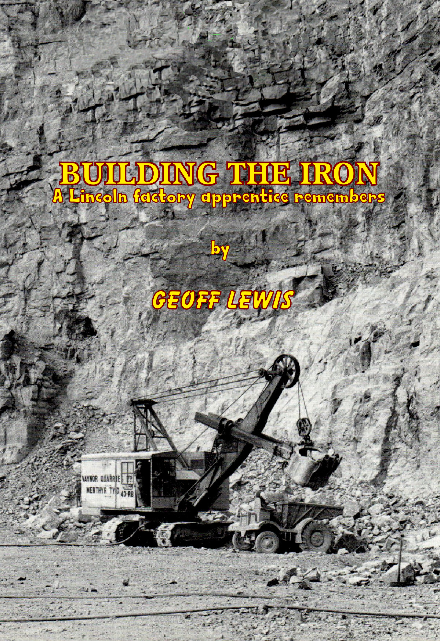

Building The Iron
© 2023 Geoffrey B. Lewis
The Author asserts the moral right to be identified as the author of this work. All rights reserved. This book is protected under the copyright laws of the United Kingdom. Any reproduction or other unauthorised use of the material or artwork herein is prohibited without the express written permission of the Publisher.

No part of this book may be reproduced, stored in a retrieval system, or transmitted in any form or by any means, electronic, electrostatic, magnetic tape, mechanical, photocopying, recording or otherwise, without the written permission of the Publisher.
Published in the United Kingdom by
Shedgnome. Caerphilly
www.swanseaboy.com
geoff@swanseaboy.com

First Edition: August 23
Category: Memoir

Grateful thanks are due West Glamorgan Archive Service and Swansea Council who own the copyright to the pictures noted with access provided by Swansea Library. The first picture: BE 40/3/2 shows a view looking east showing shops and garage demolished in preparation for general excavation at Port Tennant Road, 1958. The road in the background curving away to the left is Ysgol Street which if you stood halfway up the hill afforded a magnificent view of the huge goods shunting yard and dockland beyond. Diving down to the right and under the stone bridge is the original beginning of Fabian. The second photograph: BE 40/3/3 shows the view looking west towards the old Danygraig Bridges and Port Tennant. Work had commenced on the bridge over the access road to the docks in 1958. It is particularly interesting because of the pedestrian crossing the road walking over buried remains of old dockland railway lines. The view also shows the other side of the stone bridge and gives a better idea of the enclosed site on which the RB crane stood.

This book is dedicated to my Mother & Father who so many years
ago bravely let me leave home at age sixteen to follow my dream

and

BUILD THE IRON

A Lincoln digger factory apprentice remembers

Index

Introduction------ ------------------------------------------------------------------------------------5
Dirty Places In The 1950s -------------------------------------------------------------------------6
Digger Dude Lament ------------------------------------------------------------------------------22
The 10-RB & Other Stuff -------------------------------------------------------------------------30
Getting Mobile--------------------------------------------------------------------------------------37
The Lima Experience ------------------------------------------------------------------------------47
A Critical Year ---------------------------------------------------------------------------------------55
Prelude ---------------------------------------------------------------------------------------------- 62
Duke Of Edinburgh Dry Dock -------------------------------------------------------------------69
Considerations & Planning -----------------------------------------------------------------------73
Preparations & Goodbye ------------------------------------------------------------------------ 80
Lincoln Bound -------------------------------------------------------------------------------------- 82
Induction ------------------------------------------------------------------------------------------- 87
Marking Out ----------------------------------------------------------------------------------------113
Out & About The works -------------------------------------------------------------------------- 93
Due Diligence --------------------------------------------------------------------------------------100
Building The Iron ----------------------------------------------------------------------------------113
Shifting Coal ----------------------------------------------------------------------------------------131
Big Machines & Lots Of Teeth -----------------------------------------------------------------133
Gear Section ----------------------------------------------------------------------------------------140
38-RB Rev’ Frames --------------------------------------------------------------------------------144
38 Trucks --------------------------------------------------------------------------------------------168
Days Of Freedom ----------------------------------------------------------------------------------187
Gear Hobbing ---------------------------------------------------------------------------------------191
54 Build Simons gang ----------------------------------------------------------------------------193
Oxford Keble College -----------------------------------------------------------------------------224
Return To 54 Gang --------------------------------------------------------------------------------226
Fairleads ---------------------------------------------------------------------------------------------229
Lincoln College Visits ----------------------------------------------------------------------------231
Priestman Excavators ----------------------------------------------------------------------------234
19 & 22 Build-Drumshafts ----------------------------------------------------------------------236
Revolving Frame First Stage -------------------------------------------------------------------245
Rev Frame Onto Pedestals ---------------------------------------------------------------------250
Assembly Of Lower Works ---------------------------------------------------------------------260
Accommodation -----------------------------------------------------------------------------------265
Number 22 Bay ------------------------------------------------------------------------------------266
Calibration Gang ----------------------------------------------------------------------------------267
Marking Time --------------------------------------------------------------------------------------270
Incidents --------------------------------------------------------------------------------------------276
End Of Days & A Fond Farewell ---------------------------------------------------------------283

Introduction
I sometimes wonder just where we would be as a country if the two world wars had not occurred. On a personal basis many of us would not have been born because wars throw people together in situations and places to meet where they would not normally be. But wars also generate and accelerate the pace of development, manufacture of weaponry, transport systems and communication etc. So perhaps if they had not happened we would not be as advanced as a society and industrial nation as we are today. Another factor needing to be considered is our relationship with other countries throughout the world and in particular with America which partnered us in a very special alliance against a common enemy, providing much of the hardware to accomplish their defeat. We of course paid for it and were in hock for many years afterwards leaving us very strapped for cash leaving us to do things that needed to done till much later than we wanted. Would our aircraft industry be as advanced now without the work done in wartime developing aircraft like the Hurricane, Spitfire and Lancaster? WW2 involved a terrifying amount of bombing leaving us a legacy of ruin, rubble and mayhem with the damage and loss of life that resulted from nightly visits from Germany’s Luftwaffe. When hostilities ceased that mess and devastation visited on our country needed to be cleared away so that rebuilding could begin and from that task, unto us the boys of my generation another legacy was born: the universal digger.

My own town of Swansea had a shopping centre that was flattened during one of the most concentrated bombing raids of the war. If you type in the words Swansea and bombing on an internet search engine you’ll see what I mean. Although memories of seeing it when aged around five are faded now I can remember those subsequent years watching the changes taking place as it was slowly brought back to life. Written in the following pages are my memories of those boyhood days chasing around the town and outlying districts looking for building sites and holes in the ground to watch cranes and diggers dig them or fill them. No other boys in the future will experience those kinds of days ever again; seeing a town rebuilt from rubble and then have the good fortune to enjoy an engineering apprenticeship seeing how the machines to do it were designed and built in one of the foremost engineering companies in the western world. Those days, like the factories, are gone and will never return. I was not the only digger fan. There must have been hundreds maybe thousands of us like minded boys but we never went around in groups on a Saturday like the railway fan. To some extent we both considered slightly weird but it did actually help when gaining an entrance or to climb aboard the latest find.

There is also one other consideration which must be touched on in view of changes to world demographics and manufacturing methods very much accelerated in recent years by computerisation. From the time of industrial revolution it was the individual looking at what was needed who would through manual skills and ingenuity develop the machinery to assist and increase production. In doing so they also brought in to being the art of designing what was required and putting it onto paper in the form of engineering drawings for reference, record and repetition. All depended on the skilled individuals working alone or in a team to produce mechanical things. It was truly the mechanical age. All sorts of goods today are no longer made by hand but by automatic machines in vast quantities on a computer programme controlled units operated by individuals who may themselves not have the dexterity or knowledge to use the manual equivalent of a lathe or milling machine. The mechanical age is now however dead its slow demise sadly witnessed over the closing years of the last century sadly for our youth now augmented by another tragedy with the advent of the a time stealer of tragic proportions: the portable computer tablet. What happened to all those glorious model building days of boyhood? Our generation, and those following shortly after, could never have anticipated how these changes, imperceptibly applied, would evolve. None of us realised that the mechanical age in which we lived and were now passing through was making history, not beginning to even suspect that in those future years most of what we had learnt or made would be irrelevant and obsolete; our experience, training and skills suitable only for nostalgia and museums.

I started to write things down about twelve years ago but somehow they morphed into a novel come memoir of growing up in the 1950s against the backdrop of our town being rebuilt, schooldays and generally messing around with friends: THE SLIP - Some of my digger watching days are spoken of in this book, particularly the Lima 1201 episode, but not in as much detail as BUILDING THE IRON. So my apologies in advance if you have read it or come to do so in the future. There is one major difference in the novel in that it takes a rather sinister twist toward the end. Perhaps if you read it you to might ask the question: Did you know who all your boyhood friends really were or did you find out too late? Regrettably; there few pictures for this book of my boyhood diggery days which is really sad. I would have captured some memorable scenes.

Dirty Places In The 1950s
Looking back to the 1950's when I was a schoolboy I realise now, so many years later, how privileged and lucky it was to have been born into that particular time slot in our country’s history. It was the aftermath of a long gruelling war and Swansea, like a lot of other towns throughout Britain, had been pounded by Hitler’s Luftwaffe and its town centre flattened. I was actually born in 1943 in the West Cross district to where my parents had moved with my older sister when living near to the town centre got more than a little risky. West cross was situated approximately five miles around the sweep of the bay from the docks and west of the main town. During the blitz its inhabitants were able to watch it burn as it was reduced to rubble. A vision never forgotten that was to scar many for life. When the war ended local authorities, like the rest of the country, gradually cleared away the rubble and started a programme of rebuilding damaged homes and resurrecting commerce and industry. There was a lot of it to do and I can still vaguely remember being taken to the top of Castle Street at about aged five to gaze at the devastation that had been visited on a once busy shopping district. A fading memory comes to mind of a noisy green digger busy at work where Castle Gardens now stands. Was this my first ever glimpse of a Ruston No4? I had an aunt who worked in British Home stores in Oxford Street. One evening after the shop closed she left to go home confident of returning to stand at the counter next morning only to find the shop, the street and most of the rest of the town a flattened rubbled ruin instead.

The Brynmill district to where we moved could not have been better and to this day I believe myself to have been extremely fortunate in growing up there along with hundreds of other children; cosseted as we were by the confines and safety of two splendid parks to play in: Brynmill and Singleton, and only a ten minute walk from Swansea beach. A short few minutes in the opposite direction was the Uplands shopping centre, close to Cwmdonkin Park and a stone’s throw from the home of the late Welsh poet Dylan Thomas. Within short walking distance of our doorstep we were additionally blessed with two different bus routes. From ‘Brynmill Central’ things looked good.

Swansea was an industrial area with coal, steel and a busy seaport with its own small fishing fleet, as well as several trade and dry docks. Along their many wharfs were cranes of varying types which, if you could find the right vantage point from Danygraig or Townhill, could be seen playing lucky dip with cargo ships as they came to berth or cast off and depart out into the bay, sailing to other far off lands. Steam locomotives shunted wagons continuously through goods yards and their shrill early morning whistles signalled noisily across the morning air awaking sleepy heads to a day already begun. The dynamic combination of busy dockland activities and the nearby town reconstruction, with all its potential for machinery, presented an irresistible challenge. We grew up to the background of a town centre and surrounding districts populated with earthworks, each requiring foundations or basements to be dug, trenches prepared for drainage systems and girder-work to be erected. Cranes and excavators of various manufacturers were everywhere; the term excavators being a bit of a mouthful - and easily confused with stairway escalators - also qualifying for the simpler tag of diggers, which were ultimately the more exciting to watch as their buckets dipped, dug and dumped spoil into waiting queues of lorries. Navvy was another term used to describe them, usually by members of an older generation, referring to their original steam driven grandfathers which had in turn replaced the gangs of railway and canal digging labourers, navigating by pick and shovel the cuttings, embankments and waterways that gradually spread throughout the land.

I can still remember the excitement of those heady days. It almost seemed there was a buzz in the air with tremendous industrial activity all around us. Apart from the docks coal mining was a huge concern supplying not only export markets but several steelworks nearby at Velindre, Port Talbot, Ebbw Vale, Trostre and Llanelli; wages at Port Talbot rumoured to be so good it was nicknamed Treasure Island. These two industries with the engineering and other support jobs they generated employed thousands. Around the town and its outlying districts - today perhaps they would be called suburbia - there were numerous building sites with workmen on cold days clad in ex RAF, Army or Navy service greatcoats, as they went about their business digging ditches, pouring concrete, erecting steelwork and a myriad other things that would transform business, domestic commerce, the lives of the shopping public and their domiciliary arrangements for the better.

It was a mechanical age and those schoolboy days were years of continual invention and progress as both private and commercial transport was developed; externally changing shape to become more streamlined and under the bonnet more efficient. We became more aware and were in awe of the latest aircraft developments in the new jet age while we took more notice of cars, lorries, buses and everything else on our roads; wanting to know who made them and where, their design and technical details. As the last years of our school passed we watched them evolve. Manufacturer’s names were taken, small gatherings of like minded boys both in and out of school met to discuss the latest thing. Newspapers featuring the latest in all sorts of private, public works and service vehicles spread the word alongside magazines like Meccano, Model Engineer, Practical Mechanics and others who wrote for the hobbyist and other seekers of inspiration. Our enquiring minds scoured industrial magazines: Construction News, The Builder, and others, along with relevant newspaper articles. We visited the local library looking for books and any other references we could find to get information, taking any mechanical thingamy apart that could be taken apart to see how it worked and then hopefully put them back together again. Aahah! So there is a spring here. I wonder if...…boing- whizzz! DAMMIT! Where the Hell! did that go?

The sound of words was important to us, like axle, gearbox, and differential. One really good word for our receptive minds was piston. What a great word that was to roll around. We knew that car engines had pistons but we had probably heard it first when associated with steam engines. They also had cylinders and pistons, but were fire breathing dragons generating a more dynamic impact on the mind. Cars by comparison were more everyday mundane. Say the word in two parts: ‘pis’ and’ ton’ and it had two distinct sounds: a soft beginning with the first three letters leading up to the impact of ‘ton’ swinging on the end. It’s almost like a statement in itself; a good word we found to slip into conversation when trying to impress. It’s almost like a statement in itself; a good word we found to slip into conversation when trying to impress. Letters would be written to manufacturers for catalogues, brochures etc about cranes, diggers, cars, vans, trucks tractors and anything else and MECCANO became our ally, allowing us to replicate what we saw. Not just kids playing with a toy but junior engineers with spanners and screwdrivers just like the mechanics we saw tinkering with cars and lorries; its instruction book teaching how to interpret and convert the real thing into red and green manageable miniatures. How many of us I wonder ever got to build that magnificent block setting crane or walking dragline pictured on its cover with those two short trousered and smug looking schoolboys? The immediate post war years thus presented the ideal conditions for our digger spotting pursuit. The scene was set. How could we not succumb?

There was a long term commitment to update anything and everything on wheels, railways and in the air; a self perpetuating situation with increasing activity requiring more machinery to do it. Thousands engaged in utilisation and continual development promoting product with car, commercial and public works exhibitions and groups with modelling interests, be it aircraft, railway or Meccano, setting up clubs, associations and other groups . Some companies even started engineering societies for employees and apprentices to educate and assist our endeavours as we rebuilt and set up the country for a bright exciting future. Today all this work has been done, the demands are different and we have computers and mobile phones to distract us, tapping away at keyboards instead of filing or gluing. The age of simple principles of mechanical invention and control is perhaps over and we now add complication to our lives, even to the simplest of things, by sticking digital technology onto everything. But if
you haven’t got the initiating password…...? If it’s not the password it’s ‘THE CHIP’.
I remember chips. We sprinkled them with vinegar, eating them wrapped in old newspaper. Can you remember how to do joined-up writing or do you like me now have you to really concentrate?

From a very early age cranes and diggers had become my personal raison d'être. Don’t know why. Perhaps it was the bright red tinplate toy crane I was given when we lived in West Cross? It just was and I could stand watching them for hours. Was this normal behavior or has that boy got a screw loose? Watching steam trains it seems was OK but watching diggers was weird. It was also a more innocent age when building sites had not yet reached their zenith of health and safety zealotry and access was far more relaxed with no hoarding erected to block the public’s gaze. Site foremen and machine drivers were usually friendly and easily approachable to have a natter with and ask questions. Was it my imagination or did an easy sort of camaraderie seem to develop after several visits had been made? Oh happy days! Digger drivers in particular became our heroes and would often, if there was enough room, let you climb on board to stand behind as they pulled the various levers in front of them to dig holes that got forever bigger and trenches that got forever longer. Watching the gear wheels go around, clutches spinning and listening to brakes and clutches squealing was almost hypnotic. Being magnetised by mechanical action in the town centre at lunch times, schoolboys would often be late back for class, I would be late back for class – ‘please sir I was watching a digger’? The hours you could clock up standing behind digger drivers while sheltering from the rain on wet Saturday mornings was something only another enthusiast would ever endure or understand. But schoolboys were not the only fans. Wherever a machine was working members of the public would also gather around to watch the scene before them unfold.

The ‘tech school that gave me my secondary education couldn’t have had a better location. I don’t know what the interiors of grammar and other secondary schools looked like but by comparison The Swansea Secondary Technical School, or ‘Tech’ as it was more commonly known, must have been sheer opulence. A magnificent former Guild Hall of the town originally built in 1884 and cleverly adapted to perform the requirements of a school; full of character with corridors, alcoves leading to hidden rooms and even a small spiral stairway you could almost walk past without noticing. It also featured behind its main entrance doors a wide marble staircase leading in right angled tiers up to the main floor. How unfortunate that it was destroyed during reconstruction work for a tribute museum to the Welsh poet Dylan Thomas. For those of us who read the LION comic it became the epitome of Sandy Dean’s Schooldays or Billy Bunter at Greyfriars featured in another publication. Masters wore mortarboard and gown and hurried down draughty corridors to their various classes, black capes billowing out behind them like educational supermen. It was right at the bottom end of town, slap bang next to the dock area and alongside Weaver’s Basin. Weaver’s itself was the huge flour mill that had been built in 1898 on the Victoria wharf of the half tide basin which in former times had fed shipping to the coaling facilities in then adjoining north dock. Alongside the flour mill wharf boats from far away places regularly moored, their painted Plimsoll line revealing a gradual rise of each hull in the water as ingredients for bread and cookies were sucked out into vast storage silos. From our technical drawing classroom across the water we kept watch and were sometimes able to catch their unladen departure, now riding high in the water, as they squeezed out through the lock gates to freedom wending their way back home from whence the came across the open sea. The north dock, closed in 1930, had since been filled in and levelled for use as a goods yard and depot for British Road Transport.
Its origin was interesting. There were lots of things to know about Swansea at the time that I now wish I had known then but of course just a schoolboy what did I care? The North Dock had been constructed to handle increased activity of the burgeoning copper industry on the upper reaches of the River Tawe during the first half of the eighteenth century; the Landore copper works having been commissioned as far back as 1717. The industry had in time adapted to handle other non ferrous metals to such an extent that Swansea became acknowledged as a world leader in metallurgical processing and manufacture. With this industry and coal export it was for a period one of the busiest ports in the world and to improve handing of cargo coming down river Swansea Harbour Trust devised a cunning plan and split the lower part of the River Tawe to the left into a newly excavated channel that would henceforth run directly to the sea. The existing flow path from the junction diversion would be deepened to form an enclosed dock on the original course of the river bed. Completed in 1852 and originally named the Town Float it was re christened the North Dock some time later. The new facility allowed that having entered from the north end shipping could, once wharf business was concluded, head toward the high seas through a set of lock gates constructed at the south end of the tidal basin; in time to become known as Weaver’s after the construction of the flour mill. It was the transit passage gap between Weaver’s and the main dock needing to be regularly crossed by road and rail traffic, the railway at both high level viaduct and road level, that led to the cleverly designed drawbridges for both applications which, until I started writing all this down I confess to knowing absolutely nothing about. Wasted youth?
In mitigation I can only say that by the time I started at the Tech they had both been redundant for many years when I found myself standing next to four supporting pillars of the railway drawbridge straddling the now filled in waterway. I was watching a brown painted skimmer excavator working directly beneath. The ground at this point was normally fenced off but this chance visit found it to have been pulled back to allow the clearance of rubble. The digger was loading a tipper lorry; boom and bucket going up and down, pulleys turning dragging the bucket along the ground, three point rope reeving lifting to swing around, bucket latch working, floor dropping away. Couldn’t take my eyes off it; nearly late back for school. The fact that there was actually a drawbridge above never even occurred to me. Why would it? Sometime later during a lunch break a group of us happened upon an operation taking place to remove the remains of the road drawbridge. It hadn’t however been a castle moat bascule type draw bridge like those of medieval times, depicted in films where the portcullis is dropped and sweating guards hand cranked the wooden bit up; ‘For security reasons you understand sir. It’s all in the interest of security’. This one was the twentieth century version first taking up operation in 1903 and cleverly designed to roll back over the top of the permanent way leading up to it.
When in operation this heavily riveted beam assembly straddling the gap was first mechanically raised vertically, to give sufficient clearance beneath, and then rolled back on carrier wheels placed either side of the permanent way for the purpose. Only looking at photographs of it now in retrospect so many years later can I appreciate just how large a structure it really was, crossing the gap and stretching the width of the three: rail, vehicle and pedestrian traffic carriageways. I had an aunt living in Danygraig and travelled back and forth over it regularly when visiting on a No 76 bus, but those bus journeys took place nearly twenty years after it was decommissioned and far too late to be seen working. It must surely have been something to behold. There are some excellent pictures of both bridges and this area of lower Swansea on a website run by a local society: www.swanseadocks.co.uk.
Some large ancillary components buried at the time of its redundancy and now rediscovered were also to be disposed of and a gang of workmen with burning torches were busy cutting it all up while a crawler mounted Neal’s crane was assisting. I distinctly remember it manoeuvering a very large and heavy piece hanging from the hook, balancing on the front end of its crawler tracks, back end well clear of the ground, whilst lowering it onto a trailer. A breathtaking experience for everyone watching as we anticipated disaster. The crane was unstable, operating beyond its limits and in danger of tipping over. Will it? Won’t it? We the watchers held our breath and, as the threatening lump was finally placed, sighed with collective relief. The trailer, not so happy, immediately began to sag alarmingly. A moment to adjust and then away to a final resting place. Where did it go? Maybe to Barney Easton’s scrap yard fortunately located just some distance down the road, but things are never that simple. Not long after this incident I started making regular visits to Barney’s yard.
As already indicated the needs of my secondary education were now taken care of at the citadel for learning down by the docks which provided grounding in vocational needs with emphasis on subjects more applicable to meet the challenges of industry and commerce. It must have been in 1956 when I first entered the magnificent former town hall. Up until the year before my arrival it had also taught young gels but their presence had been reviewed, the young ladies expelled and the school become a bastion of the uncouth and noisy. The various court rooms which had been part of its original structure had been adapted to suit; the largest into a magnificent assembly hall still retaining a spectator gallery from where former generations had watched the condemned. There were chemistry and physics laboratories, well equipped carpentry and metalworking shops and a splendid technical drawing office. Wood work when not agreeable to everyone could occasionally be negotiated out of the equation and happily abandoned in preference for metalwork which although a harder material to manipulate was more resilient to our fumble fingered touch.
The metalwork shop, in which we sweated, was well equipped with work benches, two centre lathes, a shaping machine and a forge. With a selection of hammers, chisels, punches, formers, hacksaws, general tooling, flat files, round and half-round files, square files, smooth cut and rough files, and in particular, the constantly referred to with much schoolboy glee, ‘bastard file’. We made engineers dividers and callipers, inaccurate straight edges, metal containers etc and any number domestic projects: a decoratively hammered copper ash tray to help dad calm his nerves and a poker with cast aluminium handle for him to poke the fire. The lump of handle aluminium had to be melted in the forge without creating an explosion so on the word everybody was ready to run for cover. When using the lathe we were also introduced to Mike the micrometer; a very clever device for measuring diameter or thickness to an accuracy of half a thousandth of an inch. Most of us up till then had never ever considered doing such a thing or even realised that it could be accomplished.

This engineering stuff was becoming interesting. In creating all these skill testing projects one thing was always emphasised. If a finger is put near a turning lathe chuck, poked into a hot forge or placed between a hammer anvil and the metal object being struck: pain will occur. And if fingers are in touch with a moving grindstone or hacksaw teeth: blood will flow. Without realising it our engineering instinct and a healthy safety awareness was growing. We, the lucky ones who had such a foundation, would find it a blessing in the years ahead when we got more closely acquainted with running machinery. Another thing I was beginning to take notice of was the information plates attached to the sides of lorries and other things on wheels and crawler tracks. During the course of our studies we had been learning about the imperial system of weights and measures which existed then, before the present day metric one, when things like tons and cwts were used to define how heavy big things were. Well I knew what a coot was, they were feathery things that swam around getting tangled up in your fishing line, but what was a cwt? It could, I supposed, be Welsh for coot but unlikely if attached to an information plate on the side of a lorry, digger, crane or other piece if mechanical apparatus. On a vehicle it helped define the tare or unladen weight and on a crane it was part of the information telling you how much the crane could lift before it tipped over; the latter being particularly useful if you were standing anywhere near it when the load left the ground. The term cwt of course was an imperial measurement abbreviation for a hundredweight; twenty hundredweight making up a ton. But just how big did something have to be to weigh as much as a ton?

It seemed enormous when you looked at the size of a vehicle which might weigh several tons but how big would it be we wondered if it was a lump of metal weighing a ton, a container of water or a block of sand? Although we now use the European metric system it is a decidedly less colourful terminology than our original system. For myself, pounds, tons and hundredweights added more impact to a statement of heaviness than a mere kilo or bland metric ton. Another question that exercised us in class for some time was asked by the math’s master. It was a tough one. Which was heavier, a ton of lead or a ton of feathers? That one really concentrated our minds; not only wondering if it was a trick question but reminding us of the chemistry master who asked us, completely straight faced, to devise an experiment to decide which water was wetter and why: the stuff coming out of a tap or water running in a stream. Once we had found the answer we had to determine a coefficient of wetness? If they had asked us where cuckoos lived it would have been easier. We’d seen those in clocks when we went to Switzerland on the school trip.

Unplanned and purely by chance we found ourselves in more regular contact with local machinery than could have possibly been anticipated. Right outside the school technical drawing office window stood a couple of sand hoppers in a stock yard run by South Wales Sand & Gravel. Adding to this exciting view on far too many occasions for the tech’ drawing master’s hearing was a noisy grab crane. The sound of its six cylinder AEC diesel engine would very often reverberate outside as it came under load, biting mechanical fistfuls of sand from the hold of a dredger docked alongside the quay after a night spent hoovering its cargo off the floor out in the bay. The NCK304 grab crane had been manufactured by Newton Chambers of Sheffield and Stan the driver soon became a friend who let me climb aboard to stand behind. Watching him offload the moored dredger it soon became apparent that working the grab was a very skilful operation requiring a great deal of concentration. Several years later when an opportunity presented itself for me to have a go on a similar machine in another place I was able to appreciate just how much.

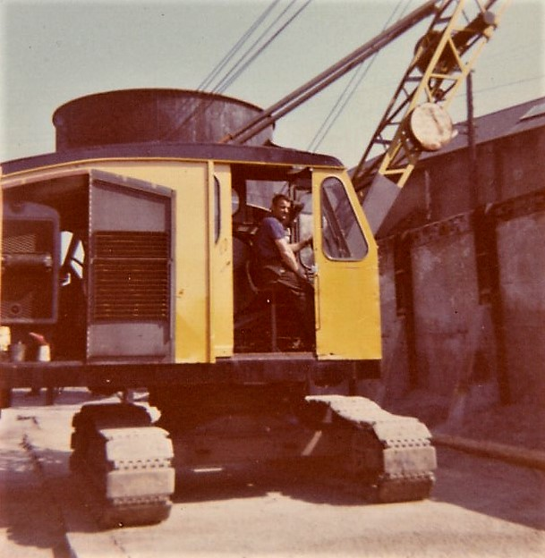

A few years into the future after leaving school and in the last years of my apprenticeship at RB, I was fortunate enough to meet up with Stan again by accident and we had a pleasant but all to brief few moments remembering those happy Weaver days of so long ago. Weaver’s old dock has long since been filled in and where the stock yard once stood is now one of the loading bays for Sainsbury’s……and it has been said that sometimes if you stand outside at around seven O’clock on a dark winter evening you can still hear the ghostly echo of brakes and clutches squealing and that AEC engine, still pulsating and throbbing on Stan’s grab crane as he fills yet another ghostly hopper………Not only did we have the grab crane working next to our technical drawing class; there was also on the opposite side of a lane adjacent to the art classroom an engineering yard with its own little pile of sand stuffed in a far corner. This would regularly be attacked by a Chaseside loader type tractor with a shovel bucket mounted in front. When there was a customer it would line up, drop the bucket arm to the floor and then charge at the sand pile to fill before hoisting in the air with a winch at the back. The art room was located on the first floor so you could see the wire rope going down behind the cab where the driver was sitting. It would then do a reverse turn before driving forward again to discharge it all into a waiting vehicle; an action watched intently for when the driver pulled a rope inside the cab to trip the dumping latch. The Chaseside made an ideal subject to replicate out of Meccano.

My kindred spirited friend who lived on the same street was also an avid model builder and his No 9 Meccano instruction book had a tractor shovel just like the Chaseside. We may have gone to look at it together one Saturday morning because not too long after we had discussed it as a possible project he completed a very fine model powered by an electric motor. Some of our discussions could be quite prolonged as we debated the various options along with the interesting content of Meccano Magazine. One of his other projects was a walking dragline based on a machine made by Ransomes & Rapier of Ipswitch; looked absolutely spiffin’ and worked just like the original. My own Meccano set was not as big. Probably a No 6 with a load of separately bought parts which served for a number of useful book projects but were sadly insufficient for a number of over ambitious independent ones that too often ran out of bits before completion.
The road at the bottom of the street on which our school stood was known as East Burrows and really was a busy location. As well as the Chaseside the yard had an engineering workshop, always busy with visitors calling. Next door was another company supplying coal with an ancient looking electric grab crane, possibly made by the Smith Company. This ran back and fore on a short raised section of rails about four feet high, picking coal from a line of bunkers to drop into a feeder silo for customer lorries. Unlike my friend Stan’s NCK which used two ropes to operate it the old rail crane used a chain attached to the end of a single hoist cable. The grab was first placed on the coal pile with the chain continuing to pay out while lowering a trip assembly down between an inner frame to engage a latch at the bottom. Raising it back up closed the grab over the load before swinging it away to be lowered onto its point of delivery with the trip assembly again lowered to the bottom of its travel where this time the latch would disengage; allowing the grab to open and discharge its contents when lifted clear. At the top of the grab there was a heavy annular ring which acted as a guide for the chain. As the chain passed through it tended to gather and bunch just a little as its progress was slowed and in doing so it made the most glorious heavy rattling sound. I can still hear it now. There were all sorts of mechanisms to find like this in those far off days and working out how the logic of this particular one worked took time but was well worth the effort when finally understood; ultimately inspiring the construction of a working Meccano version.
While writing these notes I found it necessary to jog my memory and referred to an aerial map of the district for the time. It reminded me that there were also two small dry docks on the street opening directly onto the Tawe estuary. Still scratching my head for inspiration also prompted the memory of another nearby workshop. A group of us visited it one lunch time hoping to see engineering practice in the raw and we were not disappointed. Situated at the opposite end of Weavers Basin on a patch of ground bordering Quay Parade was a relatively small workshop. Constructed of corrugated sheeting it had been painted externally in a rusty red colour adding an additional ambiance to its purpose. Access was by a small wooden door at one end and the first thing we saw on the right as we entered was a centre lathe, much bigger than the ones we were familiar with. In its jaws was a rope pulley being turned from a raw casting. My first impressions were definitely good. The gent who was doing the work on the casting seemed impressed that we had actually recognised a rope pulley and went on to describe what he was doing, also showing us a set of micrometers that were much larger than our school ones and capable of measuring diameters of up to six inches. Wow!
The workshop was scattered with engineering equipment and paraphernalia: a second much larger lathe, a big milling machine and a much bigger drill than we had at school. There was also a mechanical hacksaw standing in a far corner next to a bin of what were called off-cuts; the bits left behind that were considered to be scrap. We recognised the hacksaw because we had a much smaller one in our metalwork room. In the short time we had before getting back to school, and avoiding detention, we asked a lot of questions which were willingly answered with an invitation to come back any time if we had others they could help with. This of course was in the days of pre history in the 1950s when engineering was a respected profession. Whatever happened? I used to love the smell, excitement and bustle of a workshop. Where have they all gone and why for heavens sake?
Set into the main roadway alongside and adding to the workmanlike ambiance of the workshop were railway lines, now redundant but formerly used to shunt ten ton coal wagons into the nearby South Dock. These would have come from the east end of town from the Kings and Prince of Wales docks on other side of the estuary, crossing over an imposing swing bridge on the way. Upon arrival at their coaling point they would each have been run onto a tippler turntable to position ready for lifting and discharging into the feed chutes. By the time of our workshop visit these tipplers may well have been redundant for a few years. Trying to reconcile all these events of so long ago my sequencing may be a little out but I can however still recall the thrill of my visits to that south dock quayside and the sound of thunderous, dusty crescendo as coal crashed and tumbled down into cargo holds below. It was probably not long after the North Dock drawbridge was removed that these road level railway lines were also taken up for a new carriageway to be laid.
Easton Brothers scrap yard was just a five minute walk from school. Situated on Quay Parade just across the road from the railway line and workshop it was a hundred yards or so from the redundant North Dock Bridge and accessed from beneath the railway viaduct above carrying the LMS railway. Their premises were rather extensive and often reverberated to the loud staccato “putt, putt, putt, putt” of another Neal crane. Long suffering, well worn, weary and battered, this one was mounted on heavy duty wheels featuring integral metal plates to protect its tyre walls from scattered debris. Visits would often be made on a lunch time and if the crane was not immediately in sight one of the brothers or the foreman would grinningly inform me it was, ‘down the yard,’ which usually meant down the far end. I would find it wherever stood as it ‘putt-putt-puttered’ away marking time as various bits and pieces of scrap were loaded into a spoon shaped metal pallet suspended by three chains from the crane hook. Controlled while standing at the steering wheel even when on the public highway, it had a very meagre looking lifting arm comprised of two channel sections braced and connected together at top and bottom while being suspended by several strands of rope winding between the superstructure and gib head before disappearing into the roof of the cab. Bryn the crane driver said it was called four part suspension.
After I had been calling for some time he invited me up onto his platform. Up there was a different world. Directly behind him was the puttering diesel engine ticking over loudly with the sickly smell of fuel and alongside an assortment of spinning cogs wheels and other complicated and important looking gubbins. Below floor level lurked a mysterious winding drum with the coils of dirty wire rope around it that had disappeared through the roof. It was this winding drum, Bryn said, that moved the crane’s long lifting arm, called the jib or sometimes a boom, up and down and it was attached to a gear called a worm wheel. The worm wheel was in mesh with and was turned by its partner gear called the worm. So, there I was behind him on his crane platform standing in paradise when, with a load just ready to lift, he turned to me suddenly and said, “Righto young un, stand by there and pull that lever back gently.” So I did as bidden - and it was amazing. It’s hard to explain in one sense but I could actually feel the load as the crane responded under my feet and through my hand on the lever; a totally different sensation to what I had imagined it would be. The experience of just standing there, the smell of it, the whole thing was amazing. At that moment, as I stood staring down into the black abyss of the worm wheel well, I knew my destiny. It would be one of dirt, oil and grease and a lifetime of grime but how was I to get there? A number of boys were interested in becoming car mechanics, motor transport fitters, railways…… but a digger mechanic as a trade? It was not readily addressable at that time. A bit more head scratching.
Just one more snippet about the yard before moving on: To the left of the archway were a group of small shops, one of which purported to be your bog standard newspaper shop thingy. It was perhaps in reality a grubby dirty old mac’ shop showing strangely titled magazines in the window with names like Razzle and something about Efficient Health? Being naturally inquisitive about our health we took a healthy interest in the magazines and were really puzzled to see that they only contained pictures of young ladies clad in either the least amount of clothing or just plain skin wearing strategically placed photographic smudges. This was worrying. The relationship between Barney’s place and the school crane freak was well known as was the proximity of the ‘funny’ shop next to it. Malicious rumours spread by 3rd year mischief makers could have seen my visits to Barney’s put in severe jeopardy but fortunately the influence of 4th year health check visitors must have prevailed, everybody kept shtum and the sanctity of my scrap yard visits preserved.
In due course I learned that Easton Brothers also did a bit of outside contracting work with demolition and land clearance so with several bombed out sites still scattered around Swansea there was steady work for them. Perhaps a mile or so away from the yard by road was High Street railway station and leading away from it was Alexandra Road on which stood the fire station with its bright red fire engines inside. A little further along from the fire station and around a corner was an even greater attraction. It was the former Trinity Place Orthopaedic clinic, now defunct and one of the places they had been engaged to clear. Bryn the yard Neal crane driver was at the controls again and invited me onboard with a grin one Saturday morning after recognition from previous yard visits. This time he was attacking rubble from the demolished building and loading it into a steady stream of tipper trucks.
What he was driving now was a mechanical shovel manufactured by the Ipswitch company of Ransomes & Rapier. Designated a model 424, with bucket capacity of 5/8 cubic yard, it must surely have been one of the noisiest excavators I have ever been on, then or since, except for one other much bigger digger which will be discussed later. On the plus side it had a very interesting array of levers and rods to marvel at. Observation of them moving back and fore engaging and disengaging the various motions of the machine only served to blur the noise and add to the excitement. I can picture it now with Bryn bouncing around on the tractor type seat, fighting the levers as he tore into the rubble, while yours truly, with teeth rattling, clung for dear life to the main A frame from which the digging apparatus was suspended. I didn’t dare let go but it was absolutely thrilling. Yeah! Yeah! A whole lotta shakin’ goin’ on. There was no other experience like it. Directly across the road a more peaceful scene was being played out. One of the last Swansea farrier blacksmiths still in existence was replacing shoes for a large dray horse, standing quietly ignoring all the noise around him as he got his pedicure. Somehow it seemed appropriate.
The only other Ransomes digger encountered in the district was working at around the same time on the other side of Alexandra Road. Clearing bomb rubble from what may have been a small hillside chapel, possibly seen from the top deck of a No 74 bus while on a library visit. It was a model 410, using luffing shovel equipment, quite a popular arrangement for that size of excavator with a number of manufacturers. Not actually seen working at the time, it was just parked, but a visit a couple of days later before the job finished bore fruit. Driven by a scruffy dungaree and beret wearing wiry looking gent not seen before, it was not as smooth in operation as Bryn’s machine. Not because of the lever puller but more as a result of the way it was designed. The boom was constantly worked up and down with the bucket arm swinging beneath from mid point to increase digging radius, using gravity to assist penetration with the pull of the bucket rope. All this being suspended from an A frame by three part rope suspension, the visual imperative of movement, pulleys spinning and constantly reversing direction was quite intense.
Some time into the future I received a number of their leaflets and bulletins outlining their more popular range of excavators. Included in the package were specifications of their famous 1800 Walking dragline, then the largest in the world which a few years hence I would be happily climbing aboard at a South Wales open cast mining operation. A lot of time was spent at Barney’s place, snatched half hours at lunch times and occasional Saturday mornings with happy memories of chasing around looking for Bryn and their Neal crane. They actually stayed in business for a number more years but the viaduct and their yard were demolished in 1967 long after I had left Swansea. If you took the time to look, as you came across the various crane and excavators, you would find the manufactures name plates. There was a lot of construction activity and some machines were more prevalent than others. I can of course only speak for those that I saw: Priestman made in Hull, NCK machines like Stan’s made at Thorncliffe Works in Sheffield, and Neal Cranes as seen struggling at the draw bridge and Bryn’s battered scrap yard crane built at their Grantham works, just twenty five miles down the road from the reason I decided to make these notes of my digger spotting days: the legendry RUSTON BUCYRUS EXCAVATOR factory at the Lincoln.
Smith excavators, built by Thomas Smith & Sons at their Rodley works in Leeds, were popular in a lot of places but not around Swansea for some the reason. The only one I can remember seeing was a bright red Super 10, easy on the eye, standing all alone and forlorn at the bottom end of Singleton park, about a mile and a half walk from our doorstep. Nice and clean, it was rigged with dragshovel/backacter equipment. I might have slid the access door back to take a peek inside - very cosy; similar in a sort of way to a Priestman I thought, with my worldly expertise on such matters. My inside knowledge of Priestmans had at that time only been gained through their catalogue pictures. The main thing I can remember about Smith’s is that it was the first company I submitted an enquiry to for information on their machines, discovering that such information was available purely by accident because of an unexpected visit to the South Dock. Sometimes things just fall into your lap.

It must have been around late 1955, just before starting at the Tech, that I made the visit for one purpose and ended up doing something else. I was on a mission to take a closer look at a square and battered looking crawler mounted grab crane seen some time previously. Manufacture unknown, it was parked near to a Stothert & Pitt level luffing crane, also rigged for grab work on the south quay at the west end of the dock. I didn’t normally go looking for dockside cranes. They inhabited restricted property, but fortunately administration at Swansea was fairly casual, even the odd dock bobby not seeming to take much notice as long as you kept a low profile; quite difficult really with ginger hair signaling my presence like a beacon. So, unencumbered by authority I was able to wander pretty freely, parked my bike nearby and walked over.

Gleaned from avid reading of Meccano magazine and instruction books the term luffing was used to denote the deliberate change of angle and radius of a suspended gib or boom. More commonly associated with dockside cranes where constant change of operating radius was essential to the offloading of cargo. Used in conjunction with the Ransomes shovel seen recently it may well have been adapted from dockside origins where with a fixed length of jib the term was modified to level luffing: describing an ability for changing operating radius while the load remained at constant height. Typical methods used to accomplish it usually combined geometry and rope reeving. I didn’t know all that then of course. Just a schoolboy but steadily picking things up, like the fact that dock cranes were mostly electrically powered. Consequently, where possible, to save energy a number of methods were devised to relieve active gib weight by counterbalancing. It was all clever stuff that needed further investigation but not then. For practical reasons my interests had to remain firmly grounded with diggers. Getting around to a more detailed inspection of dockside cranes took another forty years!

Terminology had a heavy presence. Every industry has a whole rake of it and cranes and excavators had thousands of sound bite names to confuse a would-be schoolboy digger mechanic-come-engineer. It was also evident that a number of different names could be used to describe the same function or component depending how it was applied. Eg: In shipping only, it seemed a rope could be called a hawser, on a crane it was called a rope and on a digger/excavator it was a cable. However, the names cable and rope were also interchangeable so it was perhaps just a quirk of individual speech or preference as to how it was identified. The other noticeable labelling aberration was for the load carrying arm that pivoted in front of the crane or digger and over the top of which the cable/rope hung to lift a load. For both crane an excavator work it was called a gib or boom. The labels may have been more clearly defined at one time but again it seems to be a personal choice. Having said that, there was one other slang term occasionally used by those seeking perhaps to impress with a tired worldly air of ‘having been there done that sort of thing’ and they would call it a stick.
The owners of the South Dock grab crane, another sand and gravel company, had their compound adjacent to the perimeter road with the Stothert & Pitt standing on the same patch of wharf at the east end, poking its way high into the sky like a grumpy giant trying to catch scudding clouds on the end of the gib while standing sentinel over its surroundings. The crawler crane stood a short distance away next to a pair of storage hoppers, with next to them a large pile of night dredged sand. Everything was quiet and with no one about I made my way to the back of it to see what the makers name was. Aha! RUSTON BUCYRUS. So that was my mystery solved. On the compound floor a few yards away was the grab for the S&P with its twin operating ropes reaching lazily skyward to the jib head, begging for action. It loomed larger than it looked from across the other side of the dock and whilst casting a curious eye over it a discovery was made. There was indeed somebody else about.

“Hiya Ginge”, he said. “What are you looking for? You shouldn’t be around here you know. The docks aren’t a safe place for schoolboys.” Oh, Oh! Was he going to be one of these officious individuals? He seemed friendly enough though so I played it by ear and told him I’d seen his grab from the other side of the dock, hadn’t recognised the machine and come across to find out more. Telling him I hadn’t recognised the Ruston piqued his interest and he said he’d never heard an excuse like that before. So I confessed navvy watching was my thing, familiarity with a number of manufacturers, Priestman, Ruston, Neals – also dropping in a bit of terminology to impress, been going on building sites for years, befriending drivers, climbing on board, blah, blah, blah which seemed to work and got him interested enough to forget his concerns over my safety and enter into a more informative discussion about other Ruston machines that had born my inspection, like 10s and 19-RBs, but nothing as big as this. So as we stood in the shadow of Mr Stothert and Mr Pitt, talking of manly things, he identified his machine as a 33-RB with a two line grab feeding the sand hoppers from a sixty foot gib. Well spoken and clad in oil stained dark brown workwear jacket and trousers, he was around the same height as my dad, possibly a few years younger but stockier in build with neatly combed dark hair parted to one side and a bushy moustache over his top lip. He just didn’t look like any crane drivers I’d met before; his moustache reminded me of Dad’s.

After asking my name he said, “Call me Hugh”, and invited me to climb up on the tracks to have a closer look inside. It was an Aladdin’s cave of mechanical gubbins. It’s so long ago now I can’t really remember the colour the cab. Possibly some sort of cream with matching grubby cream machinery frames inside. Design was typical for the time period; boxy with natural air conditioning provided by missing windows at the front and sliding side door. It was in fact from what I could see, completely devoid of any comfort for its operator. A common design feature, he joked, with the 33-RB a typical example. Having been around diggers for a while the general layout with its gears clutches and winding drums was fairly familiar but bigger. A heavier machine, their arrangement was also subtly different to smaller ones; operating clutches in particular. On diggers these are really amazing pieces of engineering architecture. You can slam them in and out of engagement almost forever and a day and they just keep working. Yokes, compression springs, booster housings, spider castings, cams: all interlinked with coupling rods, fork ends and clevis pins. There were levers everywhere, with half a dozen or so at the front and side, three more sprouting from the centre and two foot pedals for the brakes. How did he know what to do with them all? It was exhilarating just to be there. How I longed to sit in the drivers seat and have a go. My heart sang; Hugh wetting my appetite even more for technicalities when he explained that the main clutches worked on the principle of tightening the friction band over the outer surface diameter instead of expanding internally as on other smaller machines. Having an extra wide surface area also allowed for the brake band to be mounted directly alongside.

It wasn’t running and there was no guarantee he would start the thing up if I asked so I didn’t. Holding a grease gun in his hand he said, “Going to do a bit of preventative maintenance Ginge. Got to keep things slippery or they either wear out altogether or just seize up”. After talking navvies for a while longer he said he had better get on with it but as he did so he seemed to have second thoughts and pointed out a plate attached inside the cab just behind the operators seat. “All cranes have one of these plates,” he said, “which give the serial number of each machine and the year of manufacture. It will also give you the name and address of the maker. So remember that and come back to the office with me and perhaps I can help you a bit more.” So I expectantly followed him back to their company offices on the west quay adjacent to a large timber merchant named Gregor Brothers.

Once inside he went to a filing cabinet and picked out a number of important looking catalogues to show me, explaining that machine makers would very often publicise their product range with sales specification brochures. Inside they were full of photographs depicting cranes and excavators at work with their various equipments but also, more importantly, actual deck machinery layout, gearing, winding drums, clutches and brakes and all the rest of it. Excited by what I was seeing I hurriedly made notes with a borrowed pen on a scrap of paper including the company of Blackwood Hodge, an agent for the Marion Shovel Company whose General Products Catalogue pages had thoroughly impressed me.

Gathering two more names, Thomas Smith and Ruston Bucyrus, I quickly scribbled them down as Hugh, briefly turning and looking out of a window, said he could see the dock manager talking across the other side of the dock. “It’s just possible”, he said, “that he may come over here. If he does he may not be happy to see you Ginge. It might perhaps be best if you make your self scarce just in case? He can be a moody sod sometimes”, he added, giving a sort of grimace while pointing to a side door. “If you nip out that way he won’t see you.” So I nodded my thanks and understanding, shook his hand like I’d seen dad do, feeling guilty that his kindness might get him into trouble, and made myself scarce up the bay side dock road. “Come back and see us again some time and let me know how you get on.” Last seen he was, again grease gun in hand, walking back over to the grab crane. Except for one fleeting moment several weeks later I never saw Hugh to speak to again, never found out where he went or what happened to him. But subsequently, as a result of his help, I wrote to several British and American manufacturers and agents in the UK all of whom were good enough to respond with illustrated catalogues most of which are still sitting in my personal archive today. His act of helpful kindness that day was so typical of crane and digger drivers I met in my wanderings.

Some puzzling things happened with that Stothert & Pitt crane. When I next visited the dock the scene had changed dramatically because to my surprise the revolving upper works had completely disappeared from the pedestal tower and there was no sign of the S&P cab and machinery housing. In its place was a different machine. Not a level luffer type dock crane but one with ordinary multi part rope suspension supporting a standard straight lattice gib. The undulating throb of its diesel engine welcomed me as I entered the dock. Stupefying! Where had it come from? What was it doing here? Hugh’s grab crane wasn’t working and neither he nor anybody else were about to ask questions. What machine was it I wondered? It was painted all grey I remember but its outline was unfamiliar until I suddenly thought of a Blackwood Hodge catalogue Hugh had shown me.

The structure somehow gave the impression of being American. Was it perhaps a Marion 101 upper works? Pure speculation on the part of an inquisitive schoolboy which nobody came forward to answer. The situation took an even more bizarre turn maybe a couple of months later while paying yet another visit hoping to meet up with Hugh again. The crane tower now stood naked. The whole thing derigged, its top half machinery deck slewed atop a nearby pile of sand looking forlorn and abandoned. Of the gib there was no sign. Very puzzling. Unfortunately I never did find out what was going on. Can’t even remember physically seeing the Stothert & Pitt ever again except for a photograph after it had been re instated a few years later. What I do remember on the occasion of my last visit was that Greggor Brothers yard had been consumed by fire. I never found out what happened there either.

It was funny the way that day had worked out, discovering about those sales brochures. Originally my mission was to make contact with the brother of a school friend who was a diesel fitter working next to the coal tipplers and cranes on the quayside. How grand and important that title sounded. I wanted to find out more about what he did. I knew that diesels engines were becoming more numerous than petrol to power excavators but didn’t completely understand what the difference was. Perhaps he might provide the answer. But he wasn’t there anyway; out on breakdown which far from being a disappointment worked in my favour because I’d spotted that old Ruston grab crane working on the other side of the dock and wandered over there to have a chat with the driver. It was a good day.

The first reply to my brochure enquiries came just over a week later when a large heavy brown manila envelope thudded on the doormat one morning just after I had left for school. I didn’t know about this though until about eight O’clock in the evening when mum presented it to me. There was homework she said and didn’t want me distracted because that’s what would happen wouldn’t it and it wouldn’t get done would it? I ripped open the envelope with great anticipation and was not displeased. In fact I was very pleased. A superb catalogue on the smith 21, Super 10, No 8, general lesser brochures and bulletins and a general catalogue on their railway cranes which I eventually and stupidly discarded because I was a purist and didn’t consider railway cranes relevant to my excavator obsession; as the good people of Leeds would undoubtedly have said at the time: “What a pillock!”

Machine makers brochures that landed on our doormat, directly after that visit and over time included K & L Steelfounders of Letchworth who built Jones Cranes, Priestman of Hull, Ransomes & Rapier, Ipswitch and of course Ruston Bucyrus of Lincoln, my ultimate destination. Catalogues also arrived from American manufactures like Marion Power Shovel Company and Baldwin Lima Hamilton Corporation who built Lima machines. These were the names that digger enthusiasts would have been familiar with and most were represented around Swansea at one time or another except for Marion and Lima; bigger machines only to be found in opencast mines if you were lucky enough to get access to visit one, and eventually on major motorway projects as they got underway toward and during the nineteen sixties. I have a particular story to tell about a Lima which I will get to in due course because it is worth the telling.

Digger Dude Lament
So you may well ask: Just what was the magic about these machines that drew people, holding them in thrall, watching the repetitive cycle of digging, turning and dumping? Was it the way in which the operator driver just sat casually pulling levers while the machine did all the work? Was it the novelty of its go anywhere crawler tracks that cocked a snoot at muddy site conditions, or the rope pulleys constantly turning one way and then the other as they guided the ropes that pulled the bucket that made the levers crank and the gears clatter? What exactly did it symbolise? Was it power, invincibility or just plain repetitive mechanical movement?
So much capability packed into one machine. A polite aggression unhindered in its actions in whatever direction it was facing or on what sort of ground it stood; controlled by one man who could with one movement of his hand, convert his machine into the equivalent of a small army of men able to convey whatever stood in its path from one place to another. One machine with an interchangeable array of tooling for different tasks it had become indispensable to construction, public works and many other industrial projects, providing the most suitable method of bulk material movement for prevailing conditions and also still capable of providing an occasional Kodak moment such as already described.
Surely one of the cleverest machines ever invented, the universal excavator was crammed with endless mechanisms that made them work: Lever and latch for dirt to dispatch, bell cranks that rang while the gears all sang and brake bands that squealed as the ropes outward reeled: The poetry of it all was enough to turn any aspiring young engineer’s head. Found in all sorts of places, within the town or outside in a country field, mechanical diggers were unique because they were all motion, accomplishing constantly progressing purpose until their task completed, they moved on to the next location. If you were lucky enough to befriend the man sitting behind the levers, and you usually were, you’d climb on board to stand behind as all the bits and pieces turned, rattled, squealed and clunked; with clutch yokes and cams slamming in and out as you tuned in to enjoy the ambiance and have ‘the craic’ when waiting for the next lorry to arrive. And all the while steadily pulsating in the background was the engine note, rising and falling assailing your ears. It was indeed a heady atmosphere because unlike today’s bland hydraulic diggers these draughty, noisy, smelly machines each had their own personality and idiosyncrasies. They had ‘character’. These were the glory days of their reign; their passing somewhat reminiscent of the steam engine being superseded by diesel and electric railway locomotives with a similar culture of anguish and mourning albeit more widely spread and understood by a population that actually had intimate contact with the subjects of their tears. How many of the watching public I wonder have actually stood behind a driver sitting in the saddle of a bucking bronco rodeo digger as it strained to take a bite of rock?
Today’s modern day sleek looking hydraulic machines are not for ex schoolboy connoisseurs of diggery history. Coloured cylinders, in and out, there’s nothing there to drool about. Cabs are now sound proofed from the power unit, separately enclosed and no longer have any space behind the driving position with grease buckets, odd projecting levers and unguarded rotating machinery like their predecessors. The old tractor type bum cheek rests have long gone; replaced with stylish combined cushion seats and back support, many now having two lever joystick control for all digging functions with foot pedals for propel and steering. No brakes, no brake pedals. Sadly also gone is the dipper trip, to open the bucket door along with that glorious closing cacophony of rattle as it bounced off the bucket frame, latch pin clattering, searching for its home and dropping back into place. Clunk , click every trip. I used to love the sound of the dipper trip but it’s gone now because there’s no bucket door anymore. My eyes are beginning to tear up as I say this. Now it’s all in the wrist action of the hydraulic new age open bucket and diggers are called backhoes; an American term for the drag shovel/backacter we used to know when dinosaurs like us watched them. I think I’ll leave it there and talk about something else?
The Smith 21 brochure was a revelation and still resides in my personal archive. Thirty two pages of illustrations depicting all aspects of what made a typical digger work from top to bottom. The amount of information they crammed into it was amazing. Complimenting the technical stuff was a picture gallery of the machine at work with its impressive array of front end equipment. Some years earlier the Eagle comic had posted a brilliant 3D cutaway drawing of the same machine as their own sexy centrefold feature. Disappointingly for fans though there never ever seemed to be any Smith excavators working in around Swansea.
One of the other companies that were kind enough to send brochures in reply to begging letters was Priestman of Hull. There were two occasions in particular when excavators bearing their name arrived in the town centre to help with important projects. The Oxford Street site of a new MARKS & SPENCER store in late 1952 was the first. It was a very busy corner of Swansea and a picture exists in Swansea council archive showing the steelwork skeleton having been completed by the beginning of November that year. Finding a working site to visit in those halcyon times was never a problem. Not surprising really considering the whole area had been flattened just a few years previously. Access for interested schoolboys did not seem difficult either as long as you were respectful, careful and always made your presence known by asking first. The face of the town was gradually changing and old familiar landmarks slowly disappearing with new construction like the large new BOOTS establishment getting underway a year earlier on the corner of Princess Way.

So it must have been at aged nine, wandering through Park Street at the back of the M&S project that I chanced upon a very new looking Priestman Wolf shovel, bright blue cab white roof and black painted bucket arm and bucket. Unlike the Easton Brother’s Ransomes & Rapier 410 luffing shovel seen previously it was a proper face shovel, with suspended main boom supporting a saddle through which the bucket arm was continually moving, either ‘crowding out’ or being ‘retracted’ to change the working radius and depth of cut. Working at the controls of this sophisticated looking machine was a blonde haired youth, who couldn’t have been more than twenty, pulling all the levers digging out the basement; bucket arm dipping and diving as it did so, swinging around after each bite to trip open the bucket door and discharge the rubble into a waiting tipper lorry. I wanted to be that youth. How long before I could drive a digger myself. Far too long and I was jealous. Aged nine years seven months it was going to be at least another lifetime away. Life was a bitch. A week or two later, after the ground works had been completed, a Ruston Bucyrus crane, with distinctive white slanted ‘continental’ style roof, grey cab, red gib and red painted control levers, arrived to start erecting steelwork supplied by Messrs Dawnay Engineering; a local engineering company with workshops in the Crumlin Burrows district to the east of the town. It was a 22-RB machine, slightly bigger than the 19-RBs: the basic difference being their wider crawler tracks giving greater range and lifting capacity. Both had a really important common feature: sufficient room for a schoolboy to stand behind the operator and watch it all happen in front. Next to them for space came NCK 304s on grab or dragline. But I’m getting ahead of myself.

The somewhat - perhaps 30 year - older driver than the Priestman blonde gently pulled two of the red painted levers, one after the other, to carefully lift and swing girders high into the air, suspending them from a seventy foot jib as the steel erecting crew, without safety harnesses or helmets, performed a high altitude ballet, podgering and prising bolt holes into alignment for securing horizontal members to the vertical. Would it be fair if I said I helped to rebuild Swansea? I know I was only standing behind the driver but……A couple of years previously, in the November 1950 edition of Meccano Magazine, Priestman excavators named the winners of a competition announced the previous January. Possibly a cunning device to raise their profile in the business world, the task was to construct a realistic model of their Wolf luffing shovel replicating as many of the full size actions as possible, although not necessarily using the same methods, to achieve that end. A number of photographs were shown, firstly with the full size machine posed with the bucket in full salute, followed by pictures of undercarriage, superstructure and machinery with notations against each view. There was a very posh announcement on page 524:

The Priestman
Excavator Competition
British Firm’s Awards To
Meccano Model-Builders

Two categories were specified: for home and overseas entries upto and over age 15 years of age; it was a promotional event after all. First prize was for six guineas: old money six pounds and six shillings, (today’s value six pounds and thirty pence) went to a Meccano disciple from Arundel with the second going to Horsham. Similar value awards were given to overseas builders with the overall winner in this category being a gentleman from New South Wales. Some model pictures were shown and it was interesting to note how well the differences in size between the two classes still gave very good representation of the original machine. The larger winning model had an additional picture of the top and bottom construction with text describing mechanical replication of the full size machine. This was not the only excavator type competition to be announced by Meccano magazine. There were several over the years including one announced in December 1954 for a Jones KL-66 crane.

According to KL Steelfounders during the 1950s the JONES KL66, on its various mountings, was one of the most widely used mobile cranes around so it wasn’t surprising that in November 1954 Mr Cohen got together with his sons and Meccano magazine to do a Priestman; organising a competition for the best model of their bright red star crane sporting a swan neck type jib. Like previous competitions there was an enthusiastic response with the winners announced in June of the following year. Waiting a year for results as on the Priestman competition was I suppose a tad too nerve tingling. Two classes of competitor, domestic and overseas, were allowed for as before with money prizes and the added attraction of a visit to the Jones factory at Lechworth. A picture of the lucky few appeared in the October edition of Meccano magazine.

The hobby still enjoys a following today but not on the scale that it used to be. Some clubs and societies do still exist however, occasionally taking a stand at the few model engineering exhibitions still held in some regions of the country. Sadly though these also are getting fewer for a number of reasons, not least of which is the heavy cost of insurance which seems to killed a lot activities these days. A really sad state of affairs because model shows are one of the few places that could inspire today’s generation to physically make something with their hands instead of thumb dancing virtuality on an Ipad or similar one dimension device. Consider Meccano a little further. Although initially created to amuse it became far more. At the time of my own involvement buying a copy of Meccano Magazine was an occasional treat. Foolishly only using it for reference to actual model information my lack of inquisitiveness missed its superb general content. With the internet Meccano Magazine archive gives access to every copy from the first one issued in September 1916 till the last, published in the spring of 1981. What a record! Browsing just a small number of the articles is a revelation. We had so many really clever people then and I don’t just mean seniors. I am talking of youngsters and teenagers just on the threshold of life and working careers. Some very clever ideas were tried out assembling red and green strip pieces, angle brackets, flat and braced girders, contrate wheels and pinions etc; maybe even using them for actual experimentation in an industrial setting. Some names kept cropping up on a regular basis standing alongside their projects; one individual from Kings Lynn having built the KL66 Jones crane, a lorry mounded lorry crane and a mean looking bulldozer. I wonder what became of him. Did he become an engineer or did he unexpectedly swerve off in another direction?

With the M&S and BOOTS projects being built alongside each other it seemed almost like a race to see who could finish first but it the event it was BOOTS. With their earlier start and steelwork completed by July 1952 making it ready for occupation in time for Christmas. MARKS & SPENCER was opened for business the following April. As matter of parallel interest BURTON’s gentleman’s outfitters in Castle Street seemed to have worked the same construction schedule as BOOTS, starting and completing at around the same time. BOOTS actually turned out to be particularly interesting and inspired a quick burst of enthusiasm for a new Meccano project. I hadn’t really followed details of progress or equipment being used across the street but now things were at a stage where lifting requirements were to be serviced by a derrick crane located at the back of the building adjacent the bottom end of Princess Way. It just sort of arrived and got put together when I wasn’t looking. Pay attention that boy! Being a fixed position crane by design its machinery platform was integral with a mast, the bottom end turning in a bearing mounted at the apex of a static ground based triangular lattice framework. From each base line corner an additional lattice member extended upward to meet above the cab and anchor at the top bearing of the mast. Stability of such a crane was governed by heavy ballast applied at the base line anchor points. Equipped with a hundred foot gib it was the biggest then that I had ever seen, and it needed a lot of ballast. Interestingly the crane was steam driven, its vertical coal fired boiler at the back and the machinery producing a wonderfully busy ringing sound from the open gears when engaged.

It must have been sometime in November 1952, ‘just finishin’ things off’ late one Saturday morning sheltering from the rain standing next to a chap in greasy bib overalls. Fred, the well weathered derrick crane’s operator, stood looking through the machinery and up beyond to somewhere near the top of the gib next to the roof, waiting for directions from workmen above busy sealing it from future weather. A huge bucket of molten bubbling bitumen was hanging from the hook soon to take flight. At last the signal! Fred pulls a long lever to slide the drive pinion into engagement, opens up the steam valve and the high pitched sound of gears getting busy with each other starts as the rope coils around the winding drum to lift the bucket of steaming liquid black goo up to the sealing crew. But it wouldn’t quite reach he muttered and said he would have to ‘derrick out a bit’. Now that was interesting. It meant lowering the jib to increase the working angle. Which is exactly what he did after selecting engagement of a couple of other gears in the mix, opening up the steam valve again to grumbling protest from some of the teeth involved. A couple more minutes and the bubbling caldron was safe and up amongst the roof witches.

This last control operation had been enlightening. I had always referred to lifting, hoisting or luffing the jib or boom as just that, hoisting or luffing the jib or boom, and here was yet another label: Fred said ‘derricking’? It was mind blowing and here I was in the midst of it all. How could I possibly contemplate going home - just to go out shopping for a new pair of trousers - when I’m stood there doing all this; gears ringing in my ears…..but I was going to be late for lunch again . Dad would be annoyed and I’d get detention - again. Gotta’ go Fred. ‘Aye! OK son. Take care. See you ‘gen soon.’ I always remembered that derrick crane. It was completely different and was soon gone after the events of that day. Meanwhile my Meccano set had been brought out again and a reasonable small scale replica was underway. An interesting project but a little impractical because its three foot boom and attendant ballast took up far to much room initiating complaints about always getting in everybody’s way. So it was soon decommissioned and the bits and pieces earmarked for ‘next project unknown’. Interestingly it wasn’t too long after the Marks & Spencer project was completed that another well known shop brand project began alongside for the construction of British Home Stores. As things progressed it became evident that this was part of a much bigger project because the steelwork progressed around the corner and up to the end of the block for a whole row of shops. At the heart of the extensive steelwork run on Queensway another derrick crane eventually got planted by which time other sites had taken my interest.

Jones cranes were manufactured by K&L Steel Founders at their Letchworth factory in Hertfordshire. Part of the 600 Engineering Group they responded magnificently to another information begging letter with a bright red heavy plastic covered products manual, too good to call a brochure, containing pictures and specification options for their full range. Impressed and excited I couldn’t get my head out of it for ages. Mum said it at least kept me quiet! Although having a versatile range, including the four wheel pedestrian size KL15 site crane, there generally wasn’t any full size Jones boy kit to be seen in town projects. They really seemed to be more intended for flat terrain goods handling in stock and timber yards so unless you were around the docks, railway transit compounds or similar places they remained hidden from the general public. In the back of their guide was mention of a railway crane and a lorry mounted road mobile version, one of the first purpose built in the country designated the Jones Fast Travel. A smart modern looking unit on a three axle chassis it had a lifting capacity of 7 Tons. At that time in British life ladies driving big equipment and cranes in particular was unheard of so Jones very craftily acquired the services of Nancy Spain, a radio and television personality of the era, photographed at the controls of the big hook on a number of occasions with full publicity in the industrial and other press.

One of their most popular machines, occasionally glimpsed if you were lucky, was the KL-44. Its big brother, the swan necked KL-66, was the subject of the aforementioned model building competition. Both could be mounted on wheels or crawler tracks and I remember a green painted crawler 66, owned by Dawnay Steel, being driven off a Pickford low loader at a St Helens Road building site one lunch time on my way back to school. At the time I had a sort of ‘thing’ about derricking and stood anxiously, going to be late, waiting for the jib to be raised. The operation finally getting under way it seemed painfully slow. The book indicated jib machinery to be an enclosed unit, which I surmised because of its speed, was worm driven; heady stuff for a fourteen soon to be fifteen year old. It was indeed a very slow worm making me very late. Form master gave me lines this time; not detention: It was a hundred ‘I MUST ENSURE THAT I AM ALWAYS PUNCTUAL AND BACK IN SCHOOL AFTER LUNCH IN GOOD TIME FOR THE BEGINNING OF AFTERNOON LESSONS,’ or some such drivel. Life could be tough at times.
The building site was a merchant seaman’s welfare home that I’d kept an eye on since the digging of foundations by a Watson & Horrocks 19RB dragshovel. Green was their favoured cab colour as well. It was another interesting machine first discovered some weeks previously working in the lower reaches of Singleton Park, not far from where construction of a new university would soon start. Digger drivers come in various guises, shapes and sizes, all with their individual temperament and mannerisms. On the whole I always found them friendly and all wearing a variety of workwear. The individual sitting behind the levers on the W&H 19RB was a stocky, dark haired individual, clad in heavy woollen pullover beneath an ex navy looking greatcoat, the trousers he wore also looking to be ex navy. I would have expected shoes on his feet but instead he wore Wellingtons with the tops turned down halfway. Perhaps in his late thirties his name was Donald and looked to be what my mum would have called a tough little cookie. He was however always affable with a cheery smile towards me.

His machine was working as a dragshovel and after we had been talking for some time and got easy with each other he told me that he’d complained his drag brake wasn’t working properly; juddering very badly when easing the drag rope off to lower the bucket into the trench and also when dumping. Previous to the Singleton Park job the 19 had been working dragline and that was the root of the problem. He explained: The front winding drum for dragline turned clockwise and in the opposite direction to dragshovel with the brake operating linkage arranged accordingly. On the dragshovel, drive to the front winding drum was taken from an auxiliary clutch on the rear shaft to turn it anti clockwise but somehow during conversion attention to the brake had been forgotten. Interesting…...Donald was proving a to be a mine of information, proceeding next to describe and show me the drum lagging arrangements while also pointing out that when he pushed the lever to engage the clutch it was the back cam that did the work. ’Now!’ he said, ‘when you get on a dragline, as I’m sure you will, look at the front one because, like the brake, the linkage operating the cam has to be changed over and that’s the one that will be working the drag clutch OK Ginge? Got it?’ he added grinning broadly. I nodded my head in appreciation as I enthusiastically got it!

He had been complaining about the brake for some time he said and hoped a mechanic would come and put it right before they moved on into Swansea in a couple of weeks time. Didn’t know exactly where in the town but said to keep looking. So I kept looking and eventually found the sailor’s home in the nick of time just after foundation work had been completed; his 19 parked up outside their canteen hut waiting to move on yet again. It was only by accident that I did find him, after having a haircut at Harry Wheeler’s place, a gent’s hairdressers that dad had introduced me to and a little distance from the corner of the site. It was a Saturday morning, things were running down just before lunch and Donald was grease gun in hand pumping sticky stuff into the bottom rollers. ‘Hya Ginge’, he greeted, ’wondered where you were’, then, opening up conversation confirmed a mechanic had at last now put the front brake right. Excellent! I thought. Magic could just be about to happen and an ambition fulfilled. I had been working on a cunning plan. When visiting the site at Singleton previously, standing behind watching him pushing the levers, I had initiated a number of conversations reiterating the mantra I had employed with Hugh at the South Dock: Been climbing on diggers for years sorta’ thing, laying it on, total familiarity with controls etc, sewing seeds. I was hoping to have a drive and trying to kid him, no problem, I could operate his 19. My experience on Bryn’s Neal crane at Easton Brothers had opened up a new world that could be even more exciting on a digger. Now was the time for him to be my best buddy. Brimming with over confidence I blurted out, ‘Are you going to let me check it out for myself then?’ ‘Oh, ah, um’, he responded. Taking him by surprise I had backed him into a proverbial corner. ‘Sneaky.’ After looking around, it was quiet, everyone thinking of going home, the foreman off site, he gave a quick cautious nod and before even realising what was happening I was up on the tracks and into the cab sitting in the place I longed to be: the driving seat.

The boom was parked toward the road, bucket on the floor its handle standing upright. So: brake parking latches off, feet firmly on pedals but not too heavy in case I relatched them. The engine was ticking over so just a little throttle? Donald gave a start and suddenly looked anxious. But no one could see me from the hut. Keep the drag brake on, steadily push the hoist lever forward to engage clutch and float the brake. The boom lifts of the ground a few feet. Take the weight and hold the hoist brake, slowly ease off drag pedal. No judder, lift the boom, float the brake, hold the weight and ease the drag pedal a bit more, still OK and hold both. Now for the real challenge where because I thought I could drive it things could have gone badly wrong. Ease off the boom hoist brake; engage the drag clutch bringing the bucket in floating the boom, nice’n easy with no judder. It was exactly the same kind of experience as on the Neal crane. I could actually feel the load, on the brakes and up through the seat. It was amazing.

Mission accomplished and well satisfied after repeating the sequence a couple of times, I decided not to chance my luck any more. If something went wrong and the equipment bashed into something there would be hell to pay for poor Donald - still watching apprehensively. What was a fifteen year old schoolboy doing driving your machine? So with a feeling of contentment I did the sensible thing, parked up, set the brake latches and exiting the cab onto the tracks dropped back to the ground as Donald, looking very relieved asked, ‘Are you Happy now?’ He was still furtively looking around to check nobody in authority had seen what had just happened. No one looking, we were OK. Time was getting on and my stomach was starting to rumble calling lunch. Donald didn’t then know where his next site would be so we agreed to try and stay in touch, keeping a watch out for each other around the town in the next few weeks. Then it was on my bike and off home feeling very chuffed about the way my morning had gone. I did keep a lookout for his machine but for whatever reason never saw him again. That’s just the way it was then. He could have gone anywhere in the country. Could be a bit of a lonely life really I supposed. Have digger must travel. Bearing in mind his comments about the front drum brake setup I wrote to Ruston’s at Lincoln and after making the necessary contribution to their bank balance eventually became the proud owner of a 19/22RB operators hand book. A mine of information that explained a lot of the mechanics and is still a treasured possession sixty two years later; one of the best and most comprehensive manuals ever to be written for this size of machine.

The 10-RB & Other Stuff
The first machines to hypnotize 1950s building site watchers must surely have been the Ruston Bucyrus 10-RB. Mostly, it seemed to me at the time just a schoolboy becoming aware of such things, for digging up and grading roads with what was called a skimmer scoop; a boxy sort of bucket with teeth, mounted on wheels and pulled along the digging arm by a cable when set horizontal with the road. Lifted clear on reaching the end of its travel the whole machine then swung around to drop the rubble into a waiting lorry. This was the most interesting part because to discharge the contents the driver pulled a rope from up inside the cab and the floor of the box swung open. We the spectators watched this action time and time again, totally mesmerized by the rope pulleys constantly turning first one way and then the other as the digging arm was lifted up and down and the box floor flipped open. Re-closing it was a dramatic event on its own, accomplished with a final flourish as the bucket was allowed to run free a short distance down the lifted digging arm before sudden brake application caused the floor to swing up into the keep latch and snap shut with a satisfying little clunk. For digging foundations and utility trenches, the No 10 converted to dragshovel; another crowd pleaser although not as exciting and slower in operation. Audiences watched as trenches grew deeper and longer with every bite, the bucket eating its fill and the drag and hoist ropes seeming to have a tug of war before finally lifting out of the trench to discharge spoil into a waiting lorry.

Introduced in 1934 the 10-RB’s original ‘Lincoln’ cab shape resembled an OXO cube having the multi panelled driver’s window reminiscent of domestic Georgian design. Progressive refinements over time evolved to the ultimate in elegance however, with sloping roof both side allowing for clearance when passing through railway tunnels both in Britain and on the continent. Also with just a single window panel for the operator thus was it re labelled; practical and pleasing in appearance the name stuck and with a white painted roof and green cab sides the ‘Continental’ style became standard. It was an attractive machine to observe and particularly interesting because of one feature absent from other diggers of similar capacity. Mounted in a rigid auxiliary ‘A’ frame, outside and in front of the cab, a differential rope drum controlled the bucket with two outer ropes pulling it and a middle rope winding the drum from inside the cab. Used for both skimmer and dragshovel equipment it presented a whole new dynamic to spectators in general and a very difficult scene for some schoolboy fans to withdraw from. You could stumble across a 10-RB working almost anywhere, inside or outside the town. One of the most popular of diggers around Swansea they were ubiquitous.

One job with a 10-RB remembered in particular was an example digging up roadway at the junction of Dillwyn Street and Oxford Street, working alongside the once well known school there, now long since gone. Fitted for skimmer operation it was taking around a foot’s worth of old surface off the top, swinging around towards the school and depositing the bucket contents into a couple of parked Morris lorries taking turns to receive and haul away the lumpy bits. Truck number one had recently departed with a load and a group of labourers were waiting for the navvy driver to get going with truck number two after a lunch break. It was owned by Watson & Horrocks and had a continental cab as described above and a driver who seemed to be a bit of a character. Lean maybe even skinny perhaps, thin faced with recently trimmed looking dark hair parted to one side. He was wearing grease stained, faded blue boiler overalls and had a bouncy walk with shoulders hunched just taking his time standing alongside the machine, rolling and lighting a cigarette from what looked like a Woodbine tin. But the labour force was getting restless. A few spectators were also waiting for some action and if the truth be told he was playing to the gallery, makin’em wait. For a few brief moments he was the kiddie and all eyes were on him. He might have been waiting to sign autographs but nobody asked so he clambered first onto the tracks and then grabbing hold of a cab corner post did a swing jumping pirouette into the driving seat. A quick look around again and his attack began, ripping it up, showing off again with arms flailing and exaggerated twisty hand movements each time he released a lever; a legend in his own lunch time.

I stayed watching a few minutes longer than intended and was rewarded with an operation I had not seen drivers perform on a No 10 before: Steering. He needed to travel sideways to the cut but was facing it head on with tracks pointing in the same direction. So with the boom raised at a modest angle for clearance he fiddled with a couple of levers, pulling another one back while travelling the machine backwards about ten feet. Then putting a hand to his side he appeared to start winding something, a bit awkwardly, mounted behind the A frame leg next to him. Stooping to see beneath his seat I could see a bicycle sort of chain going around a sprocket wheel at the bottom of the side frame. When he finished winding he pushed the same lever he’d pulled and the No 10 crabbed around to his right until he released it. Then winding the handle backwards a few turns he once again pushed the lever forward to make the machine travel almost back to but sideways on from his original position. After fiddling with the same two levers he had started the whole procedure with. Next time I came across a No 10 and had a chance to speak to its driver questions would be asked. The lunch time legend might have given me the answers but he was far too busy and I needed to be getting off home. I was going fishing for Carp.

As it happened the questions would be answered by Donald whom I met two or three weeks later purely by accident. It was just after he first arrived at the Singleton Park site located on the abundant acres of rich green pasture bordered by Sketty Lane on the west and to the south by the road to Mumbles. Most of this land is now home to Swansea University and Singleton General Hospital but on that particular morning I was hoping to find model aircraft enthusiasts who used a tarmac strip located at the bottom of a gentle slope leading down from the top pathway. Supposedly put there for cricket it also proved useful as a take off and landing facility. My visit was probably on another Saturday morning. With school and everything Saturdays had become crucial to finding the odd digger working in places other than the town centre. There were no model aircraft flyers that morning but spotting his machine in the distance Mr curious wandered across to investigate. Thing was - would the operator allow me on board? Most of then were OK about such things but it wasn’t so easy if you were in the town centre. But I was lucky. This would be my introduction to Donald.

It all depended sorta thing on to much and or too many; authorities and busybodies. So ideally for maximum cooperation it had to be on a quietish site preferably at holiday time or a Saturday morning and there was a protocol involved which was to first stand in front of where the machine was working, in view of the driver. Then you made you way around to the side where the door was and at the appropriate moment catch his attention because by this time you would have been seen by him, unless of course he deliberately avoided your presence. Stare at him, catch his eye looking enquiringly at him pointing to yourself and then at a point behind his driving position in the machine. Unless there was a good reason to ignore you it usually worked. If the access door was closed, unusual unless raining, acknowledgement was made, the door slid open, the invitation accepted and you’d climb aboard. Sometimes in the earlier days of digger spotting there would have been another individual involved directly with the machine.

This would have been a banksman. When mechanical diggers were steam driven there might have been a number of people involved to keep it going like a stoker, and on really early machines a crowd operator to control the digging depth standing directly alongside the boom gearing on an adjacent platform. It was a dangerous job being a crowdsman and injury and death were not unknown. When wooden matting had to be laid to progress wheeled steam navvies along the cut it would be the job of the banksman to set the rails or matting. One of his other duties would be attending to steering arrangements and manually disengage the steering dogs fitted outside the lower works frame, as on the Ruston No 6 Steam Navvy for instance, when not having a sophisticated type of arrangement to be worked from the operators cab. With more modern machines they were not really required but somehow for some time they still managed to cling to their all things diggery helping positions doing other work as well.

Finding an excavator in isolated places was always exciting. The 19-RB dragshovel was doggedly working away on a trench. Donald, whose name I did not then know, saw me watching and after a while caught my eye, pointed behind himself over his right shoulder with his left hand while tilting his head to one side as an invitation. Oh Great! No bother with him then. A willing collaborator. I walked over and the door slid back for me to climb up and stand behind him where it was all ‘appenin’. It looked like he was digging foundation footings and a few minutes after boarding he altered the swing drive to travel; rocking a lever in front of him as he pushed a banana shaped one down at his left hand side.

Through continual digger site visits and steady acquisition of catalogues over the previous few years I had by this time become familiar with a lot their mechanical gubbins and how things worked. My understanding of both swing and travel operation was that each functions was driven by a dedicated vertical drive shaft; only one of which could be engaged at any one time. Some time previously, while exploring a 22-RB crane, its driver, maybe from the London area, had described the operation as a ‘re arrangement of the power train’ accomplished by selective engagement of one of two castellated mechanical couplings called dog clutches. Donald was doing just that, converting from swing, also known as slewing operation, to propel in order to drive the machine forward, and as the two dog jaws kissed, the change lever jiggled and bounced in his hand, finally to embrace and confirm their engagement. Really romantic stuff he’d said while laughing as he described it. I think it was his own brand of humour; never did confirm his origins. It was what you might call a brief encounter.

Before actually moving forward there was one more operation and that was to disengage the travel lock pawls with another banana lever located alongside the first one. Then we were off chasing the next trench. Reaching position he stopped the machine and jiggled the lever he’d used to travel forward at the same time as another one he called the sprag lever, skewing the No19 around to the left, almost upto where some string lines were pegged out marking position for the next trench. It all seemed very complicated but eventually after a bit more fiddling he was set up ready. We had not exchange formalities of introduction up till this point so having come to a stop he first reset the digging pawls, turned around in his seat to grin and said, ‘Hi Ginge’. I’m Donald.’ Then turning to face the job he began operation as I stood behind, next to clutches, brakes, levers and cams and a throbbing diesel engine for the next half hour, enjoying the experience until all of a sudden it was tea break. He didn’t climb down from the machine however. He’d brought a flask of tea and some biscuits which he offered to share but which I politely declined. Didn’t want nick his grub now did I? I was OK anyway, having recently polished off one of mum’s cooked breakfasts and being FTB. So I used the opportunity to ask about steering on the No 10.

Apparently he had been driving a NO 10 a few months previously before managing to acquire the No 19. He liked the 19, he said in a soft- was it Irish- burr. There were a lot of Irish navy drivers about. It’s a super little digger, not too big and not to small.’ He was hoping eventually to graduate to a 22-RB, but ah, the steering of the No 10?
A bit slower and fiddly than spragging he said but it was reliable and had worked very well since the 10-RB was first introduced way back in 1934. Now not a lot of people knew that! Way back in 1934 he said. - WOW! Describing the steering mechanism he elaborated chapter and verse which, to sum it up without going into too much detail was: Rotary motion of the handle at the driver’s side transferred to a horizontal shaft in the lower works through the vertical propelling shaft via twin sets of bevel gears. A cam mounted at the end of the lower shaft controlled disengagement and friction band braking for both sides. The actual dog clutches he said, were of castellated form similar to those used when changing swing to travel. It sounded simple when he said it like that.

Conclusion: Steering with the sprag lever was a much simpler operation than fiddling around with a winding handle. None of the other machines observed used a cam system, not even in the Thomas Smith brochures. It was far less complicated and much faster to ‘sprag’. What a fabulous word that is; actually quoted in a 1949 reprinted edition of Chambers Twentieth Century Dictionary it refers to a piece of wood used to lock a wheel or a punch prop in mining: To prop or to stop by a sprag. A third definition is the name given for a young salmon? Forget the fish, I’ll settle for the piece of wood, which makes complete sense, adapting the original terminology for the locking of a crawler track.

Having watched quite a few excavators by then, in retrospect it would have been a good idea to have kept a spotter’s diary, a regular practice carried out by youthful steam railway enthusiast’s nicknamed anoraks. An uncomplimentary term I thought and undeserved. Even though they might well have gone around in groups these railway fans were not hooligans seeking out what they could destroy. What they were actually doing, apart from making notes of locomotive types, rolling stock and numbers was learning about our railway system, finding out how to get from one place to another and forging a network of friendships and contacts that could stand them in good stead for later in life. They were, even at a young age, learning to be useful citizens. I’m guessing that at the time I was about twelve, maybe even thirteen, but not that well organised when digger spotting was not a group thing like railway fans and perhaps considered more of a solitary pastime for weirdoes. With no like minded companions to influence note taking habits it must be left to memory. How could I know then where it would take me? Just two more visits to see Donald before moving to the Sailors home site and after that he was gone not seen again. What I didn’t know was that eighteen months, perhaps two years into the future I would visit the bottom of Singleton Park when building work for the new university got underway, getting tips on how to cast a 22-RB dragline bucket and discovering an interesting use for a forty five gallon fuel drum.

The No 10 was such a popular excavator that Thomas Smith Excavators are said to have made their 210 model to look as much like it as they could. I don’t know if it helped their sales. It did have the same OXO cab but you didn’t have to look too closely to see that the driving position was in the wrong place on the left hand side and there was also no sliding roof hood. Apart from the absence of other defining features however something else was missing and that was a differential rope drum. Nuff said! In 1956 the Continental style cab was updated to conform to the American view of things. The new style was altogether more rounded and a fixed colour scheme was adopted of yellow for the top half of the cab and maroon for the bottom. For me certainly and I suspect for a lot of purists, with the passing of its square cab, something was lost. The No 10 along with all the other boxy looking diggers like the Ransomes 410, the Priestman WOLF, and CUB, the Smith 8 and 210 had a raw charm that had initially attracted their followers and introduced us would be engineers to the magical wonderful world of accessible machinery.

Over this period spiders of girder work were springing into the sky from parcels of land all over the district, both in and outside of the main town and a number of well known gaps in Swansea’s landscape had began to take on a more civilised appearance. I remember one of these gaps being on the opposite side of Oxford Street to the north end of the market. It was the only rubbled hole in a line of shops and had been derelict for some time. Then suddenly a large blue windmill structure appeared to brighten things up and remained until filled with another outlet and the street was no longer broken. The name of the windmill shop, as I used to call it, has long been forgotten but the Names that I can remember include: the Maypole Restaurant opened in February 1953, Courts Furniture store June 1955, David Evans general store on Princess Way was completed in October of 1954 and the CWS store, taking almost two years to build opposite Marks & Spencer on Oxford Street, was declared fit for customers in July 1956. Not long after the opening of David Evans a really posh cooking demonstration with a guest chef had taken place. He’d cooked up the most scrumptious looking omelette and was casting an eye around for somebody to taste it. Failing miserably to entice any of the watchers and oblivious to telepathic communication from the ginger haired starving eleven year old standing in front of him, he swept it off the plate and into the bin. He surely must have seen me? A total toad! I have never forgiven him. The aroma of that lost omelette lingered on from the basement and throughout the store for months. As far as I was concerned it did anyway.

Just across the road and next to BOOTS the CWS store had a record department. Rock and Roll was happening and you could hear your favourite record in one of their audio booths downstairs. If you didn’t have the dosh to buy but still wanted to hear it you could con’ a listen and then make convincing excuses to the girl serving behind the counter before you left without buying. However Buddy Holly’s ‘That’ll Be The Day’ was not treated so lightly and a few weeks later after doing some grass and hedge cutting for funds, using dad’s lawn mower and shears, ‘The Chirping Crickets’ album was added to my collection and is still there sixty four years later. Oh happy days.

In 1996 Mr Michael Irwin published a book and started a movement. The title of the book was ‘Vintage Excavators’ and the movement he started was a raft of publishing on the same subject. Michael you brought a lot of joy to a lot of oily, grease stained, grubby digger fans who will forever be grateful for reminding us of the machines we watched so long ago. It really was a splendid book and helped so many of us trace our own vintage halcyon days, sneaking across fields and building sites to look at holes in the ground, being made with something magic called a digger, as we dodged or sucked up to the foremen and did our best to make friends with their drivers. I was looking at the book recently and was reminded of the hillside Ransomes 410 excavator off Alexander Road. A number of pictures in the book show a model 410 working as skimmer and dragshovel. What I found noticeable was the bucket. For those lucky enough to have the book photograph numbers: 55, 57 and 58 shows the machine working as a skimmer while in picture No 56 it set up as dragshovel. The style of the bucket is really graceful with elegantly cast curved floor and integral side bracing. In contrast picture number 54 shows another dragshovel but with a more utilitarian design. It is possible that the 410 seen with the luffing shovel also had the curvy bucket but it is a long time ago and I could well be mistaken. But hey! Jut look at that styling.

Occasionally perhaps, on the outskirts or even more remote areas of the town, like in the case of Donald’s Singleton Park 19-RB, there would be a glimpse of a Ransomes 410 or even a Priestman of similar capacity like the Cub or Wolf. Most of the Ransomes however, and I emphasize in my own experience, were either parked up awaiting work or in later years just derelict. An interesting feature of Priestman machines from this era was that they were all named after animals. So we had Cubs, Wolves, Panthers and Tigers with eventually in the 1960s the introduction of Lions and Bisons. Personally, in my school years very few Priestman machines crossed my path which was a pity because they were a neat looking machine and generally very popular with a good reputation. Regrettably I must also confess that I never ever had the experience of climbing on to any of their zoo animals to stand behind the driver. Very SAD!

All the other manufactures stuck with letters and numbers to designate capacity with for cranes, as in the case of NCK, the occasional combination of a pre title like ‘Pennine’ or ‘Ajax’. A lot of diggers around at the time predated the war years and still featured boxy cab designs which to some extent carried on well into the 1950s. Cab designs were basic and a throwback from the original steam navy types which apart from ensuring good access to machinery for adjustment, maintenance and repair wasn’t thought to need streamlining. The term ‘streamline’ I don’t suppose then even existed so manufacturers just used basic boxes with sliding doors, bits sticking out and maybe sloping the side opposite the driver to improve side aspect. Style stole softly and unobtrusively in some while later. I like to think that they also thought of keeping the poor fitter dry in what we like to term inclement weather, but that’s perhaps just wishful thinking.

Priestman also adopted different operating sides for the driver depending on which animal they were feeding. Thus for the Cub and Wolf it was on the left hand side and for the Tiger it was on the Right. Future Lions and Bisons would also have right sided cabs. Over time it was noted that Smith put cabs on the left with Ransomes & Rapier, later NCK - Rapier, and Ruston Bucyrus seating their operators on the right. I had to wonder at that age what governed this kind of choice at the design stage. Was it just the toss of a coin? Whoever the manufacturer most were specified by bucket capacity and usually varied from 3/8 cubic yard, like the Ransomes 410, up to the Ruston Bucyrus 7/8 cubic yard 22-RB. Construction for most, without getting into too much detail, was fabricated revolving machinery platform for upper work and usually, but not always, a cast steel turntable frame, depending on the manufacturer. The only factory to differ from this principle was Ruston Bucyrus, using very complex upper revolving frame castings for all but their No 10 and similar for the lower turntable which like the others also housed travel gear and steering clutches. The 10-RB is often quoted as being the grandfather of today’s modern JCB; the multi purpose tractor machine which for a huge army of its fans sadly sewed the seeds of their sad demise.

It was quite a while after BOOTS when two more Priestmans came to town. I had watched and waited as various other machines, mostly Ruston, arrived but it wasn’t until 1956 that a pair of more primitive looking Priestmans appeared on a car park site just around the corner in Caer Street opposite where Castle Gardens now stands. It had been there since the end of the war but the need of modern gent fashion had at last caught up with it. The machines were Primitive because they were much earlier machines than the Marks & Spencer WOLF and had brown and cream painted wooden cabs. Wooden cabs? By their lack of styling they probably dated from the mid to late 1930s or early 1940s, though by that time Britain was at war and new design work probably suspended for the duration. They were CUBS, ancient and maybe the originals I thought?

The building site was for the well known gents clothing outfitter Sidney Heath, also supplying school wear. It was dad’s ‘go-to’ shop. He really did like to dress the country squire and the style suited him down to the ground with jacket of Tweed, trousers cavalry twill, and a pair of brown brogues I remember him still. Fronted with a mock Tudor façade the new building was to be titled Beau Brumel House and extended the length of the street. It was interesting to watch the two cubs playing as they putt, putt, puttered away. Nothing like today’s bland hydraulic machines, and as a group of 1950s digger fans would have said, even though pretty old, far more pleasing to the eye. There was a problem however. The site was completely inaccessible to onlookers with no cooperative foreman, charge-hand or banksman nearby. Not a friendly site then, with high surrounding mesh fencing and entry only through a padlocked section directly off the footpath. The first cub arriving set up as dragline was soon joined by No 2 on dragshovel a couple of weeks later. Trying to catch the eye of one of the drivers was a waste of time. Disappointingly they just didn’t want to know; completely aloof.

Getting Mobile & A diversion
It was not long after the Marks & Spencer project and midway through 1953 when it became obvious that I was in need for a more suitable way of getting to the various digger locations and building sites around Swansea than just walking everywhere. My wonderings were becoming more distant than just the town centre. Dad was well aware of all the walking I did in pursuit of my obsession and had like mum occasionally funded an expedition for the bus fare. But this was nor really the answer. What was needed was my own BIKE but my pleas had fallen on deaf ears. To some extend understandable because at that time they probably didn’t have the spare cash to fund one. On the other hand I had a Meccano set. Knowing how to put things together through its ethos perhaps I could build my own but from where could all the bits be obtained to make it? I would have to consult with a couple of chums with absolutely no interest in diggers but were pretty adept at other things. Alan and Wynford whom I had not seen for a while because of that embarrassing incident of a few months ago. The humiliation of it all was really infuriating and ones parents had forbidden us to see each other ever since. Ye’ see…….we’d had a brush with the law. Nothing serious but there was all hell to pay at the time.
It really wasn’t our fault. All the films we went to see had people smoking. Dad smoked and so did my mum, but not as much as dad. Everybody, everywhere you went had a fag hanging out of their mouth or between their fingers. In gangster movies the badies had a particular way of holding them or bouncing them around in their mouths when they talked and it was very appealing. It looked really cool and we wanted to look cool like them. The three of us, Alan and Wynford, I’ll just call them that cos, you know, people talk and it sometimes causes embarrassment. Anyway the three of us found a group of deserted garages using one of them for a smoking club den. Ciggies were not that easy to acquire at our immature age although you could if you were brazen enough and knew the right shop, nod-nod-wink-wink, buy a pack of five Woodbines for a sum just about within our schoolboy budget. We were having a quiet drag one Saturday afternoon and got ambushed by a rather smug tall bluebottle who insisted on visiting our parents. Naturally that screwed everything up resulting in us being banned from communicating. The whole episode for us seemed to herald the beginning of the end of our regular days roaming as a threesome. Ones parents saw to that with the usual knee jerk response of “Keep away from them. They are both a bad influence on you.” Mum and dad said it about Alan and Wynford, Alan’s mum and dad said the same about me and Wynford, and Wynford’s mum and dad saying the same about me and Alan. Parents!!!!
We had on the quiet, loosely kept in touch anyway since our encounter with PC Plod but it always seemed that we were looking over our shoulder. Now about six months later, with the dust hopefully settled, it was time to cast off the shackles of parental dictatorship and we started knocking around together again, although we hadn’t seen much of Wynford for some reason. Making first contact I found Alan in his garage and told him of my transport dilemma. On consultation we agreed that another brain was needed and this being so Alan lay in wait to ambush Wynford coming home from school. We needed inspiration for putting a bike together however. Talking about it was easy but how did you actually get the bits and where from? James Bond sounded like a good start. NO! I don’t mean Dublo Bevan. Ian Flemming’s creation had not yet been born I mean the real James Bond. He had a bicycle shop in St Helens Road just opposite the old town hospital and we started to spend a good part of our Saturday mornings in front of his window; looking at the display deciding which one we were someday in the near future going to buy, er, or build. Fat chance! All the ones we fancied were sporty drop handlebar dude bikes or butterfly bar types with ten speed derailleur gear change. Sturmey Archer three speed gear also did not match the image we had of ourselves riding down to Langland or Caswell Bay. As well as complete bicycles, from sit up and beg granddads to racers, the window was littered with other bikey bits and pieces like fancy handlebars, lightweight pedals, wheels, pumps, bolt on change gears, boxes of other mysterious looking stuff, and even a couple of lightweight catch me if you can speed frames; one of then painted a shade of grey that really took my fancy and I pictured myself putting it all together and racing away to exotic places like Fairwood Common. Yeah!
Alan had previously mentioned an ambition to build a soap box or trolley as we called it, sometimes also known as a Gambo, depending on where you were living. “Yeah but Alan, that’s not a bike is it?”. Alan said he knew that but Soap boxes were more sophisticated than trolleys or bikes, perhaps even posh and instead of just open planks of wood with wheels bolted to them they were enclosed all around with some sort of styling brightly decorated with numbers. He’d seen them on cinema newsreels being raced down hilly streets in front of cheering supporters which was what inspired him to try and build one of his own. We pored over the collection of Raleigh leaflets we had amassed between us and dreamed. Alan had found one pedal at the back of his garage. If we could only find something else bikey to attach it to with another pedal and then a few more bits after that perhaps we could build one of our own. We would call it ‘MARK ONE’. Well that was what we understood you always did when making the first something on wheels. Once completed and road tested we would start on an improved version we would call ‘MARK TWO’. We were, alas, living in cloud cuckoo land. We needed wheels, chain, frame, handlebars, saddle as well as everything else and buying them from Dublo Bevan’s’ bike shop was not an option. We couldn’t afford a tire pump let alone the rest. Our ambitions were totally out of touch with reality and Alan, a master of distraction with his fixation on four wheels instead of the original two, we somehow lost our original sense of direction. We would develop a ‘MARK ONE’ trolley instead. “Bike Alan, Bike? This was supposed to be all about bikes.” “Yeah we will, we will,” he’d repeated,“ but we can make do with a trolley for the moment to practice our manufacturing skills.” Did he really say that? He could be a bit much at times but even during our distraction with cuckoo land planning he’d still had the foresight to put it about on the grapevine that we wanted pram wheels as well as bike ones because they were just the right size for a trolley. Up till then we still hadn’t heard anything from Wynford but about a couple of weeks later one Saturday morning a messenger of the unexpectedly kind arrived at his garage door through the back lane. It was Wynford. We hadn’t seen for a week and now he was riding his bike? Since when did Wynford have a flippin’ bike?
Apparently he’d just got lucky. One of his dad’s work colleagues had a son who had outgrown it and flogged it to him cheap and Wynford was the beneficiary. We were jealous. I was jealous but it didn’t help. We asked him why he had come. Not that we weren’t pleased to see him; it had been a while and he also brought us some good news. One of his cousins had an outgrown pram he was about to sling out. Alan’s message had reached his ears just in time and although our friendship had stalled since the Young Gentleman’s Club incident he was now welcomed back with open arms to become facilitator and bosom buddy again, taking us to retrieve the abandoned vehicle from his cousin’s back yard in Catherine Street the following week. The pram body was certainly clapped out but the wheels were good and perfectly retrievable together with the axles. We didn’t want to push the thing all the way back to the garage so his cousin gave us a hand taking the axles off the body with two side springs, just in case, and said he’d put the rest out for the rag and bone man. The three of us then carried our trophies back to Alan’s place to our metaphorical drawing board on the garage floor.
There was an old wooden sideboard set along one wall of the garage and fortunately Alan’s engineer father had made a bit of a tool store out of it with the draws and cupboards containing an assortment of nuts, bolts, wood screws, washers, other bits of mechanical thingies and a selection of hand tools like pliers, hammer, screwdriver, hacksaw and several different sized rusty spanners. Leaning against the back wall, a gift from the gods, was the old coal house door which had become redundant when his dad had extended their kitchen just before his latest trip abroad. Dead handy was Alan’s dad, fortunately at the time was still away somewhere on the other side of the world or he could have put a spoke in the wheels so to speak. Funny huh! I could almost hear Alan’s mind working, thinking that perhaps his dad could be quite useful after all. After due deliberation about possible consequences and a cover story for the future we set to work. The first thing we did was dismantle the door and make a long chassis board with cross piece on the back to mount the rear axle. Cutting the bits to length looked like being a bit of a problem until Wynford our facilitator noticed a very sharp wood saw hanging on a piece of string in one corner of the garage. He was almost as useful as Alan’s dad we told him.
With a bit more fiddling and jiggery-pokery we fixed the second axle to another sawn down plank with some heavy duty U form nails, like we had done with the back axle, and attached the assembly to the front with a bolt using two large flat washers and lock nuts so that it was free to turn in either direction. Only two things then remained to be done. The first was to acquire a piece of rope and attach it each side of the front cross plank for steering. Wynford thought we could steer with our feet but if one slipped off, we said, it would turn to one side, probably roll over and throw the rider off. No; we needed a rope. We didn’t have one and couldn’t find any so Alan, at great risk to his personal relationship with his mother, used the cord of his dressing gown; after he grubbied it up on our workshop floor to disguise it. ‘MARK ONE’ was now almost ready for its first road trial but before opening the doors the second thing to do was sorted when Alan found an old wooden crate somewhere and mounted it upside down on the chassis board to sit on. Apart from several delays to allow for injury when the hammer missed the sweet spot and the saw blade sliced through skin instead of cutting wood, a couple of weeks after starting the project we were ready to take it on its first test run. We opened the garage doors and wheeled Speedy ‘MARK ONE’ out into the waiting world. Not far from the garage was a long gentle sloping lane that went on for a couple of hundred yards, around a bend and then down a much steeper slope.
It was the ideal christening ground and since it was his project and his garage Alan became the test driver. He sat on the crate, got hold of his dressing gown cord and we gave him a shove and watched him slowly accelerate away. It took him a while to get used to the steering and almost hit one of the lane walls but by the time he got to the bend he had just about mastered it…but not quite. We had been chasing down the lane and lost sight of him as he went around the bend and only heard the crash. When we got to him he was just lying there in the middle of the lane on his back, appearing to be comatose, but laughing like an idiot. There was a pothole just around the corner that couldn’t be seen until it was too late and a front wheel had caught it, pulling the whole thing violently to one side, slewing it around and throwing him off with the trolley half rolling after him ending up on its side. We were pleased he wasn’t hurt, and even more pleased that the trolley hadn’t suffered any damage because we hadn’t yet had a go on it. So we pushed it back up the lane for a way and took several turns riding back down before calling it a day.
Over the next few weeks we took it out for a run in different and riskier, steeper locations whenever we could, falling off many times and not caring a bit. Not always the three of us but we played fair, made our contribution to running repairs and had an equal share of the fun. After an unintended tip-off from Alan’s sister that his mother was looking for a certain missing dressing gown cord, part of the repairs included a steering modification. A short piece of much stronger clothes line was slyly requisitioned from the existing wind drying service arrangements and substituted while the two ladies of the house were out shopping together. Although a great success and lots of fun the trolley project had become a major distraction from our original objective of building a bike and soon, both Alan and me still without one, we started to think about them again with Wynford still keen to get involved even though he now had a steed of his own. Since we had first asked months ago where rag and bone men took all the dead bits that they collected the answer had gradually trickled back through a friend of a friend of a friend of an even more distant cousin whose dad actually was a rag and bone man with a horse and cart whose immediate family, we also heard, had disowned him. Just how lucky could three entrepreneurial collectors of scrap bicycle bits get?

There were scrap dealers, they said, on the river’s west bank at the end of Quay Parade; down by the docks and along from the swing bridge; a part of the town now been completely rebuilt with new bridges crossing the river and an old anti-aircraft gun standing as a monument to the wartime defense of Swansea. Where now lies New Cut Road in our school days was the bombed out and cobbled remains of what until the war was originally known as Richardson street next to the river with the remains each side serving as scrap bays for the bone men and dealers. Now we knew where to go and we started to make plans. I do remember that it was dry, sunny and quite warm so it may well have been one of our summer school holidays. Now Wynford having a bicycle and Alan with the trolley things might actually be easier for carrying our bits back. It was a fair distance from where we all lived and would take a while to get to, but each of us had at some time walked the round trip to the town centre by different routes a number of times so we weren’t worried about how far it was. Walking to the river wouldn’t present much more of a challenge so we were rearing to go. Whatever day it was, we set off fairly early; Alan and me taking turns to pull the trolley which he had temporarily modified with the right way up bigger box for carrying stuff, and Wynford pushing and then riding his bike when he felt like. Daft really but he said if we had anything big to carry we could tie it to the bike and push it along.

So we made our way in a zig-zag diagonal line for the Oystermouth Road, passing the hospital on the way and then cutting through back streets, aiming to come out by the Mumble Tram terminus at Rutland Street. From there we continued our way along Quay Parade passing Hancock’s brewery and then Easton Brothers crap yard. Easton Brothers was a heavy industrial scrap yard; not what we were looking for but still interesting. A couple of years hence I was going to become very familiar with both them and Weavers Basin. The trolley was proving more of a drag than expected but by the time we realised it time was really getting on. If we gave up now we would never start building our racing bikes and we were hungry. I think I’d only brought an apple and a little bit of my pocket money with Alan and Wynford just sharing a bar of chocolate and couple of biscuits that Wynford had scrounged. We hadn’t planned very well and it turned out the cobbled street at our destination wasn’t paved with bicycle bits either. When we arrived there were a couple of bone men standing in a doorway at the top end of it where a partially damaged house had been converted into a reception office. They were in discussion with somebody at the window and we made our way up to it as they turned away to start offloading stuff from their carts. We approached the window and formally stated our business across an improvised hatch to the man inside.

He was wearing an old bowler hat and the remains of what had once been a quality silk scarf around his neck with the ends tucked into a waistcoat buttoned most of the way… but no shirt. Bowler hats were still worn in some quarters then as the symbol of authority. I didn’t know it was fashionable in scrap yards though. We began our negotiation pitch. We wanted to rummage amongst their rubbish but didn’t quite put it like that. We actually said bits and pieces for anything we could use to make a bicycle. “Oh yes,” he said smiling pleasantly with an amused expression on his face. “So you’re going to build yourselves a bike are you? I don’t think there’ll be much stuff suitable for that here but have a look around if you like. But!” he added with emphasis,” be careful what you’re doing. There’s lots of things poking up and sharp corners all over the place, OK? And when you’re done be sure to come and see me before you go. I need to know what you’re taking.” We nodded in agreement and started to wander around the bombed out remains; slowly making our way down the street through the ruins of what had once been people’s homes. We wondered briefly if anybody had been killed there and how horrible it must have been but soon put such morbid thought aside and continued with our endeavors. We were not there rummaging long when we were distracted by the sound of two old steam cranes rattling, clanking and chuffing away back and fore on railway lines right alongside the river bank.

They were busy hooking up and lifting much bigger lumps of what looked like old machinery. So we made way over to get a closer look for a while and watched them loading onto rail wagons before we went back to doing what we had come for. After just under an hour of wandering around, crossing and re-crossing the bombed out street, we had found a set of drop handlebars, saddle frame with mounting tube less actual saddle, a chain-wheel complete with pedal cranks and spindle, two bent and distorted wheels without tyres and a pair of slightly askew front forks with lamp bracket attached. Totally brilliant! We could already visualise the finished racer. The wheels might not be a hundred percent aligned but we knew you could get spare spokes and a special spanner to reset the tension. Huh! We were specialist quality bike builders weren’t we? As we contemplated our treasure I looked up to see another rag and bone man arriving and make his way to the office, recognising him from an encounter a couple of years previously. If he recognised me he didn’t show it, although I would obviously had changed a bit since that day riding on his cart. He’d diddled my dad over an old boiler but I wasn’t going to remind him. He didn’t look in a good mood and might have taken it out on poor Dobbin his cart horse looking decidedly weary and down in the dumps that morning.

We’d put what we could into the trolley box but there wasn’t room for all of it so it looked like we would have to carry some bits separately. If we could scrounge some string from the man in the office perhaps we could tie the wheels to Wynford’s bike. As we were weighing up the options though I suddenly noticed a pram lying on its side in one of the doorways underneath an upturned kitchen table and some broken drawers which had once been part of it. We dragged it out from underneath and took a closer look. It was a bit battered with just the main box of the pram and wheels around the same size as on Alan’s trolley. My brain went into overdrive. Why didn’t we take this as well? We could use it to carry the remaining bits including the wheels and also make a second trolley called ‘MARK TWO’ for me. Only snag was I didn’t think dad would let me put it in the garage at the moment. He’d temporarily hired out the space to a neighbour for parking his car and there wasn’t any room to put a pram as well so I discussed the problem with Alan and as far as he was concerned he said he could stow it.
We could store it in his dad’s garage, as recovered from the scrap yard, and if necessary keep the wheels and axles and dump the rest. In the meantime we would use it to carry the rest of our pickings. So I wheeled the pram with my bits in, Alan dragged the trolley with his bits in and Wynford pushed his bike back to the office building and we wondered what the man in the bowler hat would say about the pram. What he said was, he’d swap all the bits we had collected and the pram for Wynford’s bike. Alan and I didn’t think he was serious; Wynford did and shook his head in horror. He didn’t know what to say in reply. Mr Bowler hat looked at him in mock surprise at his reluctance like he’d offered a good deal he. Then he looked at me an Alan straight faced and winked. “You’ve got a lot of treasure there”, he said. “Are you sure you’ll be able to afford it?” Silly really but it was only when he said that we realised that it wouldn’t be for free. It was scrap wasn’t it? Why would you have to pay for scrap? He shook his head bemusedly. “You thought you could just take what you wanted because it was in a scrap yard did you?” he said, reading our minds. Then chuckling again to himself, “Sorry boys it doesn’t quite work like that, but don’t worry you won’t have to get a bank loan.” Oh this guy was funny.

“How much money have you got?” We made a big show of looking through our pockets and after pooling our resources, with Wynford finding some small change, showed him two shillings and nine pence; twenty eight pence in today’s money? “Oh dear me”, he said seeing our plight; “times really are tough aren’t they? By rights I should charge you at least sixpence for the pram.” Our hearts sank and Wynford and Alan also began to look glum. At that rate we were going to have to put most of the stuff back where we had found it. “But,” he continued, “today is your lucky day. That’s what I should charge you; but it’s my birthday. I’m in a good mood and you seem nice enough kids so how about we settle for two bob for the lot?” Great! Two shillings; we’d have some change. What a nice man. What a very, very nice man. We had become businessmen and just done our first deal. We handed over the dosh: a shilling, a sixpence, a thrupenny bit and three pennies, wished our new friend in the bowler hat a happy birthday and set off down the cobbled street to start our long trek back to civilization as we knew it.

Alan was once again pulling his newly laden trolley, I was pushing the pram with the bent wheels and other bits and Wynford who had stayed uncomplaining throughout was once again just wheeling his bike. The cobbles made the bits in the pram rattle and vibrate and until we got to the end of the street the wheels kept falling out. Once we turned the corner into Quay Parade things settled down and we just kept slogging back home taking turns and swapping the trolley, pram and bike around. Pulling the trolley was hard work. We were tired and looking forward to something to eat. My apple had long since been eaten and the bar of chocolate and biscuits had been shared between the other two. Alan also seemed preoccupied and deep in thought and I asked him what was on his mind. He had he said had news his dad would be home in the next couple of days and was worried about what he’d say about the coal house door we’d destroyed and converted into a trolley. I didn’t blame him. I’d be worried as well, but I didn’t tell him that. Apart from that things were uneventful - until we were going through one of the back streets someway past The Vetch football ground behind the jail. We must have looked a motley sight and along the way had already drawn a few funny looks. We were looking decidedly scruffier than when we had set out that morning. Not surprising really after having climbed over the junk-pile for an hour or more. I knew I was going to catch it off my mum because I’d torn my pullover and put a deep gash in one of my shoes. “Sorry Dad. Dad! Dad – I said I’m sorry?

Rounding a corner we saw a group of four rough looking boys, around our age, fifty yards away walking towards us on the same side of the street. We were outnumbered and our sixth sense immediately told us they were predators and saw us as prey. They were spoiling for a fight; we were not. The three of us looked at each other, our past lives flashing down through the ages bringing us to the present encounter. Were we destined to die here, savaged by a gang of Swansea’s back street boys? It was so unfair. We had only recently had our smoking lounge closed down by the law and now this! What would I give for a last chug on a Woodbine? In between our two gangs two women chatting away on a doorstep immediately began to look wary as soon as they clocked our grubby little threesome had entered their street, so we had a quickly muttered consultation, still walking, still trying to act casual and unconcerned about the local hit squad. “Oh ‘eck!” Wynford said, “Look tough.” “Yeah,” Alan agreed, also looking worried, “Look tough.” So we did our best to brazen it out looking sullen and glaring at everybody. Then a really funny thing happened.

“Roger!” One of the women who obviously knew the boys and seemed at the time to be looking at me in particular said, and then again more sharply for a second time. “Roger, stay clear of them. They’re trouble; they’re Didicoy boys.” What was a Didicoy boy? We wondered, and glared harder as the group of boys slowly crossed to the other side of the street. We kept looking tough and sullen and then Wynford, the idiot, decided to almost ruin our escape with a spontaneous attack of bravado, turning and staring in a brief threatening last look at them and then back to me as though he was saying something. The doorstep woman repeated the warning to her friend, then again nodding her head emphatically, “Yes they’re trouble alright; especially that one with the bicycle.” Irony, pure irony. We kept walking to the end of the street like we didn’t have a care in the world and after turning the next corner, out of sight, Alan said what we had all been thinking for some time. “Quick! Run like hell in case they change their minds and come after us.” And as one we accelerated to full pelt and ran to the end of that street and halfway down the next until we had to stop and catch our breath.

Heaven only knows what people thought as we ran past; me pushing the pram trying not to lose the contents, Alan running and dragging a very noisy trolley, slewing all over the pavement, and Wynford shoving his bike ahead of him instead of riding it. When we judged we were safe we slowed down, laughing like idiots, and pressed onward to eventually arrive back at Alan’s garage. Wynford parted company with us at the bottom of Ryddings Hill glad to still be alive. In fact he pedalled away so quickly he almost burned rubber. He had been eager to slip away for some time but hung on valiantly till he could wait no more. Alan went in through the lane door, opened up the garage and we dragged the trolley and pram inside where we gave our bits and pieces a last once over before we parted company, arranging to meet up again tomorrow… but the tomorrow we planned never came.

It was well past lunch time by then and unfortunately dear father was not in a good mood and thwarted my plans for the next day by detaining me against my will for my various misdemeanors. A bad tear in one good jumper, a deep cut in a good pair of school shoes, and late; very late; too late for lunch. So I didn’t see Alan until the day after we had planned and in the meantime his father had arrived home by train early that same morning. Not knowing all this I called in some time before mid-day on the way back from having my hair cut at Harry Wheelers in St Helens Road just around the corner from the Seamen’s Home where the 19 had been. Thinking Alan would be in the garage I went the back way through the lane and knocked on the door shouting “It’s me.” A gruff voice I wasn’t expecting and hadn’t heard for some time answered, “Come on through the back door lad. It’s not bolted.” It was Alan’s dad and I heard muffled protests and a bump against the garage door. Was he? Was he pushing him around? He must be giving him a heck of a telling off and now he’s going to have a go at me. Hell’s teeth! Standing outside in the lane somewhat apprehensively I did as instructed, went in through the door, putting it on the latch behind me and walked up the path alongside the garage, which was quite large. Things were not as bad as they sounded. In fact they were considerably better as I saw when I entered. The natural gloom, only relieved by daylight coming through a side window, allowed me to see what was going on. His father, dressed in a pair of knockabout dark grey trousers and dark blue heavy cotton shirt was wearing a pair of good quality black leather brogues.

Of leaner build than Alan, but a powerful looking figure none the less, he stood a couple of inches over five and a half feet in height with short cropped graying hair and bushy eyebrows over a set of blue eyes like his son’s. His facial features made it easy to recognise that he was Alan’s dad and he had hold of him, bent double, in a playful headlock talking to him with a big grin across his face. Alan was both laughing and protesting repeating his plea to daddy to “g-e-r-r-o-f-f” while being slowly walked around the garage clamped under his arm. I think his dad was hoping that he would eventually follow in his footsteps and take up an engineering career and it was quite honestly a bit surprising that he was being playful. Normally he was like a bear with a sore head but they hadn’t seen each other for two months so in one way I suppose it was his version of a joyful reunion.

He was addressing Alan. “I said what happened to my coal house door you little horror? I had plans for that door and you and your friend destroyed it haven’t you?” he said, whipping his head around suddenly and looking in my direction asking, “Are you the one who’s been helping my wayward son?” I gulped, wondering what was going to happen next. “But we needed it dad. It was just leaning against the wall.” He’d forgotten all about our pre-arranged cover story and was still trying to stop laughing. “Yes it was leaning against the wall where I parked it until I came back to re acquaint myself with it and decide what I was going to do with it.” As daddy bear said this he gave Alan another little shake bringing further laughing protest before finally releasing him. “Alright then,” he said. “I was probably going to throw it out anyway but you seem to have made good use of it. Let’s have a look at this trolley you’ve made.” The look on Alan’s face was utter enjoyment at the masochistic banter they had just shared and I stood to one side and only commented sparingly as Alan told how the three of us had put it together, the finer points of its design and the tribulations we had endured. I could have sworn that his dad wanted to have a go but couldn’t quite bring himself to submit to the sacrifice of personal dignity.

Eventually he turned to the far corner of the garage where the pram containing our bicycle bits was standing. It must have been nagging away at his peripheral vision for some time and he finally got around to asking why we had a pram parked in there and where it had come from. So we both explained the bicycle and trolley projects including Wynford’s help in getting some of the bits and wheeling it all the way home from the scrap yard. He seemed both amused and aghast. I suppose we should have mentioned our encounter in the back streets and asked him what a Didicoy boy was but it might have taken the shine off his mood so we didn’t. “Well, you and your two friends have been busy haven’t you?” he said as he went over to inspect the junk we had salvaged. Shaking his head and sighing in a show of disappointment he added, looking at me again and winking, “It’s a pity really.” Alan was puzzled. So was I for that matter. “How d’you mean dad?” he said. “Well If I’d been able to sell the door instead of you cutting it up the money could have gone towards that bicycle you’ve been chasing me for. It’s a real pity.” He was really winding him up trying not to laugh.

Alan’s expression became contorted. I wasn’t sure whether it was disappointment or anguish; probably both and I thought,” you jammy sod.” First Wynford gets a bike and now it looked like Alan could be going to get one. Then as he stood there trying to work it out daddy bear confirmed my fears, took him in another headlock and finally put him out of his misery. “Alright,” he said, “You’ll get your bike. You’ll have to wait a few weeks yet but you’ll get your bike. How’s that?” Alan responded with a grin from one ear to the other but things were getting embarrassing and I decided it was time to make my excuses and leave them to finish bonding. It was also getting exasperating and I reviewed my own situation yet again. Wynford had just turned up on a new bike, albeit second hand, but still a bike; and now it looked like Alan was going to get one. Could this be a good negotiating strategy with one’s parents for a bike of my own? I could see our bicycle factory venture turning to dust. That evening after tea I tried to make dad see sense, to make him feel guilty, telling him that bereft of my own transport my few remaining friends would be lost and I would wander alone in the wilderness. No dice! Adapt, expand your horizons, seek out and make friends with pedestrians. But it was a vicious circle. As I sought them out to befriend more and more ex-pedestrians had seen the light and converted to cycle transport.

I didn’t see Alan again till the end of the following week because of his dad being home and also the fact that we were back at school. The three of us went to different ones so there wasn’t any chance to hook up again till then. When we did it was just to potter around to clean off the bits and pieces from the scrap yard and dismantle the pram so that we could throw out the body. Ostensibly we were saving the axles for my trolley but in truth I knew it was never going to happen..…just like the bike. The project, like a lot of other fleeting and fanciful schoolboy schemes, died a natural death over the next few weeks and apart from the axles kept for spare trolley parts, the pram body and the rest of the collection eventually found its way, presumably on a horse and cart, back to the bombed out cobbled street on the west bank of the river Tawe. I wondered briefly if they had been booked in and recognised by the elegant old gent in the bowler hat and if he was now wearing a shirt under his waistcoat with the weather turning cooler.

The Lima Experience
The town centre and immediate surrounding district was not the only place to find diggers. One of my most abiding memories involved my father’s occupation. Sitting by a window looking out across a locomotive turntable, he was headquartered at High Street Station but had nothing to do with motive power. Dad was a property inspector for the Great Western Railway, travelling quite extensively all over Wales either in a carriage behind a choo choo or driving the office car when I would sometimes assist and accompany him on some his expeditions. One of his calls took him through the steel town of Port Talbot crossing the river Neath over the new Briton Ferry Bridge completed in 1955. Entry to the bridge was from the Earlswood Roundabout at the top of a long sloping hill; termination point for the four mile stretch of dual carriageway known as The Jersey Marine. Officially it was the A483 and named Fabian Way. You had to turn right at this point because the road directly ahead did not then exist. It was just a blank wall of rock; blank but bearing the scars of having been attacked.

On one of dad’s trips our attention had been drawn to two sets of long arms sticking heavenward above main road level at the bottom of the opposite carriageway where an access lane to some workshop buildings had been used to park a couple of large Ruston Bucyrus mechanical shovels. Not having time to investigate on the outward journey we made a point of stopping on the way home and took our time to inspected them with great delight. Painted dark brown with black front end equipment they were much bigger than those seen around town, with enough gear wheels, clutches and roller chains to get any mechanically mined schoolboy excited. Although not thus minded himself it would be fair to say dad was also suitably impressed. They were each heavily secured to their own low loader trailer; the smaller of the two a 33-RB but not a grab crane like the South Dock machine I had inspected. It was a face shovel and standing alongside was an even bigger digger; a type 43-RB and it too was wearing a shovel suit. Oh boy! They were obviously designed for tough out of town quarry work that needed big teeth and they both had very big teeth. The type 43-RB was in fact the first excavator series introduced by the new company formed when Ruston & Hornsby of Lincoln amalgamated with Bucyrus Erie of America to establish Ruston Bucyrus Excavators in January 1930. To get an appreciation of its size; in comparison the 22-RB face shovel weighed in at just under 20 ½ Ton; the 43-RB dressed up as a face shovel weighed 53 ¾ Ton.

It was a good day. I would have loved to have seen them working but it was not to be. The question was where had they come from? The name COWMAN was painted on the cab sides and dad later established that they had been parked up while awaiting their fate after the company had gone bankrupt attempting to dig away the solid rock wall at the top of the hill. It was going to be the gateway of a new trunk road joining London to Carmarthen and beyond to the ferry port of Fishguard. Digging away the rock had obviously been a tougher and more costly job than had been appreciated and that was their bad luck and my good fortune because soon after our discovery of the two lay-by shovels we were again on our way to cross the bridge. But as we again approached the roundabout we discovered the rock wall had finally been breached and thrusting its magnificent black digging arm into the air from below ground level was an even bigger mechanical shovel. Oooooh boy!

Unfortunately, as before, we could not stop for an inspection and several hours had to be endured on the other side before our return journey allowed for one. We parked the car a little way off and scrambled over some rocky ground to where we could look down on it. But a much closer examination was required. It was huge, bigger than dad with bucket teeth more terrifying than the bigger of the two Ruston machines, and had obviously not been idle very long; still ticking and creaking as the machinery cooled, wafting the wonderful smell of hot clutch and brake linings and diesel oil through the air. Painted in a two tone silver and red colour scheme, the rotating machinery deck was mounted on a black under carriage set between very wide crawler tracks each side. Main centre boom and side digging arms also painted black it was the meanest looking machine I had ever seen. Above the cab door was a pale blue display board announcing Cleveland Bridge & Engineering Co Ltd the name of the contractor in white lettering. A diamond name plate proclaimed the name LIMA on the side of the boom.

While we looked on the surrounding rocks seeming to cower as it stood menacingly waiting to attack them again; all ninety eight tons of it, I was later to learn. More than the combined weight of the two Cowman’s in the lay-by. Of American origin I was in awe, couldn’t wait to see it working. By the size of the thing that ambition couldn’t be left too long either or it would have eaten a lot more rock and be even further away from the road. Our visit that day was a mid-week one because of the holidays. The following Saturday saw my return, this time pedalling away like fury. An opportunity not to be missed but all the way from Swansea was a much bigger undertaking than anticipated; around eleven miles from the house. Phew! Although familiar with the road through my journeys with dad through Port Talbot I had not cycled it before and it proved to be a very long road to Earlswood.

I’d set out that morning along a route through the main town, progressing to the industrial area along Quay Parade, passing Barney Eastons yard opposite Weaver’s Mill and basin, under the Cuba high level dock railway transfer bridge and then over the no longer swinging Tawe River Swing bridge. It had ceased working a few years before unfortunately and I confess to a feeling of having been cheated. It would have been a thing to behold like the roll back one at Weaver’s. For those interested in mechanical architecture this area was totally fascinating still playing host to remains of Victorian influence which because of my youth was not appreciated at the time. Very much the legacy of a declining coal industry the district was still busy with goods trains seeming to go everywhere. Sadly most of it had ceased by my 1950’s schooldays, although one occasion is vaguely remembered with a pannier tank locomotive shunting across the swing bridge into Quay Parade, passing under the Cuba railway bridge, itself built to carry countless trailing wagons crossing from the kings dock railway sidings and onto the midlands and other destinations via the high level stone viaduct on Quay Parade’s north side. The locomotive, shunting the closed goods wagons was possibly on its way to the south dock but I quickly lost sight of it, just a fleeting glimpse of bygone days.

After the no longer swinging swing bridge and passing the main dock entrance my next destination was Port Tennant Road in the Danygraig district, to where just beyond my aunt’s house in Bay Street a gentle fork in the road to the right dropped suddenly away curving under a stone arch carrying a railway spur above to buffers just beyond. It was to my mind a very quaint and almost magical location that had long fascinated me, watching traffic disappear while standing at the bottom of Bay Street years before. This was where Fabian Way started its journey as a single lane carriageway, with a couple of hostelries, assorted industrial buildings, fencing and high banks either side before eventually merging into the Crymlyn Burrows district where its route converted into dual carriage ways.

Worthy of note is that when built the new A483 employed some forward thinking; a separate track for cyclists on each carriageway making their journeys a lot safer than being directly alongside heavy goods vehicles. Construction taking place between May 1946 and September 1950 with the addition of the Bridge some years later, a direct link saving around nine miles travelling distance over the original route was finally established, joining Swansea docks with the A48/A40 London trunk road. The east bound lane also included a spur, designated the B4290, leading first to the village of Jersey Marine and then onward to the oil refinery at Llandarcy opened in June of 1922. It proved to be a useful back road to save journey time a few weeks hence.

So I pedalled on through Crymlyn Burrows, onto the new cycle track and kept on pedalling, reasonably on the level till the last uphill roundabout stretch which was steeper and longer than it looked. A good thing it was a fine day otherwise I’d have arrived looking like a drowned rat. It was more than fine, it was warm so I arrived mid morning steaming like a race horse much later than intended. Gathering my breath as I looked around my first reaction was frustration that I didn’t own a camera to record the scene. When dad and I had first inspected the site the Lima was the only piece of equipment there, standing at rest awaiting its next day’s tussle with the tough terrain. Now, after finding a place to park my bike, I looked around at a far more interesting scene with the Lima fully engaged loading a fleet of distinctive bright green dumper trucks as, in the background, the biggest bulldozer I had witnessed up until then was busy having an argument with several large boulders.

I stood for some time watching the activity, listening to the engine note of the digger as it alternated between an insistent labouring drone of diesel engine power, moving everything aside in its path while filling the bucket, and a near stalling surrender as the ancient ground fought back. It was doing what a big American digger had to do and I stood alongside in a digger spotter’s wonderland, thinking things couldn’t have been better but they improved steadily as the morning progressed. I had been watching for around ten minutes without anybody on site taking notice when a freshly loaded truck came toward where I was standing, off to one side, a little higher than site floor level. As it drew up next to me I noticed the EUCLID legend on the cab door and as it came to a halt, the driver wound down the window, poked his head out and said the magic words, “Wanna ride?” I remember nodding my head so enthusiastically that I felt it might fall off. I was up alongside the driver in his cab like a shot. With the hiss of released air brakes and one quick rev of its monstrous diesel engine, we were away down the site road. He was a cheery sort of individual and also a cool looking dude. Dressed as he was in a set of denim genes and jacket like Elvis Presley, Doc Martins on his feet, I got the immediate impression that he was very much enjoying his big green Euc’. He soon told me to call him Roddy and that the rocks in the back of the truck were going to make the road up further along, fill in holes and bringing it up to a base level for topping up with smaller stones and gravel in preparation for the final finish.

It only took about five minutes to get to the dumping point, bumping steadily along, changing up and down gears as we went, before finally arriving to reverse the vehicle into position ready do discharge its load. The engine had been noisy enough in the cab as we were driving there but now as Roddy put his foot to the floor to lift the body it screamed in protest as he wound it right up and a three stage hydraulic ram expanded, punching it into the air. I watched in wonder through the back window as it lifted from its resting place, pivoting on its back end to throw the rocky load out in a noisy cascade behind us reminding me of the south dock coal tipplers. When he had done tipping he released the auxiliary drive and quite quickly the body dropped back onto the chassis with a satisfying little jolt and we started on our way back to collect another helping. I took two more round trips with Roddy and after returning from the second one he pulled into position under the Lima shovel again, leaned out through the cab window catching the operator’s eye, pointing to me sitting grinning hopefully, alongside. The rather dour operator, whose name I learned was Russell, nodded back to Roddy and I found myself scrambling out of the 25 ton capacity Euc’ truck to walk around the front as he waited patiently for me to climb first onto the tracks and then up into the cab behind him from the surrounding walkway.

I had been on quite few construction sites by now, starting as I did from about age eight or nine, so was quite familiar with plant machinery and site protocols. There were no Hi Visibility vests then so I made sure of always keeping a wary eye out for potential danger and that I could always be seen. The other thing I did was to always ask before going near any machines. It must have paid dividends because I never fell out with any of the drivers or site foremen and never had any accidents. But being on board that machine was an experience like no other. As well as being several times bigger than the one that my scrap yard friend Bryn drove at Trinity Place, it was much, much noisier. One reason for this was the three sets of heavy duty roller chains used as part of the digging machinery, one of them winding halfway up the main digging arm and back. As the machinery turned they made the most glorious cacophony of banging and clattering, driving the bucket teeth directly into the wall of ancient resisting rock. It had apparently not been blasted. The Lima also had another feature I had not seen before. This was air controlled operation of the clutches and brakes. Instead of long mechanical hand levers connecting everything through yet more levers and bell cranks there were short easily operated stubby ones working air valves for clutches with air assisted cylinders for the foot operated brake pedals.

Maybe I was just a fourteen year old but I was learning about machinery and terminology fast. It was not the usual schoolboy pursuit to chase mechanical diggers, but I made the most of my opportunities when they came. Because of its size, the bucket was 3 ½ cubic yard and twice the capacity of the 1 ¾ yard Ruston 43-RB. It also had a walkway around the outside of its upper works, referred to as the machinery deck, enabling me to swap position several times and stand either alongside Russell outside the cab or behind him inside. It was exciting to watch the machinery turning; to see and feel the clutches expand and contract; alternating and combining duty with the brakes as both utilities squealed their protest, radiating heat and the smell of hot linings. The clutch housings must have been at least five feet in diameter. There was nothing like it. A well-known advertising hoarding in the Swansea town centre and around the country at the time was proclaiming the aroma virtues of a well-known gravy ingredient with the portrayal of two young urchins sniffing as it wafted under their noses with the slogan: Ah! BISTO. At that moment, to fit the occasion, I could think of another one: Mmm! – FERRODO Hot linings! A very distinctive aroma. It wasn’t only exciting, it was exhilarating, just to be there and be part of the operation, feeling the machine responding to the challenge as it dug hard into the bank of rock, straining and overcoming resistance to fill the bucket and hoist it away, turning in a half circle to discharge the winnings into a waiting truck. Like the latch on a garden gate, a latch on the back door of the bucket operated with an air cylinder mechanism mounted on the digging arm, allowing the hinged door to swing open and discharge the contents. As Russell turned the machine back to take another bite the weight of the bucket door pivoting on two enormous half circular hinges automatically reset the latch in its keep and digging began as before.

Compared to Bryn’s Ransomes & Rapier digger at Trinity Place the noise was more solid and not so high pitched an assault on the ear drums. It was an altogether deeper, all-enveloping staccato sound brought on by those heavy duty roller chains as they rattled slack and then banged and clattered tight over their sprocket gears with the back end of the machine regularly lifting off the ground when ‘getting stuck in’ and then just as quickly sitting back down with a jolt as the rock surrendered to the biggest set of teeth I had ever seen. The experience was of course in some ways exaggerated because of my age and the fact that it was all new, different and dynamic - completely unlike school. It was also greasy and dirty and it all smelled wonderful. To Russell and the other site workers of course it was all just work.

Not long after electing to stand on the side platform a workman suddenly emerged through a side door around the back of the machine where he had been hidden from view doing a bit of mechanical tinkering. This, I learned, was Dai. He was dressed in a well-worn and elegantly torn boiler suit, professionally stained with overzealous use of oil and grease and held together, more by chance than design, with a wide leather belt around his waist. Complementing the boiler suit was a black beret pulled down tightly around his forehead. What I noticed most though was his feet. Instead of Wellingtons like the other men he wore wooden soled clogs with leather uppers. Very comfortable and durable he told me. “Just the job for working on the Lima,” he said. “The soles aren’t affected by oil so they last a long time.” When querying this statement he told me that he was the official greaser, traveling with the machine wherever sent.

He looked very much the part and I did wonder if he actually slept on board. It was not unheard of on some sites and it did of course save on lodging money especially if there was on-site catering for food. I don’t think he was that old, probably in his twenties, but he had so much oil and grease about him that his facial features were obscured and it was difficult to tell without asking. Very much aware of my lack of status in a grown up world I refrained from doing so. I was having too good a time and in the course of our ensuing conversation I also found out that he could drive the machine if necessary and almost asked if he wanted to swap places with me. The time passed far too quickly and suddenly everything on the site went quiet and came to a halt. It was time to experience my first personal on site industrial experience. Tea break!

They were a friendly bunch and I was invited to sit with them and have a cuppa. I followed Dai to what today would be called a Porta-Cabin, although ‘Porta’ it definitely was not. More like a temporary shed on wheels. Nevertheless I joined them inside and was very kindly given a mug of tea of my own to sup whilst sitting with him along with the rest of the crew on that first phase of the new road to Carmarthen and beyond. It’s funny how even so long ago I can remember so many details of that day and oh what a day. There was Russell and Dai on the Lima, three dump truck drivers, the fellow driving the yellow bulldozer, a couple of general labourers and the foreman. A fair bit of leg pulling went on between them all with reference to nicknames like Elvis, for Roddy, Blunt head, another truck driver and Daisy to name just a few. What Daisy drove or did escapes me now but Blunt head? Occasionally a profanity would slip in to conversation - what we now call industrial language - the culprit chastised by a pointed look from the foreman reminded everyone that they had an honored guest amongst them: namely Moi; mumbled apologies. But it was I who felt honored, to be accepted and welcomed into their conclave. Nine of them in all and later on a mobile fitter and the greaser service van would turn up. As we all sat, supped and chatted I was closely questioned about my interests in general and excavators in particular and it was during some more leg pulling banter that I got introduced to Billy who drove the big yellow bulldozer, or as he called it ‘LE CAT’. To those in the know it was ‘The Machine’ to drive: A D8, which in future years would become a bulldozing legend surpassing all others.

To cut a long story short Billy had a word with the site foreman and fixed it for me to sit alongside him on the dozer. With tea break over everybody trooped out of the canteen, making their way back to what they were doing and I followed Billy up onto the bulldozer. Unlike later practice it had no cab, just a bench seat with the operator sitting out in the open enjoying whatever weather was happening at the time. Billy gave me a hand as I climbed up alongside in great anticipation. “Ang on tight kid,” was his only instruction before he started the engine with a mighty roar. In front of him were two angled pull levers, two brake pedals - worked together to steer, and a manual gear box with several forward and reverse speeds as well as a throttle lever. The ‘dozer was parked a little way from the canteen so the first job was to travel further on to where rocks needed pushing somewhere else so that’s what we did, leaping forward over rough ground as we went. To an onlooker our journey would have looked relatively smooth but this was a deception. Now I understood Billy’s instruction to ‘ang on tight. I was bouncing all over the place even though I had one hand gripping the side of the seat and the other thrown over the back as best I could to stop myself sliding off onto the floor. When we actually made contact with rocks it got even rougher.

Billy was doing fine, changing gear speeds, reversing a distance, braking and disengaging clutches to steer and then going forward again in a different direction, lifting or dropping the blade as needed, occasionally turning to grin at me ‘angin’ in there’ and ready to grab and stop me falling over the side if necessary. It was so much fun I couldn’t stop laughing. Today such activity would give the health and safety brigade a heart attack. Well hard luck chaps; I’m glad you weren’t around. After about ten or perhaps fifteen minutes I had to call a halt. Both arms and legs were weak and aching from bracing and holding and my rear end was also suffering from cushion bounce. It was by no means a soft seat. It was still a fantastic ride though and I gratefully thanked Billy for the experience as I reluctantly and somewhat sorely clambered off to see if I could get one last stint at watching the big digger working.

I was only just in time to see it finish loading the last truck before Russell climbed down and everybody else, as if by telepathic command, also stopped what they were doing and made their way to where their own transport was parked further down next to the site office. It was time to go home and enjoy the remains of their day at leisure. Some of them made their way slowly on foot and the others either cadged a lift in one of the Eucs’ or managing sitting, however they could, on ‘LE CAT’ bulldozer. My own preference was a lift on the Lima, along with one of the labourers and my bike, while Dai sat at the controls to move it out of the cut, winding a big wheel mounted next to the operating levers to steer the tracks and then drive it down to where the fitter and his mate had set up a temporary service area not far from the office. The Caterpillar bulldozer, Lima, and the three Euclid trucks would be inspected, greased and adjusted during the rest of the afternoon.

Next to the site office was an exit lane leading onto the main road by Llandarcy oil refinery. I would go back home using that road because it lead through Jersey Marine village back onto the main dual carriageway route to Swansea. But there was a bonus. A short distance to one side of the lane was another area which was being utilised for the supply of additional rubble and hardcore filler for the construction site. The material seemed to have been dumped there years previously and now another smaller shovel was digging and loading it into a second fleet of smaller commercial tipper lorries. The Continental style cab with its distinctive white painted sloping roof sides looked familiar. The side panels, painted a sort of grey blue colour, displayed the name Ruston Bucyrus while announcing that it was a 22-RB. Remember the Marks & Spencer’s job I was telling you about; standing behind the driver, riggers doing their high altitude ballet hoisting girders into place way back in 1952? Five years had gone by since that day. How could time have passed so quickly? Same model machine and again room to stand behind the driver. Perhaps on my next visit we could get chatting.

It was late and the morning’s activities were coming to an end, the 22-RB also shutting down, so getting acquainted with it would have to wait. When I did arrive on site the following weekend it was to some disappointment. The Euclid trucks had all gone; Billy and his big yellow Caterpillar were noisily busy bulldozing prehistoric rubble further along the site but of Russell and Dai there was no sign. The Lima had already completed its work, eaten all there was on offer and was now standing idle while waiting to be moved to a new location. The digging arm and bucket had both been detached from the front and were lying on the ground alongside. It looked hungry and dejected just standing there, dismembered with nothing left to chew on. Someone from the office later told me that its next site was near Cardiff and completely beyond a bicycle ride so I never saw it, the crew or, as things turned out, any other 1201 Lima again. That day, that weekend, that brief unique moment in time snatched with the Lima, Roddy, Russell, Dai, Billy, and the rest of the crew, jawing and supping mugs of tea in the cabin; the memory of that day is a one I have cherished and will live for ever.

However, while sorry the Lima was not operational the day was not over, not to be wasted and presented an opportunity to get more acquainted with the 22-RB. Having attracted his attention I was soon standing onboard behind its fashionably attired driver. His name was Jimmy; a dark haired heavily tanned individual I guessed to be in his early thirties wearing, would you believe, a seen better days faded blue pinstripe suit which looked like it had been tailored especially for him - unlike Dai’s Lima outfit. Matching the suit he had on a light blue open necked shirt beneath a plain blue buttoned up waistcoat of similar vintage but no wooden clogs on his feet. Instead he was wearing a pair of black leather brogues. I’m sure if it had been raining he would have had an umbrella. The gentleman driver and he made it look so easy that I longed to ask him if I could have a go. Deluded! With roller chains rattling, clutch setting cams slamming front and rear drive drum clutches to ‘dig in’ and then reset the bucket for the next cut it crossed my mind to wonder how many men with picks and shovels would have been needed in its place. Not as noisy as the 1201 but still enjoyable none the less. Good digger drivers always made it look easy and although I yearned to sit in the seat that he was occupying thought it best not to ask. He might just have agreed to the request and said yes only for me to get his ropes all tangled. I could just see myself driving one of these I thought and wishfully wondered if fate would grant me the same privilege with a Lima 1201. It never did.

It had been a good sunny day on my first visit the weekend before as it would be again on my last, a couple of weeks later. That last day I bade farewell to the RB support crew after a morning standing on the platform of Jimmy’s digger again, watching it all happening for the last time; digging arm dipping and diving into the spoil heap and then swinging out over an ever changing line of tipper trucks to dump the rubble into to each in turn. The spoil tip almost dug out by this time I would not be returning. Making my way along the spur road from site I reflected on both the 1201 Lima and the Ruston 43 that had brought me there. The Lima‘s performance was impressive with its air control system but I was still mightily interested in that 43, in essence a bigger version of the 33. Hugh, the operator for the 33-RB grab crane at the South Dock, had told me a year or so previously that the operating clutches on his machine were externally contracting and I’d briefly noted the same feature on the parked up 43. This larger machine’s cab style was particularly boxy but they both looked good and I just wondered how much extra noise the 43-RB would have made digging into the rock with all its lever linkage, fork ends and bellcranks. Probably louder than the Lima but still supreme to be standing on. I am deaf now by the way. Win some loose some. It must have been around this time in June 1957, that I wrote to Ruston’s to ask for catalogues but since both were by then out of production no information was available. I had to wait another thirty five years to get any by which time alas Ruston Bucyrus had already been laid to rest for over ten sad years.

Things were getting busy on the East side of town with a major road improvement scheme soon to be discovered and a new dry dock to be built. I was also going to find another digger surprise at the bottom of Singleton Park. But I nearly didn’t do any of that because as I passed just beyond Jersey Marine village an eight wheel Foden tipper truck, its driver not paying my presence on the road any attention, came shooting past knocking me clean of my steed, luckily onto a gravel covered lay-by fortuitously positioned to receive my sprawling body. It didn’t actually strike me it was the slab of air it displaced as it passed. Mr Foden didn’t even slow down, obviously not having even seen me. Hands badly grazed and a bit shaken up but that was all luckily. Told mum and dad I’d hit a stray stone and left the Foden out of it, else I might have been banned from further digger expeditions.

Lima Footnote.
It was only many years after these events when I studied the machine more diligently that I actually began to appreciate the clever arrangement of the machinery deck. My own opinion being that it is was work of genius which design may have originated from the original Ohio Power Shovel Company subsequently taken into ownership by BLH. The four shaft layout of the 1201 was also common to the 802 and 803 and may have originated with the 101 of the Power Shovel Company; of which unfortunately I have no information. It is quite interesting to compare details with the more conventional; the difference being that whereas normal practice used an expanding friction band clutch and drive spider keyed to a shaft to engage with and drive the housing, the Lima used friction housings integral with the gear drive train to supply rotation to the clutch spider. A second feature combined with this arrangement assigned it as one of pure engineering. This was the number of teeth used either side of the gear trains which although being different provided the same output ration and speed for transmission of swing, propel, and crowd clutch functions either side.

A Critical Year
Occasionally our family caught a local bus to visit an aunt in Danygraig, taking us through the dockland area described previously. Her house had a commanding view over the whole of the docks. Port Tennant Road off which it led was the main thoroughfare and had a carpentry business situated on the street opposite the junction. It was a large two storey timber clad, pitched roof building with storage below and wide wooden stairway running up outside to office and workshop floor above. Behind it on the other side of a grassy railway embankment pulsated the vast Prince of Wales dock marshalling yards whose noisy early morning capers caused much annoyance to sleepy schoolboys but nevertheless alarmed working men in sufficient time to beat the clock into work. Fifty yards further along from the premises was the fork in the road at Ysgol Street and Fabian way referred to earlier.

The owner proprietor was Mr Beynon Davies a chapel going gentleman with whom my father had formed a loose business association in the course of his work duties. In time they became friends and he and his wife became Uncle and Auntie Davies, adopting us as a second family sort of thing. We would sometimes go visiting their home on the lower reaches of Town Hill at Carlton Terrace, climbing a flight of high stone steps to reach their dwelling through back garden hedges and bushes; certainly different to our postage stamp sized one at Brynmill. They were a few years senior to mum and dad so their son and daughter were considerably older than Jeannette my big sister and me. They would reciprocate visits as a family visiting us at Christmas and in summertime arrive in their black 1938 Wolesley 14/60 saloon to take us out, sometimes on a mystery picnic into the countryside. They were a lot of fun.

Uncle Davies had an office in his house which we thought was very posh. Even posher when we saw his enormous black telephone with the round dial which we were occasionally permitted to dial as a special treat and listen to the funny lady with the posh voice at the other end telling us, ‘At the third stroke it will be one O’clock precisely.’ Not many households had a telephone then. We didn’t get ours until the 1960s after I had left home. As well as doing basic carpentry Beynon Davies also took on cabinet making. I knew one of his customers very well. One day dad arrived home, bouncy, exceedingly chuffed but very tight lipped. Something was up! The next day, a Saturday, a beautiful oak, nine draw, red leather inlaid, four foot kneehole desk was delivered unto us. I’m seated at as I write. Just ‘knocked up out of the odd bit of wood lying around’ dad said with a wink, but possibly I thought maybe for services rendered.

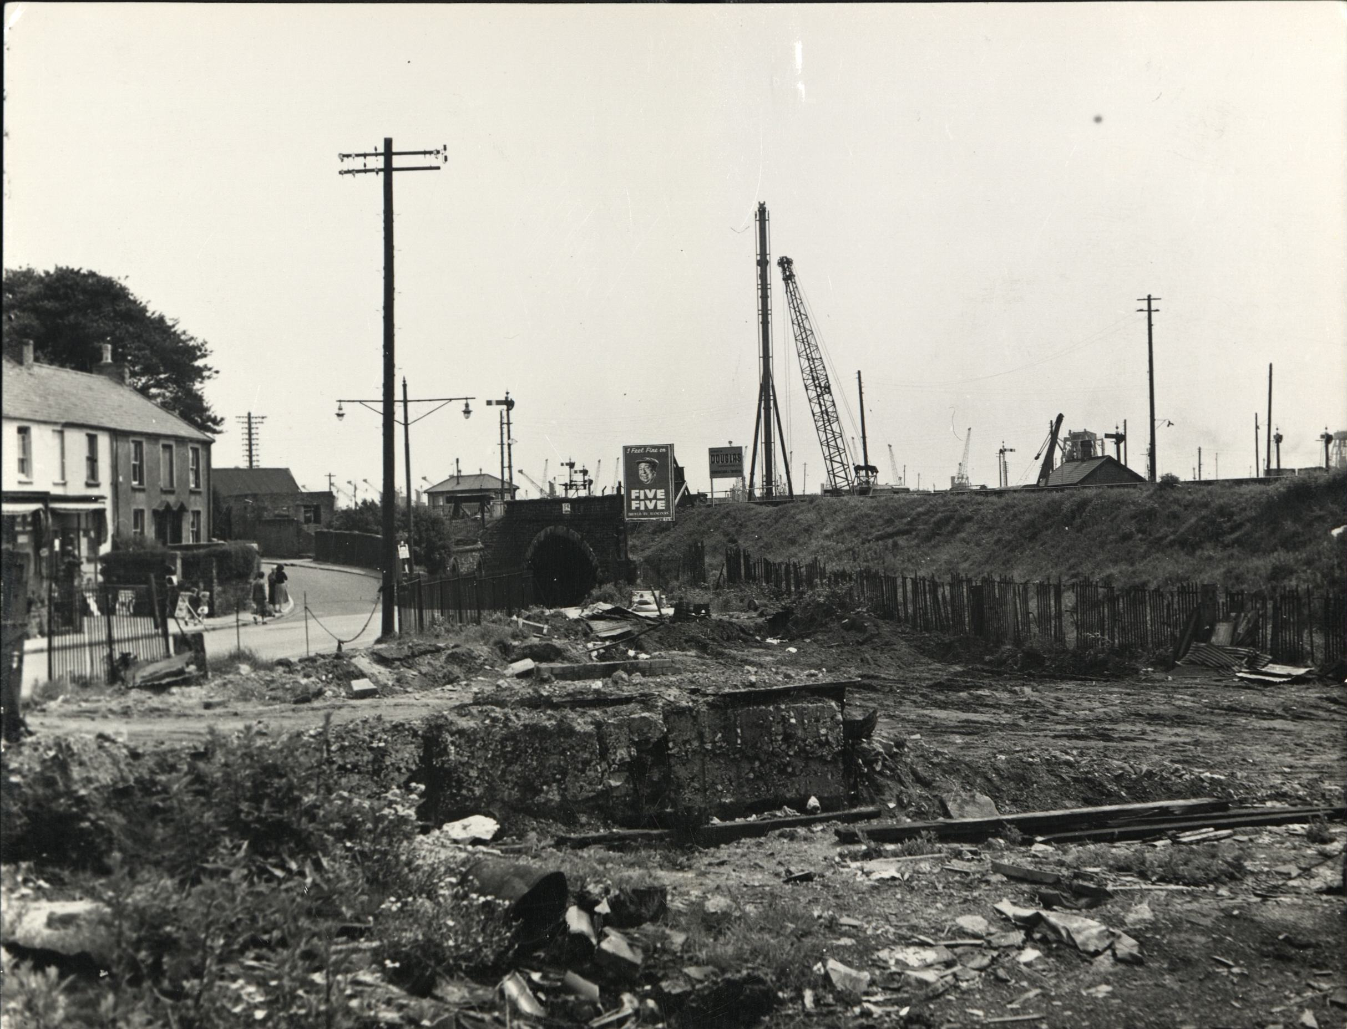

My parent’s generation, and others who had survived the trauma of war almost became used to seeing shops and other buildings suddenly become vacant or reduced to rubble after a bombing raid. Familiar landmarks had almost become a temporary presence. It was another aunt living in the Port Tennant district of Danygraig who went into work one morning after a Luftwaffe raid seventeen years before only to find the shop in Oxford Street a bombed out shell. But that is a simplification of the event. The whole street had also been destroyed along with most of the town centre. Not having endured this kind of experience my generation assumed that buildings were a permanent fixture, like the running of a regular business from a local shop. Dad never warned me, never said anything about it, but one day I went over to see my Aunt on the bus and got a shock. Arriving at the bottom of Bay Street expecting to see the usual clutter of small shops alongside the carpentry building, the silver painted police box, the return bus stop at the end I found just a huge empty space; Uncle Davies’s premises, everything around it totally flattened. They were totally gone. All that remained was building debris being slowly consumed by a Ruston No 10 skimmer scoop, wiping up and dumping remnants into a small Bedford truck. That was it! I was totally stunned. The photograph below shows just what remained of the workshop foundations

Then after my head cleared something materialised in the background that definitely wasn’t there last time I’d been there. The railway embankment at the back of the cleared space ran diagonally and crossed the stone archway straddling Fabian Way beneath with the goods line it carried, ending at a set of buffers just beyond a signal box the other side. Standing behind the bridge and poking its way into the sky was a long crane gib with another vertical framework standing alongside; a pile driver perhaps? At the front site corner a contractor’s hoarding had also been erected proclaiming the name DOUGLAS, a local civil engineering company. What was going on? What and whose machine was it, with the long gib, blue roof and stubby A frame? It was June 1958 and something big was up. The crane workforce desperately needed to be consulted but first things first; arrangements had been made to feed me with fish and chips. My Auntie Lilly would surely know what was happening…… but she didn’t know much, only that demolition and clearance had been going on since the end of February, beginning of March and something about a new road being built. The crew with the crane would definitely know. Before leaving to seek them out she let me know that the return bust stop home had been moved further up along the road. So that was some good news. I was glad they hadn’t taken that away as well.

It was a dullish, showery day, not very warm, and as I walked through the twisty road beneath the arch I kept particularly alert for heavy goods vehicles passing at the same time. Sometimes they could punch a slab of air ahead of them. I’d already been swept off my bike. Not a funny experience. The crane, parked on a piece of solid ground three or four feet above road level, was easily accessible standing a couple of machine widths into the site. Behind it, all around a busy port reverberated and echoed with the occasional clank and clatter of goods wagons being shunted and buffered against one another, couplings released or hooked in matrimony by the shunter running alongside with his hook pole as their tank engines whistled a happy tune to announce the event. Further in the background rows of Stothert & Pitt cranes lurked, aloof and remote, giants in the sky, their long arms reaching out ready to pounce on their next cargo. The ground on which the mysterious crane stood was between the stone bridge and two steel fabricated ones further on forming its own little haven which for the next two weeks became the centre of my universe. From an earlier period the picture below shows the area before the project began. The site working level would have been excavated to the left just the other side of the bridge.
It is perhaps worth noting that all the dockland seen in the foreground and to the left of the picture has now gone along with the signal box!
The purpose of my visit turned out to be another Ruston 33-RB, my third and the last I would encounter for the next forty seven years. Unfortunately it was silent with no throbbing engine in the background and no rattle and clatter of turning machinery from inside the weather beaten blue painted cab. The only bright thing about it was the white roof. Remarkably all front cab windows were intact unlike the last one I’d seen with them all missing. Wearing well stained dark blue overalls and looking at me enquiringly was a fortyish heavy set fellow standing just over six foot with wavy dark hair, bushy eyebrows, and a boxer’s nose. In one of his enormous hands he was holding a grease gun which he was just placing onto one of the tracks.

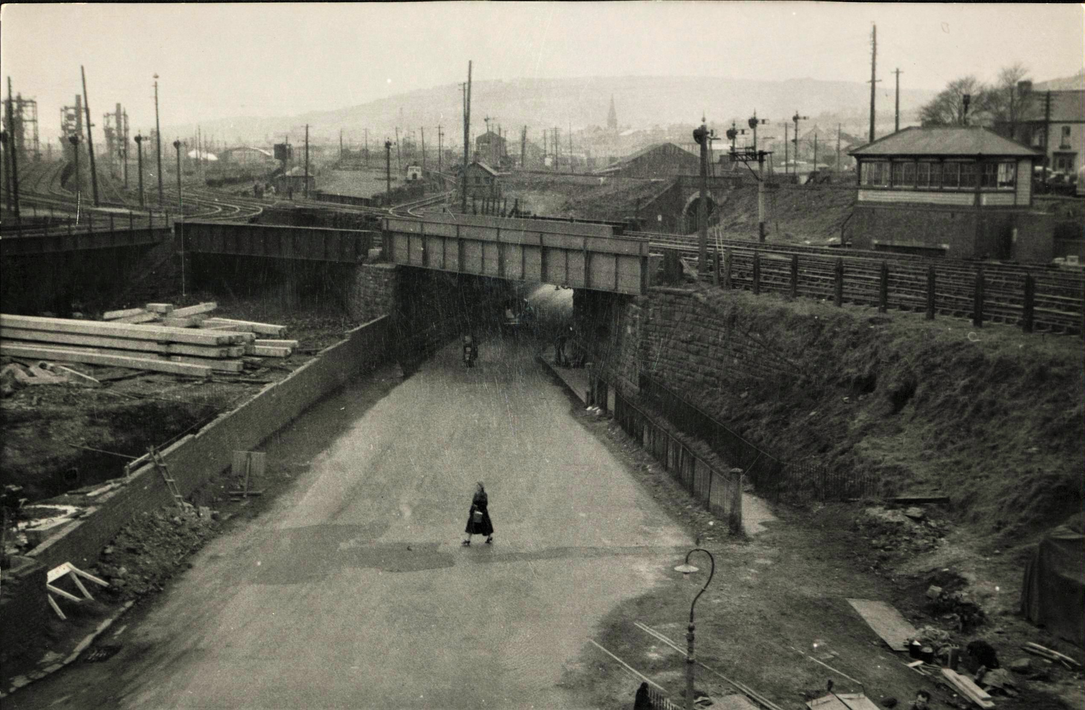

Standing a little to one side of the crane fiddling with the vertical framed apparatus close by was his banksman. His name was Gilbert he told me when we eventually got introduced. Most crane or digger driver assistants that I’d met up until then seemed to be in their late forties or fifties, slight of build, tough and wiry and nobody’s pushover. They were fit and deceptively strong. This was Gilbert, with short greying hair, just visible from under a battered grey trilby hat shrouding his weather beaten features. Had I seen him on some other site? He was somehow vaguely familiar. Perhaps like the 10-RB digger redundant banksmen cum machine assistants also became ubiquitous to building sites. The big fellow spoke with a typical greeting from people I didn’t know. His voice reminiscent of Richard Burton but with harder nuances he was already a star; he drove a crane. Originally when younger I treated the colour of my hair as a curse making me too easily identifiable. ‘I know it was ‘im coz’ ‘e ‘ad ginger hair.’ Not always me. Now I found it a good ice breaker, taking no offence because it gave complete strangers, like any machine operators, an easy familiarity as though they knew me already. With a knowing but not unpleasant half smirk he said’ ‘You lookin’ for a job then ginger?’

Gilbert the banksman stopped fiddling and looked across. Unsure how to reply I just told him I was only there to look at his crane, that it looked like an RB, adding the question, ‘A 33 Isn’t it?’ Raising a set of bushy eyebrows he confirmed that indeed it was but then queried how I knew. So I related my interest as I had done to other operators before and we soon became buddies. Gilbert sidled across to listen and confirmed the equipment he was tending was in fact a drill for taking soil samples, prior to foundation work for a new bridge. ‘Big fella’ confirmed that yes he was indeed the crane driver and introduced himself as Terry, also imparting the information that it had 50 foot of gib. Lying on the track next to him was a turntable roller which he explained had worn a flat and needed replacing. A new one was hopefully going to be delivered that afternoon ‘Or’, he said, ‘we are in the schtook.’ I didn’t know that word so memorised and stored it away for another time. ‘Schtook’.

Alongside the roller was a stubby hydraulic jack and noting my scrutiny he started to give me a few pointers about turntable rollers. They were tapered to match and engage on the mating tapered path of the turntable he said, turning it over to show me the flattened portion that had been skidding. Parallel cylinder rollers, he explained further, would because of their geometry always skid over a circular flat roller path generating constant wear. He was hoping the replacement would be the right size to match the worn one but if there were still problems it might mean replacing the whole set which would be expensive and time consuming. Changing them, he carried on with his narrative, was actually quite easy with the jack being used to relieve any weight still on them. The roller assembly simply unbolted from the underside of the main casting and slid out from its mating back support. I was actually quite elated by what he was telling me and also his manner, seeing my interest was genuine and treating me seriously. His opening question about my looking for a job had also reminded me.

I was in my fifteenth year; my sixteenth birthday due in February and my last year at school. Time was creeping up fast to GCE exams and the prospect was terrifying. I was better with me ‘ands than my brain. Maybe I would stand a better chance for a mechanical apprenticeship with somewhere like the contractor doing this road project I thought, guessing they would have their own repair shops. By my logic the more I knew about this kind of technical stuff the better my chances. Keep listening. Terry carried on explaining in more detail describing how when a turntable path wore over time the rotating machinery deck dropped accordingly, perhaps lifting and rocking in operation, causing excessive wear on the centre post bushing around which it turned. If this occurred appropriate adjustment was facilitated by a specially designed nut allowing for any play to be tightened down on. At this point he abruptly stopped speaking as if remembering something and clambered up into the cab. After first peering over the machinery down to the floor gearing he then reached into a pocket on the inside wall of the cab before returning to ground level with the contents.
.
“Here we,” are he said.’ Here’s the CARE & MAINTENANCE INSTRUCTION book for this machine - and if we look here, he said scanning the pages, it has a section called Centre Post Adjustment and it describes how to take up the slack. He held it out for me to study. A real piece of engineering information with a cross section drawing to illustrate the adjusting procedure, which with his patient assistance, I began to understand. He then took me over to the front of the machine and pointed inside to one of the floor gears which he said was the one illustrated in the diagram and used to assist in the adjustment. I felt really chuffed to be given such consideration. Holding the instruction book again he commented, ‘Really the whole job should have been done before the machine left our yard but as usual - everything is done in a panic.’ The new roller by this time had still not arrived and he said with a big grin, ‘We’ll probably get some overtime this afternoon. ‘If that doesn’t fix it we’ll perhaps be in for even more overtime.’ Gilbert had been listening to the conversation, occasionally nodding, as we stood together and I took the opportunity to ask what bridge he’d been talking about earlier. He started to explain but then wheezing, a little short of breath, deferred to Terry who also had a grasp of the whole scheme. A native of Porth in the Rhonda Valley he had worked down the pit from a fairly young age and although bodily fit Gilbert’s time as a miner had caught up with his lungs. A soft but sometimes raspy voice was the result so Terry explained in his place.

The area on which we stood, bridge and everything else, was soon going to disappear. It would all be swallowed up by a new roadway that would run from the main dock entrance at the Tawe River Bridge, linking up with the existing Jersey Marine section built some years before. Thousands of tons of material would be removed enabling a modern dual carriageway through Port Tennant to meet the existing four mile stretch from the Briton Ferry Bridge to Crymlyn Burrows. It would also be at a much lower level with dramatic consequences to the view so familiar to the local community. A whole swathe of marshalling yards that for many years had engaged so many lives both in and outside dockland would suddenly disappear. I was rather fond of this quaint little corner where apparently, just where we were standing, a new bridge would eventually launch to carry buses across a new carriageway below from a car park to be built further east along the route. As I considered the implications, trying to visualise it, droplets of water were starting to fall from the sky. I had exhausted my questions by now and needed to get my head around what I had learnt, so telling my companions I’d try and keep in touch I made off homeward. Later over tea after relating my discoveries to mum and dad a short discussion ensued with regard to my future career prospects, part of which dad reiterated, or was it re irritated?, relied upon hard work to obtain good GCE results the following year. He was hopeful, mum smiled and I kept shtum. Que Sera Sera!

The first 33-RB to come out of the No 3 bay erecting shop was in 1938, replacing the last batch of twenty four 32-RBs lovingly assembled in 1936. It soon became a very popular machine with 527 being built over its lifetime of eighteen years. For Ruston & Hornsby their amalgamation with Bucyrus Erie to form Ruston Bucyrus was also to give them an additional captive and growing market for their developing diesel engine range. The engine fitted to the crane at Port Tenant was a 5 cylinder Ruston VPHN producing 110 B.H.P with a 5 & 3/8 inch cylinder bore, piston stroke of 8 inches and engine speed of 1,000.RPM. Today’s modern diesel engines run much faster with a much shorter stroke ratio.

I did make one brief return visit a week later but this time the weather was sunny so the bus was exchanged for my bike. Terry was basically mooching around looking for something to do because the site was on standby waiting for test results or something while the drill, along with Gilbert, had gone to another part of the job. Terry walked from around the back of his 33 waving a greeting as it stood alongside the railway embankment gently ticking over. ‘I see you’ve got the crane going this time,’ I ventured as he leaned back on one of the tracks. ’Yup! He said. ‘The roller came about half an hour after you left. Bit of a fiddle but it seems OK and turns like it should with the others. We moved the drill this morning. You missed all the fun. It was chaos. We lifted it onto a Pickford low loader with this,’ he said patting the 33 fondly with a hand. ‘Held up the traffic and even had a copper here supervising it all. That’s why the machine is running. They haven’t been gone that long.’ Machine running, no management about, my chance had come. So taking my opportunity, in the same cheeky manner as previously with Donald on his 19, I asked if I could go onboard to take a closer look informing Terry that the 33-RBs I’d seen before had not been working. “Yeah, course you can,” he said. “Just be careful. The machine guards are missing. They forgot to put them back before it came out of the yard”……. I didn’t wait.

Almost before he’d finished speaking it was up on the tracks stepping around the corner post into the sort of place I now considered my second home. Bigger machinery than the 19s and 22s with different winding drum arrangement set out twin fashion, both barrels on the same shaft, seeing for myself how different the clutch mechanisms were to what I knew. The Ruston engine at the rear meanwhile was ticking over, barking out a double Chugga-Chugga-Phutt-Phutt in protest, perhaps because it too was bored with almost nothing to do. I passed this thought on to Terry who gave a little chuckle and said he understood how it felt adding that although it was a long contract job it was not a good one to be on for interest because there was so much waiting around with no action. He would, he said, much prefer to be on a dragline. Then he asked me about school and when I would be leaving, so I gave him a brief run down on my situation and work ambition with him nodding in acknowledgement and we left it at that. I needed to get back home, there wasn’t really anything else to look at now I’d been on board. He wished me well and I set off on a fairly long ride back.

I must take pause here to talk about the two photographs I have been allowed to reproduce by Swansea Council who own the copyright with access provided by West Glamorgan Archive Service. The first picture: BE 40/3/2 shows a view looking east showing shops and garage demolished in preparation for general excavation at Port Tennant Road, 1958. The road in the background curving away to the left is Ysgol Street which if you stood halfway up the hill afforded a magnificent view of the huge goods shunting yard and dockland beyond. Diving down to the right and under the stone bridge is the original beginning of Fabian Way and my exit gate from the town and onto the first leg of the journey to see the Lima the previous year. Momentous days indeed. The second photograph: BE 40/3/3 shows the view looking west towards the old Danygraig Bridges and Port Tennant. Work had commenced on the bridge over the access road to the docks, 1958. It is particularly interesting because of the pedestrian crossing the road and walking over buried remains of old dockland railway lines. The view also shows the other side of the stone bridge and gives a better idea of the enclosed site. Originals may be viewed at Swansea Archive.

Thinking about it many years later I can’t ever remember seeing Terry or that 33 again although undoubtedly I would have been close to the site when visiting my aunt in Bay Street. I can only conclude that they had both moved on not long after the purpose of their presence expired. The amount of earthmoving proposed at the time would have involved a lot of kit, possibly including both shovels and draglines but I never saw any. In the period following, the last year I would spend in Swansea, there were only two other sites I can actually remember properly investigating while still attending school. It was a strange time. Attitudes to our education at the Secondary Tech were gradually becoming attuned to the industrial world and as we morphed into sluggish maturity came the realisation that with our last year a working life, perhaps a proper career, was beckoning and we would have to knuckle down. The Fabian Way road project didn’t really start moving until early in the1960’s by which time I was already living in the city of Lincoln learning the first stages of how to build diggers, living in ‘digs’ and not returning to a very different Swansea, except for brief holiday visits, for another six years.
Prelude
Some years ago I produced a series of videos and DVDs under the title ‘Cranes & Excavators At work’. The second programme was simply titled ‘DRAGLINE’ with the following introduction:

Of all excavating machines beloved by excavator the dragline holds the most fascination. Unlike other digging machines of cable winding design or modern hydraulic excavators, the digging bucket is not fixed rigidly to the machine. Being only loosely tethered by rope and chain it depends on the skill of the operator to guide it through the cut, lift the spoil to dumping position and then return to the starting point smoothly in one operation. Watching a large dragline going through a digging cycle is to see poetry in motion. If you are one of the many devotees of old equipment this assessment may well find a place in your mechanical heart.

So it must have been sometime later in 1958 that a swinging dragline jib came into view while cycling past a fairly wide and rough sloping track leading off the Mumbles Road. The contractor’s hoarding announcing a new University project was planned at the entrance. A disappointing early morning foray to Ashleigh Road playing fields in search of a Smith dragshovel had been bad information, nothing to see only long grass on a nondescript day, neither sunny nor cold, just couldn’t make up its mind. I was feeling annoyed but then on the way back the lucky dragline sighting; it might be a sunny day after all. The machine itself was perhaps a couple of hundred yards away and unmissable with bright red cab fifty feet of white lattice gib sticking out in front.

Turning off the main road and putting a bit of welly into pedalling I eventually deciphered the dynamic in yer’ face contractor’s name on its side, also painted white proclaiming: DEMOLITION & CONSTRUCTION CO LIMITED. Equipment used in civil engineering at the time was usually owned and supplied by companies that did the work. Plant hire as an industry had not yet been born and didn’t really get under way till the beginning of the 1960s. Also on the site, busily whizzing around, was a small International Harvester multi purpose crawler tractor; not yet a common presence but soon they would be painted red and known forever after as a DROTT. Just beyond and behind the Ruston on a cleared patch of ground was the reclining form of a drag shovel boom, resting on timber balks straddling two upturned forty five gallon oil drums. AHAH! A significant find and questions needed to be asked.

The site was only just getting under way and two important looking suited types were spreading plans over a car bonnet trying to stop them flapping about in the breeze. A large batch type cement mixer was chugging away merrily in the far corner next to a pile of sand and several labourers were also busy stacking a recently delivered consignment of bricks. It was going to be a big job but my first priority was that dragline which was just begging to make my acquaintance. I was impressed by its operator, casting the bucket well beyond the gib head to make the cut. Another 22-RB with continental design cab and white painted roof it was a proclamation of style that came to an end a couple of years previously in 1956 when an updated more racy rounded version replaced it, as it did with the 10. I really liked that style. Silly perhaps but with its passing so had an era of diggers and their seductive mechanical allsorts of gubbins magic box shape that first inspired schoolboys to go and find them. But, I digress. Parking my bike I put myself in full view of the operator as per the ‘see me‘ protocol described earlier.

Thankfully it didn’t take too long before a scruffy fifteen year old was onboard standing behind its busy driver. I watched in admiration as he skilfully cast the bucket way out beyond the jib head. A practised sequence; first bringing it close to the fairlead, machine partially turned away from landing point, then, bucket released, swinging outward in a short arc before boosting momentarily with a quick snatch of the hoist clutch to provide outward acceleration, swing clutch then engaged pointing us to the cut, controlled release of hoist brake to land bucket gently on target. Boy did that bucket swing?

Have you ever looked at a dragline bucket…..closely I mean, looked at them properly. They have quite have a number of components which have, from those seeking to impress, been described as both accoutrements and appurtenances. I would have just called them bits or fittings: Drag chains, the bale or spreader bar from which the bucket hangs by its upper and lower suspension chains, dump sheave, tipping rope, and the wonderfully titled crow’s foot where drag rope, drag chains and one end of the tipping rope all meet and anchor, the other end of the tipping rope passing up around the dump sheave and returning to anchor on the bucket arch. Buckets themselves are almost mesmerising to watch as they tip and sometimes, after release, just hanging, swinging back to the cut, you might just catch a tired little groan, or is it a sigh? as it passes you by, on its way back to mother earth. If you’re lucky enough and get the chance to watch another old dragline, lend an ear and see if you can hear it.

Draglines observed previously had only been in brief glimpses on rare occasions. Now there was time to study dumping technique which was not a steady progress of bucket ascending parallel to the boom as imagined. It was far more dynamic. Bucket filled, hoist clutch engaged, release of drag rope delayed until ground level height attained, controlled release of drag rope at some pace allowing bucket weight to carry it rapidly outward at the same time as machine turns to the waiting lorry. Allowing for adjustment, drag rope brake applied when just under the gib head, bucket now only moving upward to dumping height before drag rope released for discharge. It was a rapid technique giving a fast digging cycle and with my limited knowledge of such matters I was highly impressed.

His name was Norman, a Swansea boy born and bred, apparently living at the top of Town Hill next to the sports playing fields. Almost a neighbour I told him, passing his house every time we had our Thursday afternoon school games session. It was sometime in 1958 walking to catch the single decker Town Hill ferry bus at Dynevor Place that a group of us got distracted by a fire at Marks & Spencer in Oxford Street. Remembering how I’d been there when they were building it the presence of fire engines outside now was a surreal experience. Today nobody remembers the event with neither M&S nor even the Swansea Fire Brigade having a record of it. Suffice to say that on that particular afternoon we missed games, the ferry bus travelling light. When I mentioned it to him Norman was completely unaware so we continued talking diggery things until mid morning coffee break when he mentioned a forthcoming change of equipment. Standing several feet above where he’d been digging out a basement the 22 had reached a point where dragshovel would be needed to complete the planned level and conversion would happen in the next couple of days. If you look at the site today we would have been standing just west of centre on the patch of ground at the top of the slope, facing toward Mumbles.

Taking my cue I told him I’d spotted the dragshovel boom parked up with some lumpy tarpaulin alongside and wondered….? ‘We’re all ready for the change,’ he said smiling. ‘The bits under tarp’ are the drum laggings and roller chains. Probably happening day after tomorrow - first thing in the morning. Come along, you might find it interesting. There is a chance though,’ he said hesitatingly,’ that we might make a start tomorrow afternoon if the fitter turns up and things go OK. They’ve got to deliver the A frame and the tie rods as well. There’s a fair bit of work involved with erecting that.’ “Come on,” he added, ‘it’s a bit quiet at the moment. I’ll show you.’ and having spoken thus he stood up from his seat, clambering down onto the ground to lead me over to the dragshovel equipment. Pulling aside the heavy tarpaulin he showed me the treasures beneath, including a change of hoist and drag ropes. I was rather pleased at this gesture and he went on to explain about the work involved and how useful forty five gallon oil drums were when stood on end. ‘If you arrange timbers on top right you can just run the boom feet between the pin holes, line em’ up, and with a bit of jiggery pokery, just knock the pins in. What do think?’ he said, pausing for breath. ‘Do think you might be able to pop down tomorrow?’ I considered the proposition. I was going out with dad in the morning. Sidney Heath, new jacket and trousers. Dad usually liked to get things done first thing in the morning and if I explained about the equipment change he would understand. He’d followed my obsession for a long time. So I said I’d try to get there and left it at that and as I left the site Norman was just casting his bucket out again, fishing for more dirt.

Dragline work was a different experience to dragshovel; distinctly so with machinery set up. Donald on the No 19 had mentioned his front brake needed changing and now seeing it all for myself and remembering his comments it was easier to understand. The front rope drum for dragline turned clockwise, gathering rope from the underside using lagging with guide grooves to assist uniform coiling. When Norman pushed the control lever it turned the front cam mechanism to engage the front clutch; something Donald had told me to look out for. On dragshovel the front lagging is narrower with integral chain sprocket teeth permitting chain coupling to the rear shaft auxiliary clutch. The rear clutch then serving as master for dragshovel duty winds rope anti clockwise over the top of the drum lagging. Changed rotation required resetting of control linkages to initiate the auxiliary clutch using the back cam; also necessitating brake link adjustment for application of the brake on a drum surface turning in the opposite direction. The front drum shaft was the key to this versatility; optional arrangements designed to accommodate whatever function was required utilising appropriate lagging and roller chain connections to the rear shaft; an adaptability I remembered admirably illustrated on ‘gentleman’ Jimmy’s 22-RB shovel working on the Carmarthen trunk road.

Norman was still working on dragline the following day when I arrived after lunch and my morning visit to town with dad.. Seeing me puffin’ away up the slope he stopped operations briefly to let me onboard telling me that the A frame for his machine had somehow gone missing from their yard. A replacement had been located however - big drama he said - and would arrive on the weekend. It was ‘flippin’ annoying’. He’d been quite looking to the change of routine. Things postponed I didn’t want to stay too long. I could be doing other things, like fishing, which I’d been neglecting recently; digger chasing instead. There was one thing I wanted to ask him: about the boom suspension rope. On my visit to the 33-RB at Port Tennant I’d noticed the rope coming through the roof and going down to its worm driven storage drum set in the bed frame. Checking the 22 revealed the boom hoist rope running from under an A frame pulley and reaching out to another rope drum and clutch assembly alongside the drag drum. Very interesting. That front shaft was even more complicated than I’d realised. You just could not overstate its importance; a truly elegant element of design conferring the machine’s adaptability. On Terry’s Port Tennant crane the boom drum was set into the revolving frame and powered by a worm arrangement driven from the reverse transmission clutches and selected by a vertical dog clutch. Quite a number of machines I knew of then used worm drive for the boom hoist utility including Priestman, Smith, Marion and also I had seen on the LIMA 1201. So the boom hoist system was very different on the 22 and I hoped that Norman would be able to enlighten me and supply more information.

He was keeping busy, the site agent was about. I didn’t know if he was aware of my presence and had a sneaky feeing that he didn’t, instinctively staying out of sight. I wanted to pursue the subject of the boom hoist but it was coming up to the afternoon tea break and not wanting to stay any longer told Norman I could catch up on some fishing instead. My questions could wait till next time. The carp were waiting I told Norman as, with a half smile, he brought the 22 to a halt. Acknowledging my disappointment he looked at me with his head cocked to one side, raising his eyebrows to emphasise concern as he voiced, ‘Are you coming back next week?’ Seeming both pleased and relieved at my confirmation. I had the feeling that we’d sort of bonded over the last couple of days and become buddies. From memory the week to come was the last of the school holidays, the week after being the beginning of the September term. Where would I be this time next year I wondered? Would I have a job and where would it be? The last thing Norman said as I jumped down off the tracks was, ‘Don’t leave it too long. I can’t see me being more than a week or so on dragshovel and then I’m going up country.’

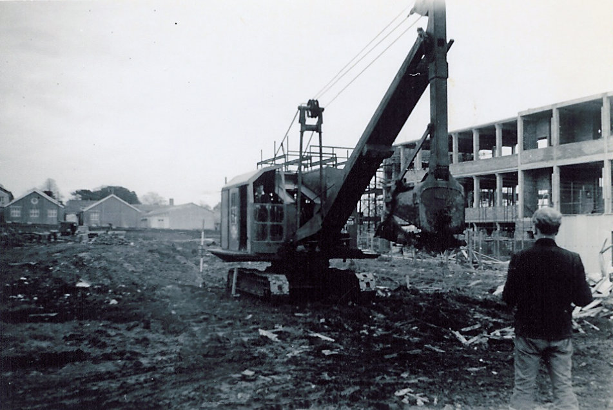
A typical 1950’s Drag-Shovel with sloping continental style cab

It was mid week, the 22 was sportin’ its newly fitted dragshovel equipment and Norman was it seemed quietly enjoying the experience having the bucket in closer proximity where, he said dryly, he could keep an eye on it. Having become better acquainted on previous visits he was quite relaxed and talked quite easily when opportunities arose. His first question was to ask about my fishing exploits of the previous week and if I’d had any luck. I told him the fish had unfortunately not seen my bait. ‘They needed glasses did they?’ he joked. Softly spoken with no discernable accent he wore a cloth cap of indeterminate pattern and many years acquaintance along with an unbuttoned donkey style jacket. It was only when he occasionally removed the cap to reseat it for comfort that I realised he was lacking some top thatch. Of sturdy build he wore a heavy knit pattern jersey beneath the ‘donkey’ and a set of corduroy trousers with dark stained workwear boots completed the ensemble.

I would have guessed his age to have been mid forties. He reminded me of some one else in the game and I suddenly realised that it was Stan, the NCK 304 driver at Weavers Basin. Similar roundish face but not so heavily built. Although he had a dry wit and seemed cheerful enough there was also a world weariness about him which was I thought simply explained by part of his life thus far. Like, a lot of men of his generation he was ex army having joined up when he was eighteen there not being much other work around at the time. Being mechanically inclined had landed him with the REME division and, although he would not elaborate and did not want to talk about it, had meant his taking part in the D-Day Normandy landings and seen far too many things that he would not have chosen to. The REME experience however had given him an excellent mechanical grounding in transport and construction equipment mechanics which he’d used to get a job on demob as soon as able after hostilities had ceased. He’d had few jobs he’d said but this one suited him just right. ‘Wife not too happy though,’ he added, ‘with all the travelling and time away from home.’ and he shrugged his shoulders. He was a very affable and interesting individual I thought and as this was crossing my mind he was just scooping another bucket full as he started to tell me about the fun they’d had converting it all.

Compared to mounting the front ‘A’ frame legs and tie rods the main boom had been a doddle he said. George their fitter had enlisted mechanised help from the multi purpose International tractor as well Norman and an additional labourer. ‘You would have been very interested if you’d been here,’ he said as I looked around for the dragline boom and other bits and pieces. But he anticipated my query saying it had all been taken away the previous day. The back tie rods he added, shaking his head in disbelief, had been particularly challenging to mount the main ‘A’ frame shaft. If they hadn’t had the machine to help they would have been in Schtook. That word again. Where had I heard it before? ‘Anyway’, he said recovering from bad memories, ‘it’s all done now and won’t have to be changed for the next job as far as I’ve heard, so that’s OK.’ I nodded my head as he spoke and took the opportunity to interrupt his unhappy memory to ask about the boom hoist arrangements.

“Ah, yes,” he said, “the boom hoist. It’s a clever system and very simple. Not as complicated as a worm drive. You know about worm drives do you?” he asked. I confirmed that I did and told him that the 19 and 22 machines had been puzzling me for some time. When he was able to have a quick break waiting for the next lorry he led me around to the front pointing out the drum and clutch band. Due to limitations of space yoke actuation was not possible he explained. Instead the boom hoist lever controlled a small brake band acting on a free turning drum called a booster; mounted on the clutch spider boss. The lever set the brake causing the drum to turn on the boss, relaying the displacement to a bellcrank linked to the clutch band. Anticipating my next question he added that the brake maintained drag on the drum and engagement of the boom hoist until released. Unfortunately a demonstration to confirm my understanding of what he was saying was not possible at that moment, in part because the machine was set up for dragshovel anyway, but also at that moment another tipper lorry was arriving and Norman had to get back to loading.

I climbed back aboard with him to stand behind one last time, which he seemed to sense because once it was loaded and pulled away he dropped the bucket to the ground, locked the brakes then turned toward me smiling to ask, ’Back to school again next week then is it Ginge? So I don’t suppose I’ll see you again.’ I acknowledged his comment with, ’Yeah. Looks that way.’ and he carried on,’ I’m off up to Shrewsbury for a month or so. It was supposed to be Manchester,’ he said with a grimace,’ which I wasn’t looking forward to, but, with the delay over getting the 22 converted they had to send someone else. Penalties over the contract starting date or something they said. So they put me on this other job. Wife wasn’t best pleased at first. Told you she didn’t like my travelling didn’t I? She’s a bit happier with Shrewsbury though it means I can at least get a train home. But,’ he added, ‘It looks like I’m going have to start having a look around.’

I stood listening not sure what to say. I was going to miss having the crac with him. He was easy to get along with and I’d enjoyed our little get togethers. He carried on. ‘You never l know, you might see me again yet. Keep a look out. I’ll be seeing if I can find a driving job a bit more local after that contract. There’s plenty going on around Swansea so we’ll see what happens. And the best of luck with what ever you do. I’ll keep my eyes open for you.’ And with that he stuck out his hand to shake mine just as the next wagon turned up. It was that noisy Commer again; a piece of immaculate timing. I hope he got sorted with a local job but like so many crane and digger drivers I’d had the good fortune to meet in those wonderful days of my boyhood years our paths never crossed again. One last thought I had about the front drum shaft on the 19 and 22-RB machines was to wonder at just how much trust was put in the four one inch diameter bolts that secured the bearing housings to the machinery deck side frames. It sort of concentrated the mind and made me gasp in wonder. I was really beginning to appreciate the wonders of engineering and Ruston Bucyrus excavators in particular.

My visits to Norman’s 22 are such a long time ago now and my memory plays tricks. I can’t really put dates on them but I do know it must have been in the latter half of 1958, site preparation for the university being on record. Visits getting to know operators over a few days were not that common. Mostly they were just that; brief encounters in all sots of places just watching. It was however a very special time it being the last year of schooling with my learned colleagues and I was beginning to really think and wonder about getting a job, what sort it would be, how to differentiate between the classification of manual and office type careers and deciding what we wanted to aim for. I tried; I really tried that last year, was muddling on selflessly trying to develop my learning curve when the effort was cruelly interrupted by a tip off.

Running in parallel with making big career decisions construction work both in and outside the town was still happening. Still in touch with Bryn at Easton Brothers and Stan at South Wales Sand & Gravel in Weavers, one of them tipped me off about the new Duke of Edinburgh Dry Dock. It was an inspiring piece of information which had I not had wheels would have been difficult to take full advantage of. Getting to most parts of Swansea was usually no problem. If we didn’t have a bike, sufficient bus fare in our kitty or couldn’t scrounge off mum or dad we used shanks’ pony. Thinking about those the far off days of our childhood we really did walk our asses off. The arrival of my bike in time for those years at the Tech’ had meant a huge culture change with my ever increasing independence and travel ambitions. A BSA Hercules with white wall tyres and four speed Sturmey Archer gearbox it had been key to my days with the Lima crew on the new Port Talbot to Carmarthen trunk road and would accordingly now make it so much easier to investigate another exciting project almost on my doorstep but not really busable.

Duke Of Edinburgh Dry Dock
Access to the new project was problematical. Getting through the entrance gate meant being fleet of foot. There was a police box on the gate. Hmmm! I’d tried to scope it out a couple of times but things were always busy: steam locomotives shunting around the place and numerous other things to fall over required constant awareness, not to mention other unofficial busybody style authority. Security at the South Dock had been easy. The bobbies on the Kings Dock entrance gate were a lot sharper and there was a lot of ground to cover when trying to get familiar where everything was. Weekends were the best time to visit and it was on a Saturday that I was able to make my first entrance and inspect the lie of the land. Surprisingly I needn’t have worried. I think it was probably more of a holiday weekend with the box for once being unattended allowing me to get much further than anticipated, spending fruitless time cycling around the top of the dock instead of going more or less straight down to the bottom, looking around at everything and eventually spying a couple of swinging lattice type crane booms in the distance. They were just beyond a large shed located on a wharf the other side of some lock gates. The tide level was right up at the time so I was unfazed by any difference in the water levels either side when having to cross them to get there. On other occasions the difference was considerable, the narrow wooden walkway becoming a no man’s land with no way to wheel the bike to the other side without falling into the murky and sullen depths below.

From what I can remember there was no formal gateway to the site, just workshop buildings each side of a gap big enough for tipper lorries to pass through. The building immediately to the right with some sort of large press or cutting machine utility was open to the elements as part of a well equipped workshop that had evolved since the business was founded in 1934. The existing dry dock was built by Palmers in 1924 and the workshop had now grown to stretch across its width. Dry docking at this time was healthy enough that an NCK-304 dragline was busy digging away to extend its hull capacity while on the opposite side of the plot of land, adjacent to where I entered, another machine, a Ruston Bucyrus 22-RB, greeted me working alongside another line of building. This was growing hole No 2 ‘The Duke’s Dock’ being diligently excavated from scratch. Looking at things in retrospect I would guess that perhaps two thirds of the planned cavity had been dug by then so it must have been toward the end of 1958 when me and the ‘Dook’ first became acquainted with regular visits for several weeks, probably overlapping a couple of months or more into 1959 and thankfully with my unofficial presence being endured without challenge.

The 22-RB was drab grey in colour and sportin’ a continental style roof painted white. A contractor’s name on its cab side was the same as on the NCK-304 digging for Mr Palmer, also painted grey but no white trimmed roof. Not long after arriving it started to rain and having positioned myself to be seen the operator for the 22 soon took pity and invited me into his draughty but dry control centre. I made friends of both drivers and when the rains came took turns with each, standing behind them as the holes in front grew ever larger. For hours at a time I watched the spinning winding clutches slam in and out of engagement coiling and uncoiling protesting, squealing snakes of steel as they dragged home bucket loads of earth to feed trucks that would in turn feed other hungry holes on other building sites. It was a continual line of ever changing payload vehicles, quite a number of which were mid to late forties vintage including ex military square bonneted Bedford OW types, a couple of OSBT 5 toners and more upto date Morris and Leylands taking turns from various contractors to join the procession. I should have made detailed notes but at the time was only really interested in the diggers. Transport was just part of the background with their classic rugged lines not then appreciated. We never realise or appreciate when we are really passing through history as it occurs do we? The tipper fleet kept coming and I was struck at how content the various drivers seemed to be, occasionally acknowledging my presence with a friendly grin and asking if I was the new foreman; all good humoured stuff. I was content being where I was, watching it all happening.

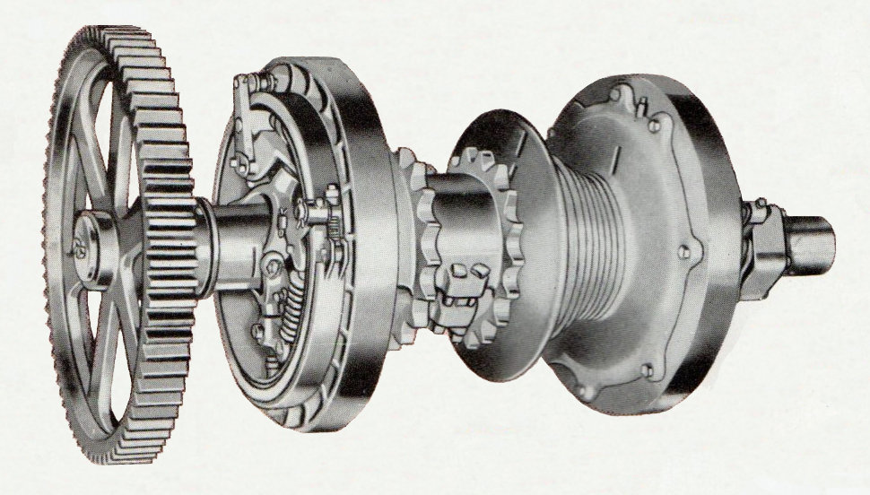

Standing behind digger drivers on worksites where they were to be found was my spiritual home where I was comfortable. It had become essential to my existence and at age fifteen there was always something to learn; like on that first day there. Both machines were of similar size but there was one feature of the NCK that immediately drew my attention. The fairlead on the Ruston was a pretty basic affair: two vertically mounted guide rollers leading the drag rope from its winding drum through a pulley frame incorporating limited directional side swing with wear plates either side; an essential component for both dispensing the rope smoothly from between the boom feet and providing a fixed location to control the bucket on its return and when discharging the spoil. I’d noticed this arrangement on Norman’s dragline at the university, remembering having seen similar on other machines like the two Priestman Cubs working foundations at the Sydney Heath site and also there were pictures in Smith Excavator catalogues. The fairlead on the NCK was completely different and not as basic in comparison as those seen on RBs. The Continental cabbed Rustons were by 1958 being superseded by the latest American design and for all I knew also fitting updated fairleads as well. The NCK in fact had a fully rotating fairlead housing sleeve with the addition of rollers directly in front extending above the pulley frame to provide rolling guidance to the rope in either direction. It was interesting to compare operator technique and timing, very similar to Norman’s on his 22 at Singleton, each casting the bucket an extra few yards by first pulling it close to the fairlead before releasing and allowing it to swinging out some way like a pendulum before applying a quick hoist snatch and increasing its momentum for greater reach. They weren’t untidy with the hoist rope when pulling back either; maintaining a floating tension on the bail bar and tipping assembly so that it always hung above the bucket ready for the lift.

The driver of the Ruston dragline was named Duggan but everybody called him Dug’ which at first mislead me into believing his name to be Douglas, a misunderstanding he corrected in a gentle and courteous manner. He was bare headed with a square set face, slightly hooked nosed and hair tidily parted to one side. Like a number of operators I had met by then I would have put him in his early thirties. Quiet voiced, with perhaps the occasional trace of Scottish ancestry, he was neatly dressed, wearing collar and tie beneath casual jacket, well worn dark coloured trousers and sometimes polished, but still scuffed, black lace up shoes. Mum and dad would have called him dapper. His machine was also neatly dressed inside with red wire mesh machinery guard next to his perch and supposed to be present on all open machinery. A safety feature, quite often missing, which had first caught my attention on the 22-RB girder lifting crane working Marks & Spencer’s site all those years ago. Nearly six years; I was getting old!

He didn’t say a lot but seemed to be quite comfortable with me standing behind looking over his shoulder until tea break came along and everybody on the boisterous site crew raced to the wooden shack they called the canteena. He didn’t join them however but pulled out a flask to drink onboard when he let slip that he was living in Townhill with his parents. On its lower slopes not far from Dynevor secondary school he said qualifying this piece of information with a smile adding that he would only be there for the next few months before being whisked off to be held prisoner by some woman: his new bride; his words not mine. Like a number of site workers he normally got the contractor’s bus from the town centre to the job but sometimes chose instead to meet up with Milo the NCK driver operator, getting a lift in his battered ex Post Office green Morris 8 van. I didn’t find out much about Milo except that he shared a caravan with his wife living on a former bomb site in the town centre with a group of other people in the same situation. It had been cleared and made available as a parking lot for temporary housing, a situation not uncommon just after the war with lack of bricks but plenty of open ground. Milo didn’t give away much about his origins to a schoolboy but Duggan said he was actually of Polish descent having made his way across to the UK during the early days of the war, first joining the RAF and then afterwards leading a nomadic life touring the country in his caravan to follow construction work wherever it took him. Like Duggan he was quite content to have me stand behind him but I did spend more time with Duggan, usually on rainy Saturday mornings and it rained quite a lot in Swansea. I can’t actually ever remember meeting a really miserable digger driver. Most of them seemed to be pretty content but of course that was just a schoolboy perspective at the time.

For sitting behind his array of operating levers Milo wore what had once been a smart brown two piece suit with trouser bottom turn-ups. Now heavily work stained it had seen better days. A full head of black hair, no hat, thin face heavy workwear blue shirt and a lightweight white scarf around his neck were the basic details of his working attire. Brake pedals were controlled by feet wearing black brogues shoes. There were I had noticed a number of drivers around who seemed to favour this style of footwear. Dad liked to wear them as well but I knew he’d never even thought of sitting in any digger. Couldn’t really say much about his voice because, like I said earlier, he didn’t say much although there was a bit of an accent which I assumed was polish. I would have guessed him age to be in his mid forties although it was just a guess, certainly a good few years older than Duggan.

Although familiar with Stan’s 304 at Weaver’s it was interesting to swap onto a dragline version with different set up and operation. Although clutch architecture remained basically the same NCKs had different machinery deck layout arrangements to RB. Unlike RB with a one piece casting for the revolving frame, NCKs were of all fabricated construction. The main difference was the rope drum barrels were not so visible from behind the operator because they were twinned and mounted outside the cab although the clutch housings and brake surfaces were inboard right next to the driving position. Swing and propel were also derived from a single assembly with the boom hoist/derricking drum mounted below machinery deck level on the opposite side to the driving position. Watching the clutch housing next to Milo something seemed different to Stan’s machine. It nagged at the back of my mind till visiting Weavers one lunch time later the following week. It was really fortunate having school just around the corner. I’ve often wondered how different things might have been if I had not been so lucky.

So I told Stan about the dragline setup and he was just as interested. Climbing onboard his 304 we could soon see the difference; far more complicated than the Duke Dock dragline. In addition to the internally expanding clutch band on the inside surface there was and externally contracting band on the outer diameter coupled to act at the same time. Milo’s 304 didn’t have this additional feature. Having identified the difference Stan said his machine had been that way when delivered and he guessed that it was a special arrangement to cope with grab duty. Sometimes he said he could be all night offloading a couple sand dredgers, one after the other with the clutches getting extremely hot; adding that another NCK grab he’d driven at their Briton Ferry yard had the standard clutches which were much heavier and more tiring to operate. So I wrote to NCK in Sheffield and they very kindly replied with more detail than I was expecting with annotated drawings confirming that what Stan had indirectly surmised; namely the external booster clutch was there specifically to reduce pull on the operating levers. I still have those drawings over sixty years later.

My visit to the Duke of Edinburgh dry dock was the last major project that I can recall visiting before events and a job offer overtook me. There must have been some other sites also visited briefly or machines watched from a distance but they obviously didn’t make much of an impact or they would be mentioned. I now look back and consider how privileged my boyhood had been in taking me along the path of machine exploration and into contact with so many individuals, machine operators and site foremen, who had allowed me to come into their world before official permission would need to be granted or withheld by the authoritarian busybodies of today. It was the perfect introduction to a working life and the ways of the working man; the way they would speak, sometimes curse and take the mickey. I never met any that treated me unkindly. Never again after ‘The Duke’ experience would I visit a site with cranes or excavators as a spectator schoolboy. The reality of having to work was approaching fast and I needed to be ready.

Considerations & Planning
From our youthful inexperience and optimistic perspective Swansea was buzzing with commerce and industry all around us. Finding work we thought shouldn’t present any problems. We were personally unfamiliar with the concept of unemployment then. Everybody who wanted a job seemed to have one as far as we knew. If you didn’t have one we assumed it was by choice, you just ‘weren’t working’ and that was that. We didn’t really dwell on the personal ramifications of the situation. There was also another serious consideration: 1959 would see the prospect of the G.C.E. - The General Certificate of Education exams mid year. While there was a slight shift in the way we were directed we were nevertheless expected to ‘knuckle down’ and display a more mature attitude. The term ‘career’- not to be confused with the three year Korean war that kept popping up with some pupils going for ‘guidance’ next door to the youth employment centre. Masters would sometimes interrogate a class to establish our choices, occasionally with interesting results, like an ambitious declaration by one member of our brotherhood to become a detective. We, his scholarly colleagues, were a bit wary of him after that making a mental note to watch out for him in the years ahead ‘just in case’. We were shown films in the assembly hall about what it was like to work in a factory, how a car was built and similar engineering themes and small groups would be taken out to visit companies like Metal Box which was a fairly long bus ride away in Neath. Not having visited real factories before, only having read articles about them in local newspapers, we were astounded at all the machinery involved and how noisy they were; power presses in particular. An experience that for several of us confirmed our choice of career while at the same time disenchanting others.

Fortunately, my own mind already set on which direction to take, the only thing to get on with was establishing at which company to apply to for a job, preferably with a proper apprenticeship scheme. As mentioned earlier Initial discussions with dad had already begun. It was not long after my 16th birthday when things were hotting up when he said. “Well - have you decided what you are going to do for a career? Because if you want to apply for an engineering apprenticeship you’ll have to get a move on and let me know where you think you would like to go.” Or something like that. He had a point. Until we actually started to get moving on it I didn’t realize that it would be such a long drawn out process. There were apprenticeships available but they had to be applied for and acceptance by any firm was not a forgone conclusion. They’d have to be convinced that I was the right man for the job. Dad thought that because he worked on the railways I should stand a good chance of getting into Swindon, one of the world’s premier places for engineering. The advantage as far as he and mum were concerned was that it was not too far away to travel there and back by train. I could find lodgings during the week and be home every weekend to mam, with travel being free as a potential future railway engineer.

Well yeah! But - thing was, I was not that much, if anything, into choo choos which at the time were still steam driven although diesel was rearing its head in the not too distant future; and who at that time also would have thought there would ultimately be a complete demise of those world famous railway workshops? Lots of kids then were into train spotting but it just wasn’t my sort of thing. No sir. Not for me sir. I was hooked on something else; machines that dug ‘oles in the ground and lifted important looking stuff like steel girders into the sky. Possibly the biggest hobby at the time for kids of all ages would have been reserved for the railway industry and its vast array of steam fire breathing locomotives still actively running with ongoing design reviews until their sudden demise and scrapping literally overnight in 1962 to make way for diesel power. Why did it have to be overnight? Completely daft! It was not just the physical aspect of steam. All things of interest generate their following and railways were a leading example not only with train spotters on the stations but also the model aspect with table top clockwork and electric train sets, live steam scale engineered models, books and other railwayana generating many clubs. Then suddenly all that steam knowledge and application to modern steam locomotives yet to be designed went out of the window. For the enthusiast it was a tragedy. But railway locomotives need a railway line and a station to be seen? You wouldn’t find one in a town centre street or working in a field. That was the magic of diggers! Railway locomotives, alas, did nothing for me.

It must have been around this time that my approaching career possibilities had also been awakening interest in machinery in dad’s mind because one evening, completely out of the blue, he mentioned seeing an advert for something he called a plant or industrial exhibition that would shortly be taking place. It would, he said, either be held on the recreation ground alongside Mumbles road or at the bottom of Singleton Park where back in the late forties there had been an agricultural show he’d taken me to see. I remembered it because of an Allis Chalmers tractor he let me sit on. Alongside was a Dakota DC10 airplane that had dropped parachutists in the Normandy landings and I’d wondered how they got it into the park. I was mightily impressed by both and reminded him, tongue in check, that it was the same site where Norman had let me climb on his dragline to assist on the construction of the new University building not that long ago.

It was actually going to be at the place we knew as the Rec’ a stretch of open ground on the Oystermouth road next to St Helens Rugby Club. There were a couple of weeks still to go before the event so I had time to adjust mentally. In concept it was the forerunner of what would soon be called a public works exhibition. So we went; not sure on what day but it didn’t matter. In all honesty I cannot remember much about it or which companies were there except for one with the familiar name of Blackwood Hodge headquartered a million mile away in Cardiff. They were promoting Euclid as the main UK agent at the time and were giving away catalogues and information to traders but not schoolboys. Under a big marquee with all and sundry gathered tightly around they were having a ball prominently demonstrating front loading shovels and similar equipment with three young lady engineers clad in bright red skirts and jackets. Assisting in the dialogue spouting from the master of ceremonies when he said ‘get right down into the dirt’ they would suddenly drop down and squat imitating forks with arms stretched, bent at the elbow hands upward, and then suddenly spring back up as if lifting a load. Completely daft but the guys loved it; even made dad smile; a memorable event.

So I made a list of all the crane and excavator companies I knew that would fight to have me and discussed it with head of house. We thinned them out a bit first, ruling out Stothert & Pitt because although well known for building dockside cranes and located on the railway route at Bath they also made cement mixers and lawnmowers along with a variety of other stuff not as glamorous or interesting as the cranes and diggers spread out around Swansea; I could maybe end up putting cement mixers and road rollers together. No thanks! Ransomes & Rapier were vetoed, mainly because of distance but also their manufacturing catalogue, also embracing as it did a tremendous range of what I again considered to be the mundane and unexciting; a lot of it agricultural although it has to be acknowledged they were still renowned world leaders for huge walking draglines. But you couldn’t really get down and dirty crawling under a walking dragline could you? Although several years later I did clamber aboard their 1800 walking dragline not long after it was commissioned, then biggest in the world.

Thomas Smith of Rodley, Leeds, in spite of having sent me a brilliant product catalogue a few years previously was again just too far away. Jones Cranes at Letchworth were considered briefly but not put on the list because apart from being painted red their cranes were not as dynamic as excavators and didn’t seem exciting enough even though they also had previously donated a brilliant bright red covered bible of their product range; still on my bookshelf over sixty years later. Same conclusion reached about Neal Cranes in Grantham, although I had got very excited about driving one of theirs in Easton Brothers yard on one of my lunchtime visits. So the lucky recipients of dad’s begging letters were Priestman Brothers in Hull, Ruston Bucyrus in Lincoln and Newton Chambers in Sheffield who built the NCK range of excavators. The NCK technical department, as previously mentioned, had actually written a very nice letter to me about the clutches on Stan’s South Wales Sand’s 304 but were not then officially associated with Ransomes & Rapier. So guess where I ended up? But it was by no means a foregone conclusion. I still had to get a job interview. Oooh Y--e--a--h?

Initially we had been very relaxed about the whole apprenticeship hunting thing, believing that it was just a matter of formality to get offered a place. Neither of us had realized that it was of a far more urgent and picky nature and I was in danger of not getting one at all. Failure would mean being stuck in Swansea doing something else which might not, I was sure would not, be so appealing as excavating machinery and cranes. There was in truth also another reason I wanted to get the apprenticeship in Lincoln. Not a really serious reason but did lurk in the deeper corners of my mind. Age sixteen, without committing any major misdemeanour, fate had nevertheless cruelly given me a head easily identifiable from great distance full of ginger hair; also placing our house in the ideal position for it to be easily eyeballed. A senior police constable lived two doors up and a police sergeant four doors down. Nice friendly guys, good as gold but the fuzz! Anyway - I thought dad was beginning to interfere in my life too much and we were beginning to clash. I could only see things getting worse. Perhaps he also recognised how things were going and thought it might be wisest to let me find my independence. Looking back it was a brave decision for him but especially for mum with me at only sixteen years of age and really no life experience to speak of at all. Things were a lot more innocent then. Alas I gave no thought to my poor mother who must have been anguishing quietly without complaint at the prospect of her unworldly son, who she had loved and cared for over so many years, being sent to the other end of the world, two hundred and fifty miles way at Lincoln, to ostensibly be looked after, uncherished, by another woman and a complete stranger at that. She must have been breaking her heart on the quiet but selfishly, only concerned with me, I don’t think I gave much thought to her feelings at all.

Time was passing fast, my sixteenth birthday already gone we put a spurt on with dad composing some extra impressive letters for who ever we could flannel. He had actually written to Priestman on the 31st of March 1959. We must have had a response but unfortunately lost from his personal reference file. Now the keeper of that file I found a letter from them dated 31st July 1959 basically slagging us off, stating: “As we have received no further communication from you we have assumed you are no longer interested in an apprenticeship in the company,” etc, etc and that, “they had now completed arrangements for 1959/60 without considering your son’s application.” Oops! They were definitely miffed. Dad must have slipped up there. He would not normally be remiss in the simple courtesy of responding to such an important letter. Several years later I was to make my own personal visit to Priestman Brother’s but that story can wait for later. Dad had also written to Newton Chambers, Sheffield on 31st March 1959 but had not on that occasion received any acknowledgement.

It was years ago now but not that long after his knock, knock, knocking on heaven’s door while delving into any remaining personal memorabilia from schooldays that I came across the file which my meticulous father had put together covering the period of my Lincoln days. I had seen it lying around from time to time and taken a cursory squint now and then to see what was in it but never a detailed examination. When I finally did give it a proper look over it was a revelation. He’d written to Ruston Bucyrus on the 20th of March 1959 and put an absolutely brilliant letter together. If your spiritual ghost is watching me now dad I offer my grateful thanks. A bit late but I only just found the evidence:

Dear Sirs,
I am writing in the interests, and at the specific and urgent request of my son to enquire as to the possibilities of his obtaining an apprenticeship in Mechanical Engineering with your firm etc, etc……….
He really buttered it up telling them I was chasing their diggers all over the place, building Meccano models: RB and other stuff, and providing photographic evidence along with original correspondence from their publicity department to me when scrounging sales catalogues and brochures seeking information and inspiration. On the 26th of March a Mr J. Crowther their personnel manager had written back advising that they were indeed anxious to complete their apprentice intake arrangements for the year and if we wanted to progress the application could dad suggest some alternative dates to bring his son up to Lincoln for interview. With this encouraging reply came a booklet detailing their apprenticeship training scheme. It had a wonderful line drawing of a large 54 RB mechanical digger on the cover. This was good! It was a very enticing booklet with photographs of the factory, the apprentice school, works canteen and their own sports ground called Moorlands. There were also pictures of excavators being assembled in their factory workshops along with a schematic layout of the various workshop departments passed through for various training schedules. I looked keenly to see how long it would be before I could start putting diggers together. It was far too long.

Among the photographs was a one of keen craft apprentices sitting in a group being lectured to. On a blackboard behind the smartly dressed and mature gentleman giving it was a drawing of either a large gear or what I assumed was an excavator turntable. Highly impressive I thought. They were being taught the theory of design. This was a very misleading picture; a complete con, as I later realised. All the time I was there nobody ever told us about design. If they did it was in the drawing office with student apprentices who by virtue of more academic aptitude went on a slightly different path than a craft apprentices who ended up as journeymen fitters; exactly what I wanted to be. I wanted to get down and dirty; as dirty and greasy as possible. Before I did however I had an interview to get through. Dad wrote back and arrangements were agreed for a visit to the works on the afternoon of Friday the 17th April at 2:00 PM. We would travel up to London the day before and stay overnight, completing our journey to Lincoln Friday morning.

Lincoln City is a long way from Swansea. You could get a long distance bus which took forever and a day or you could let a train take the strain. Dad got some railway passes but by steam train, as it then was, still meant a journey there and back in a day would not be possible. We would have to travel up the day before and return the next. First to London Paddington, book a hotel to stop overnight and then next morning find our way to Kings Cross station for the second leg of our expedition to Lincoln. It was a slower journey to London than today’s modern service and fortunately on arrival at Paddington it transpired our hotel was only just around the corner from the station at a place called Sussex Gardens. I suppose there had been gardens there at sometime in the past but that must have been some time ago. All that could be seen was a long avenue of boarding houses and hotels, mostly I assumed to service railway passengers like us. So we had dinner at the hotel and, at dad’s insistence, retired early for the night. Tomorrow he said was going to be a big day for me. Up till then it was probably the longest railway journey I had ever undertaken and next morning we set forth once more to decide my destiny arriving in Lincoln after successfully negotiating our way across London to Kings Cross on a very crowded tube train. That journey in itself was an experience with everybody crammin’, pushin’, shovin’ and squeezin’ themselves into coaches like sardines into a can at the very peak of the morning rush hour. A steam buff would have been able to tell you exactly what class of locomotive it was that pulled our coaches to London and Lincoln but that level of interest in railway engineering only came many years later when I finally caught up with steam power as a hobby.

Apart from chasing diggers all over Swansea I was also a keen fisherman and read a paper called The Angling Times in which there were always reports of fishing matches on the river Witham and various others at romantic places like Bardney, Fisherman’s Dyke, etc. What I had not realized was that Lincoln seemed to be the centre of all this activity because when we arrived at the station, both outside in the yard and inside on the platform, was absolutely teeming with fishermen and their tackle: creel baskets, rod holdalls etc. Very interesting I thought Very interesting. Finding something to do after work shouldn’t present a problem. Having arrived in good time we took a brief look around the nearby busy City centre which was compact and absolutely nothing like Swansea. Dad worked for the property maintenance side of the railways and having studied architecture was in his element, looking upwards and pointing to brickwork, stonework, guttering and anything else he could find. Then after grabbing a quick lunch we set forth for my inquisition. I’m not sure but we might have walked down ‘The Ropewalk’, a very evocative name, for out destination. It would be just like dad to do that but thinking about it now we must have caught a bus or maybe even a taxi. It wouldn’t have been good to be late after having come so far.

At 2:00 PM on the dot we arrived at Becor House to meet the personnel manager Mr J.Crowther and the apprentice training supervisor Mr James. I can’t really remember anything about the interview except trying to stress my interest in stalking their products around Swansea building sites and building Mecano models; which I backed up by telling them about correspondence I had already engaged in with their sales office to obtain catalogues. One thing that did impress me was afterwards being taken to the field engineer’s office down the adjacent corridor where a young early twenty something fitter was receiving last minute instructions before flying to Germany to assist in putting together one of their recently exported, and in pieces, mechanical shovels. Perhaps one day, Mr Crowther said encouragingly, I would be doing the same thing. The highlight of the visit for me however was not the interview. Almost as an after thought Mr James said he would show us around the works. The sight of the factory was most impressive, especially the huge letters mounted high across the three biggest bays proclaiming the legend Ruston Bucyrus Excavators. I looked on, not with misgivings as I might well have done, but in awe. My life was possibly going to change.

It would not be incorrect to say I was almost overwhelmed. The place was huge; the first three bays were stunningly high like the inside of a cathedral, also very wide and seeming to stretch into the distance forever with glass fitted roofs. At that time the factory was reputed to be the largest in Europe specialising in the manufacture of diggers. It was vast. A real factory: the sort of place that you read about in books and saw on cinema newsreels and television programmes. In No 2 bay there were all kinds of heavy production machinery bigger than I had ever seen before and for what exact purpose I was not then able to identify. Hopefully that would come soon enough. A whole line of busy whirring and humming activity each side of a central gangway, running almost the length of the factory, with metal castings being machined as various other bits and pieces already processed or standing by awaited their turn on a worktable.

On this occasion of my inaugural tour everything was surreal. Our visit to the next bay - No 3 - was worth the trip all by itself. Being ‘erected’ piece by piece at one end was a machine I had only ever seen in their sales catalogues; the reality was most interesting. There were a number of them in different stages of assembly with men working behind racks laden with bits and pieces that bolted together to make a complete machine. A completed 38-RB shovel was standing waiting behind two large sliding exit doors leading out into Beevor Street at the north end. It stretched from the thoroughfare called ‘The Ropewalk’ - very appropriate - leading past the front of the factory to their test field at the far end. At the south end of the bay a similar build procedure was in progress for a much larger 54-RB machine; another first sighting of the actual thing. In front of where we stood watching with Mr James, hanging from one of the 25 Ton overhead gantry cranes that straddled each bay was a rope winding drum shaft; a large complicated assembly with a large gear at one end. As we watched we saw it being carefully lowered into place by a gang of men wearing the typical fitter’s garb I would hopefully come to know so well; a blue boiler suit. Was this real or was I just dreaming it all? To complete my I-Spy hat trick alongside the 54 was the largest crawler mounted excavator then being built at Lincoln or in Britain for that matter: an enormous electric 110-RB shovel. Up till then, apart from my short stints standing behind digger drivers at home I thought it was one of the high point of my life and a machine spotting milestone.

I thought that was going to be the end of our tour but oh joy of joys it wasn’t. We carried on through the top end to the outside yard through a small exit door set into a huge sliding one normally moved aside for completed digging monsters finished and ready to chew mountains. Turning right we headed east to walk perhaps a couple of hundred yards or so to another group of workshops. The one we stopped at was the top end of No 18 bay where as we walked through to the far end we were able to see their 10, 19 and 22-RB excavators in various stages of assembly, bits and pieces of components and sub assemblies everywhere. Standing in front of the doors where we entered where several completed shovel and dragline equipped machines in both standard RB and customer livery parked awaiting shipment to their first assignments. I was getting tired although chuffed to be where I was but Mr James fair play had one more card up his sleeve. “We better not miss the test field while we are here,” he said, so we walked on past some more bays for another hundred yards or so into open ground. Sadly however, from my point of view, there were no machines working on the test field that day which really would have been a treat but he offered a consolation prize by taking us up a ladder to have a look inside a parked up 110-RB electric shovel machinery deck and check the operator’s view of things. OOH! It was big. The bucket was absolutely huge. I could stand up in it.

Before going on our main factory tour Mr James had taken us to see the actual apprentice school which was also at the bottom end of No 2 bay. For some reason it was not inhabited by apprentices on that day because it was the compulsory fixed attendance day on which they all attended Lincoln technical college as part of the training curriculum to study engineering theory. It was at this point that Dad’s eyes had lit up. He was no doubt looking into the future with visions of his Mech Eng, Dip Eng qualified son to brag about. From what I can remember the workshop was equipped with several large sturdy vice benches, two centre lathes, a pillar and bench drill and shaping machine. Mr James told us a little about what sort of craft skills and projects would be undertaken when or if an apprenticeship was offered. This was when I think I sort of got under his skin just trying to appear interested and keen on being shown some simple hand tools: like callipers and dividers that the current crop of apprentices had made. Anyway! Responding to the work samples and mentioning that our class at Swansea Tech had made similar tools in the metal workshop I had the distinct impression that he thought I was a bit of a smartarse! Don’t know why but even when I eventually started there I had the feeling that there was always something lurking beneath.

Some further discussion about more mundane sort of stuff like my future welfare, money, lodgings etc and we made our way back to Lincoln Central for the journey home. It was of course a Friday afternoon and over a thousand other people at that particular time had the same idea so since it was getting on a bit and we were not up to fighting our way through a sea of bikes I think we may then have got a taxi. There hadn’t been any time for a canteen visit to get a cup of tea and a sandwich until we got one on the station. I was so completely knackered and can’t really remember. My head was in a fuzz, completely overwhelmed by it all. I don’t know about dad; he must also have been feeling weary but if he was he never let on. Stoic! The journey home seemed to take forever. Crossing on the London underground railway from Kings Cross to Paddington for the train home I could hardly keep my eyes open; and then from Paddington sleeping fitfully through a good portion of it with carriage railway track music trying to deaden my senses: fiddledidi, fiddlediduh, fiddledidi, fiddlediduh, fiddlededidldedidlededuh, fiddledidi, fiddlediduh. I was only occasionally awoken by dad describing in gory detail his recent operation for a duodenal ulcer to a complete stranger as they swapped anecdotes about their medical history.

Preparations Goodbyes - Destiny Awaits
At last the letter offering me an apprenticeship with Ruston Bucyrus arrived on the morning of Saturday 8th of May. It was the only interview and offer I’d had, which was when the realities of what I was embarking on started to bite, proposing to live in a place two hundred and fifty miles from where I had grown up and moving to a place where I didn’t know anyone. I must have been mad to even consider the prospect of leaving all I knew and loved behind when nobody was asking me to. I could have got an apprenticeship in industry locally surely but so fixated had I been on RB that I’d not even sought any other interviews. Not diggers perhaps but maybe something similar like a construction company workshop running their own equipment servicing side. I just didn’t even stop to consider the alternatives and what might be available to me. None of my friends were daft enough to leave home. They were going for jobs with careers in things like post office telecommunications - putting up telegraph poles and other stuff, into transport with garages and the coal and steel industry which offered their own top quality mechanical and electrical engineering apprenticeships.

Some of my fellow seekers of learning and a future were staying on for their higher GCSE certificates and eventual university, in time themselves to become members of the teaching profession; whose local members they had only recently subjected to so much abuse. But I wanted to go to a digger factory and nothing would sway me. In truth the thought that I would be leaving my so far cosseted existence didn’t seem to worry me as much as it should. Livin’ in another world that boy is. Everything done for me without question with regard to so many things I had never before considered but taken for granted. Even after dad once again questioned my desire to leave home and all that it really involved, like living with complete strangers and starting again with forming new friendships after abandoning so many of years standing, finding a doctor and dentist who would take me on, sorting out who was going to do my laundry, where I was going to study to get my engineering certificates and diplomas - Oh no not again! I thought I was escaping all that. There was so much to organise.

Like all the kit I was going to take with me. My fishing tackle. That was a priority - Yes it is dad! Even if you don’t think it is. What about my MECCANO set? “Whoever you are staying with won’t want all those bits and pieces all over the place under their feet. You can’t expect to take that with you. In any case you will be too busy studying.” Uncontrolled exasperation was coursing through me at this point. I would get it to Lincoln somehow. Smokey my buddy le cat would not understand Lincoln cats so he would also be left behind. They mewed with a different accent! The other thing of course was money. How much would I need? How much would lodging cost. Would I have to make separate arrangements for laundry and what would that cost. One of the most important considerations was the proximity of eventual living quarters to my place of work and getting there and back. But as dad pointed out I did now have a bike. There was an additional culture shock awaiting me with regard to the time people actually started work in the factory environment. Completely uncivilised I thought.

Dad left for work not long after 8 O’clock to catch his bus to the office; maybe a bit later. In Lincoln the factory began work at 7:30 AM. YIKES! But this was not the end of my mental adjustment. The lodgings which the apprentice master found for me was three miles from the works which meant arising at 6:30 am latest, possibly earlier, in order to get ready, have breakfast and then mount my trusty steed for the ride three miles to the works amongst a sea of others; and I mean hundreds, doing the same thing. No doubt for his own, and definitely mum’s, piece of mind dad decided to make another trip to Lincoln to investigate the lie of the land, perhaps have another word with Mr James the apprentice master, also to interrogate my future landlady and obtain any other tit bits of information that related to my future welfare. My own attendance thankfully was not required. I don’t remember him actually going but on his return he was a mine of information about how to get to my ‘digs’ from the station and the amount of pedalling I would have to do between said ‘digs’ and the works. He had also been warned by the landlady’s husband, “T’lad’ll need is’elf ah set’n oilskins t’get t’yon woks tha ‘noz.” Or summat like that. It was a good attempt by dad to do an accent. He must have really enjoyed hisen, sorry, I mean himself. Apparently it did occasionally rain quite hard at work times both to and from the factory. Oh! This was going to be fun.

He didn’t say too much about my landlady to be but she must have passed muster because for the foreseeable future it would be the address to which ones parents would write their reply every week to the brim full letters which I would be writing to them. Lodgings would cost the princely sum of £4 a week and I would be getting the sum of two pounds seventeen shillings and ninepence (£2-17-9), which today would equate to two pounds and seventy nine pence (£2.79) per week for my apprentice wage. There was a big hole there I thought, “Wos’ ‘appenin?” There was, dad said, a government grant that would apparently bless me with the balance. I would still be broke!! In his benevolence and pity he said he would send me the princely sum of fourteen shillings a week pocket money so that I wouldn’t have to go begging. When my future colleagues found out what I had to live on they were aghast. In truth however that was a reasonable sum of money to fork out then and it was an extra cost for them both. A fair compromise; I would not starve. Apart from breakfast and evening meal, I can’t remember about supper, I would not be getting quality cuisine for lunch munch either. That expense would also have to be born by yours truly.
In school time passed and we knuckled down. The GCE exams came and went and so did my fellowship at Cambridge University. I had suspected the outcome for a while. My exam paper was probably drivel. The eleven plus hadn’t been a success either so at least I was consistent. Dad was disappointed as well but in truth I don’t think he really expected anything else. Que sera, sera! The City of Lincoln beckoned. Much needed to be done. More time passed but for some reason the impending future and my leaving just seemed to go over my head. Was I just thick or what? Said a few goodbyes and got my stuff together. Dad with his organisational skill and knowledge of British rail freight had my bike sent on ahead, hoping that it wouldn’t disappear on the way. Typical dad he’d also organised my new landlady to confirm its arrival and send a postcard which duly arrived at our household by return. And so the big day arrived when I would sever connections with Swansea and make new ones with the City of Lincoln.

Lincoln Bound
Dad was employed by the Great Western Railway and had his office at the main station in High Street where as a small boy I had occasionally visited to look out of the corner window bordering The Strand far below, alongside the railway turntable where I once did see a locomotive being turned around. It was from this office that dad had assembled our family on the occasion of the Queen’s visit to Swansea back in 1954 before leading us onto the platform far below to watch her arrival. When they report that visit of long ago they always say it was to tumulus cheers. I do not remember that happening. She was within fifteen feet of me as she walked past to almost complete silence. I was shocked and also worried as I waited for them to make a noise, cheer, do something as she moved further to the exit but they still seemed far too quiet for what a small boy was expecting. IT WAS THE QUEEN. How could they be so quiet and why? I’m sure some people will tell me I am mistaken, probably those who were not there.

I think it was at this same platform that the Queen got off the train then that I got on it several years later to depart my home town accompanied by a very subdued mum and stoic dad to head for a glittering, or would it be foggy – and sometimes flippin’ freezin’ - future in the City of Lincoln. Only time would tell. Working for the railway dad had privileges like cheap travel or passes which were used every year to go on holiday. For eight years running we went to Bournemouth and every year it was the same luggage ritual with quite a lot of it for our four person family: One medium size case and hand bag for mum, one big suitcase for dad, and, over the years big sis’ and me graduating from Dandy and Beano to later carrying rolled up copies of School Friend, the Eagle and Lion comics which has been saved and hidden from us the previous two weeks so that we would have something to read on the way as well as playing noughts and crosses and counting cows and sheep. But there was also a much bigger heavily reinforced family case, surrounded with a heavy strap ‘sent on’.

When the morning of our departure came we didn’t catch the bus to the station. We couldn’t carry the cases all the way to the uplands bus stop, we went in style. Dad had ordered a taxi; wow! I always looked forward to that journey. Travelling through a familiar bus route sitting in the back of a limo was different and in those days. The taxis, usually with a long 1950s style bonnet, shone inside and out drivers smart, very often wearing a demob suit with a tie, shinny shoes with a yes sir no sir. It was all part of the era. After boarding the train there was just one more inescapable ritual before we knew we were really on our way. Auntie Elsie lived in the Hafod district at Aberdiberthi Street and had a front room shop selling ladies fashion wear. Not unusual then. From her front door she could see across the main Carmarthen road and beyond to the railway bridge that crossed the off-shoot road leading to the River Tawe. We all new the timing and as the train crossed the bridge she would be there waving to us almost a quarter of a mile away. These memories of days long gone were now clouding my thoughts. The same train was now going to take me away to a different kind of place two hundred and fifty miles away and it wasn’t going to be for a holiday.

As on the initial prospecting visit dad and I had made months previously we arrived at Paddington station first then transferred across to Kings Cross on the underground railway. Fortunately although mum and dad carried their overnight kit they also assisted with my long stay stuff including surprise, surprise my fishing tackle. Dad of course was not best pleased about that but eventually realised that in a strange new place it would probably help settle me in although it was a bit of a pain to drag all through the corridors though, especially the two rods which kept getting into awkward places. Fiddledee, Fildedeeduh, Fiddledee, Fildedeeduh, Fiddledeedidldeedidldeeduh, on and on the carriages clattered and cluttered as we passed cows and horses in the fields, cows lying down horses scattering; chuffing GWR smoke and smuts, oggling other people’s back gardens and wondering how much they really liked living next to a railway line. Station announcements: This is Cardiff……,This is Newport……, Bristol, Swindon, Reading, and at last the outer reaches of line side industry and commerce as we…..look dad! there’s a 22-RB……chuffed under stone bridges, footbridges, passing stone walls, brick walls, suburban local train stop stations, more back gardens, bridges, advertising hoardings, lines side signals and signal boxes, and finally we draw into Paddington main station. “Well,” dad said, “you can’t change your mind now can you”?

It was another step closer to Lincoln and poor mum was trying her best to be stoic. It must have been really hard on her but of course I just didn’t understand. She was being really brave about the whole thing hiding much of her anguish. Dad must also have been concerned wondering if they had done the right thing in letting me go but I don’t think it really bothered me at all. Mum as usual had packed some sandwiches and a bit of cake but there was still a long journey ahead to get through so after walking down the long concourse we sat in the refreshment area to consume a cup of tea and another piece of cake before going down below to the TUBE, also known as the underground. It seemed to be especially draughty today as we went down the escalator onto the Circle line that would take us to Kings Cross. It was what Londoners called lunch time, very crowded and not easy to manoeuvre down the steps onto the platforms, let alone fight you way into the actual carriages. I think I poked my fishing rod into some woman’s face actually. She wer’ not best pleased. But we finally emerged into the main station which then was nothing like it is today. We had a bit of time, less rush and a little easier for mum feeling a little giddy with the pressure and it was still going to be a long journey.

The train steamed out bound for the north first stop I think was Potters Bar. What a fascinating name. What did they do at Potters bar I wondered? We had about 120 miles to cover taking just over a couple of hours quite late in the afternoon when we finally drew into Lincoln Central. It was rather busy by that time being a Friday with regular arrangements for Saturday match fishing journeys already evident outside the station with a great deal of fishing tackle being made ready for train journeys to place names I would soon become familiar with but never visit. Dad soon commandeered a taxi to my new address and twenty or so minutes later we parked in one of the numerous avenues branching off the main Skellingthorpe Road to be greeted and assisted at the gate by our new landlord and landlady whom I will call Mr & Mrs Bradford. The house was situated on a huge council estate, one of numerous such dwelling areas serving the industrial metropolis of Lincoln.

The avenue on which it was located I remember not always being well lit, very often pitch black with nothing to guide you but your bicycle lamp, if you had it switched on. The Bradford’s house always seemed to be in darkness at night and if you were even just side scooting, balancing on one pedal the last hundred yards after switching it off the local ambitious young bobby would be waiting quietly in the dark to ambush the unsuspecting; very mean spirited. The one I remember was very tall and would literally jump out and startle you, no doubt hoping you would fall off to teach you a lesson. Back home I knew it was fairly strict for vehicles when parked in the roadway and they had to have side lights switched on or a purpose made one for mounting on an outer door. Things seem a lot more casual regarding side lights these days. All the estate houses were red brick three bedroomed from what I can remember with small front garden and a longer one at the back. I think they kindly put mum and dad up for a couple of nights to make things easy as they had planned to show us around the main part of the City over the weekend. Lincoln although considerably smaller than Swansea centre was a city. There was a son in the RAF billeted on the camp and two daughters, one of them married living on the other side of the city, leaving just enough space for mum and dad to be squeezed in over the Friday and Saturday night.

I’m not going to spend much time on detail but it was interesting how different things were compared to what I was familiar with at home. Getting used to eating my meals regularly with strangers was going to take some getting used to. We sat down to Sunday lunch and were immediately struck by the fact that they ate Yorkshire pudding and gravy by itself as a starter unlike at home where it was included with the rest of the meat and veg’. Food looked like it was going to be interesting. My bike had already arrived, sent on by dad, and Sketchley’s would be looking after my laundry each week. The next morning Mr & Mrs B had arranged to take us to see Lincoln Castle and Cathedral and have a general look around the City Centre. On Sunday Dad would lead me behind him through city suburbia astride and hopefully balancing on the bicycle kindly borrowed from Mr Bradford. Now that was going to be interesting. I had never seen dad ride a bike, ever; never new he could even ride one. This was going to be fun, even more so I thought when I saw the one he was going to use. It was a real ‘sit up and beg’ type with huge wheels.

Did dad suffer from vertigo I wondered? After self consciously tucking his trouser bottoms into socks you could see he really thought he was the kiddie. The pathway led from the right hand side of the property down to the bottom of the garden at the back with as small shed. His take off from the shed was brilliant. Just to re acquaint himself with boyhood and get the hang of it he mounted at the far end. You could see the years fall away and youth flood back but cruelly giving him a kick in the teeth when with a look of horror he realised he was indeed out of practice as he headed straight for and through the flower bed on the left. That was the first time I had ever seem him embarrassed as he sort of scrabbled back half on and half off the saddle trying to hop-scoot with any remaining dignity down to the front gate. The anguished look and Mr Bradford’s face was worth a thousand words. I just casually wheeled my own bike down the path and out through the gate before mounting it with dad wisely deciding to do a few circles before heading for the main Skellingthorpe Road a hundred and fifty yards away.

Doing the recy’ on Sunday was a wise decision. It was out onto Skellingthorpe Road and head a couple of hundred yards to the roundabout at the bottom where you could either turn onto the Boutham Estate, Rookery Lane, or North to the works. We headed North turning left down Boutham Park Road. It was a very long road almost split in two equal lengths where it zigged off to the right for some distance before zagging back again proceeding onward to eventually pass beneath a heavy brick railway arch emerging at the Coulson Road Tee junction. Turning left we then rode parallel to a dyke behind the Ruston Boiler works. Dad was feeing the pressure but determined not to lose face he pedalled on keeping abreast until we came to the last turn into Firth Road on the right running between a rugged row of terraced houses and Industrial buildings. We were knackered but nearly there. Oh how those two words resonated. They really meant something! The open level crossing gates opposite Dawson’s Vee Belting Works beckoned at the far end where we eventually crossed over its hump in the road into Beevor Street and the RB time hall a short distance further on, coming to a halt as dad finally ran out of steam. I was sympathetic to his condition so we took a few minutes to recover. I really had not expected such a long bike ride. What had I let myself in for? This was going to be great on a rainy morning. Mr Bradford had said something about rain capes? I thought about tomorrow morning as we headed for home at a much easier pace. Considering he hadn’t been on a bike in all the years I’d known him dad had done exceedingly well. Perhaps it was his dormant fitness genes hidden beneath his non athletic facade that I have inherited to keep me going till now. Thanks dad. I owe you.

Mum was obviously relieved when we both got to the house in one piece. She had been worrying that dad might have fallen off as he had in the garden but all was well and it was lunch time and the rest of the day for chit chat with the Bedfords…… and then it was suddenly 6.30.a.m. Monday morning, with cooked breakfast and a hearty Hi ho Silver; Mr Bedford mounting his steed for Ruston’s Anchor works, and me to Beevor Street for my first day as an engineering apprentice. Good lucks from dad, a tearfully wet goodbye kiss and hug from mum and my undertaking an oath to write regularly. Mum and dad would set forth to catch a train homeward in another taxi later that morning. If it had been busy as on a work day when we did our test run I think we could both have been swamped and easily drowned in the normal sea of factory bound pedal commuters. Now on this my inaugural first workday morning accompanied by Mr Bedford that assessment proved to be correct. As we first turned into the main road it was evident that we would not be short of company. There was already a steady stream of bike mounted bodies coming from other estates further up as well as more exiting into the flow further along. The Bedford’s housing estate ran parallel to several others along the main road all densely populated and as we proceeded en route it became apparent that biking it with an unfamiliar crowd trying to have some sort of early morning conversation was different from doing it with a small group of your own chums. Things tended to get densely packed and you could suddenly find yourself leaning into somebody else to prevent them leaning further into you. It did however all remain friendly with Mr Bradford keeping a wary eye on me knowing of my inexperience in crowd control. But eventually seeing I was doing OK he peeled away from beside me to turn off just before the railway arch and head to the Ruston Anchor Street works further on.

The City of Lincoln Head Quarters 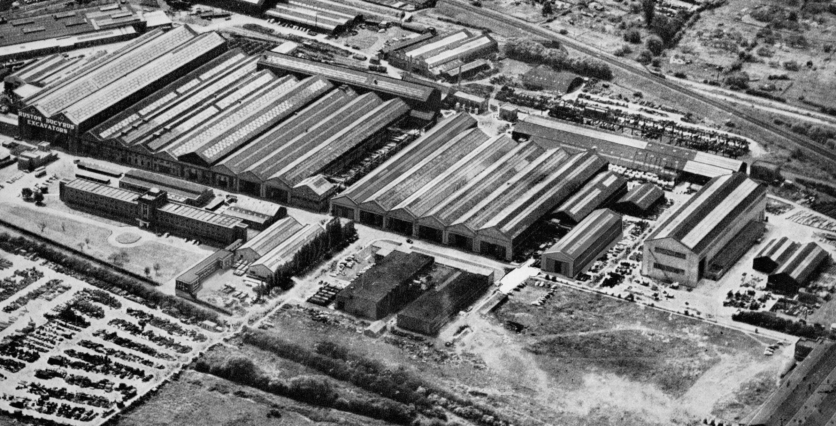
The full set of 22 bays with at the extreme left of the picture the legend:
Ruston Bucyrus Excavators

Induction
One of the inevitable preludes to actually starting work was the acquisition of work ware and tools. I think from memory we were supplied with basics, like a limited number of hand files, but anything else, even hammers, we would have to buy for ourselves and it was going to be quite an expensive exercise for the apprentice wages of both myself and my new colleagues. The required dirt protection cum apprentice uniform ensemble we were given to wriggle into was a set of overalls known as a boiler suit. These days they would probably be called onesies and as the name implies they were one piece coveralls which became known as boiler suits after they were first worm by men who attended coal fired boilers. They were darkish blue in colour and at first rather stiff to wear. They were also a little shiny as I recall and all new apprentices therefore could be identified by their spotless semi gleaming sets of work attire. The sooner we could get them good and dirty the easier we would blend into the factory background. For a modest fee the factory scheme allowed regular changes into a clean set and it soon became a weekly ritual to have them collected and exchanged by Sketchley’s industrial laundry service. There were about twelve of us in the group that started that August. As it turned out and unknown to me before I walked through that hallowed RB clocking in hall I was to be the sole occupant of the training school for a whole week before everybody else arrived. My passage through didn’t go without the initiating ceremony. My details taken while pleasantly grilled for formal identification I was given the prize of my clock number - 414. Something perhaps like the military service number but a lot shorter. The date was Monday August 10th another day in infamy. I’d been conned. There was the apprentice supervisor Mr James, John his assistant who surprisingly was a migrant of some years from Port Talbot, and me a Swansea Jack. The training centre or school was at the north end of the works, backing onto Beevor Street and next to No 2 bay. Communication between the apprentice school and No 2 bay was through a pinkish painted sliding door supposed to remain closed so that the goings on there would not distract trainees from their learning.

It was fortunate that there was a means to see beyond into the main works otherwise I would have gone nuts. Like I said I was the only one there and I wasn’t learning a cotton pickin’ thing. For that first week my mission was: should I choose to accept it and wasn’t given any choice; to acquire a piece of emery cloth and rub down a four foot square cast iron surface table, sub divided into four separate two foot squares by central grooves that kept catching my finger nails. How imaginative was that? I must confess that I was more than disappointed. It was bad enough being on my own and soon bored out of my skull only able to relieve this state of affairs when Jamesy was preoccupied in the office or out and about skiving, by taking a peek through the sliding door gap to look across the great divide of 2 Bay to No 3 where they were assembling 38-RBs. Sometimes it was really interesting and they would be lowering a completed upper works revolving frame onto its mating crawler assembly. With fitters stood around as it floated in the air one of their number would mount the superstructure itself, signalling the gantry crane driver as they lined up the centre with the propel shaft poking out of the lower works. One day it would be me?

How long before I would do something like that? My reverie was soon broken. “You’re supposed to be working on that table lad. Come on!” Oh boy was I loving this? Occasionally an individual from the test department, a rather suave smoothy would break the monotony. Coming in pushing through the slide door to inspect the new apprentice and offer worldly views on his experiences and question me on mine which were none. Considering the fact that there was a lathe a shaping machine and some other bits and pieces I did ask if they would reconsider and give me a proper project but Jamesy told John nothing doing; I’d have to wait for the rest of the crew. We all had to be doing the same thing. Infamy! Pure and simple I just knew he’d got it infamy but eventually I did indeed have the last laugh.

Getting kitted up with our hand tools was in itself quite educational as we were able to see in one place the vast array of hand equipment used to assist in the production of finished machines. It was endless. This was Bell’s tool shop just over the Rope Walk level crossing gates and around the corner. It was an Aladdin’s cave of shiny equipment. All important tecki looking stuff like the several huge micrometers for measuring three foot and more across their anvils stood in their storage brackets against the back wall and inviting a lot of questions. We would soon be seeing these and larger ones in use when we went out onto the factory floor but for now we would concentrate on buying the more common one inch capacity and other things like steel rules. That’s what you called them when you were an aspiring professional engineer; no longer the wooden schoolboy ruler; it was an engineer’s steel rule and compasses became dividers. Another hand tool we would become familiar with was the scraper in both straight and curved forms. What were we going to ’scrape’ we wondered? And what was this yuki stuff they called engineers blue that once touched by enquiring fumble fingers took so long to wash off. Not to worry! When people saw that on your fingers you would immediately be identified an engineer. Anything and everything we could desire even if not fully understood but all having to be paid for by the new workin’ for a pittance owner so we had to curb our enthusiasm. Soon we would also require spanners and socket sets but fortunately the heavy expense of tools was covered by membership of an apprentice tool club which we all quickly joined.

My fellow pilgrims, those that I can remember, in no particular order were: Nicholas Gostick, Charlie Creasey, George Sims, Cliff Hildred, Richard Hall, Raymond Hunt, Keith Tippler, Jacko Jackson - whose father was the proud owner of a 22-RB, a lad by the name of Franklin along with George Simms wanting to be fabricators, Colin Fanthorpe, Alan Johnson who was still there when the company closed, another by the name of Finlay whose father was involved with overseas service or similar, and one more whom I can only recall as Peter. We were all lads now not boys, they having all come from local schools and basically attracted by engineering generally and nothing to do with the end product. I don’t think any of them had actually had the same experience growing up watching and climbing on board diggers around building sites that I was lucky enough to have. For a short time not long after we started we also had a couple of Oxford or Cambridge graduates who came to familiarise themselves with dirt on their hands. Two very pleasant individuals one of whom stayed to take up a position in the engineering department. Surprisingly one of the things they found difficult to adjust to was the use of a hacksaw. But of course we had been using them for a few weeks before they arrived so we were old hands by then.

One job given unto us, which after producing simple variations of hand dividers and compasses we all found tedious, was an exercise with scrapers. It looked like it was going to be a doddle but as we all said afterwards relating our sad tales of unrequited scrapin’, it weren’t. It was a cast iron annular ring measuring around six inches in diameter with hole in’t middle measuring about inch and a half; still days of imperial measurement. About three inches in depth it had on the uppermost surface four shallow grooves ground at right angles dividing it into quarters. Our task was remove the grooves by chipping away what was between them, first with hammer and chisel - Oh Boy! - then filing across it and finally by application of hand scrapers in conjunction with engineers blue. We found the task arduous and frustrating, especially the scraper part when we often scraped the blue we had spread on instead of the shiny high spots revealed by rubbing it across a surface plate.

Giving me a quizzical look John took my cast iron Polo Mint and laid it face down on the surface plate before him. Squinting at me through his heavily magnified black rimmed glasses he took a set of feeler gauges from his smock pocket. Then selecting a one and as half thou blade he very deliberately poked it around the circumference in several places. I noted with smug satisfaction that there was resistance. But he gave me a funny ‘I don’t believe this,’ kind of look and with eyebrows raised picked up the masterpiece placing a rule edge across it, squinting more intensely before shaking his head observing with a look of pity, “Y’see where the rule is touching the outer edges lad, and where the light is shining through everywhere else?” “Yes John.” “Well see if you can move the edge in and spread it around a bit more to meet the hole.” “Can you say that again John?” One of our engineering buddies was really annoying, never giving the impression of any particular aptitude but completing it in record time; a student apprentice. I think there were about three of them. Most of us were craft but not all as fitters the two already mentioned there for the fabricating shop. They had all come from local schools basically attracted by basic engineering and nowt to do wi diggers.

Exercises on the shaping machine and lathe were probably the easiest, just having to clamp something in the vice and watch the tool shunt back and fore after being shown the various points on how to adjust the cutting stroke etc. The lathe held our interest more because there was so much that could be done with it. At the Swansea Secondary Tech school metalwork shop with fellow classmates I had done a little bit of turning on the Myford or Boxford lathe. Screw cutting was the main exercise with details of thread angle being matched to the cutting tool feed, depth of cut and when and how to engage the saddle it back in the same place without “screwing things up completely” as the metalwork master cynically added. To help in this key endeavour there was an attachment fitted to the side of the apron; a marked dial driven around by the screw to line up with a mark on the saddle face when in the right place to engage. We diligently practiced with very few casualties. The merits of three and four jaw chucks were discussed and with the four jaw a simple demonstration of imbalance if the item being gripped was not correctly centred and then turned at too fast a speed; the school Myford lathe on which the demonstration took place being allowed to rock and roll very briefly for clarity.

That was my memory of Swansea Tech but here at the RB apprentice school we were working on an old Harrison lathe. This was much bigger and heavier, easily capable of doing considerable damage if proper attention was not paid. Our first exercise was to cut a ¾ Inch Whitworh thread with a matching nut. Cliffy Hildred always use to refer to Whitworth as Woolworth because they sounded similar and were both well known. Supervisor John showed us how to set things up, hand sharpening the cutting tool for correct helix angle, front angle and top rake and then how to hold your breath while taking the first tentative cuts. This was for the bolt part, pretty straight forward but then came boring out the nutty half. Actually he let us getaway with just doing an internal thread in some round bar instead of a hexagon piece; less hassle than trying to find some to suit. But was John satisfied? No! Now we had to do the same exercise for producing a 7/8 Inch square form thread, a little more challenging to get the boring tool right. Cutting the external thread it was easy to check as it spiralled along the length but squiggling down the bore was worrying. We were over concerned however. Our confidence grew and we became almost blaze’ about it. I think John’s original plan was for us to make a nut on the shaper and then set that up in a four jaw chuck to practice setting and centring procedure but perhaps seeing my efforts he got cold feet and we just used bright round stock bar instead.

We were also attending college for day release by this time for theory and practice. I can remember meeting my fellow students for the first time at the Technical College on Monks Road; none of whom were fellow employees at RB. Another bunch of Lincoln lads, a number of them living in villages on the outskirts of the City travelling every day to other centres of engineering: mostly Ruston & Hornsby who had about four different heavily populated establishments. Other companies in part were represented by Smith Clayton and Clayton Dewander Company. We had all equipped ourselves with books like: Senior Workshop Calculations, and three different volumes of Workshop Technology; all by Mr W.A.J Chapman PH.D, M.Sc (ENG.), M.I.Mech.E., M.I.P.E. That fella’ certainly knew his stuff. We all started investigating the calculation problems and I remember looking around terrified at all my new companions and wondered how much more did they know than me. It was all so completely alien I was convinced that I would soon reveal my level of ignorance. It soon became apparent however that we were all more or less in the same situation and got along fine.

Our main lecturer was a gentleman by the name of Davies. He also gave us the impression that he too knew his stuff. Slight in stature but brisk in manner he held us in disbelief immediately after his initial introduction of himself. Without further preamble he declared that we each had the ability to measure and judge accurately with forefinger and the thumb down to an accuracy of five thousandths of an inch. His opening gambit, totally preposterous, was very clever; getting everybody’s attention immediately and after long excitable discussion amongst keen minds moved us on to discuss measurement, methods in general and in particular the considerations of the standardisation system for component interchangeability, limits and fits when applied to mass production. Over the course of the remaining term the theme was developed and amended, our engineering knowledge growing steadily for application when the right occasions presented themselves. There were many tools he said that could be used for measurement and one then touched on was the use of slip gauges, not the feeler type gauge we had used on our scraper exercise but slip gauges until then not heard of by the ignorati among us. They were pieces of hardened and ground steel of standard dimensions and thickness with such a fine surface finish that they could actually be wrung together on their combined surfaces to form a single piece. Seeing our disbelief and anticipating our unworldly doubting minds he produced a few samples of the said slips and demonstrated; allowing us to try for ourselves and confirm the possibilities even for the unskilled.

Officially studying for our City & Guilds Diploma in Machine Shop Engineering Practice we were beginning to get the picture of the academic mountains we had to climb. Problem with exams was putting what you had learned and seen into words, especially when they had the effrontery to request a drawing or sketch to illustrate what you were trying to say. I was not too optimistic over my chances but that particular obstacle was then still a while into the future. There was quite a bit in Mr Chapman’s book about materials and the formation of metal chips when the tool was actually cutting and removing swarf; things you would never normally think of. The Study of tool composition led quite naturally to alloys in general and how to machine them; with the subject on one particular day leading to swarf and chips in the morning, fish and chips for lunch and how to brew a nickel or cobalt alloy stew in the afternoon.

Slowly but steadily over the progressing months we were led through the world of engineering and its many facets, some of which we would not be involved with and others with which we would become very familiar. One of these was the bushings and bearings in the excavators we produced - notice the royal we; now part of the RB family - there were many. Having been acquainted with diggers in my previous life as a schoolboy and a Meccano builder I knew exactly where to look. Basically split into two types; the engineered ball or roller shiny ones that came in cardboard boxes used for your actual power machinery and the brass, bronze or hardened steel ones. Associated with precision bearings Mr Davies informed us we must consider component assembly parameters. What he meant was how they fitted together; you’ve got to learn the jargon haven’t you? It’s like the notes on sheet music. If you don’t know them you’ll never be in tune. What he was actually referring to was push, running, loose, interference, press, heat press or shrink freeze fit assembly of shaft into bore. To understand all this mind boggling stuff we would, he added rather gleefully, have to consider their plus or minus factor matching relationships. Are you suitably confused? So were we. I was actually terrified. He was certainly enthusiastic about it all, a little more so than we the happy few who could only sit and gape.

One of the things we were advised to do was visit the respective tool rooms where we worked and ask questions. Speaking for myself I was happy to undertake such missions when I was first allowed out into that big world beyond the ‘sliding door’ and act as first assistant on a turret lathe. We did spend quite a bit of time out and about on different machines in various departments and if ever a special something required us to visit the tool-room stores located in the tool-room I would often overstay my welcome until the foreman noticed a congregation forming. “Now lads……is this an informal meeting or just a general revolt?” “Oh er, sorry Stan, we were.…Blah, Blah.” Stan begins to smirk. He’s heard it all before. “Yeah well I’m sure somebody is missing you….” Later when we had been out in the woks for a while, visiting more often, melting into the shadows and becoming part of the furniture, we were able to extend our visits and briefly move around the various tool sharpening and setting sections to briefly learn the techniques. It was only the apprentice toolmakers who would spend any real time here though so the experience was limited.

It was in this very tool room however that we had the second noteworthy engineering thingy that we were told to look out for; notably the air conditioned temperature controlled ‘Standards Room’ because things that measure other things actually change their own dimensions with any temperature fluctuation making it necessary to take this into account when establishing veracity of measurement datum. As stated in an article written for ‘The Digger’ magazine by Mr R.Clayton, A.M.I.E.I in the Spring of 1962 it meant that the company needed a standard against which to make the thousands of measuring instruments used throughout the factory so that they all measured reasonably accurately and could always be relied on for making interchangeable parts. The RB Standards Room was equipped with a piece of equipment that supplied that basic standard for the factory. It was we were informed to the same standard as the equipment used at the National Physical Laboratory at Teddington; so chew the meat out of that! It was a special machine designed and built by Societe Genevoise capable of measuring any given length, thread, radius or angle to within 0.000,01” But was this level of measurement really necessary it was asked? Well yes it was because it had already been established that if a component were made to 0.001” limit, measurements must be able to be made to 0.0001” and if manufactured to even finer limits, say 0.0001”, then measurement must be able to be made to 0.00001”. The basic conclusion reached was that if work has to be made to a particular tolerance then to project that accuracy it must be possible to measure to one-tenth of that tolerance. The article also reported an example of temperature easily affecting measuring apparatus describing how an 8-9 Inch outside micrometer held in anyone’s hand for five minutes will expand up to 0.003” and take forty five minutes to contract.

Out & About In The Works
That part of the bay directly outside our sliding door was occasionally used as a temporary parking place for the odd piece of machinery or engineering paraphernalia that could not be placed elsewhere. Sometimes the items parked could be very interesting like a few 30-RB excavator base machines that suddenly materialised over one weekend. There they were stood nonchalantly posing naked not yet fitted with cab or front end equipment and showing all their insides. The original machinery layout introduced in 1956 did not have full air control. Where it was missing was on the boom hoist clutch unit mounted forward of the engine on the left hand side. Clutches for this were still operated by manually activated cams through mechanical linkage to engage drive direction: either roller chain or a pair of gears. It was a very compact unit tightly put together and I gave it due inspection. There was something about the 30-RB, apart from the new air controls, that made it stand out from the others; unadorned even with out its clothing giving the impression, for me, of solid purpose reminding me of the Lima I made friends with a couple of years previously; another mean looking machine. I would climb onboard one of them at lunch time sometimes getting odd looks wondering why an apprentice was taking an interest in the product. Over the next couple of weeks, one by one when I wasn’t looking, they transferred over to No 3 Bay where they were fitted with special high vision cabs bound for the logging industry in Norway but what I cannot forget was some busybody jobsworh actually did once tell me to “Get down off there. What did I think I was doing?” Can’t have an apprentice showing an interest.

After a couple of weeks getting settled a tentative exploration of the factory seemed to be the thing to do; finding my way around while hoping my presence would not be a problem if I kept my beacon like head down. New shiny apprentices were however quite acceptable and even curiosities in the most out of the way cubby holes used as temporary refuge and solace from factory life. One of them was Joss’s kingdom, the oil stores: a corrugated shed with oil drums stacked one on top of the other making a very good hiding place for the desperate. In time to come I too would occasionally find it a quiet haven bolt hole. Progressing over time through the various departments and becoming more familiar with the geography it was pleasing to find my co workers friendly so I needn’t have worried. The factory was vast with the first eleven bays conjoined to each other and effectively under one roof with distance end to end sufficient that while bays actually ran north to south from Beevor Street two service roads also ran east to west dividing each into three sections. Fork trucks hustled back and forth between them and up and down their centre gangways laden with red painted stacker pallets. You just had be on the lookout as they dropped their loads in parking spots next to lathe, milling machine or drill etc. There were two types, the most common being battery driven, their operators standing on a short platform able to face either direction while steering with a tiller handle. They didn’t hang about either, racing hither and thither constantly for most of the day. “Oy! Watch out ginge’ or they’ll ‘avew.” Running alongside No 11 shop a roadway stretched from Beevor Street to the rear of the factory together with an open to the elements material stock yard taking the space of two bays No’s 12 and 13. A second covered group of production workshops numbered 14 to 18 followed. Bay No 18 was where 10,19 and 22-RB machines were born and where a few years hence destiny would take me.

All the bays were accessible from Beevor Street north end and through a separate side door at No 1 bay adjacent to the time hall giving easier access for personnel working those parts of the factory that required them. The first five bays were the longest at just over six hundred feet with No’s 2 and 3 the widest; approximately fifty feet and standing the highest, their all glass roofs making them seem almost Cathedral like at eighty feet. Hung at each end were the biggest sets of sliding doors I had ever seen. No 3 bay was the main erecting shop for 30-RB, 38-RB, 54-RB, 71-RB, 110-RB and 150-RB machines with completed 30 and 38-RB machines exiting at the Beevor Street end taking a gentle nose dive dipping down a sloping ramp to meet and greet Beevor Street outside. The 54-RB, 71-RB, 110-RB & 150-RB were erected and exited at the south end of the bay on the same level.

The machine shops were truly something to behold. Ruston Bucyrus did almost every form of production engineering involving all kinds of turning, milling, gear cutting, grinding, planing, horizontal and vertical boring, drilling, broaching, keyway forming and spline cutting, with in addition all the manipulation and cutting of metal sheets and sections associated with fabricating and welding together the various structural components of the finished products which made up a world renowned range of diggers. Numbers 1 and 2 Bay specialised in the heavy end of machining having Webster & Bennett vertical and Kearns Richards horizontal boring machines, Asquith and Archdale radial drills, vertical box and round column drills from companies like Fredrick Town and Pollard & Co with Herbert vertical mills and similar equipment having manufacturer’s names now long now forgotten. From what I can remember there were also medium sized planing machines and the simply enormous hundred foot Noble and Lund with twin beds operating either joined in tandem or with tables split; one to work while the other had the next job set up on it for swapping over when ready. All sorts of machinery populated the works which I would eventually find including those residing in an extremely well equipped gear cutting section. However the boring and drilling machines, particularly in No 3 Bay, played such a vital role in machining major components that they deserve more than just a cursory mention and I will get to them a little further into the narrative.

Apart from its main function as a heavy production centre the junction created at the north service road and the central gangway had also become a sort of unofficial meet and greet point after lunch. Although you had to clock in on arrival for the morning shift it was not necessary to clock out at lunch time. Ruston Bucyrus had a very good canteen on the opposite side of Beevor Street just before the link road to the back of the factory. There was quite a choice on the menu and it was where I usually got my reasonably priced grub which included a pudding. Fish and chips were always on the menu with alternatives like Shepherds or corned beef Pie just as enjoyable. It was after dining at the RB canteen I found the best time to explore the works. The place was for the most part deserted with only the odd few bodies around giving plenty of time to explore before having to clock in again. A few yards before the time hall on the same side of the street was another canteen belonging to and run by Ruston & Hornsby. It was some time before I realised that it was also available to RB personnel so why not give it a try? It was here that I was introduced to fish and chips with gravy; a totally different but enjoyable culinary experience. Oh yes! The folks back home just wouldn’t believe me. It was Tony Crane another apprentice who introduced me to it. A very friendly individual from our first meeting he was a year or more ahead of me and forever wearing a big grin on his face, always good to know somebody like that, and he found my reaction rather amusing. It was on my personal lunch menu quite regularly after that.

Not clocking back in for the afternoon shift wasn’t an option so there was always a steady stream of bodies exiting the time hall to walk beneath the north service road roller doors at No 1 Bay and on into No 2 where everyone dispersed to where they were due elsewhere in the factory. If you carried on walking through it led to the far end stockyard, already referred to, while on the way passing tool room, general stores and fabricating shops. New apprentices would either go directly to the school or very often chat with older ones already loose in the works picking up gossip and tips for survival. I remember it being a very convivial atmosphere with everyone taking the mickey out of each other when ever possible. Sometimes we would wander through the machinery set out on either side of the gangway to chat with machine operators working at that south end. The Kearns Richards horizontal boring machines were quite large and had their own platform adjacent to the spindle gearbox. Unless my memory is playing tricks I believe that when they raised the spindle level the platform also went up with it so they had a pretty good vantage point for operators and apprentices to see what was happening around them. I remember a couple of Webster & Bennet vertical borers also being located near this junction and also at the top service road.

It was a good opportunity to see how large components were machined and if you wanted to ask any questions about anything there was usually a foreman hanging around nearby. On the right looking South were three or four Kearns Richards horizontal borers and the two heavy lumps of Webster Bennet vertical ones while to the left were three Kearns Richards, maybe slightly bigger and possibly a Butler planing machine along with other bits of kit which I cannot now identify. Management were fairly relaxed as long as they could see you actually taking an interest and not just wasting time. Friday afternoons were particularly memorable for everybody because it was payday. At the junction of service road and No 2 Bay gangway the wages team would arrive and set up the pay booth sometime around mid afternoon. The booth was three pieces of joined up and hinged together wooden planks with another piece across the top for the counter. Pay was doled out sometime between 4.00 – 4.30.pm. with other parts of the works having similar arrangements for their own area. So we all stood around waiting for our names to be called before walking up to the wages clerk with baited breath. I did anyway because I knew that what ever they gave me those first few years would not let me pay my way. My wage for about a year was £2-17-9. In today’s financial system this would be £2.89. My lodgings were £4-0-0 a week so dad had arranged a government grant to make it up. Busking was then unheard of so fortunately he’d realised this dipped into the family reserves and, although it made things tight, for some considerable time regularly sent a 14 shilling postal order for pocket money every week. That was the easy part. The government grant to pay the balance for my lodgings was in the form of a voucher to be collected personally every week on a Friday after work from the government offices at the top of Steep Hill. If you’ve seen the Hovis bread Advert on TV you will understand. Not the same hill but close enough; every cotton pickin’ week come rain, hail, snow or sunshine there was that arrangement to take care of. It lasted for a couple of years but I enjoyed pushing my bike up that hill. Heyup lad!

Of the excavator range in production at the time the 10-RB was the only one using a fabricated revolving frame so we didn’t see much of it in No 2 Bay. It was the 19-RB up to 54-RB that were the regular subjects with a growing number of 71-RB after 1961. All had extremely complex revolving frame castings and were a salute to the pattern makers skills associated with producing them. The lower works truck casting was less complicated than the revolving frames and carried just propelling shaft and steering arrangements internally its principle feature being the turntable on which machinery deck together with front end equipment revolved as a single unit carried on tapered rollers running between upper and lower precision machined surfaces. The number of truck and revolving frames passing through the workshops meant regular repetition and consequently used purpose made jigs for quick location, securing and machining to already established methods and protocols. Old records show that in 1958 the number of 38-RB machines rolling out of the erecting shops was 47, for 54-RB it was 26 and the most popular 22-RB was 305. So they’d had plenty of experience setting up the methodology and it was the Webster and Kearns Richards that were kept busy with these two base components. To the best of my memory I don’t think I was partnered on any of them and wish now I had taken more notice of the machining setups and procedures for tracking them from delivery through the works. Too late now boy!

Details for both Webster & Bennet and Kearns Richards can be found on the internet so it’s worth taking a look just to get an appreciation if you are not familiar with their size. The W&B was arranged with a large diameter rotating work table similar to a lathe chuck but turning around a vertical axis. Normally equipped with facility for independent work holding arrangements the RB production department substituted this for their own purpose designed jigs. Straddling the table between two columns a cross beam, which could be raised or lowered and on which powered tool heads were mounted, was set to machine both roller paths and their vertical wall along with the top face as a first operation. Centre post diameter and bore were machined as a second with appropriate change to tooling set up. I think some were equipped with a tool head either side of the cross beam, each being used in turn for top and bottom roller paths with perhaps tool changes for the vertical diameter wall and centre post machining. But I am just speculating. It was a long time ago. In due course during assembly of the excavator a heavy bush would be fitted into the bore to act as a guide and support for the vertical propel shaft while externally the post would serve to locate in the revolving frame centre bushing with both married together.

I remember walking past one of the VBMs just as a 38-RB truck frame was being dropped onto the table. Perhaps dropped is an unfortunate choice of word. A non official slinger, one of the machinists, had taken the liberty of putting the chain around it but had done so incorrectly with an open hook. He wasn’t supposed to have slung it at all but being a new man on the scene, being consciences, trying to give a good impression he’d actually committed a faux pas. Ruston Bucyrus had a strong union presence and he had sinned. No big fuss was made of it but the official union approved slinger who had just briskly walked on the scene after seeing the overhead crane movement ‘ad a quiet word’. With the face of the hook open it is easy in the wrong circumstances for a taut chain to slip out from the hook and loose the load. Sorta Dangerous! I’ll talk a little more about slingers further into the narrative. Some of them were ‘stars’.

The next operation on the truck frame casting was to machine the horizontal drive shaft bores locating the bevel gear and dog clutch assembly along with final drive and sprocket shafts; carried out on a Kearns Richards Horizontal borer. Unlike the previous circular table turning about a fixed vertical axis the Richards had either a square or rectangular compound arrangement of table and bedframe slides for X and Y axis movement. Angular relationship of the table could also be changed under power. At one end of the bedframe a large diameter rotating tool head and gearbox assembly supported an extending spindle for the boring function. Tool head and gearbox unit could be raised and lowered allowing great versatility in function including face milling. As with the W&B an RB dedicated jig design featuring multiple workholding T slots was employed to mount and manipulate the workpiece.

To machine the bores the casting would have been secured face down on the jig assembly; axis on line with that of the boring spindle. Not actually have seen this being set up myself I assume preparation and fitting of the centre journal bearing cap stud locations for securing them had already been carried out; boring then being a straight forward procedure. With regard to the turntable gear ring both 19 and 22-RBs had them cast integrally while 30s, 38s, 54s and 71s utilised separate factory machined ones bolted into place and welded circumferentially at regular intervals for added strength. All models upto 71-RB would have undergone machining procedures as described with adaptation to suit size. 110 and 150-RBs because of their dimensions posed another challenge. A rather involved machining challenge for one essential component common to all was the main revolving frame on which all machinery was mounted. You can now join the ‘in the know club’ and refer to it under the official slang as the ‘rev’ frame.

Consider the basic casting of a 19/22-RB as a reference point, and, assuming that it would stand level when sat on its hook roller lugs the first operation could be to machine each side on either planing or milling machine. The deck can also be prepared on the same machine if sufficiently equipped or could be moved to another machine to stand on its side for face milling; an operation I had seen occasionally on some of the larger castings. The most expeditious procedure however would be for all three at the first setting so that flat bolting surfaces, gear well recesses, swing shaft and vertical propel shaft bores, seal locating counter bores and faces etc, and the not to be forgotten mounting surface for rear end casting bolt holes. Turn the rev’ frame 180 degrees and you have the underside of swing and propel shafts and centre gudgeon bore to machine for its bushing. Stand it on the four hook roller pin lugs as illustrated in the picture below and they can each in turn be bored with retaining set screw holes drilled and tapped to secure each roller pin flange by indexing the work table to angular position. Let’s not forget the boom feet mounting with angle and height adjustment for the spindle on a totally different axis and one more. What’s that? One vertical bolt hole between, below and in front of the boom feet and used to secure the bottom leg of the dragline fairlead. Now what else is there? ……….. Oops! I nearly forgot. Even the smallest of holes had to be accurately placed and machined and the pivot pin special bolt hole for mounting the swing lock arm on the massive centre gudgeon is another one of them.

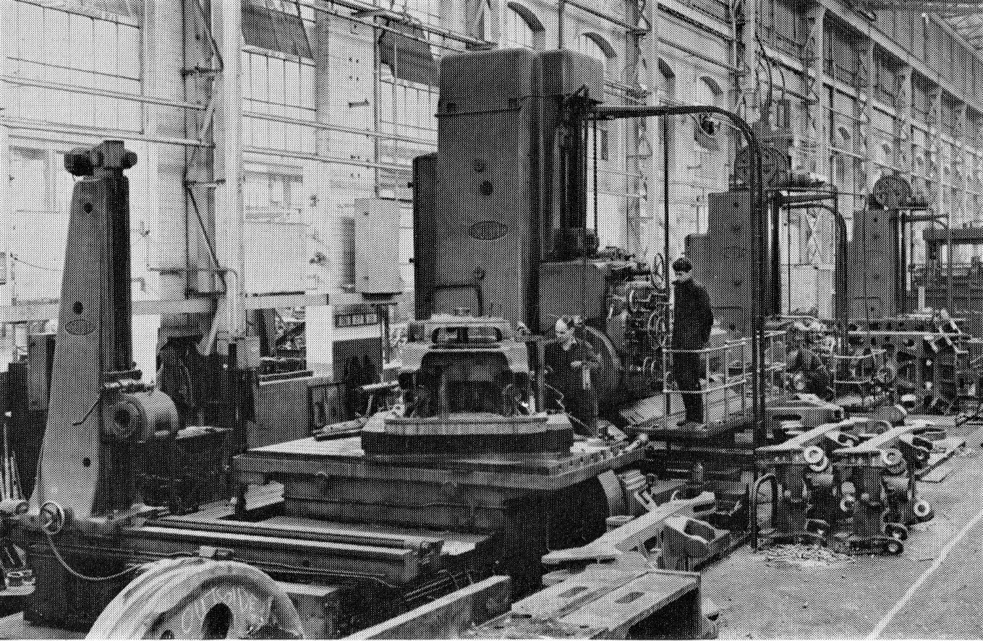
Richards horizontal borer machining 22-RB hook roller lugs as
in the gangway two finished rev frames lying on their side

There was a lot of this sort of thing taking place but did I pay enough attention? By the way we are not done with the truck frame yet. We mustn’t forget those bolt holes fixing the rev frame casting to the rear end but I have a sneaky feeling that these may have been jig drilled separately; certainly for the 19/22 RB because I remember seeing them drilled in such fashion with a custom jig and radial drill. Just across the corner of the gangway on the south service road was another VBM manned by a solid individual and no nonsense kinda guy also an RSM for the local branch Territorial Army barracks. A pleasant individual who also did his fair share of truck frame work alongside Big Tony the operator driving one of the larger sized Archdale radial drills. Featuring an ability to position the spindle anywhere in the working radius of the arm, with adjustable height and distance from its centre of rotation, the radial drill was an extremely versatile bit of kit. As with the W&B and Kearns Richards boring machines full information on radial drills can now be found on the internet.

Although doing a lot of general work I noticed on a number of occasions that he was jig drilling and spot facing truck frame bolt holes with a plate jig using hardened steel bushings to guide the drill through at each location. Speeding up the operation was his use of a quick change drill holder manufactured by the Sheffield Company of Frank Guylee & Son. This piece of kit permitted each drill size required to be quickly swapped without stopping the machine. Drills were set up in their own collet sleeve with driving tang at the top engaging a slotted driver in the chuck. When the outer sleeve holder was grasped and moved upwards it allowing the retainer barrel to move clear of the collet enabling its withdrawal. Both sleeve and knurled collar on the collet ran free and ceased turning when held by hand. I wonder if today’s health and safety legislation would allow the use of such quick change equipment. Personally just the thought of it terrified me. I just knew that if I tried grip the sleeve it would lock and tear my hand off. Big Tony was quite happy about it all though and just kept on singing a Pearl Car & Teddy Johnson song of the day. - “Looking high, high, high, looking low, low, low, tell me why? Why? Why.......?”

Working on the opposite side of the RSM against the adjoining wall of No 1 bay was a medium size planing machine whose operator had a story to tell but unsurprisingly never did. He had apparently escaped Poland with some of his family losing everything they had when it was invaded at the start of the war. Somehow he had found his way to Lincoln and Ruston Bucyrus where I believe he had been for several years. There were in fact a number of Polish people around the works having had very similar unhappy experience but were now fully integrated and welcomed into Lincolnshire life. Behind the planing machine in the far corner of the bay was the lubrication and air piping area, sometimes referred to as the cage, were the team would prepare copper pipe work in terms of bends and length with their various connections and compression fittings. Work benches were laden with brass olives and unions, various lengths of ready measured and cut pipe, off cuts of curly pipe, work trays of jobs in hand and associated paraphernalia. When ‘piping up’ gang members had completed a few sets they would disperse into the erecting shops or wherever needed to install the various runs from grease nipple to feed points on each machinery journal. Some of the runs could be a bit fiddly involving clip drilling in awkward places. When the 30-RBs arrived in 1956 the gang took care of developing first copper and then nylon pipe work installation from control valves to clutches.

Without the morning tea break I don’t think British industry could carry on. It’s so ingrained into our psyche. Apart from the rest and refreshment aspect there is also is also gossip and occasionally useful information. Having now become more associated with practical aspects of lubrication the subject of bronze bearing bushes had ploughed a furrow in my mind. Mentioning this to Alan, one of the pipe fitters, he said I should go find the bay they were made. “You will,” he said, “be surprised.” So one lunch time after fish, chips and gravy I sought out the bush bay and was indeed surprised. I hadn’t at all appreciated the extent of this specialised subject; a whole department devoted to it. Following up on Alan’s suggestion an unofficial errand for the foreman soon permitted a detour through the quiet bushy backwater. If the numbers produced for all past machines were added to those currently under production then it was a considerable industry in itself: Top and bottom crawler frame rollers, truck frame horizontal main drive shaft and half bearings, drive tumblers, take up tumblers, vertical propelling shaft bushing, rev frame centre gudgeon, rev frame swing shaft bushing, main deck vertical shaft propel and swing gears, ancillary bolt on crowd assembly castings gears and sprockets, all the different rope pulleys etc. The list was becoming endless and don’t’ forget the 150-RB size machines. Some of those bushes were really big.

One of the operations being carried out on newly turned bushing blanks was internal scrolling of two spiral grooves bisecting each other diametrically opposite halfway along its length. At this point a drilled hole aligning with an outer circumferential slot permitted grease to be fed through from one of the pipe connections. For the size range observed the spiral was generated on a dedicated grooving machine with a quick feed arrangement to move the slide. Larger bushings might have used a different method but my initial curiosity on how things were done was satisfied. Not long after this visit I remember being given the prize of an hour’s overtime, with Ernie our charge hand, groping around one balmy summer evening on the back of a waiting lorry installing piping to a special pumping system. It was lovely and peaceful as we worked with an aura of tranquillity and wellbeing until a crash of thunder suddenly wrent the air followed by a flash of lightening as the heavens opened and an overwhelming cloudburst sent everything a different kind of barmy.

Due Diligence
As far as I can recall it was after about six months in the apprentice school that I was officially led out into the works itself to see what life was like beyond the sliding door. I was taken into No 4 bay and introduced to Bob, a lanky quiet type of individual possibly in his late forties, standing before a very large Ward combination turret lathe. The turret lathe then was the equivalent of a modern CNC machine but unlike a conventional lathe having work holding chuck, tool post mounted on a saddle and a tail stock, the arrangement dispensed with the tailstock completely replacing the standard tool post mounting with a heavy duty saddle on which was mounted an indexable six station rotary turret holding the various attachments and custom tooling to perform different cutting and support functions. Projecting from the turret centre post at the top was an additional guide boss that slid over a headstock steady bar to impart greater rigidity when machining close to the chuck. The chuck could also be replaced by a collet system when required and there was usually an arrangement of rotating saddle stops working in conjunction with the various cutting operations. I was firmly told by the apprentice master to pay attention to what I was told, watch what I was doing and not to mess around. The implications being that bad things would happen if I was found wanting. I was only too happy to comply.
At last: Freedom from the shackles of the apprentice school. Bob was obviously used to apprentices and was easy to get along with. Not very talkative and didn’t ask any questions. The job he was doing was not one that I would have described as easy. He was turning the bearing journals for a 38-RB lower works drive assembly consisting of propelling shaft with integral main bevel gear and a counter-bored steering dog clutch half at each end. The counter-bore located the inner end of the half shaft on which was mounted the chain drive sprocket. The counter bore also assisted greatly in setting it up for machining in a rather unexpected way. Having been brought to the lathe by an overhead crane it was loosely suspended with one end fed into the chuck and gripped in approximately the correct position for turning around its axis. The crane was then released for Bob to set about adjusting and ‘truing up’ the opposite end to the chuck; the procedure almost laughable but it worked. The lathe was set running at moderate speed noting the amount of deviation from centre of the unsupported end for appropriate adjustments to be made to the chuck jaws. The method was interesting: Holding a piece of chalk at job height bracing with one leg for it to just touch the outer diameter of the spinning bevel gear, jaw grip was then adjusted to reducing the throw, the chalk mark removed and the propelling shaft spun again to mark the gear rim as before, the procedure repeated until chalk contact made in a number of positions in a manner deemed to be satisfactory. Then everything was tightened down ready to commence machining.

In order to ensure no major disaster occurred with the spinning end I believe he also knocked a wooden bung into the counter-bore supporting it temporarily with a running centre. Once true enough for machining the bung was then removed and the load completely supported with the running centre. This was how I remember it. My memory may well be playing tricks on me after all this time because perhaps a better way to hold the tail end in the turret would have been for a running centre directly into the machined counter bore. But he was the turner and knew his trade so obviously there was a reason for doing it that way. Something sticks in my mind about the wooden bung however so I guess we may never now know the whole truth.

In other parts of the bay Herbert and Ward lathes were regularly machining clutch housings up to 38-RB size with 54-RB and larger, like the 110-RB, set up on Webster Bennett Vertical borers. There was always some way to do the bigger stuff. With the ebb and flow of components coming through the workshops drum laggings of various sizes for both rope winding and crowd chain duty would sometimes show up in their raw cast state. Arriving with their separate halves tied together by integrally cast webbing they would later be separated by oxy acetylene flame and dressed with a grindstone. In gangways red painted pallets of bottom roller pins of all sizes slowly built up to over flowing before collection by fork trucks and in one of the other bays I found two Colchester lathes along with a Dean Smith & Grace tucked away in a corner quietly knocking out drumshafts. They can’t have been the only ones knocking them out because the digger output of those days was quite healthy. There must surely have been other hidden corners making interesting bits not yet found. Roller pins were supplied from bright heavy shafting of the required diameter ready cut to length the only machining requirement being a small chamfer each end, drilling through part way to centre for lubricant distribution with a short counter bore for housing a nipple. A thread would also be tapped later in the milling section, after a grease distribution hole had been drilled to meet the half way nipple feed. I would find these set up on a jig for shaving off the end flats seating them in position on the underside of the crawler frame to be secured with U bolts.

The thing you really had to watch out for when doing metal removal by machine was swarf. The long red hot curls of metal came away at an alarming rate when turning on a lathe and could quite easily remove an arm or hand if you were careless. Even in today’s health and safety environment it would be difficult to put guarding on this operation without a redesign of the component. But it was still necessary for swarf to be physically removed during the operation to prevent clogging the job and a ‘special tool’ was provided for this. It was a piece of rod about two feet long with a wooden handle at one end and a slight hook bent over on the working end. True the swarf did break up as it was formed but the idea was to encourage it to do so whenever you could do it safely. When the job was completed the production inspector would arrive and check dimensions according to official drawings. Bob produced a winner every time. Unlike his nearest neighbour who was turning some kind of spacing ring about two feet in diameter that were not meeting specification and several of which had to be scrapped. I think company policy was to allow a certain amount of scrap but after that you were looking for a new job. When I moved on from ‘assisting’ Bob his neighbour was still there but what happened after that I know not.

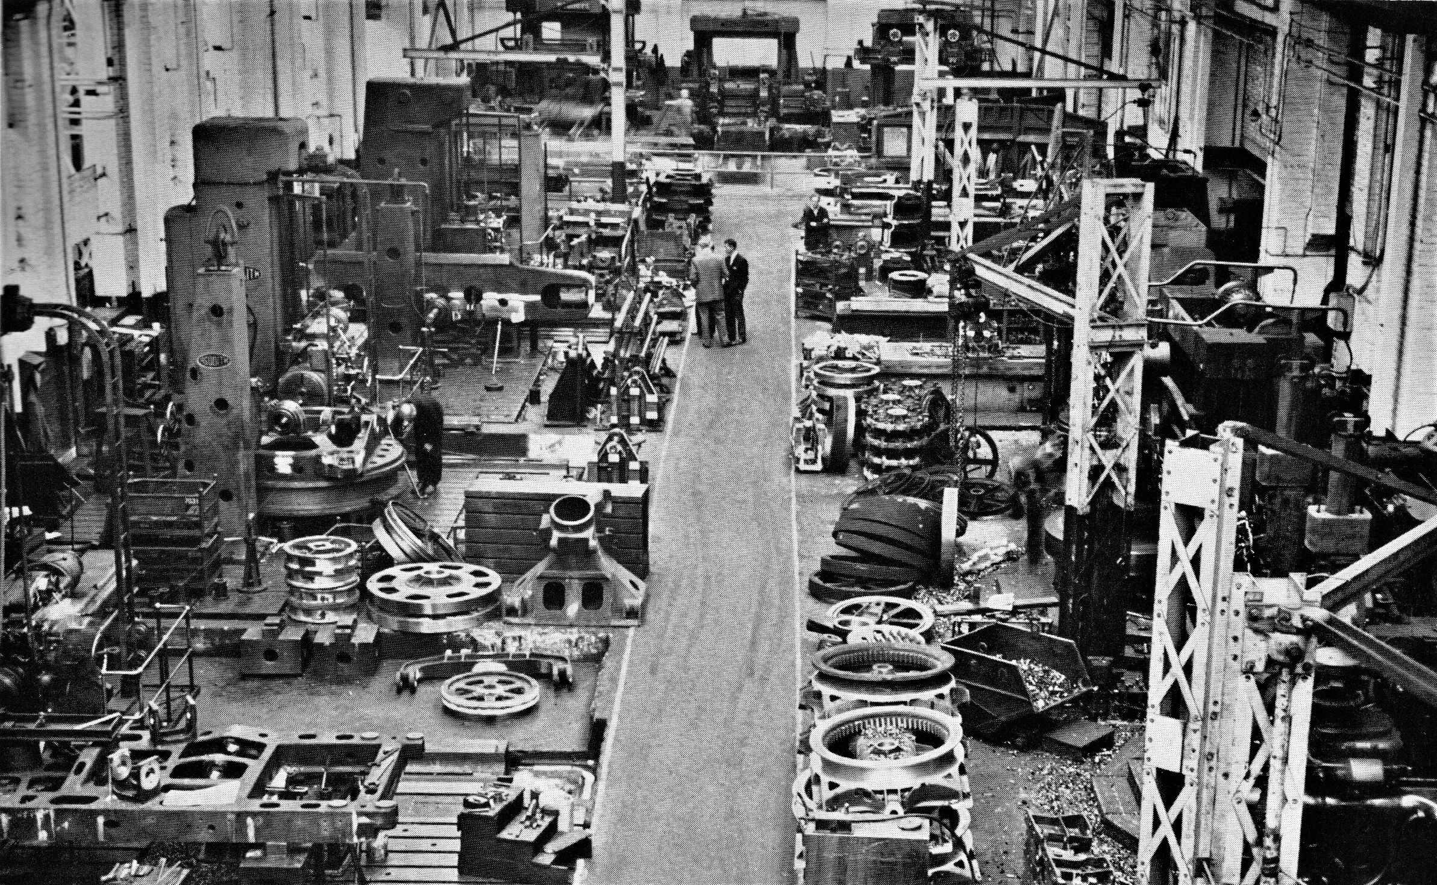
Above the upturned rear end of a 54-RB rev frame is being machined

As I inferred earlier, Bob was fairly easy going and was not averse to me taking the occasional ‘break’ and exploring activities in other parts of the bay. As long as I was not gone for too long and told him where I was going to be it was OK. If the foreman came looking it would not be doing him any favours by being AWOL because I was his responsibility. If he knew where I was to be found he could cover for me and also I would not get the sharp end of the foreman’s tongue. Fortunately and thankfully he did not take the opportunity do to me what was done to some of the other apprentices who, legend had it, would be sent to the stores for ‘a long rest, a tin of ½ inch holes or some elbow grease. When I did wander it was usually further down the bay towards the capstan lathe section. These were the junior version of a turret lathe producing much smaller components in larger batches maybe running into thousands. At the south end of the section was one of the first enclosed automatic lathes of American origin. Lots of whirring, clunking, clonking and other noises going on under the hood with small components coughed out and down a chute into a bin at the back. The operator, looking pretty bored, just seemed to stand around waiting in attendance and loading raw bar whenever required which didn’t seem to be that often. Interesting in one way but with nothing to really see the capstans were more dynamic; certainly more so for the operator. On my first foray there I was lucky enough to hit it off with Harold one of the operators who always seemed friendly, pleased to see me and asking how I was getting on.

With a round cherubic face, shiny teeth and a grin to go with it he was one of nature’s sunny people always wearing a smile. Working at RB for several years he was like greased lightning with the machine, very often producing some form of screwed piece when I visited. This usually involved mechanical auto feeding hexagon section bar held in a manually operated collet chuck, turning a shoulder of one diameter and then a second smaller diameter after indexing the tailstock capstan around to a different tool set up. The capstan would then be indexed around one more time to feed a special screw cutting tool head called a Coventry die box to finish cut the thread and then automatically disengage at a predetermined setting. Unlike the previous large work on the turret section mass production required large amounts of coolant and Harold my new friend always seemed to be up to his elbows in it. Later when eventually working on a gang in the erecting shops I was able to identify quite a number of Harold’s components. One of them a special bolt for mounting phosphor bronze wear slippers used on lower works dog clutches. Whenever seen they remind me of my sunny friend from long ago. There was also a section labourer who would go around sweeping up keeping gangways and walkways clear between all the machines. He too was of a friendly disposition but unfortunately seemed to have the troubles of the world on his shoulders, constantly in a state of depression stemming from a worrying domestic situation with a bullying son.

Life as many of us would agree is a game of chance and on one of my regular visits to see Harold I got acquainted with another capstan lathe operator. Alan at twenty four years of age seemed a lot older than me still just sixteen but he again was a very friendly type and shortly to play an important part in my life. My landlady and I were still not ‘not getting along’ then and were unlikely to anytime soon, our mutual dislike making it inevitable that I looked for an escape to other digs. Happening to mention this to him one day he said he might know of some alternative accommodation. That sounded good I told him but wasn’t really expecting anything more to come of it until, only a couple of weeks later on another one of my visits to see Harold and now Alan as well, he brought the subject up again. Only married about eighteen months he and the Mrs thought they might be able to take on a lodger to help out with their mortgage.
I was a bit apprehensive at first thinking they might find it more difficult having me around than they imagined. They insisted however that they were quite happy to give it a try so I was delighted that weekend to be able to tell my landlady that I was leaving. She was not a happy bunny. Things did not go quite as smoothly as imagined however since I was still only sixteen and the company was by default bound to keep ‘an eye on me’. I think actually that they were a bit put out that I had undertaken the quest without consulting them first. But now aware of my escape plan the apprentice supervisor, having found the lodgings in the first place, reluctantly decided to call on the lady of the house again, this time to inform her ‘one would be moving on’. I can’t remember the actual chronological order of events. Suffice to say that on my return from collecting my lodging voucher that particular Friday afternoon I was ambushed by my favourite landlady who gave me a real good ear bashing to give vent to her displeasure. “She wer’ not best pleased lad,” was how Jamesy put it. She was after all going to lose four quid a week until she could find a replacement lodger which I didn’t think was going to be very easy. Things were a bit tense for the next few days but soon got better the following weekend after moving in with Alan and his wife. They actually lived not that much farther away. Just about a mile or so up the road on the outskirts of Skellingthorpe village where several happy months were spent with them until I judged it was time to move on. Alan and his wife had been very kind in giving me refuge for a while but I could not impose myself for too long and found myself a new set of digs elsewhere before outstaying my welcome.

One amusing thing noticed in a few work bays was the way fitters and machinists on the shop floor would call for assistance from the overhead crane. In number four bay for instance it was usually summoned by hearty hails and the waving of arms. Bob in the turret section was more subtle. How he actually tuned in to the crane driver’s wave length was a mystery. He would just utter a barely audible ‘WOOOP’, - no waving of arms - and the crane would arrive overhead a short while later. All through the works if you noticed, there were these little quirks and signals going on, born out of familiarity and organisation. I found particularly noticeable the antics and postures displayed by some of the slingers. These were the individuals whose job it was to attach chain hook slings to the various components and assemblies that had to be lifted by the overhead gantry cranes and taken either from one part of the bay to another or loaded onto transport. In the erecting shops the job would usually be assembling excavators by placing a completed rev frame on the lower works or a drum-shaft into position on the machinery deck. In No 3 bay both jobs were a regular occurrence for 30, 38, 54s and later when they come on stream, 71 RB machines. Using two twenty five tonners when a completed upper revolving frame was ready for placing on the lower works crawler frame they would be eased into place; one sling set in front attached to the boom foot lugs and the other arranged under the rear counterweight casting. In the first couple of years that I was there the larger 110 and 150 RB machines were also assembled at the south end of this bay but subsequently moved to the much larger purpose built No 22 bay when that came on stream.

There is a right way and a wrong way to wrap the hook around something to make it secure. Chain slings are not as pliant as a rope one. If done the wrong way it is quite possible for a hook to detach itself and cause mayhem. There is these a days a set pattern of hand signals to give a crane driver and in many cases they are in direct contact with ground people by radio. In the ‘good old days’ it was hand signals and I distinctly remember one of the slingers who by way of physical characteristics had a pronounced bobbing ‘Adam's apple’ and was also short in stature. He hand signalled with the movements of a prima ballerina. When ‘inching’ a component into place he would be balanced on tip toe, pirouetting on his hobnailed boot, stretching one arm gracefully outward while his hand on the other performed a delicate pincer action with fingers. He really was a sight to behold. One other thing I noticed was the display of respect by a bereaved individual for family members who had been recently lost. On one particular occasion I remember it was a very hot summer day and the slinger concerned was bare chested but wearing a cap. Around his neck however he had a black tie. Others in similar circumstances displayed a black armband. It was not only behaviour surrounding death however. Some of the most poignant displays of future uncertainty came with that of retirement when an individual would arrive deliberately late in the morning dressed up in a suit nobody at work had seen before because this time he had come to say goodbye, solemnly doing the rounds in the bay where he had spent a good part of his life as a labourer or slinger for the last twenty or even thirty years and now it was coming to an end as he stiffly shook hands with work colleagues, some of whom he would never see again because this had been their only regular meeting place every morning. Lincoln was a sprawling area with many housing states created for the factory workers with a number of outlying commuter villages from which many would cycle if not too distant. What would they find to take up their time now their work days had ceased? In the company magazine every year you would see that for some the futility of an empty day had led to an announcement of their early passing after only a few years more had gone by.

For me those empty days would fortunately be far off. I am pleased to say that even at eighty at the time of writing they have still not arrived and while at RB most people I talked to, apprentices and tradesmen alike, just couldn’t equate contentment with working at Ruston Bucyrus and when they realised that I obviously was some gave me funny looks and occasionally shook their heads sadly. The best was yet to come. After about a month with Bob I was moved to the milling section in another bay. Milling machines generate flat surfaces unlike a lathe which turns cylindrical forms. Extremely versatile these machines carry cutters in either the horizontal or vertical plain to produce keyways, slots, splines, flat surfaces etc and even cut gears when used with appropriate ancillary equipment. Using metholodgy developed at the start of the First World War it was also possible to produce reasonably accurate bevel gears for non precision application. Other machine names remembered there were Cincinnati, Bridgeport, Ajax, Victoria, and Parkson along with some very solid looking drills manufactured by Fredrick Town & Sons and Pollard & Co. Sixty years on down the line my appreciation of what clever machines they were is now sadly tempered by the knowledge of their relentless obsolescence, being replaced by computer controlled machines no longer requiring the manual skills and dexterity of individuals. At the time I considered my association with them just another step closer to reaching my goal of putting the end product together in the work shops.

The milling section was located alongside the busy Beevor Street end service road directly opposite the main stores. Leaning on its counter trying to look busy provided another useful refuge from factory pressures and a place to digest the latest rumours. Don the regular counter guy was a mine of both useful and useless information. He was also a very helpful storeman obliging the most obscure requests. I was put to work on a machine built by Adcock & Shipley, alas another great British engineering company that is no more. It was set up for horizontal mill production with my new workmate and instructor going by the name of Arthur. It’s funny how memory works after such a long time, forgetting some details and remembering others. One of the jobs we were doing was cutting serrations at either end of some wear strips of about three inches in length. I say we because I was put in charge of loading each piece into the jig fixture which held them in place while the cutter made the grooves. We had a batch of a thousand to do and with me at the controls it took a few days. It was a steady job and there didn’t seem to be any hurry. The strips were part of the setting mechanism for engaging mechanical clutches used on most of the RB excavators at the time except for the air operated 30RB and 71RB. Several months further into my apprenticeship when working on the 38-RB drum shafts gang it was gratifying to see the strips ready slotted into position to act as wear guides in shifter sleeves.

It was a very busy section basically devoted to all things milling and drilling and also where I learnt apocryphal tales of the driller with loose clothing and a captive water otter. The driller, name unknown so I’ll call him Harvey, apparently was a bit of an intense character given to wearing a very loose boiler suit, never buttoned so it flapped. The sleeves were also a bit long and always unfurling from where he had tucked them. Apparently not a bad worker but not safety conscious he had been warned about the loose overall on a number of occasions by colleagues and foreman but took no notice. One morning tea break he didn’t show up where their group usually parked in a corner. Normally oblivious to his occasional absence this time one of then sensed something wrong and it was. They found him wrapped around the radial drill spindle, or to be more precise trying to catch up with the spindle it as it turned at a fortunately low speed. He had, he said, been shouting while chasing it for a few minutes, sometimes slipping but managing to stay upright, only because there were no obstructions. They stopped the drill and luckily he was not seriously injured. Some cuts and bruises to his wrist and a grazed knee. Rushed off to hospital he was back a week later. Not long after commencing work the foreman found him again working with loose overall and immediately sacked him. There are aspects of that story which might be questionable but the teller didn’t say when the event had occurred so I’ll leave it up to you. On a more cheerful note: Wilfred the water otter:

Just next to one of the crane rail support stanchions in a far corner was a steel cupboard standing a little way from an old Victoria mill. It was the usual type used for tools and other bits and pieces standing around six foot in height, eighteen inches in depth and three feet wide. Split by a vertical divider the left hand side had shelves slotted at four feet and five feet for bits and pieces with industrial and domestic detritus lying beneath. There were no shelves on the right of the divider. Its two doors were faced with wire mesh with the right hand one having a piece of cardboard a couple of feet high secured to it by wire at each corner to hide its surprise from prying eyes. The cupboard is allocated to Alfred and has been for a good many years. He is its keeper and guards it vigorously. The scene is set and word casually goes around about Wilfred’s otter. The office staff are not forgotten and little snippets are wafted up to them for analysis. It doesn’t take long and Alfred likes to retell one of his favourite encounters which he says went something like this:

“Water otter?” Don’t be daft! There’s no water otters around here. Where?” In Alfred’s cupboard in’t corner b’ind ‘is Bridgeport lad.” “Yeah. Pull the other one.” “No, no, seriously. One of the lads found it on’t river bank early this morning.” The shiny young new production office wallah’s scepticism is laudable but he is curious. “Is Alfred around?” Yeah he’s over there talking to Charlie by the Shipley. What’s your name son?” “Oh it’s Clive”. Well Clive he’ll be over in a minute. “Charlie has seen the enquiry being made and gives Alfred and unobtrusive nod so that he can finish their conversation and amble casually back to his machine as everybody watches him, while pretending he hadn’t notice Clive. Mr Wallah like a lamb to the slaughter slowly, self consciously, still unsure, follows him. Alfred looks almost startled. He’s a good actor. “Oh, Hi! The um, er, I’m Clive. They were saying up, upstairs, er, something about a water otter?” “Oh hello mate. How you doin?” “Is that right? Is it alright, um is it hurt?” What a kind fellow showing concern for an otter he’s never met. “Is it wild? Is it dangerous?” Clive asks. “Nah! You’ll be alright. You want to see it do you? I don’t think it’ll bite.”

Just stand back while I open the door.” He reaches down near to the bottom of the doors where they are secured by another wrap of wire. “Stand back, stand back,” he says as he gingerly slides a hand behind the cardboard and suddenly jumps back giving a yelp shaking his hand and looking at the forefinger which had been out of sight behind the door. Startled Clive jumps back as well. Then in one swift movement Alfred grabs hold at the edge of the door and rips it open. Clive is ready to run. The otter he decides is fierce. Then his jaw drops as he screws up his face mouthing something inaudible looking ever so embarrassed as onlookers who have slowly been gathering enjoy the moment. He’s been had and everybody is laughing. In Alfred’s hand is a very large very rusty kettle. It was immaculate timing. Just at that moment the production office manager arrived on the scene. Taking it all in he immediately understands. Trying unsuccessfully not to laugh he turned to Clive grinning and said. “Been knobbled have you.. I should have warned you about this lot they can be a right bunch of monkeys - Snigger, snigger. Don’t panic. Nothing to worry about but Frank Phillips is looking for you.” The funny thing about it all was that nobody ever twigged there was no nearby river bank only, the railway line

A considerable amount of clever stuff was going on around me beyond the very basic setup on Arthur’s machine. Apart from simple operations with material held in a vice other more challenging projects employing various jigs and fixtures specifically made for a particular component were also being used. Being familiar with some of the bits diggers were made of I took a closer look. I remembered the rope winding drumshafts I had seen produced by the DSG and Colchester lathes were plain, straight off the lathes with their keyways then uncut. Knowing that clutch spiders would be keyed in place when assembled it would be interesting to see how keyways were machined generally. A reasonable sized shaft would do and I found another Victoria vertical mill cutting them in a 2½ inch diameter workpiece 24 inches in length with a reduced short portion at one end. Two 5/8 Inch keyways were being machined with a slot drill, the first one on the main diameter and the second in the reduced portion running out over the end. Held in a jig with quick release clamps, on completion of the first cut the tool was then withdrawn to reposition at the reduced end for re setting to depth against a gauge block ready for the second cut. Subsequent machining of each shaft began at alternate ends to save time repositioning the table. Eventually over the next couple of days I actually located the specially adapted long bed milling machines that keyed drumshafts, set up with a sliding carrier jig for quick positional change over the full length. I think there were actually two of them, both capable of machining all but the largest of sizes which were instead machined on a specially set up horizontal boring machine.

More complicated jigs were employed for something called gang milling, with cutters of differing diameters sandwiched together on a horizontal mill to generate a particular profile, and along with keyway cutting was a milling operation making numerous circumferential cuts around a larger shaft to produce splines; a stronger and more sophisticated method of securing components. The operator on this machine was obliged to physically hand wind around to each position using something called an indexing plate to set the chuck for cutting the next slot and concentration I could see was essential. Following up this particular job revealed that it was to eventually fit a chain wheel bore and being an amiable sort of fellow the foreman found one set up ready for me to observe on the rotary table of a Butler slotting machine in the next bay over. Several different sized Butlers and other makes were owned by the company, some with automatic cutting depth feed and indexing to the next angular position. This one however was pumping a keying tool up and down with depth of cut increased each stroke by the man winding the handle. It was satisfying somehow to be able to establish the history of both components and know where they were going. Whether I would be there for their wedding was anybody’s guess. It was whilst discussing slotting operations that Rex the foreman mentioned it not being the only method used. There comes a point when the number or size of slots make it uneconomical or impractical and with heavier cuts force required necessitates a different method like broaching; do you know about that? I did not know about that so he went on to explain:

The broaching operation was basic using hardened alloy strips of teeth mounted in a drawbar and pulled or pressed through the bore to generate the slot, each subsequent tooth gradually increasing cutting height as it progressed with the component usually immersed in lubricant. The method used could sometimes be slightly different he said, with the broach drawn through a number of times and the height of packing slips under the broach increased with each pass. A day or so later when things were quiet I ambled over to the south end of 7 Bay to take a look for myself and observing the operation wondered if the operator had any skin problems with hands constantly awash under lubricant as he changed slip pieces. Straight slotting of keyways was not the only form used Rex continued. There was one job where a square broach was used but there wasn’t an example to show me at the time. Typical of components keyed in this way were large drive tumblers for 110-RBs and their big gear bosses. Jobs cutting multi splined components by this method were on the horizon for RB he said and applications for broaching in engineering were growing, but with a wry grin he added that unfortunately the product we were making wasn’t sophisticated enough to warrant them.

Earlier I made reference to an indexing plate. In text books, and occasionally in raw metal, rotary tables and important sounding dividing heads had already crossed my path but only in passing. Now they were in physical touching distance to get more acquainted with and although not actually using one with Arthur’s mill he put me in touch directly with a couple of the machinists that were, letting me make personal contact to visit and observe. There was a lump of equipment lying at the side of his own A&S, a complete universal head with a circular plate densely populated with lot of small holes. I had just seen one of those recently. “What is that for Arnold and why all the holes?” After a few seconds pondering the question he replied something like, “That circular thing with all the holes is called an indexing plate and when you use it on a milling machine it allows you to make equal and accurate angular turns of the workpiece.” Looking at him blankly he looked back and asked with a knowing smirk, “Are you any the wiser?” I was being mentally challenged. “Sort of.“ He continued ,”All the holes you see are not put in random places. There are a number of hole circles on the plate and each circle has a different number of them equally spaced. If you look you can see that they are all different OK?”

How I wondered can he remember all this? Will I have to remember it all as well? He continued. “Index plates may have perhaps eight rows of holes and the plate chosen is then fixed to the body with the worm shaft end poking through the middle. Turning the adjustable radius of the crank handle fitted on the end will allow you to choose the row of holes giving the divisions required.” Arthur stopped for breath and also to asses how much of this I was taking in. Was I asking too many questions? “Now,” he said, “pay attention, this is important and needs to be understood okay?” I nodded my understanding. “The two sector arms behind the handle looking like the letter V can be adjusted to include any angle and are used for dividing off any particular portion of the circle circumference so the embraced setting can be transferred around to the next position.” Having made the last declaration he bent down to the dividing head on the floor to show me how the adjustment worked. That last bit grabbed my attention which up till then had been a bit fuzzy with information overload. He continued, “The other most important thing you need to know is the ratio of the worm and wheel which is forty complete turns of the handle for a full turn of the worm wheel and don’t forget the arbor shaft on which the worm wheel is mounted also carries the means by which the workpiece is held; like the chuck.” Somewhere in my head a small light was beginning glow - probably around five Watt - as my mind wandered to the function of a plain rotary table being used in the college workshop for both vertical and horizontal positions. Were they maybe more suitable for some applications with angular divisions inscribed around their edge if greater accuracy was not required. With an indexing plate fitted Arthur confirmed divisions would be more precise.

I was mulling all this over thinking that all the questions had now been answered when he said he’d seen me looking at the miller set up to cut splines and asked me if I had noted how many were being cut. No I hadn’t. “Okay then; you remember me telling you that the worm turned a forty times to one ratio with the worm wheel? So how many degrees per one turn of the worm would that be?” While the question and answer session was going on he had without my realising it unobtrusively taken over the machining duty otherwise production would have come to a halt. One complete turn was 360 degrees so it had to be one fortieth of that. Take away the noughts from 40 and 360 left 36 divided by 4 and that equalled nine degrees I told him. “Okay; so if I tell you that George over there on the machine you were looking at is cutting ten splines how many turns of the handle will you need for every spline?” That would be thirty six degrees I reasoned and nine goes into 36 four times so that means four turns of the handle per spline. I gave him my answer and he asked if I would like to go and have a lie down, because I looked exhausted. Sarcasm was rife on the mill shop floor. “Now you are thinking,” he said. Never forget how to think. It is an engineer’s key to success. If you want to, go over and have another look at George’s miller with a fresh set of eyes you’ll understand it all much better.” So that was what I did and there was definitely a difference in the way I was able to look at the job. “George, a skinny angular looking sort with craggy face to match, had seen me in deep discussion and remembering my original visit some time previously greeted me with a grin asking,” Arthur been tellin’ you what’s what has he?” A friendly sort like most of them. So I spent ten minutes watching him sort out another shaft before returning to my mentor in case the foreman began to wonder about my wandering, albeit in a good cause.

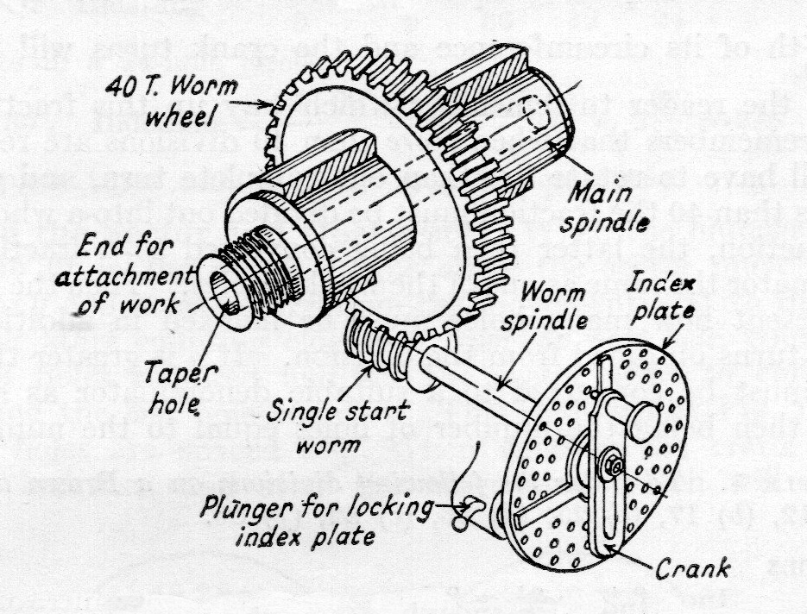

My indexing plate education had begun after tea break that morning. Time had passed and it was some while after lunch when Arthur began to revive and review our conversation saying that the example of the spline cutting wasn’t a really good one because four complete turns of the handle just ended up in the same peg hole every time. The number of 40 was also used as a reference for a complete turn when working out other divisions. A better example would be the cutting of gear with - say - 52 teeth. As he said that he walked over to a nearby table and draw set nonchalantly leaning against the steel sheet partition separating our work area from the service road. Rummaging around for a minute he withdrew a folder, ambling back looking around to see if the foreman was about before telling me to finish up winding the mill handle for a couple of minutes while he showed me what he had found. “This is the manual for that Browne & Sharpe dividing head on the floor there.” He points to the assembly by my feet. “They show details of the three index plates that came with it and the number of holes in each of them. “Here, have a look:” He shows me the list of plates, each with six different combinations of holes, and then starts on what could have been a complicated explanation on how to pick and use the right one for the number of divisions required. The plate listing showed:

Plate No 1: 15, 16, 17, 18, 19 & 20 holes.
Plate No 2: 21, 23, 27, 29, 31 & 33 holes.
Plate No 3: 37, 39, 41, 43, 47 & 49 holes.

Fortunately my concern was unfounded because the way he actually explained it was a great help to my understanding what at first seemed possibly beyond my unscholarly brain. “Remember,” he said, “that the 40:1 ration is the key because 40 also represents one complete turn of the handle in the method we use. We want to cut 52 teeth so you make up the fraction with the figure 40 on top and the number of required teeth below: 40/52. Convert to the lowest common denominator… you know what I mean by that?....in this case 4 and the fraction becomes 10/13. Now we look at the choice of index plates and find that in set No 3 we have a 39 hole circle. Convert that the same as before and 10/13 becomes 30/39 meaning 30 holes of a 39-hole circle.” He looked at me expectantly as I gave an enthusiastic blank look while the wheels within added it all up. “I think I get it. - Clever innit?” - “Try another one he said. Try 36.”

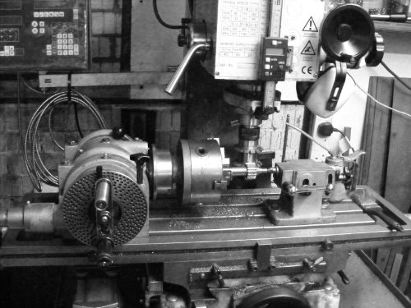

So with an oily biro that barely worked I scribbled 40/36 which didn’t look quite right because the 36 actually divided in to 40 once leaving 4 over which deserved a learned comment. “Okay then, have a look at the listing again. You have 1 turn, remember 40, and the 4/36…. and No 3 set has a 27 hole circle plate.” 4/36 converts to 1/9…. 9 divides into 27 three times so you have 1 complete turn and 3 holes in a 27 hole circle.” It was becoming clearer but then he said we had better get on doing what we were supposed to be doing. He’d noticed the foreman just coming back into the shop. Not he said that there was any problem because he was after all teaching his pupil he said giving me a wink. I understood though. Better crafty safe than sobbin’ sorry - and that’s an original quote. I thought he was looking a little pleased with himself as well he might, seeing his lesson had found its mark and now also myself understanding a little more of the real engineering going on around us standing perhaps a little more upright. Not quite an engineer yet but one small step for an aspiring apprentice.

Perhaps it was this new feeing of learning how to think, actually beginning to understand things that generated my next query; ”What actually is a skew gear? Is it something like a helical gear – whatever that is?” Considering carefully my newly appointed oracle he replied, “The term skew is really slang for helical, referring to the tooth face not being parallel to the gear axis but at an angle. It’s like the term cog as in cog wheel when describing a normal gear. If you take a walk over to that machine over in the corner,” he said, nodding his head to it,” you’ll see our Sidney set up with what we call a universal dividing head cutting a helical gear. Have a word with him and I’m sure he won’t mind telling you about it, especially if you ask about the gear train connecting it to the table feed. That ought to really confuse you he added,” with a chuckle. I assumed he was having his own private joke but walked over to spend half an hour with Sid on his Parkson Horizontal, ”learning ‘elical and ‘ow to do um.” He was another David Niven look alike with pencil moustache but also wearing a dark coloured beret for head cover, reminding me of a digger driver I’d met some years previously as I wandered the bomb sites in Swansea watching them morph from rubble into shops.

While he himself was enthusiastic and thoroughly engrossed it all seemed a lot more complicated and perhaps a little overwhelming with helix angles, gear train ratios and index plate numbers all melding into one. He was doing his best to sew seeds but they were not necessarily falling on fertile ground and the prospect for a good harvest were not good as I returned to Arthur’s Adcock & Shipley. Applications for angular milling processes seemed limitless. Typical of other head scratching work for them was the cutting of gears with something called a hobb, another basic worm but having regular gashes across its very heavy thread form, converting it to a cutting tool designed to slice diagonally through a gear blank and leave behind a trail of involute gear teeth. A hobbing job was taking place next to the gangway and after having cleared it with Arthur I wandered over to take a closer look. “Hiya Ginge,” the operator said grinning cheerfully. “Watchew after?” So telling him that it looked to be an interesting project I asked if he could explain it and also what the gear was to be used for, thinking it might have been for one of our diggers. But no, it wasn’t for one of the company products, he said, but another milling machine used in the millwright department that took care of general factory repairs.

His machine was an American built Cincinnati horizontal type with a hobbing cutter mounted on the spindle and table set at an angle for the work in hand. On the table was a universal dividing head fitted with a three jaw chuck and mounted on an arbor held between the chuck and a tailstock centre was a gear blank, about four inches in diameter and half an inch wide. A chain of gears from the back of the worm shaft linked to the longitudinal table feed screw so that as the hobb cut its way through the blank they both turned looking as though they were a worm and wheel set in mesh. Georgie, the fair haired, still youthish looking, boiler suited operator endeavoured to explain the principle, watching closely as another new apprentice tried to understand, knowing that it would have to be repeatedly reviewed in the confines of his pupil’s mind until it coalesced into a eureka moment. After a few more minutes chatting techi stuff with him I reluctantly went back to my official duties winding the A&S handle a little more knowledgeable than before. But was it too much? My head was hurting.

During a tea break Arthur explained that they knew him as George the 2nd because there used to be another machinist in the section by the name of George who’d been there “since Adam wer’ a lad” but had now retired. Another one of the little quirks of working in a big factory. It seemed that humour was everything and of all colours. It was about that time in my stay that I noticed a sort of circular wooden hall stand piece of furniture stood in a corner. It had been nagging the corner of my eye for a few days, carrying hats, jackets and overcoats looking completely out of place but adding a touch of unexpected elegance to the surroundings. The following weeks moved along much in the same way with the usual activity, banter and mickey taking between machine operators with the knowledge that my time there with Arthur was drawing to a close. He’d been good to work with and said to keep in touch which I promised to do popping in from time as opportunities arose. And so it came to pass with a message from HQ to pack my kit and be ready to move out beginning of next week.

Marking Out
So the following Monday found me in something completely different at the marking out section located just next to the south service road end of No 6 bay. As before Charlie Everitt turned up more or less first thing to lead the way. It doesn’t sound very exciting but in fact it was a very good place to be. Although down as a craft apprentice destined to go into the erecting shops, it was an engineering company and apprentices were expected to get a full grounding in engineering practice. You cannot begin to machine a casting if you don’t know its datum points so for machining components made from castings the production cycle began at the marking out table which measured eight feet in length by four feet in width. The man in charge was called the ganger and as far as I can remember our ganger’s name was Johnny. He had two assistants and he was master over two tables which were his pride and joy. Not far off retirement as I recall and he was quite a character. Marking out might not sound very interesting to some but it was an essential job and one in which you had to have you wits about you to ensure you were as accurate as possible. Castings would come in all shapes and sizes very often lifted onto the table by the overhead crane which travelled up and down the full length of the bay serving all the activities on either side of the central gangway.

In order to mark out the castings they first hade to be coated with a whitewash at the various points concerned. Hole centres were centre popped and all lines marked with a pair of dividers or scribing block, the pop marks used as the reference point before dragging the scribe along the work piece. Where a castings had holes and bosses that required machining in relation to a flat surface consideration always had to be taken of the amount to be removed from the flat surface and its relationship to them. If there was not enough material left on the castings after machining to allow correct positioning of holes in the centre of the bosses they would be rejected. Marking out actually was a good introduction to the disciplines of engineering production and the responsibilities of even the most basic of tasks. Johnny was a bit of a character. During the hourly lunch breaks many of us would go off to the canteen or make a visit to the city centre which was only a short bike ride away. Some of the labour force would stay at their posts, have a cuppa’, a gossip, eat their own packed lunch etc. Some would use the time to read the newspaper or a book.

The year was 1960 and one day it was noticed that when he came back from his visit to the canteen Johnny had taken rather avidly to burying his nose in a copy of ‘Readers Digest’ which was popular at the time. The particular issue which he had been reading for several days we noticed had a picture of the queen sitting on a horse at the trooping of the colour ceremony. We somehow never thought of him as the intellectual type so we became suspicious trying on several occasions to read over his shoulder but he became very protective and we smelt a rat. A month or so earlier the notorious ‘Lady Chatterley’ novel had been publish and when somebody eventually managed to get a closer look at the ‘Digest’ cover a paperback copy of the said novel was discovered sandwiched inside instead of the Digest scrip. Johnny took a long time to live that one down. Of course nobody from our gang ever told anybody else on the shop floor. There was one other amusing incident which involved one of Johnny’s assistants and this was when he visited the ablutions to have a quiet sit in one of the cubicles, read the paper and have a cigarette. One morning sometime after he had retired into his hidey-hole smoke was seen coming over the top of the door. It transpired that he was so comfortable he had fallen asleep and set himself alight when the cigarette fell out of his mouth and by fluke into his smock pocket. It was only a few days after the event that the story leaked out but he put on a brave face on in spite of the ribbing he got from some quarters. Such was the life on a marking out table. Today the incident might well be labelled ’Toiletgate’.

Building The Iron
The time had now been reached when at last my next move would be into No 3 Bay erecting shop but before I get into that we’ll outline the general plan for putting a mechanical digging machine together which, although more than a little different to assembling a car, did employ similar principles of assembly line technique albeit totally hand built with heavier components and a slower production rate. Car assembly by comparison could often prove extremely boring with its repetitive hand movements relentlessly bolting on the same bracket or clamping the same wheel nuts. Digger bits were generally heavier, made of steel or cast iron and put together by one or more fitters teamed up to build sub assemblies as part of a much bigger unit: such as the independent reverse clutch transmission housing which will be described later in this section. Building diggers was also not so time critical for a couple of minutes absence by an individual as would be the case for a car line. Digger building was a steady plod.

An excavator has two distinctly different and separate main assemblies which when conjoined provided the mobile platform for a variety of digging and lifting attachments able to turn around a central axis performing its intended function:- It comprised: the upper works revolving machinery deck, known as the rev frame, and the lower works truck undercarriage married together to provide a working base unit. The bed for the machinery deck was a complex casting with sides and upper surface machined flat and precision drilled for attaching rear end counterweight casting, two machinery side frame castings, sundry ancillary control brackets, transmission and access platforms each side.

To this would be added the power unit coupled to a very simple two shaft gear train layout: First was the main transmission shaft arranged in two halves united by a simple bolted coupling. The outer coupled shafting half controlled raising and lowering of the boom and also mounted a pinion to drive the main drumshaft while the inboard end coupled to an independent reverse clutch unit for swing or propel function; the pinion driven front drumshaft representing the second part of the two shaft layout. A six or seven man team led by chargehand Charlie Dixon assembled deck machinery with the swing propel reverse unit and main drumshaft put together by Sid Lucas and his long time colleague Cyril Carter on their own patch of ground further along the bay. When the revolving frame was ready it was time for big hooks and marriage to the lower works undercarriage with chargehand Dixon conducting the service.

Lower works assembly was located further north down the bay on the other side of the main east to west access road not far from the big exit doors leading into Beevor Street and it was always a special moment when a completed machinery deck was floated across, suspended by the two overhead gantry cranes to be lowered into place with attendant crew spotting and steadying while fitting the turntable rollers. The team for building a lower works unit was usually a senior fitter assisted by a highly skilled and intelligent, soon to be me, apprentice, first installing the power train gears and steering clutches etc with the truck casting inverted, then adding the axles for undercarriage side frames, bottom rollers and end tumblers before arighting it all with nifty crane work to team up with its rolling feet in the form of track pads. I had it all to look forward to.

A six or seven man team led by chargehand Charlie Dixon assembled deck machinery with the swing propel reverse unit and main drumshaft put together by Sid Lucas and his long time colleague Cyril Carter on their own patch of ground further along the bay. When the revolving frame was ready it was time for big hooks and marriage to the lower works undercarriage with chargehand Dixon conducting the service.

Lower works assembly was located further north down the bay on the other side of the main east to west access road not far from the big exit doors leading into Beevor Street and it was always a special moment when a completed machinery deck was floated across, suspended by the two overhead gantry cranes to be lowered into place with attendant crew spotting and steadying while fitting the turntable rollers. The team for building a lower works unit was usually a senior fitter assisted by a highly skilled and intelligent, soon to be me, apprentice, first installing the power train gears and steering clutches etc with the truck casting inverted, then adding the axles for undercarriage side frames, bottom rollers and end tumblers before arighting it all with

Monday Morning
The hour had come; my first foray into the erecting shops was about to occur where I would be let loose to build drumshafts and independent transmission units. I had arrived. The apprentice scheme book of 1950's strongly inferred that it was only when an apprentice reached the manly age of nineteen that he had his first taste of putting machines together. Until then you spent time on the capstan lathe 6 six months, then shaper or slotting machine 6 months, borer 6 months, marking off 6 months, and final six month period in salvage. Having reached the age of just seventeen and completed a full month’s stint on the marking off table it was a very pleasant surprise to be taken from the north end of the milling workshop, turning left on to the south service road and around to No 3 bay for more exciting things.

Through a gap between the next bay dividing wall and a component rack hard at work could be seen two boiler suited fitters assembling a 38-RB drumshaft. The older of the two, sweating profusely, was Sid Lucas the charge hand with his not so laboured spanner wielding colleague Cyril Carter. Leading me through the gap into occupied territory Charlie, the new apprentice supervisor, introduced me as Taff; a label which seemed to have stuck. It was not malicious and I was quite happy to wear it. Sid, my new immediate boss, was rather preoccupied so it was just a brief encounter and acknowledgement of his new assistant before the supervisor departed, telling me with friendly grin to pay attention and he would be in touch again soon. We still hadn’t really met properly at that time only recently having been briefly introduced when moving from the milling section around to ‘marking out’ a month before. How very interesting. Where had Jamesy gone?

Sid was a short stocky individual aged mid fifties, heavy jowled round faced with less hair than he used to have and it soon became apparent that perspiration was not new to him, giving me the impression of worrying a lot but a pleasant individual none the less. Cyril was a deal younger, possibly fortyish, square faced with mousy coloured hair, quite slim but solid and standing, I guessed, around five foot eight. I surmised that they had worked together for some time and were a well honed team. Was my arrival going to be a good day for them? Both friendly it didn’t take long for them to wonder why I’d come so far for an apprenticeship, the answers to which proved to be a good ice breaker.

The space they occupied was about sixteen feet square having a component rack where we entered with a couple of similar ones running parallel on the opposite side of the patch at right angles to two heavy work benches set along the wall. Fitted to each bench were heavy duty engineer’s vices, each of which I would soon get to know intimately. An assortment of engineering detritus was also arrayed on the shelving beneath, files, a couple of heavy hammers, drifts, chisels and wedges etc, and between the benches was an oil bath for heating up bearings to assist in their placement. There was also a charge hand’s desk with engineering drawings which they told me to consult regularly and become familiar with how actual components or assemblies related to cross sectional representation. I would then begin to think like an engineer they said.

Seeing I was perhaps a little overwhelmed Cyril took me around the component racks explaining what each item did. There were all manner of bit and pieces: nuts and bolts, split pins, spacers, tension and compression springs of various gauges, diameter and lengths, clutch locating keys, yoke collars, bushings, universal bearings, clutch band guide plates, eye bolts, bell cranks etc along with ball and roller bearing packs in their distinctive Timken and R&M logoed boxes. Storage space was also arranged for 38-RB clutch bands and shoes to suit 30-RB. So there was a lot to become acquainted with. Would I ever? At that moment there was a 38-RB main drumshaft getting their attention and stood between that and the far racks was a reverse clutch transmission assembly just about to be lifted and transferred north up the bay to Charlie Dixon’s rev frame gang. After initial introduction and relaxed encouragement over the next few hours they painted a picture of what they did and basically what was expected of me. It would also be good Cyril said to assimilate information about how and when all the components arrived, remembering to check the racks regularly for shortages; the idea being for me to gain familiarity with the total job.

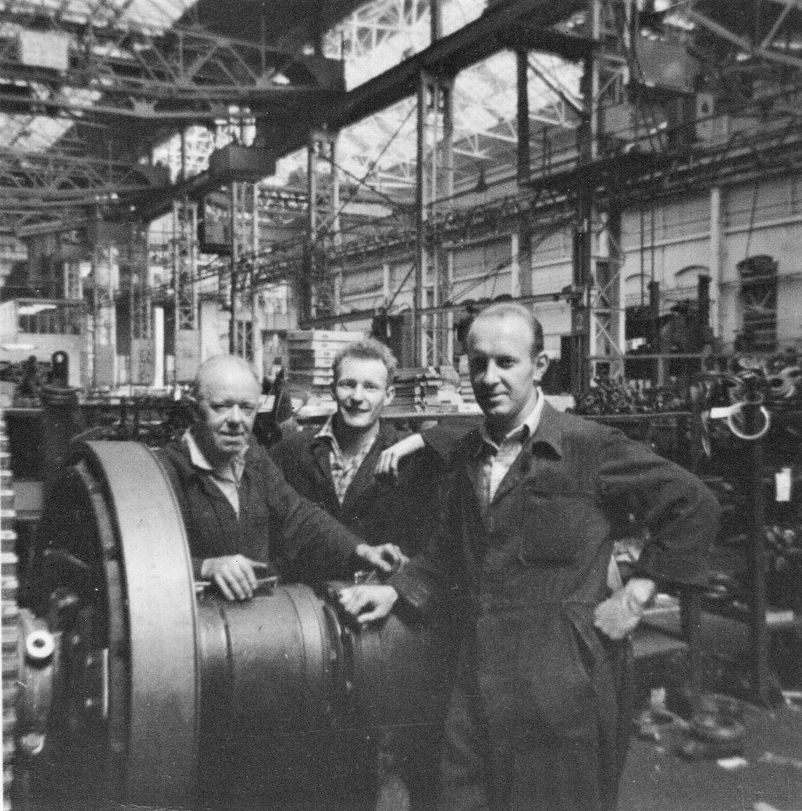
A fine and promising apprentice

So just to get me started on something and while Sid was bent over his desk making a few notes, Cyril sort of asked, ‘tongue in cheek’ if I knew how to file. Was it a genuine query or was he just taking the mickey. They both had that kind of humour I was to learn. After assuring him of my familiarity, because I hadn't really contributed much up until then, he decided to goad me into action and took from one of the racks a couple of pieces of ¾ inch square section steel. They were both around five inches in length and waving them under my nose he said, “Here you are Taff this will be your first job; keys to secure the clutch spiders. What you need to do is file down half the height of each side until it’s a firm fit with the knocking stick.” Making him aware that the file for the job wasn’t in my kit I told him I needed a second cut twelve inch. What a little smartarse. Acknowledging my assessment while trying not to smile he replied, “Under the bench,” pointing to the relevant cubby hole. “You’ll find the keys just too wide to go into the milled slots.” So with key number one in my left mitt I placed it in the vice, tightened up and tried my hand at filing. The twelve inch was quite big to wield when not used to the weight but practice makes perfect etc and as time with Sid and Cyril passed I became more proficient. Number one key, as might have been expected, “wer’ too slack in’t slot lad,” and was scrapped to mild disapproval.

The rest of that day was spent showing me around the drumshaft they were currently working on and where all the components went. “What we try to do,” Sid repeated, “when not busy putting it all together,” is prepare the various bits and pieces for when we need them so we don’t waste time. If we are not ready to pass things on to the rev frame gang when they need it we hold things up and that is not a position we want to get into.” The official department that actually took responsibility for keeping racks replenished and up to date was called the progress department and was manned by progress chasers. Wouldn’t you know that their two storey office block was just across the gangway taking up twice as much space as our production patch?

All day the chasers would race hither and thither around the bays they were responsible for, poking their heads through window hatches every so often to enquire of the “latest situation with them spacers George. Have you not heard ‘owt about them yet?” Type writers clattering, telephones ringing themselves almost off their cradles, ring binder being lifted and impatiently flung open to cross reference dates, quantities and part numbers; all of them stored in draws and draws of thousands of punch cards with the secret code that delivered all the answers. The age of the tablet or desktop computer has not yet arrived. “But ‘ang on a minute George, you told me yesterday they would arrive lunch time and now Frank Phillipson is chasing mine and everybody else’s arse.” ”Yeah I know Ron, I know but......” George grovels on the other end of the telephone line. This is life in the excavator factory dedicated to making holes in the ground. Paperwork, paperwork and more paperwork, but without it and the chasers to chase it things would not progress and the works would grind to a halt because they looked after everybody and were essential to smooth production flow and planning ahead. Not far into the future through acquaintance with his son, then soon to also become an apprentice, one of the senior managers would befriend me and assist occasionally if I needed help. He was extremely kind and while lodging with the retired couple in the same district for a couple of years we were almost neighbours and he would occasionally invite me around to his home for a family evening.

Now it has been a long time so some of the following detail may be a bit inaccurate so please bear with me. While learning how not to file Cyril and Sid had been putting the drumshaft together. It seemed illogical that it wouldn’t be assembled on some kind of framework so I am assuming the first job would be to bolt the gear end bearing onto some sort of vertical support frame giving sufficient clearance that allowed it to rotate. As components were added temporary support could be given to relieve weight on the other end. You just couldn’t have a long and heavy assembly like that rolling around on the loose. It wouldn't make sense. Anyway; both of them took turns demonstrating how the spiders were put together. Fortunately with my schoolboy digger background, plus observations since arriving, what things did was already understood; it was just a case of becoming physically familiar and confident enough to put them all together.

Compared to a familiar 22-RB the clutch housings were much larger and heavier but still employing like methods of mounting clutch bands. One notable difference was the lack of heavy toggle setting spring. Instead was a more direct configuration of screwed eye bolt and figure 8 links mounting a very large and gracefully curved bellcrank lever. Resembling a piece of sculptured art it was initiated by a curved relay link to the back of a booster collar I christened the banana relay system. Reference was made earlier to schoolboy site visits when I had learned about the RB boom hoist bellcrank being set by booster band relay. Setting the 38-RB drum clutch was based on a similar principle but using a relay boosting collar and friction disc instead of brake band. The said booster collar consisted of two halves straddling the width of the casting and held together by four bolts, the assembly turning freely while mounted on the front and rear extended boss of the clutch spider and able to convey sufficient rotary movement to engage the clutch. This took place when the operator, through control lever and linkage, applied pressure to the friction disc lined front face of the booster collar by a non rotating metal disc thus displacing its angular position sufficient to turn the bellcrank via the relay link. Don’t scratch your head too hard or you’ll get splinters.

Cyril had also been busy with the transmission housing delivered by overhead crane. In operation its two reverse clutches controlled propelling and swing direction. When the drum shaft was completed I was expecting an invitation to join him although not today. Did I forget to mention that we had our own air hoist? Well we did but it was parked off to the side and I hadn’t really noticed it lost in the background. Fixed to the dividing wall between benches it had a reach just over half the depth of our ground and would be needed when putting clutch housings over the shaft. So the morning progressed until just before lunch when a message came about an apprentice meeting in the new supervisor’s office immediately after lunch. I’d been wondering about that because it was no longer Jamesy. He had apparently left the company some weeks previously and the new chap who’d delivered me earlier had been appointed from the millwrights department.

After Lunch
Charles Everitt was a practical man who knew his theory as well having spent his working life there for many years. It was he who had walked me from the milling section to my new workmates. Of lean build, longish face, parted white hair and totally unassuming in manner I considered him to be a gentleman. A completely different sort of bearing compared to Jamesy. Now he was going to introduce himself more formally for a general chat - perhaps over champagne and caviar? So I didn’t get back to the drumshaft section till well gone 2 0’clock . They couldn’t protest at my absence because it was the sort of accepted thing that could happen with apprentices and while away significant progress had been made on the project I’d had to abandon. Both clutch housings were now on the shaft almost complete with spiders and end bearing and soon it would be flying to its new home with Dixon’s gang and I would have to find something else to do. But I wasn’t worried. I knew uncle Cyril was there just itching to indoctrinate me into matters relative to transmission maybe tomorrow? In the meantime he said to get some bits and pieces ready for the morning. But before we could get in too deep the hooter blew proclaiming tea break and with that out of the way it didn’t seem very long until it went off for the second time telling us it was the end of yet another busy day at Beevor Street and we all ran for the bike sheds.

Tuesday Morning
So that was more or less my accomplishment for the first day building iron and now it was day two another drumshaft had just arrived so it wouldn’t be the anticipated transmission. It was just the basic shaft with main gear keyed and bolted at one end. Like yesterday we would have to put the rest of it together from the other. The split heavy boss of the gear had been pressed on over a locating key after first mounting the left hand roller bearing and housing against a machined shoulder. It had then been clamped in place by a 7/8 inch heavy bolt and I stood looking at it admiringly, just as Sid and Cyril stood watching and waiting, possibly for me to make a start and spring into action after becoming acclimatised the day before. Still a little unsure of myself I thought try for humour. “Is that honey for your toast?” I ask Sid looking at a small tin of grease on the floor where he is standing. I think they actually used it for gaskets to hold them in place. He gives me a look, the sort of nonplussed look that skilled men around here often give to callow youth they do not understand and I know what he’s thinking. He’s thinking the phrase often said to such callow youth: “Eyup lad. Promise me tha’ll buck wp.” It was one he quoth unto me a number of times during my stay. Not maliciously or with spite it was just their kind of humour. But I wasn’t standing looking vacantly into space; what apprentices allegedly were supposed to do. A myth solely perpetuated by a small number of factory elders jealous of our youth, vitality and our music. Rock & Roll was here to stay and Lincoln had a lively scene, which I will tell you about later, but there was a chill in the air with the recent loss of Buddy Holly. They just didn’t understand.

But I digress. At that moment I was actually looking at one of the banana relay’s spherical bushing sockets in my hand trying to look intelligent when Sid, looking rather amused, said to leave it on the floor with the link till needed and instead do something useful and give him a hand assembling the clutch spider he was putting over the end of the shaft. So that was what we did after making sure the shaft was secure by bolting the bearing to the assembly frame, as before propping the shaft halfway along. Lifting the spider over the end we pushed it over the right hand key already prepared and knocked into place by Cyril. Pushing it over the key would prevent it rolling around the shaft. As well as preparing the keys one of the other prep jobs we had to do was fettle around the castings for any bits of rough un cleared swarf. It was very easy to gash you hand or finger if you didn’t see it. So that was a quick spider check before mounting it. The casting was also split at the bottom allowing a thru bolt to secure it in position over the key. After assembling the split servo collar to the spider and checking its freedom of rotation the bellcrank with clutch band setting eyebolt was mounted next proving a little awkward when threading the locating pin through each of the two 8 links without dropping one. But Percy perseverance prevailed with a locking dowel pin soon in place. After completing that it seemed surprisingly quick when the tea break hooter went off everybody to downing tools as if by royal command looking for their flask or racing to the tea trolley progressing down the gangway. Tea break always ruled supreme. A well known film actor once recorded a song entitled ‘Everything Stops For Tea’ and that was certainly the case at RB.

All to soon it seemed we were back to it with Sid looking at me asking, “Right then lad what’s next?” But I was ready for him and replied almost smugly, “We need to connect the banana link.” He sort of looked puzzled for a second and then the penny dropped. “Oh! That’s what you call it is it. Very technical,” he said with half smile. “So you have been taking notice. There’s hope for you yet.” Then with a mischievous grin added,“ You should put a Suggestogram in for that. You might even earn yourself a fiver.” I liked his humour but decided not to take up his suggestion. So the servo link was pinned in position next after squeezing the special bushings sockets into place at each end with the bench vice and hooking up to the bellcrank and servo collar. There was a slight offset to connect them at each end so they had cleverly designed the spherical bushings for the purpose. It was one of these that I had been inspecting before we started. Now with them locked in place with split pins it was time to mount the clutch band support. At that time ours was a curved sculptured casting and much heavier than the formed bar type bracket introduced a while later shown in the picture below in which the curved servo (banana) link can also clearly be seen.

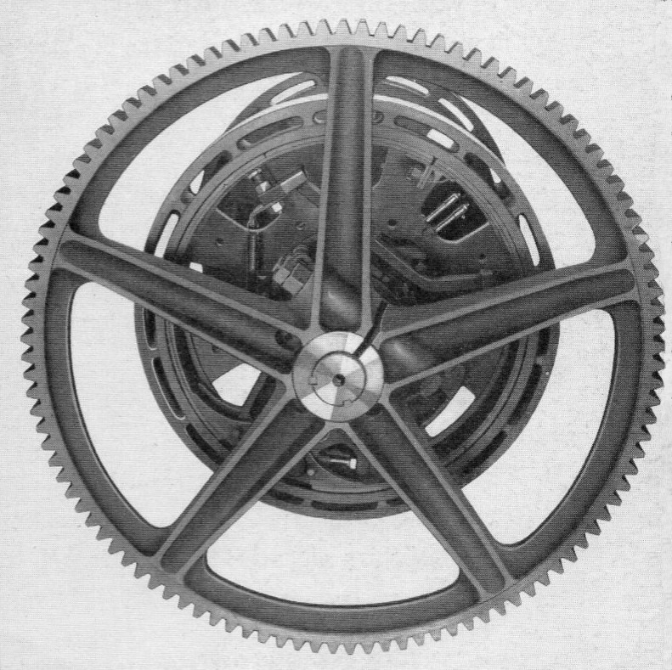
38-RB main drumshaft gear

The carrier adjustment screws were next and then we were ready but that was when Sid brought my attention to the fact the spider would need to be pulled off and turned around because it was for the opposite end of the shaft. He gave me a look that said he was about to take the mickey. “But you knew all that didn’t you?” “Yes I did know that. I was dreaming about it last night Sid. Part of your master plan for me isn’t it? ” Two can play that game I thought half smiling and staring back at him. Touché. He was a good soul half smiling and chuckling as he quoted to me - this time, “Think on lad. Think on.” Cyril working on the reverse housing next to us heard it all and also seemed to be enjoying the exchange.

So together we humped the thing off, removed the driving key, fitted it in the other end slot, turned the spider around, removing the temporary shaft support to slide it all the way back over the key up to the left side bearing housing, dogging down the thru bolt to make everything solid. It was quite heavy but with two pairs of hands the task quickly done. A feature of the 38-RB friction band was their construction being two bolted together halves. No advantage when in the works but some times out in the cruel world, out in the field, you needed at little extra bit of flexibility when things got tight. Manoeuvring into position it proved a bit fiddley at the live end but with the links and the eyebolt sorted the dead end was secured and that was job done. “What we do next,” Sid said as he stood back, “is assemble the right hand clutch complete and then park it against one of the racks till we can mount it after both drums are on okay?” I affirmed, “Uhuh.” My senior mentor added, ”Just to help you along Cyril has taken it upon himself to get the roller bearings and spacer barrels ready for you to put in the clutch housing body.” Then he sort of pulled a half snicker as he added, “He thinks you’re becoming stressed!” Cyril heard him and looked across from where he was actually bashing in a bearing as he chuckled,” Take no notice Taff he’s just trying to make trouble.” Sid in reply shaking his head smiling walked back over to his desk as I become a blur of activity assembling the clutch and laying it aside till needed.

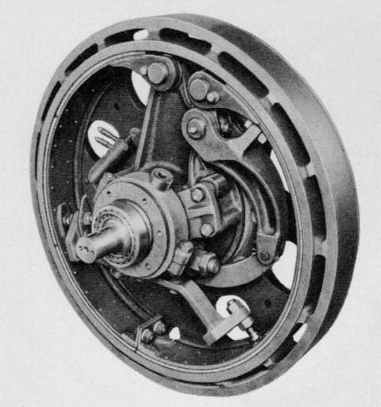
38-RB hoist clutch showing banana servo link

It was a little earlier that Sid had asked Cyril to take time out and pop some bearing sets into the oil bath, heating them up ready for insertion, cooking expanding them to slide over the shaft easier. I had some thoughts about this, kept to myself because as an apprentice and bearing in mind my lack of practical experience it was the wisest thing to do. It was just that warming up the bearings meant a tighter fit for the outer race. Not really a problem; I didn’t think it would have expanded that much. But when it came to the inner race sliding over the shaft I wondered how much it would have cooled down by the time we came to push the spacer and housing unit into place. Just a couple of my stray independent thoughts nobody else would worry or care about.

The two drum castings had just formed part of the industrial scene being parked up on our patch to one side. Now however they would become live and after swapping supports when necessary we were ready to put it all together. Each assembled housing was lifted through one of its peripheral cooling slots with a specially devised hook like a square letter U having a lip at one end to prevent the thing sliding off; the other leg bent up at right angles in the middle with an eye formed at the top for a shackle. The horizontally end was fed through a slot and lifted, floating the casting and pushing it over the drum shaft, feeding over the friction band already installed and up to the spider boss. An end cap was then screwed on to the inner barrel end to retain the bearing with its inside diameter allowing a tight running clearance over a spacing collar keeping both drums clear of each other. Component assembly was carried out for the opposite side completing the drumshaft with the right hand end bearing and housing. The only item that would be added later once installed on the machinery deck was the dipper trip. Job done! How many more would I do before moving down to ‘Dixon’s Dell.’ I think I spent the whole of that week mainly on drum shafts only occasionally helping out on the transmission units until the following week when at long last they convened the meeting of minds and got me busy on them almost full time.

On Friday as usual after work found me wending my way up steep hill to the council offices to collect my lodgings make up voucher. Once I’d reached the Stonebow arch it was a case of get off the bike and push as things got progressively steeper, my actual destination situated almost at the top. In dry temperate weather it could be pleasant but in rain and then snow the novelty wore a bit thin. Hey! No good complaining; if it wasn’t for that voucher perhaps I wouldn’t have found myself in Lincoln at all. And there was one feature about the climb that always made it worthwhile. Just before the turning to the council office a lane off to the left showed a clear view of the works with the legend:- RUSTON BUCYRUS EXCAVATORS writ large across the gabled ends of two and three bay. To this day I regret not having had the foresight to take a picture. A small restaurant nearby on the occasional Saturday would sometimes find me having a fry up. Supposed to be bacon egg and chips mine host always made it gammon with slices of pineapple. Now for me that was dining in style.

Coasting down the hill for the rest of the journey back to my lodging I contemplated the past week. For exploration beyond drumshafts our location was ideal. Whereas before, needing to be on guard wandering away from my actual workplace, inspecting the bay’s activities in both directions could now be done after lunch without worrying about trespassing onto foreign soil. Chatting with Charlie Dixon’s gang, inspecting the interesting but dormant digger organs became a regular occurrence often moving on down to where they built the crawler truck assembly ready to marrying up with the revolving frame. A great opportunity to get to know the bay both ends and up the middle making new acquaintances for the future. The bay on the south side of the service road was Stan Simons gang with the 54-RB crew vying for space with 110 and 150 RB machines but it would still be a while yet before I found myself working in that part of the bay, remaining with Sid and Cyril for a couple of months before the next move. Even then it wasn’t to where I expected.

But I digress. It was the usual kind of weekend and after arriving back at my lodgings to a solid evening meal I took a bus back to the city for the Friday night Drill Hall gathering of rock and roller band groupies. A fine morning saw me back there on Saturday around the city centre generally socialising with my peers and trying out the new frothy coffee that was supposed to be the rage. Unlike Friday nights Saturdays were more sedate affairs perhaps with dancing at The Court ballroom and on Sunday morning once again with rod and tackle fishing in the nearby Hartsholme Park Lake, still seemingly devoid of fish, followed by lunch at Bayons house with my surrogate parents. Since moving on from Alan and his wife I had been lucky enough to find new residence with the elderly couple I was now lodging with in the Swanpool district south west of the town. Their dwelling was on the ground floor of a group of five three storey flats set in their own patch of ground with tall trees to one side, grassland and a short bus stop walk direct to the city. They were extremely kind and looked after their rusty haired teenage lodger with great patience for a couple of years before an unfortunate family matter intervened and my nomadic life began again. My coming had not been without drama and a rude awakening however. One evening not long after having returned from work I entered the hallway to hear my landlady exclaiming anxiously from behind the living room door, “Dad, dad, dad!” Her husband, Harold I think his name was although she always referred to him as dad, was writhing on the floor having a fit. In his mid sixties he was prone to suffer an occasional seizure and I found myself struggling to hold him down until he became calm. Afterwards he couldn’t remember a thing about it and for the duration of my stay with them he never had another one. Never experiencing that kind of event before it was a little unsettling.

All soon forgotten and life just carried on with a more pleasant interlude when during a severe thunderstorm. ‘Dad’ got really excited and they took dinning chairs out into the sheltered porchway while the sky above rumbled and ruptured sending bolts of forked lightening streaking across the sky, almost it seeming within arms reach, the static literally prickling your skin. Eventually it dissipated and they went back inside to brew a fresh cup of tea, smiling and laughing with joy written on their faces in appreciation of the wondrous show of nature loosing its temper. It must then have been a couple of months later when on a Sunday, doing a little bit of swotting for college work just after lunchtime, that Harold suddenly appeared alongside and dropped a pile of catalogues on the table. “Are these any good to you?” He had mentioned a while previously that he’d worked for Ruston’s at one time and that was all he’d said, never when. I was stunned at what he had dropped in front of me: Several catalogues, all of them in excellent condition, original Ruston Steam navvies and the Ruston No 4 which was the first adopted from the American range and produced by Ruston Bucyrus in 1930. They were near enough immaculate and covered both Ruston and Bucyrus Erie equipment of the day, full of pictures and high quality specifications. That weekend couldn’t have finished on a higher note.

Back on the job Monday morning there was a little clearing up to do from Friday but soon another drumshaft was landing to be quickly followed by a transmission pedestal. First off was fettling and sorting through the various pins, springs, levers and lumpy bits to line them up all ready. Working with Cyril this time we were well on with things when, heralded by the hooter, that old tea lady arrived pushing her trolley to be quickly surrounded by a bunch of thirsty overalls. With tea break over instead of carrying on assembling Cyril pulled out and unfolded a large scale engineering drawing measuring about four feet by three. Officially they were known as a blueprint because that was the colour of the ink. It revealed a beautifully drawn and fully detailed cross section of the transmission assembly: pedestal casting, vertical and horizontal shaft with bevel gearing and assembled clutches. I had seen drawings associated with rev frame castings with all the dimensions and had been highly impressed then with the detail and skill with which they had been produced. The illustration of a power shaft assembly was something else again with all component pieces being numbered and labelled for identification in a table to the side. Cyril pointed out some of the features and related them to the physical entities arrayed around us. This I thought beats my Meccano any day!

Meanwhile Sid returned from a visit with Frank Phillipson where he had learnt that we would shortly be switching to 30-RB assemblies at the beginning of next month. A totally different layout, very similar to the 22-RB but with air control now replacing mechanical linkage for setting individual pairs of clutch shoes instead of expanding a single friction band. Not much involved with 38-RB transmission a change imminent I was going to miss out if I didn’t get with them soon. I decided Cyril and Sid needed a nudge and made an opportunity give them a reminder. Well received by Sid who was still sweating while I still wasn’t, he took his opportunity; “You need to think on lad! You need to think on.” I think that meant the same as, “Please tell me you’ll buck up.” So that very same afternoon I bucked up and got stuck in with Cyril on the transmission housing and reverse clutches while Sid carried on with wi’ drumshaft.

As previously mentioned the machinery deck had an interesting layout with the chain driven primary transmission shaft being divided into two sections, the first half driving both main drumshaft and boom hoist. When installed by Charlie Dixon’s gang the reverse clutch unit was connected to it by a split coupling. Hopefully at some time in the future I would be there to receive one just like it. The reverse clutch system worked on the premise that if two bevel gears running freely on a common shaft straddle and mesh with a vertical bevel gear they will when turned in the same direction each impart a different direction of rotation to that gear. In practice each horizontal bevel gear integral with a clutch housing was in constant mesh with a partner bevel gear at the top of the vertical shaft. The bottom of this shaft carried the pinion meshing with well gears that either swung the revolving frame or powered the whole travel function. Integral to the transmission casting at the top a counter bored bridge piece positioned the shaft and its bearing, the top bevel gear being splined to the shaft and precisely positioned using locking collars to permit appropriate setting of backlash.

To put the unit together it would first be fettled and then laid on its side making it easier to assemble the innards: two oil seals first, mounting them on a simple shoulder spigot dolly tapping home into a counter bore at the bottom of the casing. Below that a lower bearing retainer also acted as a spacing sleeve. However it was easier to slide this loosely over the shaft first before mounting the bottom tapered roller bearing and pinion. So huffing and puffing for effect that was what we did, securing the pinion against coming adrift with a lock wired retaining plate. We decided we were ready to push the shaft through - but - fitting the bevel gear to the top of the shaft could be tricky. The shaft could not actually be pushed all the way home until the bevel gear was in position, a task that required narrow fingers and a knowledge of Anglo Saxon. Space between the bottom of the bridge and casting side wall was rather narrow and having to hold the sharp toothed, fairly heavy gear vertical then turn it ninety degrees to feed onto splines at the top of the shaft could be physically, painfully wounding. The first time I found that out the hard way, drawing blood by stubbing the top of my middle finger onto an unfettled bit of casting. Unsympathetically Cyril just sniggered and offered to fetch a plaster from the ambulance room? Its good to have considerate workmates, gave me a warm glow! Eventually the thing slid on and the shaft pushed up through the bearing allowing the adjusting collars to be screwed in place, left loose for final adjustments. The gear turned, everything moved, no fingers sliced, no snags so we put our air hoist to good use upending the pedestal and setting it into a custom made tube lined hole in the floor. Having said that; I remember in the spare parts list drawing that it indicated a 3/8 inch flanged spigot on the bottom. So there may well have been some additional means to steady it. It was a heavy lump if it fell over. This far in years way from those events I don’t suppose anybody is left to confirm anything so let’s get on with putting the horizontal trannie shaft together.

The two friction clutch housings were normally bolted integral with the bevel pinion sleeves that ran directly on the transmission shaft. Sometimes they didn’t come that way and had to be assembled by us on the job. Already machined in accordance with limits, fits and interchangeability tolerances discussed at the technical college they didn’t present a problem. It was a simple matter of fitting three ball races and keying on each bevel gear; the gears usually being quite a tight fit over the sleeves and keys. Not surprising really considering the sort of duty they had to perform. One bearing went into the clutch end of each sleeve to carry the transmission shaft followed by an oil seal while those on the sleeves ran in machined grooves between the main casting and top cover. It would have been interesting to see the set up for machining the complete assembly which may have been performed on one of the horizontal boring machines. The removable split cover would have meant an interesting set up.

Next step: Fit the inner left hand clutch spider. The transmission shaft when it arrived with the other components came with the other half of the coupling already in place, a press fit and couldn’t be removed. To mount the clutch spider we’d have to push it on from the other end, keeping in mind that with friction band clutches there is a live and a dead end. The dead end of the spider casting is the vertical one that nearly touches the housing; the live end at an angle with more space to accommodate the spring loaded toggling bellcrank. In terms of rotation the dead end must always lead so that friction of the trailing live end kissing as it expands into the housing drives it into solid engagement. Mounting the left hand inner spider we made sure, when looking directly at it, the arm carrying the bellcrank was on the right hand side. So......first job prepare the shaft: and I surmised that trying to hold it to file and fit the keys looked like it might be a bit tricky, until Cyril asked, because he’d done it all before, “How wide do you think those two bench vices will open? Come on, give me a lift with it then.”

They were plenty wide enough and seemed to have been spaced just right so we parked it between them using one of the vices on the other bench to file up the keys. That done we removed the trannie shaft, stood it on the coupling end and slid the spider over the top….”Ang on! Ang on! It might be a good idea,” Cyril said,” to put the shifter sleeve on first before we fit the key?” “Oooooh yeah!” said his mate. “That’s a good idea.” So we quietly, without any fuss, slid the clutch shifter sleeve over the far end pushing it all the way down to where it was meant to be and hammered home the spider key. It was a little tight for the spider but an excellent fit in the shaft so a thin wedge was hammered in to the split to ease the boss open, loosen it off and help it on its way. Then completing the basics we lifted a clutch housing assembly, bevel gear uppermost, with the air winch and dropped it over the top to slide down against the back end of the spider. We then manoeuvred it all to a position where we could roll and mount the right hand clutch housing assembly on the other end of the shaft lifting it onto the pedestal after placing the right hand spider to balance it all.

Both clutch housings in place we interposed a piece of wood between the inner ends to stop then coming together and using a wire strop each side lifted and dropped it all into both bearing race locations in the lower casing half. The weight of assembled components sufficient to give proper running contact for the bevel gears at this stage we were now able to check the backlash. The two adjusting collars would pull the vertical shaft upward to engage the bevel gears more fully. The less they rattled together the smoother the contact. Using a dial indicator allowed a precise adjustment of mesh to be maintained with the locking collars. That completed Cyril gave me a lift to manhandle the casing cover into place and after securing all around left me to fettle and prepare the other clutch components like the toggle lever, bushings, 8 links, locking pins, fulcrum pins etc. So many components really that you could be forgiven for thinking that it would rattle like billio but everything was so well designed that it just didn’t?

And so the day had progressed till the afternoon brew up during which I noticed Sid looking at me intently, a puzzled expression on his face leaning over from where he was sitting. With Cyril sitting next to him Sid pointed at me sitting opposite and said, “Keep an eye on him. I’m worried about him. ”Cyril sensed something I had not and nodded his head knowingly. “Yes, I had noticed,” he said. I was now wondering what was going on but of course they were setting me up for a mickey take. Perhaps that I’d not yet reached my productive zenith? What had he noticed? Then Cyril, with a cynical grin on his face said, ”It’s perspiration Sid. A rare phenomenon for an apprentice but it is perspiration.” Then he turned to me and said, ”He’s noticed a bead of sweat on you forehead, doesn’t want you to overdo things.” They both chuckled, or was snickered the right word. I didn’t really know what to say to that and seeing my discomfort they had another good laugh. But it was just their good humoured banter so I returned it with a muttered good natured, “Bastards,” and they chortled even more. But yes, I was beginning to perspire and realised my work pace was picking up, not at what they might consider a productive zenith maybe, but I was slowly beginning to enjoy myself, becoming part of the process instead of being on the outside. Keep calm and carry on.

Tea break over and with lighter heart I made a start and began putting the rest of it together. Excavator clutch design had become almost a standardised concept with only minor nuances of difference between manufacturers. However, looking at RB when compared to others their components did seem to be that more robust and having an enviable reputation for longevity in heavy duty. Like other diggers RB used an over centre toggle mechanism initiated by a shifter sleeve pushing in toward the clutch spider boss, engaging a yoke link and expanding the live end of a friction band into the inner surface of the clutch housing. To put the swing clutch together my first task was to fit the clutch driver bolt which also carried hardened steel bushes either side on which the toggle links were mounted and still able to move freely when clamped by a pinned nut one end and lock nutted at the other. A radially flanged casting, the band guide, could then be fitted attaching to extended lugs at the bottom of the spider. Spring loaded radial pull off eyebolts were circumferentially positioned inboard of guide screws located at each end with eyebolts pinned to integral lugs.

The heaviest component was the toggle assembly, intended to compensate for heat expansion and hold the clutch in engagement until manually released. It comprised two main parts: a bent form toggle lever casting having a flat portion at one end and ball stud bolt at the other, sandwiched together with the bellcrank also with a flattened end. Both were mounted on a common bushing with opposite ends clamped together by heavy compression spring providing the toggle pressure unit. The bushing on which the assembly was mounted extended sufficient to accommodate the 8 links between the sidewalls of the spider with the bellcrank also mounting an adjustable eyebolt securing them to the live end of the friction band; quite a bit to remember when you are reading about it but much easier to understand when assembling. Having now built the toggle unit it was inserted between the spider lugs with the links pointing upward and fulcrum pin pushed into place to be secured with the pin lock.

Almost the final item on the agenda was to slide the shifter sleeve onto the main shaft and the yoke between the spider walls onto the toggle lever ball stud bolt. The links then connected to the yoke legs with bushes, their tongue pins locating in the shifter sleeve slots. The shifter sleeve was the final link in the puzzle; the golden key that made it happen using the very wear strips from the milling machine worked on several months previously, and, as I hammered them into place I wondered if any of them were actually mine. A thousand batch and all excavators with the yoke system used them. Was it possible? Add that batch to the current stock holding, four strips to a sleeve; how many diggers in the last month?

With details secured the friction band was next, sliding it into the housing with ends either side of the vertical dead end of the spider; turning it to line up all anchor pin holes, first the bellcrank adjusting bolt and threading the two 8 links into place. The dead end anchor pin was then fed through and the pin lock secured. Feeling very pleased with myself I attended to the clutch on the other side adding the split brass collars on each shifter flange. Both done! Perhaps I could skive off for half an hour before the hooter went. I was thinking Joss’s place, the oil stores. Asked Sid if I could go and have a lie down somewhere quiet??? He curled the corner of his mouth to one side, gave me a funny look and said, “Promise me..........!”

There was a distinct breeze in the air and I had a look around. On the Monday morning a couple of days ago taking a walk to the stores I’d been passing Dixon’s heavy gang while two twenty five ton overheads were setting up to lift another completed rev frame. Having later sorted things at the stores and on my return journey it had already been floated over the service road and they were busy lowering it in to place on a waiting truck frame. As they messed around with the transmission the Beevor street doors were open wide and in the distance standing on one of the cab side duckboards Phil Turner from the test department was running up a completed machine. It was about ready to go down the ramp out in to the street with nice stubby shovel equipment. I couldn’t stop to look; busy trying to score brownie points. Once the machine was through the doors Phil’ would sprag it left and head for the test field at the far end. Pssst! Shouldn’t really mention this but no one’s about eh? Funny thing was.....the next machine that went through those doors and turned left was rigged with not so stubby dragline and quite a long boom. Somehow after spragging to follow the road up the street to the test field the end of the boom caught and modified the end corner of the fire station which they’d put in a very silly place... and another legend was born. I am pleased to report that it was not our Phil who was driving it that time.

It was more than just the normal breeze and taking another quick squint up the other end of the bay; no wonder it was so draughty. The other south end set of doors were wide open as well with more activity going on with a 150-RB electric shovel. It seemed to have been standing around at that end of the bay for weeks, going nowhere but still with a lot of bodies buzzing all over it. In the last few days however they had started to put the top boom section on and were now hooked up with power cables running it up in the yard. A pretty big machine with apparently insufficient headroom to link the pendant suspension ropes to the A frame while parked inside the shop, they had taken it outside. Interesting! Why was it that they had to do things that way? Too far away to see the details of what was actually being done when a spare moment presented itself I told myself to investigate further. “What’s up Taff? Looks like you’ve seen a vision.” ”Oh, nowt Cyril. Just wondering where that bloody draught wer’ comin’ from.” I was beginning to talk like a Lincolnite.

Thinking about it on the quiet I realised just how busy this part of the factory was, literally throbbing with all the activity around it. There was always banging and clattering going on with air drills and spanners whizzing, air hoists, general air blow offs, all the other sounds of industry echoing under the huge roof with, right next door, in 4 Bay the regular rumble of their cranes ambling from one end of the bay to the other occasionally joined by one of our own twenty five tonners. All along the gangway and service road fork and pallet trucks were doing their best to avoid the occasional pedestrian. Adding up numbers: fitters working on each erecting station, machinists, office workers, inspectors, labourers, foremen, occasional machine servicing visitors and thrill seekers there must have been around sixty or more bodies shared between the first three bays.

We had been quite busy. So busy in fact that my afternoon seemed to have passed in flash and the hooter was sounding. However, seasoned veterans had long ago acquired a sixth sense about the hooter, having already prepared themselves for the outside world in the communal washroom, feeling the vibrations and slowly making their way to the starting chocks with a significant number standing outside the bay doors……waiting. If you had been an observer standing outside the time hall looking up the street you would have seen hundreds of heavy feet leave daylight underneath as if conjoined as the mournful wail first wrent the air. Once clocked off hundreds of bikes then took to the streets. Almost everybody including office staff had a bike. It was Lincolnshire; the flat lands with the only hill for miles around being the one at the top of Steep Hill crowned with a Cathedral. On one occasion I remember there had been an industrial engineering dispute resulting in withdrawal of labour; a strike at RB as well as other local companies. Being just mere apprentices we were not allowed to participate and with the event unfolding before us as their labour was withdrawn it was interesting to look directly back down Beevor Street from the railway crossing, hundreds of our striking colleagues cycling out into The Ropewalk and beyond. Seeing them that first evening as we watched on the television news it seemed almost surreal; people we worked with were starring in a drama live on TV. Hey! There’s Jack! I know him. He works in my bay.

The main bicycle racks were situated around the time hall but there were also others for the Becor House office staff outside the main gates and adjacent to their car park. It must surely have been like the Le Mans Grad Prix with drivers running to beat cyclists to a getaway and if they didn’t get away before the first batch of bikers they were stuck. Even today’s bikers are territorial guarding their tyre space from all interlopers. As a cyclist regularly riding in such a bunch I was also aware of the need to keep ones balance and avoid collision. I saw it happen a few times where a gently pulsating sea of bicycles turned to a tidal wave of falling bodies pulled into a vortex of spinning wheels. While not drawing blood it did give vent to much cursing and a little humour as, apart from the odd hobbler, most victims remounted and got underway again. Even the oddbod with a motor bike didn’t fare that well, making very little headway against pedal pushers. I remembered, when living near Skellingthorpe with Alan and his wife, twice succumbing to the temptation of being chauffeured in a big black American V8 Ford. Mike the driver, a work acquaintance from another bay, also felt the isolation of being a lone car in a sea of bikes and only just beat the clock on the first occasion and completely failed on the second. Independence was king and I soon reverted to pedal power. Being just a couple minutes late could easily get you the sack if done on a regular basis. With me living away from home there was no way I could take that kind of chance. It was on an independently pedal powered rain swept yellow cape morning next day that I pedalled back to the clocking hall and No 3 Bay to start my next shift. Would it be another transmission or a main drumshaft? I couldn’t wait.

Our component racks had started to fill up with bits and pieces for the 30-RB, later than planned because management was obviously trying to squeeze out a few more current production models before the change over. You could see this happening because of all the comings and goings with the progress department. Looking up the records many years later was revealing. They didn’t half knock out some machines. In 1960 the listing shows sixty 38-RB and fifty five 30-RB excavators rolled out of the erecting shops into Beevor Street. Thinking of the way Sid and me had been sweating I thought it would have been more. But the new stuff was in the racks and needed my acquaintance. Much smaller clutch components because the 30-RBs didn’t use friction bands but lined shoes instead, similar to car brakes but a lot bigger and actuated by air cylinders with no mechanical linkage. The machinery deck was thus cleaner and less encumbered by connecting rods and forked clevises. I’m sure somebody said it was like the 22-RB on steroids?

Because the drumshaft gears were a lot smaller I’m almost sure they were built on the floor. My memories of 30 build are almost non existent. As far as I can determine the last one came out of the factory doors around the mid 1980s. At the time of writing that’s around 33 years ago and I’ve just had my eightieth birthday so it’s unlikely that any of my build memories can be checked since working on the drumshaft gang back in 1960/61. There ain’t’ nobody left who could verify or care. So: on the front shaft the left hand main bearing assembly would have been installed first, up against the back of the gear shoulder before sliding on a spacer tube. The clutch housing unit, with anti friction bearings in place, could then position correctly against the tube. Its clutch spider was then also pushed in to position and secured before mounting the main right hand end bearing. The last item to be fitted on the shaft was the reverse clutch housing and spider assembly at the opposite end. Rotary air supply elbows were probably fitted at this stage although we didn’t fit any piping. The basic drumshaft would have been supplied, as for the 38, with the gear ready keyed and pressed on with the main bearing and housing in place on the inside with the clutch housing spacer abutting.

Assembly of the rear shaft would have been a similar procedure but with two housings; the hoist drum replacing he spacer tube, and the more compact auxiliary clutch for back-haul and power load lowering on crane work. (We must not of course forget the two swing/propel clutches which are sort of critical?) With regard to assembly of the clutch spiders I think I can remember the operation being carried out on the benches. Their smaller size and symmetrical design would have made assembly much easier. Two clutch shoes and the single casting would still have been quite heavy, possibly needing the services of our air hoist. If you had fat fingers it didn’t help and fitting the compact air cylinders could also be a bit fiddly depending on individual dexterity. We were also given the job of assembling the independent boom hoist unit. Quite an interesting job because at that time they were still using mechanical lever and cam operation; the friction band drive remaining unchanged throughout its life but with cam and roller engagement changing to air cylinder around 1960. The unit was installed bolting onto the side of the revolving frame behind the rear drumshaft. With regard to assembly of the 30-RB main revolving frame it never happened because I never got onto Charlie Dixon’s gang again. My stay with Sid and Cyril came to an abrupt and unexpected end when Charlie Everitt turned up on a Monday morning, might have been the beginning of June, and took me over to meet Arnold on the hundred foot Noble & Lund planer. I had actually for some reason stayed longer than intended. I knew Sid still wasn’t happy about my output, considering me a production unit with an unfulfilled capacity. I was sorry about that. It was a different situation to the other locations where my ‘output’ was not a consideration and hadn’t really mattered. However; drumshafts were ‘production sensitive’ and I had not shone. You need to ‘think on’ and ‘buck up. He hadn’t said as much but that was what he thought because he was supposed to submit an apprentice report at the end of my stay and had sidled up to me with Cyril and shown it to me with unkind comments writ very faint; a sly grin on his face. I don’t think he actually submitted it but the fact that it had been written sort of triggered a rebellion and the conviction that he’d had been a bit unfair. Somehow I would return to prove it and made plans accordingly.

Shifting Coal
Time in Lincoln was passing fast and having been there for around eighteen months things were becoming strained and financially tight having to live quite frugally even after my increase in apprentice pay by fifteen shillings a week. Frothy coffee was now becoming popular, particularly doing social rounds in the city amongst the growing number of coffee bars on a Saturday afternoon, and keeping up with teenage fashion didn’t help; although my taste was a little astray of the norm being more dad’s country gent style almost becoming his clone. Also in need of some better fishing equipment and with my eyes on a ten foot Richard Walker carp rod I’d heard a rumour that the fish were getting anxious. Inspiration, careful thought and a cunning plan was required and then I saw the light.

Lincoln City was completely unlike my own home town which although more spread out was still undergoing rebuilding with new shops and department stores, general construction work and a town centre dual carriageways being laid. The main part of Lincoln’s shopping area to the north of the main line level crossing was very densely populated with an eclectic mix of stores and a few noteworthy buildings like the Stonebow arch leading from the main High Street, up through a line of quaint shops and other dwellings either side of Steep Hill, and on up to the summit where stood the renowned landmark Cathedral and battlements of its neighbouring castle. A feature Lincoln luckily did not have was bomb damage. Although surrounded by RAF airfields supporting bomber command during the war Lincoln City itself had been lucky and escaped the damage that Swansea had received from the Luftwaffe. Thus unscathed a swathe of pristine shops ran along the main street, both north and south and in the alleyways branching off with the Corn Exchange providing a focus point for the town square. To the South and all the way down the very long High Street a number of cafes, a coffee bar, music shop, a bicycle shop called Currys and other shops and enterprises offered a variety of services with the Odeon cinema standing next to St Marks station. Lincoln Central regularly swung their clattering crossing gates closed to allow through traffic headed by members of a newly evolving diesel fleet, last remnants of Thompson B1 steam locomotives and other chuffing legends while hundreds of tired legs climbed
the tiered steps of the pedestrian crossover seeking the Promised Land of shops on one side and La Petite coffee bar and St Marks bus station on the other. La Petite was ultra new and fashionable for the ‘with it crowd’ and had vertigo inducing slippery leather covered high stools to balance on, or fall off!

Rail crossings hold-ups on the main thoroughfare had become legend so it was fortunate that St Marks Station was not so busy. If it had been then perhaps the coal yard on the opposite side of the road to the station would not have existed and I would not have found my, albeit temporary, financial saviour. It had been passed many times as bus passenger, pedestrian and cyclist, never really taking notice of activities until a few months after my seventeenth birthday when money matters first started sliding downhill. An apprentice didn’t usually get overtime on a Saturday unless working in the erecting shops and the gang I was on at the time were managing just fine without my input. The question was how to improve the situation? Thus with regular Saturday morning industry in the coal yard noted more serious observations were made of the men working, shovelling coal into bags and loading them onto a continually changing queue of lorries.

Making enquiries of the foreman he told me his name was Clive. He was a slightly built middle aged but friendly gent dressed in well worn sports jacked, matching cloth cap and string around his trouser legs, he asked my age. Telling him seventeen and a half as an answer didn’t do the trick and he looked perplexed. I wondered if I’d killed my chances. “Sorry son,” he said, ”You got to be eighteen - er, but you look like your eighteen. Are you sure your not?” “Oh! Did I say seventeen? I meant eighteen.” “Yes I thought you did. When can you start? Perhaps next Saturday?” he winked twice, I nodded once and had a Saturday morning job. We started our labours at 7.30’ am as in the regular day job. Nothing very complicated about it. Muscle power was all that was required. Immediately as you entered a gate from the pavement there was a little shed which acted as the office and tool store. Beyond that were some concrete partitioned bays and standing next to them two dormant trucks awaiting coal sacks; an old 5 Ton OSB Bedford tipper and a Morris CV Commercial with tipper ram. Quite a few of them about at the time……and I’m also pretty sure from memory that a little way off from the coal sidings and parked up to one side was a 10-RB on skimmer equipment. That was interesting but possibly be a bit of a hot potato given my main employer so I made no comment.

The job was to fill them from either the wooden sided coal bays or the coal wagons which had drop sides lying agape for access. Three other bodies were already there shovelling so showing willing and getting stuck in I joined them. One worker held open a sack and a mate would do the filling for a bit. Then they’d swap duties. I was paired with a fortyish individual called Riley who looked like he’d lived rough for a while. Long thin face with sad watery eyes, he was rather unkempt wearing an old brownish coloured demob looking suit over a faded grey pullover, a battered cloth cap covered his head. His attire like him had seen better day and understandably he wasn’t much of a talker and the way he hugged himself it looked like he was perished. If it was cold, which it frequently was, you’d soon work it off and get into a sweat instead. It was surprising how quickly the time passed even though it wasn’t high pressure relentless. In fact with Clive the foreman it was all pretty relaxed so at 10 O’clock we knocked off for a 15 minute break and I slipped away to the Rainbow cafe just along from the Ropewalk corner. We carried on filling and loading for the rest of the morning getting dusty, eventually calling a halt at noon. Payment was in cash no questions asked and the 30 bob earned was a very welcome addition to my funds with a regular Saturday morning spot for, I think, the next five weeks when for whatever reason the job came to a halt. At the time weekly pay for a seventeen year old apprentice was just a mear £3 - 8- 0 so I’d earned half that in just a few hours. When I left that lunch time it seemed that poor Riley never did get warm. Even though he’d shovelled away like everyone else he was still looking perished and we never saw him there again.

Big Machines & Lots Of Teeth
In the 1960s engineering was in full swing, vibrant and healthy and at a time when new methods and machine were being developed any company worth its salt would do its best to draw industry and the general public’s attention to its latest thingy. Ruston Bucyrus had two thingies which they could brag about apart from the fact that they were one of the country’s leading manufacturers and exporters. These were the most accurate engineering measuring system in the country and the biggest twin bed planing machine. Of course this was all unknown to me at the time and even if it was it would have had no impact other than to explain why we had small executive type groups come to visit more frequently than other parts of the shop. So the move to No 2 Bay took me by both surprise and disappointment after expecting go straight onto rev frames further along the bay from drumshafts. ‘Charlie’s Place’ it seemed would have to wait longer than even the worst case scenario anticipated. However, having quietly made the request to Frank Phillipson the workshop superintendent to put me back with Cyril and Sid some time when he could, he did so straight after the month I was now about to spend on the planer, actually with it all working out rather well because Sid was struggling. They were back on 38-RB stuff by that time but Cyril was off sick and he was in deep doo, doo badly in need of an experienced hand? Who could he turn to? Frank Phillipson had an idea. Enter Super-Taff. “Oh! your back!” was all he said. He was not ecstatic. He’d had to take on a new temporary assistant and my arrival was an added complication. But there was more experience under my belt now and also the understanding of what was required of me so I just got stuck in and he eventually seemed content. But I digress and was going to tell you about the biggest planer in the land.

The Noble & Lund was an impressive structure and stood filling a lot of space at the South end of No 2 bay just across the dividing wall from the Fatchett gang on 110/150-RB assembly and Stan Simon’s 54-RB crew. My new commanding officer became Clayton. He was thick set standing at around 5ft 8 inches and wore heavy black framed glasses beneath a full head of well groomed dark coloured hair. He was in his late forties and wearing a grey smock instead of a boiler suit that perhaps unintentionally implied an authority which he never had. Square faced with a well defined nose that might have been punched some time in his past, he sort of projected a quiet ability, not saying much but easy going enough and we got along. He had, he told me later, been on the machine for four years so was by now used to its occasional tantrums and quirks? My arrival coincided with his setting up to machine the first of two crawler side frames for a 110-RB, and having already manoeuvred it into place, with the assistance of a slinger he seemed glad of an extra pair of hands to dog it down with extension piping on the end of already extra long spanners. Although designated a 100 foot planer the length was actually made up of two halves bolted together and my new instructor said they were setting up on one half after separating them for the particular job in hand, emphasising they seldom worked as a combined unit because the usual component size didn’t warrant it. Normal practice was to have one table working while the other could be stood down and loaded with the next project. Planing anything above the length of fifty feet was unusual and as we were speaking, setting up on the parked half, the other table was sliding back and fore alongside shunting and shaving another heavy section.

The crawler side frames for both 110 and 150 machines were almost identical and had machined back faces for bolting to the lower works box frame at the top and a locating groove at the bottom for hooking into a matching tongue on the under frame. What Clayton was setting up for was to machine the locating grooves with other surfaces requiring attention being presented as required. It should be borne in mind that the side frames were quite a lump and extremely heavy, each nearly twenty foot in length and presenting quite a loose mass to be swinging around being manoeuvred into place on the table. Once released if not quite in position long pinch bars were the order of the day. According to the slinger just leaving for the other end of the bay not long after my arrival the side frames were, “A lot of fun and a barrel of laughs.”

Two heavy section vertical columns straddling the planer tables carried a cross beam slide mounting two large swivelling tool heads each having a dedicated power feed screw for cross travel. I must confess that I didn’t pay sufficient attention to establish if there was also an auto cross feed on the return stroke but ‘thinking on’ it would have been a strange omission. You should have seen the size of the tools. They were huge. After I had been there for a week or so Clayton showed me how to grind them ready for use with him putting the finishing touches before they rubbed any metal. Apart from that little exercise and when helping on subsequent set ups the job was rather un interesting. What it did generate though was a lot of flying swarf chips and big ones at that. Thing was, it was a hot summer and you know what happens in a hot workshop if you’re just standing around, you try to find something to sit on or lean against and if you have any sense you find a place that’s not in the flight path of very hot flying chips of swarf. That’s if you have any sense.

Young, foolish – no, make that stupid, and in my prime I compounded the felony by doing it on the parked half, leaning in a trance with chips whizzing past far too close as the working half slowly moved back and forth till I was awakened from my reverie by; “H-O-Y TAFF!” a very loud commanding voice from the ever so very cross machine shop superintendent; a dour Scott by the name of Jock Kennan, bespectacled, square jawed, greying hair, in a well worn grey tweedy suite, staring hard, glaring at me chin thrust forward, eyebrows raised in question. I could feel the heat from across the gangway. He said uncomplimentary words, including stupid, and they all rumbled forcefully in my direction before he finally turned to walk off down the machine shop shaking his head in disbelief. Surprisingly my transgression was never ever mentioned again by anyone; although a heavy hand on my shoulder or a call to go see Charlie Everitt was expected anytime. But the guv’nor had said his piece and that was it, never ever referring to it in any occasional conversation with him over the following years.

The 110 introduced in 1955 was revolutionary because of its projecting front end framework designed to combine the lower half of the boom with the main A frame and thus take digging stresses directly to the machinery deck. Sixteen were sold in the first year of its production and by the end of 1960 sixty eight had been shipped out to dig dirt in Britain and overseas. They generated a lot of interest and would often draw visitors to the works to inspect under construction. Some of them would stand in awe to watch the mighty planer accompanied by smartly attired sales personnel and you could always tell when the really important people were coming. Foreign potentates and government representative visits in particular would be preceded by a couple of weeks of anxious flurry throughout various bays, No 2 in particular, stacking finished rev frames tidily and painting white lines everywhere. On one occasion management acquired a shiny new Landrover so they could do a sit and drive by; entering the works through Beevor street, turning left to go South up the wide gangway in No 2 to see the machinery either side and then a three point turn at the far end to come back. No one on the shop floor had a clue as to who they were; we had no need to know. By the end of its production a hundred and fifty five 110-RB units had rolled slowly out of the erecting shop, the last one leaving the works in 1978. However that was not the complete story because its success in mining and heavy construction projects around the world lead to further development with the 150-RB appearing in 1957 and then ultimately the 195-B in 1976 with a hundred and twenty six 150-RBs and another forty two 195-Bs being built in total before production ceased around 1980.

There was something special about working in those two bays, the high Cathedral like roofs protecting us from the rain, no matter how heavy, the sun giving constant light beneath for the scurrying bodies in the town like factory going about their labours. Sometimes sunlight would throw down a concentrated shaft focussed on a particular group in veiled and dusty relief; a tableau of factory life. Whoever was responsible for doing the roof maintenance had done a good job. I don’t remember there ever being any leaks. What it couldn’t protect us from was heat, sometimes magnified to stifling proportions and that’s what I remember about balmy days in those Cathedral like bays on’t Biggest bloody Planer in’t land.

We were only just over the other side of the fence with regards to the really big machines but also the next biggest built on the far side of that bay; this was the 54-RB. Eventually becoming a temporary member of the 54 assembly crew some months later I could only now for the odd moment look over the garden fence to see what was currently ‘occurrin.’ Sometimes good things could be seen from where I might be leaning on the planer because every so often a major move would be made when a couple of slingers would arrive down the south end to accompany the two twenty five ton overhead gantry cranes as they, along with Stan Simons supervising and another two or three crew members assisting, put slings in place to lift the now fully kitted out with machinery revolving frame. With the forward end slung in the boom foot pin positions, back end tailored hooks under the rear counterweight casting the signal would be given and the lift would commence, raising sufficiently to clear the vertical propel shaft poking out of the lower works crawler assembly, floating it forward till a fitter up on the deck could line up through the centre bushing, then slowly it easing down into position, hook roller lugs level with the turntable and in line to push the mounting pins into mating rollers already sitting on the turntable path. From there it wouldn’t take more than perhaps two or three days to complete adjustments, fit the cab, front end equipment and roll it out of the shop and up to the test field. It was not unknown for me to be so absorbed by all this that I would get a loud but still good humoured throat clearing from Clayton patiently still awaiting my assistance.

As well as the crawler side frames two other jobs were a regular. One was machining the box like truck frame lower works housing for propel gear machinery and bearings and in particular the top surface on which the ten foot diameter swing gear was to be mounted; a critical part of the whole machine. Very soon on the gear section I would learn how they cut the very large teeth. The second job was planing the upper works revolving frame casting on which all deck machinery was aligned and mounted and on which everything else that made it work was bolted. As to eventually working in No 3 Bay on assembly of these large machines it seemed that the process was rather slow with each one taking several weeks to erect. Not really surprising when the size of components are considered so it was no disappointment to be only called in on them during my last few months with the company, then still a few years into the future and in the newly built No 22 Bay purpose designed for biggies. It was to be shortly before completing my partnership with Noble & Lund that Charlie Everitt had sent for me to discuss another matter, illustrating the silly overbearing attitude of some management types towards underlings who have the effrontery to ask intelligent questions. In this instance the directive was initiated by faraway management across the Atlantic pond. Sometimes the most innocent and well intentioned actions come back to bite you.

During our first six months at the apprentice school we would occasionally get visits from test department types, just for a chat, keeping in touch to see what new recruits were coming their way, whatever. One individual however was attached to the field department and had just come back from the ‘Stateside’ apparently having visited the big noo 3850-B stripping shovel on site at the mine. “Yup! I was actually on board. Yes Siree!” Or words to that effect and he was taking questions. Can’t remember his name but he was dressed in full lumberjack regalia for the part and loving every minute of attention he was getting, although Jamesy the apprentice supervisor at that time was not so impressed. He was proving to be an unwanted distraction, becoming a nuisance and was eventually persuaded to leave. He did however impart one snippet of vital information before sliding out of the sliding door. Bucyrus Erie published a company bulletin with the title of ‘EARTHMOVING’ or similar: A general magazine apparently covering all sorts of muck shifting and mining stuff. It was a while later after Jamesy had departed when I wrote to Bucyrus Erie publicity dept asking to acquire a copy, possibly on a regular basis. The letter created a bolt of lightening eliciting a thunderous response. Under no circumstances was cross the pond communication permitted from company individuals to the company, let alone non executive types. A powerful letter from the executive parent flew across the water to the British RB executive Lincoln. An executive visit to the apprentice supervisor soon followed. An objection was raised over serious infringement of international protocol. The sales exec’ had had what he believed Americans referred to as a conniption fit, according to Charlie and was almost apoplectic. You have been censured he said shaking his head.

The whole thing was utterly stupid. A similar attitude also arose when venturing to buy spare parts and instruction manuals. What! Why does an apprentice need a spare parts book and instruction manual? It’s just not the done thing. The whole attitude was so wrong and so disappointing but almost didn’t matter. Making the effort to buy it almost killed me and my apprenticeship stone dead when on the way over from the works a rope net full of bucket teeth gave way as it passed over my head, deliverance by a hairs breadth, contents landing just behind my right shoulder. There were some very shaky people in dispatch for the rest of the day and a number of questions being asked. I think all this occurred on my last week on the planer, an interesting but very slow experience so when the message came after lunch that Friday that I would be reporting for my promised second visit to drumshafts with Sid I was ready and able.
As mentioned earlier it wasn’t a joyous reunion but accepted with good grace and no unpleasantries. We were pretty busy then and time soon passed while I mucked in for another month with his new mate, occasionally with an exaggerated wiping away of perspiration from my forehead in front of Sid. And I swear he was trying not to laugh. And then it was time to move on to Industrial Dentistry with the intervening weekend turning out to be a memorable transition buffer into the tooth fairy’s lair, because on that Saturday night the Hollies at the Drill Hall gave a flawless performance and even set aside a little of their time for me to have a chat. It also produced good weather for model aircraft. I will elaborate a little further for some light relief:

The most noticeable difference between Swansea and Lincoln on first inspection was the lack of bomb sites and other holes in the ground. As indicated earlier the shopping centre was a lot more compact and everything in easy walking distance. The sixties and rock and roll had also arrived along with my independence but what I had left behind was the seaside and Brynmill Park with all the tree climbing. Oh well! Not to worry there was plenty of fishing to be had. RB had a number of sporting clubs for cricket, soccer, bowls, tennis etc hosted by their official company grounds at Moorlands on the Newark Road with a very active angling association. I wasn’t a fee paying member of that either. Perhaps I was a bit too independent and not much into sport except for the fishing when the apprentice section had a few matches with a whole lot of us joining in. The river Witham also ran through the city and every weekend would see its banks full of anglers match fishing with much longer rods than I had been used to; the emphasis was on numbers and not size. River fishing was not the same as lying in wait alongside a lake for a large Carp or Tench so we didn’t get together very often. However there were other things to do and one of them was to hook up with a splendid group of lads living around the Swanpool area where I was then living at Beyon’s house.

Keen model aircraft builders, weather permitting, they usually spent a Saturday afternoon or occasional Sunday morning flying some of their control line aircraft. They were all keen and although I’d had to abandon my own building attempts due to lack of space I enjoyed assisting them in their own endeavours. It was good fun reminding me of schoolboy weekends in Singleton Park back home in Swansea. We got together on a regular basis most weekends, usually on a Saturday afternoon, calling our unofficial club Lindum Aviation Interests!! - Something to do with the Roman occupation and Lindum Hill apparently - After a successful meeting in the afternoon we had tea in our various dwellings and then a chinwag for a couple of hours. These were the halcyon days for Aeromodelling all over the country my new association with them allowing me to once again take up the activity from having to abandon it on leaving home. There must have been around twenty of us when all together on a Saturday morning, one of whom eventually joined up as an apprentice. We were the only group in the Swanpool area but not an official club as such. We just got together to build and fly. A whisper on the wind informed us that there was a city centre club that gathered in another field just outside the main town. A few of us went to spy and possibly make friends but it seemed they were a little older and a bit snotty so we eventually formed our own band of brothers under the heading of Lindum Aviation Interests. We thought it sounded rather grand.
The pages of Aeromodeller magazine were inspiring and informative telling one keen eyed member that there was to be a big event at a place called RAF Barkston Heath airfield. It was in fact the national rally at which all writers, noteworthy model builders and competition participants would be. The same club informant had a cousin or uncle or something with a camper van and who for a small consideration could take us there. Fantastic! I think there were about eight of us including the driver so it was quiet a good party and we would be camping overnight but not in the van. The relation with the van would also be proving the camping gear to go with it so on arrival we picked a patch and pitched our tents along with a couple of sleeping bags for the hosts. The rest of us would have to slum our own sleeping arrangements. It was a big aerodrome fortunately supplying an ablutions block for overnight catering. It was also at times, as we would discover during our stay, very windy. So we set off, about eight of us altogether, on a quite long journey arriving juts before midday even after starting first thing in the morning. It was a big space and pretty crowded with all classes of models being present and all on display. The build standard was extremely high and very impressive, especially the radio controlled scale models including Spitfire, Hurricane and Messerschmitt 109. It was rather late at night or was it early morning when we finally settled down in the tents only to be woken up very early to a mass panic when a nearby tent caught fire with thankfully no casualties. They had been told not to cook in the tent but what can you say? Sleepybye night time peace didn’t last however. There were several American Air force builders present making themselves very much known to everybody’s annoyance, starting up and running their engines early morning at around 5 AM.

Along with the models would come all the kit: most noticeable, with its overpowering smell, were bottles of diesel fuel, then there were spanners, spare propellers, batteries, rags etc., all carried in an assortment of important looking boxes. We stood as close as possible watching every move as they unwound control lines onto the grass and attached them to the wire connections sticking out of the wings that directed the flight pattern. When everything was ready the squeezy fuel bottles would be connected up to fill the tanks, elevator controls checked again and then came the moment everybody was waiting for: starting the engine or engines if there was going to be two of them in flight. There was no mechanical assistance. It was an operation that had to be conducted manually; turning the propellers over by hand, flicking them over repeatedly until the engine suddenly screamed into life. The thing I suppose that amazed me most was that nobody ever lost a finger. The propellers were usually made of plastic, fairly large and quite sharp, whizzing around at several thousand revs a minute. Occasionally they would backfire or kick back while being turned in this manner and would give you a nasty knock. I found that out later when I had my own models. “Try more compression, too much fuel, you’re flooding it, not enough fuel, try givin’ it a bit more fuel; de-compress, yeah! de-compress, watch what you’re doing, don’t tread on the lines you idiot!” would usually come from one or more of the flyers keeping desperate vigil that in our enthusiasm to get closer we, the watchers, didn’t spoil their day. We learnt all the buzz words and phrases, occasionally making our own suggestions to pilots as they struggled to start their engines. Our advice, not appreciated, drawing some very cryptic instructions to us by way of reply.

Once the engines had fired up it was time to launch which would be done either from the tarmac strip if the model had an undercarriage or otherwise by hand. Then the fun began as we watched them perform the various stunts that they were capable of: loops, bunts which were reverse loops starting nose down, and wing-overs performed by climbing the aircraft vertically over the pilot’s head and bisecting the flying circle to level off flying in the reverse direction on the opposite side. The most fun for both flyers and onlookers would be had when two models were ‘in combat’ trailing coloured streamers behind them. Each airplane would try to get behind the other using all the stunts in the book to cut its streamer with the propeller. Inevitably there were collisions resulting in much wreckage but fortunately for the builders this was not a frequent event. They were usually highly skilled pilots as well.

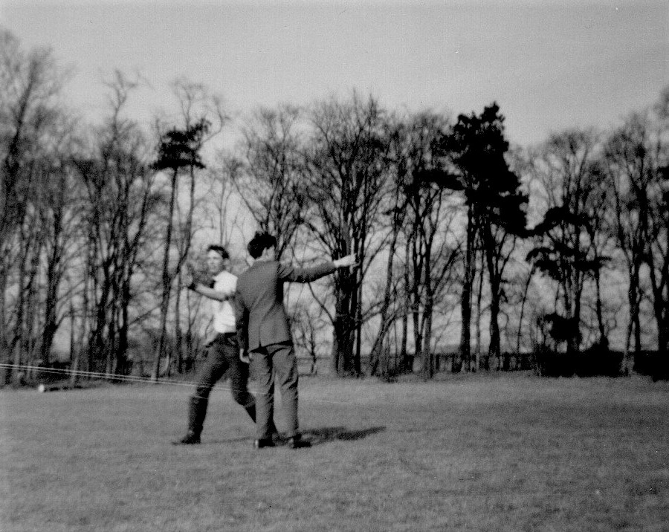
Lindum Aviation members in Saturday Combat

Having mentioned pilots I feel I should elaborate. The model builders and their pilots came from all over the country but also from the Barkston Heath station manned by our American cousins. Their presence was very much felt, and, through overheard conversations and comments particularly with reference to one rather loud individual we learnt that he held the rank of an American Air Force Major. This was interesting to us because he wasn’t hat much older than us along with some of his companions. This guy was a Major? He was the “Try more compression, de-compress, yeah! de-compress instructor, fair haired, heavily built and the pain in the arse who woke everybody up at 5 a.m. every morning to test his engine. Only in retrospect when we returned to our daily life did I and maybe some of my club chums reflect that he was also representative of the many our own and American youth who just twenty years ago had answered the call to defended our countries in the skies above us. It was a sobering thought then and for me now even more so since I have read so much of what they actually did at the time. We are only here because of what they did and the lives that they so selflessly gave and I salute them.

The control line stunt flyers were something to watch and learn from. Some people like dancers know how to do it because they have been trained to cope and compensate accordingly. Pilots of model control line aircraft had to learn the hard way and I have included a picture of two club members flying combat mode, one walking around the other. Standing and continuously turning on one spot without getting dizzy is not that easy. Some of them made it look really casual without a care in the world apart from that required to keep the aircraft under control. The trick was to walk in a circle and not stand in one spot but I didn’t know that then only later after the damage was done. The giddy barrier was experienced on my own first control line project which flew fine for a few laps and then, as things became progressively more blurred, seemed to fly in ever decreasing circles until it crash landed into the long grass which was our Lincoln airfield. The inward flight characteristic was probably caused by some misalignment in construction but dizziness was definitely a problem. It was a good couple of days and for us all a grand and enjoyable experience. We packed all the kit and uncle drove us back to Lincoln without incident on the Sunday afternoon. It had been a good weekend.

When not attending a fly meet or fishing the city centre could be my destination, having a look around getting the record shop assistant to play the latest Buddy Holly record and not buying it, doing ‘catch-up’ over tea or coffee; coffee being the latest in thing. All pretty relaxing stuff. Gee! Life could be exciting. On Sunday if fishing it was up and about fairly early to nearby Hartsholme lake or cycle further afield out to Saxilby where there was a very good little gravel pit filled with reed beds and very promising Tench of reasonable size. Fairly unknown by the masses then it was nice and quiet with a couple of two pounders finding my hook after I’d discouraged three rather bad tempered swans from staying. Back in civilisation after tea what could you do in Lincoln for Sunday evening entertainment? I soon found out: not a lot. A Cathedral city and the watch committee apparently didn’t like people being able to enjoy themselves on a Sunday. They did allow the local Odeon cinema but there were no restaurants open. Hostelries yes but not restaurants. The only high living I managed on a Sunday evening was beans on toast in the small café above Burton’s gentleman’s tailor next to the bridge over the river Witham.

The Gear Section
It is only now, after so many years have gone by as I sit writing this that I realise how much better organised I should have been. But there you are that’s youth. I say this with particular regard to the comparatively short time spent in the gear section, but suppose it could also be said of some other department in which I found myself placed. The only excuse I can offer is that at the time, particularly because of the glass roof, it was just too frigginott to feel like doing anything. There were three of us dotted around the section with nowt to do but stand and watch the gear cutting machines hypnotise us as they cut very sharp teeth. So hot was it at times that if one dared to sit down it would be to doze off with fond memories of swarf whizzing past my head as experienced on the Noble & Lund. The only way to avoid it was perhaps ask the occasional question which with limited knowledge and desire didn’t come naturally. Although shown how to use the special vernier calipers for checking addendum and dedendum once understood the information was basically just assimilated and tucked away for a rainy day.

I should have looked at the way gears were made in far more detail as I had done in the milling section, taking note of machine makers names, methods employed and established where installed in our diggers. Others might have had the maturity to think like that but regrettably at the time not me. Evaluating our time in the machine shops there was in fact no formal directive on how to spend it apart from remaining at our station. On reflection what we should have done, with all departments, was look at the various components; like the main revolving frames as an example, from delivery of raw casting, following its progress through setup, machining and all the way on to the erecting shop. A little more effort would have made us far more aware of engineering fundamentals and over time instilled our own mental reference library to which we could refer in years to come. When time came to actually get involved putting iron together there were few if any gears which brought back any intimate memories of them being created. The 38-RB main drumshaft ‘cog wheel’ is the perfect example along with perhaps the even more numerable 19 and 22 RB drum shaft gear teeth.

I cannot recall ever actually looking in the gear section for them being processed which was a great pity and another foolishly missed opportunity. When I joined the company in 1959 they built four hundred and forty four 19/22 machines. In 1960 it was four hundred and ninety eight and in 1961 it increased to five hundred and eighty seven. With two gears per machine we are talking a total of three thousand and fifty eight over the three years and I can’t even begin to remember any pilgrimage to seek out their birthing fathers and that’s a lot of gears; especially if you want to add the one thousand five hundred and twenty nine intermediate gears they meshed with. It is only now that I begin to wonder where exactly they had that capacity. Not knowing is a definite failure on my part. Looking at figures more closely for 1960 and making an allowance of three dead manufacturing weeks for holidays, four hundred and ninety eight machines gives just over 10 per week so we’ll make it simple and call it 10, double it for the gears making it 20 and that’s how many were required to meet the demand at the time. A very approximate illustration but made to exemplify the point that somewhere in the gear section they had to be knocking out at least 20 large ones a week for one line of excavator and I cannot recall the operation. Respectable numbers of 30-RB machines were also rolling off the lines at the same time with a similar machinery layout albeit with slightly bigger gears. So what was I doing?

The two minders we were to assist and hold our hands were Russell, a forty something tall, burleyish sort of fellow, dark curly hair parted to one side, round faced and a double chin. With a pleasant disposition he was readily willing to answer any questions we put to him, although it has to be said we certainly didn’t exhaust his stock of answers. His mate, not much shorter, was called Monty and was of Polish origin. Compared to Russell he was like a rake and too thin to even cast a shadow. Also thin faced to match his build he was rapidly loosing what remained of a straw coloured thatch barely sprouting here and there. Sallow cheeked he had a ready grin with a quick wit and they both helped alleviate our boredom by showing us how to load and set up the machines for cutting the gears.

Various machinery types and manufactures were in evidence around us, the choice of which one used depending on gear teeth required; the straight spur type with tooth face parallel to the axis, helical with face angled to the axis or the bevel gear for going around right hand corners. The machine we got most familiar with during our stay was the Sunderland gear planer’s steady plodding back and fore movement as it generated teeth with a vertically mounted rack. These worked on a principle established in the early years of the 20th century by the inventor and patentee a Mr Sam Sunderland of Keighley in Yorkshire. Basically it was the process of shunting a vertically mounted straight rack of cutting teeth back and fore while in contact with the slowly rotating gear blank set up on a horizontal arbor. In moving back and fore it also moved slightly up or down as the blank slowly rotated, as if in mesh, thus generating the profile until it had moved a predetermined amount before the rack reset itself to the top of its stroke. To keep the length of the rack cutters short; after the traverse of one or more pitches the action was stopped allowing the cutter slide to be automatically withdrawn at the end of the pitch movement for a reset allowing the cutter to step back one or more teeth on the partially-formed blank before re engaging automatically for generation to resume.

The mechanism for resetting was interesting to watch because every movement it made engaged a ratchet wheel on the end of a winding drum system to lift a heavy weight hanging from an over arm. The limit of head movement being reached the winding mechanism released the weight which then reset the cutting head. In practice the operation was fascinating thing to observe. The only drawback with this method was a cutting stroke in only one direction, the head folding back on the return stroke. To overcome the wasted stroke sometimes a machine with two work strokes was used with a two gear set up, the return stroke from one being employed as a cutting stroke for the second gear. They were quite a heavy machine and consequently used for largish gears as on the 19/22 RB type already mentioned.

A couple of days after we’d arrived on the job and got ourselves comfortable Russell interrupted our reverie and asked me, why me? if I would like to lend a hand changing out a gear that had just been finished. It was quite a large one and may well have been for a 30-RB drumshaft. Instinctively I knew it wasn’t from a 22 but being lazy didn’t seek to confirm it with any drawings. It had been a lone gear but we were now going to set up a pair of smaller ones back to back. Fortunately there was an air hoist to service the section so after loosening off and removing the 7/8 Inch nuts anchoring the arbor support frame we were able to slide it out of its guide slots, swinging it out of the way to lean up against the end of the machine. Those anchor nuts were tight and probably down to Russell now intently watching our every move wondering how we were going to remove the finished gear held on the arbor between spacing collars and a very large nut on the end. I decided to call Nick Gostick over to give assistance. Not a strong lad but willing he stood alongside wondering what tools we had when Russell came to our rescue along with a big grin accompanied by the appropriate large spanner. Single ended with a long flattened tube over the end making it around five feet in length it was just the job. So we both hung on the end of it to loosen the gear off with Russell watching and directing making the odd comment about wimps and oats then adding a couple of ounces more weight to make the difference. I’ll give you a hand putting the other ones on,” he said. Nick, out of puff just nodded, said, ”Your welcome anytime,” and sloped off back to whence he had come. Ray Hunt another apprentice on the job recruited at the same time as me and Nick had managed to get himself an important errand and had now disappeared.

Having removed the clamp nut we attached the sling through the gear spokes, took the weight and slid it off the arbor to put ready for final checks before being whisked away with three similar gears stood waiting to be collected. Russell wheeled around the two new gear blanks pointing out that the projecting centre bosses on only one side would simplify holding them. The back was level with the gear side face so they could be mounted and clamped back to back on the arbor with adaptor collars before clamping, this time with Russell assisting to put his considerable weight behind it. The air winch commandeered to assist we lifted the support bracket, sliding it back into the Tee slots for re clamping. Both gears bigger than the one we’d replaced we had to wind the cutting head back to accommodate the increased diameter and then with everything reset we stood clear. Russell pointed at the start button and let me capture the moment to make it all happen.

Gear cutting machines of various types were spread over the area. Six Sunderlands were stood together with two of them cutting bevel gear teeth, the face on which they were cut set horizontal and parallel to its axis. Two reciprocating heads generated the tapered tooth form each side of the blank for one full revolution, one moving forward the other backward so they did not collide, resetting for the next cut. In production gear cutting there are several ways in which teeth can be formed, some of them being required for internal applications as well as external with the simplest method seeming to be the oscillating action of a circular cutter pumping either up and down or doing so horizontally while rotating together with the workpiece. A similar cutting method was already in use for the change-over dog clutches on swing to propel motion for the 30 model excavator using involute spline teeth instead of the cast lobes still remaining on the 22. The involute system was eventually adopted and applied to 19/22 machines and I was to see the fruits of this development three years later when working on the production line building 22s as it was introduced with much comment from the crew.

The biggest gear machine of them all cut straight spur teeth on a ten foot diameter swing gear and was another Gleason; this one a hobbing operation for putting teeth on the swing ring fitted to 110 and 150 size machines. I must confess that like many other things I did not then give it sufficient attention to understand the method fully. The gear blank was laid flat and teeth generated by the hob cutter lying almost horizontally as it spun on its column mounted slide gear slowly turning as teeth were formed. Not asking sufficient questions this particular application was discovered quite accidentally when I went walkabout to the next bay. Gear cutting with its different methods and all the ramifications was an extremely interesting department and if I hadn’t focused on building the iron I might well have drifted into industrial dentistry instead.
Part of the gear cutting section lay on a patch enclosed by two main gangways heavily used by fork trucks for servicing both delivery and take-aways. No! Not hot food but hot product newly completed or to bring new material for processing. They arrived and departed into the south yard either side of this island through rubber doors and an opening of around seven or eight feet wide and perhaps nine feet high to accommodate the truck mast. The doors both had windows for driver and pedestrians to see the other coming and to one side of the opening a set of safety railings made sure pedestrians were kept away from the entering truck. It was a good system and emphasized the diligence necessary in such a place at all times. However if my memory serves me well respect to safety could almost be undone around a hundred feet into the works due to a couple of cylindrical production grinders working right alongside the gangway. The grinding machines were okay, it was the machine operators who had their backsides in harm’s way so everybody had to be aware at all times. Fork truck entry could, if it were blustery outside, be preceded by a warning breeze. Occasionally an apprentice on gear section would stop to have the craic with one of the grinding machine operators. Highly skilled, they were working to then thousandths of an inch, but oh how boring. I could never see myself standing around in front of a machine like that for hours on end. Although interesting I was pleased at last to be moved on.

38-RB Rev’ Frames
Monday
Finally arriving at 38-RB rev frame build section was almost an anti climax. The beating heart of No 3 bay with responsibility for one of the company’s most popular products built on the same ground as the 33, 37 and 43 RBs before it. Occupying four or five times the area than Drumshafts and separated by some sort of heavy storage structure it was more to the north ending at the service road. Alongside both main gangway and the dividing structure were several component racks and against the partition wall of No 4 bay two more with three heavy work benches. In the top corner next to a support stanchion a nest of operating levers were huddled trying to hide, almost lost amongst the rest of the digger paraphernalia filling any space available: brake pedal pads, reach rods, cam levers, roller and pin sets, fulcrum pins, straight pins, split pins, clevis fork ends, clutch toggle yokes and collars, reach rods, adjustable clevis rods long, short, left and right handed, bellcranks, tension and compression springs long, large and small, hex head bolts, nuts and lock washers - also known as Colocs - various sizes, bushes large and small, roller chains, retainer plates, bearing races, brake and clutch bands....... you get the picture. The list was endless and I had to get acquainted with everything needed to make our digger. And as if they couldn’t squeeze enough in; four side platforms were just being leaned against the section divider, one of which would very quickly be bolted on to the next waiting rev frame.

I think I mentioned earlier my growing familiarity with some of the gang members, exchanging banter and good humoured insults when walking past, sometimes even crossing the unmarked perimeter line for more convivial discussion. Also now getting to know the chargehand or boss Charlie -“Hiya Ginge, Y’areet?” - Dixon, I made it known unto him that I was ready and willing - little creep! - asking what he wanted me to do first.” Ah! Oh!” he said, taken off guard but then suggesting that the boom hoist drum would be a good place. “I’ll get some things ready for you.” Aged early fifties he was a no nonsense individual standing around five seven in height, a craggy face on a solid but wiry frame with a full head of greying hair parted old style to one side. The other thing that you couldn’t help notice was two very large hands. In manner he was easy going but always alert, preoccupied with the running of the section, and, due to regular bicycle journeys, along with the nature of regular physical activity also very fit.

The workspace was organised with three rev frames, boom feet facing north, always under construction. Set up on the opposite side of the partition structure from the drumshaft gang the first position would be the bare rev frame casting inverted to allow necessary preparation work to be carried out on its underside first. It would then be turned right way and moved on to heavy trestle posts at the next position where side frames, side platforms, general components, controls and the rest of the machinery would be installed. In practice there would actually be two rev frames at this stage their build progress choreographed for one to be ahead of the other coinciding with a parallel build schedule on truck frame assembly at the north side of the service road. Watching the No 1 position prep’ frame being turned over was an experience in itself. With official union approved slingers in attendance chains were slung around the rear cross beam member to lift on end, carry it forward, and then spin it around before tipping in a controlled descent to land on its hook roller brackets. Sometimes gremlins would get involved dithering, refusing to lie down until somebody muttered the right incantation. When ready the rev frame at No 3 position next to the service road, having moved up from No 2 with all machinery and controls in place, was suspended between overhead cranes to float across this road for marriage with the lower works. The frame occupying No 3 space on Friday last week had been so moved and now sat on its crawler base. It had been a busy afternoon with a parked rear end casting also being bolted to the middle No 2 position frame at the same time. Now beginning a new week it was almost ready for its Paxman power unit while across the way a test department fitter was setting up clutches for the newly married couple a gleaming yellow and maroon painted cab hovering above.

It was a game of catch up and I was ‘thinking on’. With an empty space now at the end of the line it was quite possible the rev frame with the recently fitted rear end casting would move up a place. Meaning the one the boss was putting me to work on would, when done, be moved up to the middle number two position leaving room for the next prep frame. Thinking about it all was making me light headed. How exciting was this? And just how confused about all this juggling of rev frames are you getting? Working with five or six fitters crawling over and under everything could sometimes get a little crowded. But it was going to be my new home for a couple of months so now after finally arriving at the heart of No 3 Bay activities and the section that put everything together I was happy to live there. Build started with the inverted prep casting having various attachments and other insertions put into place along with hook roller pins and carriages. The swing-lock assembly would be fitted, main bushings and boom hoist drum etc, before righting to receive side frames and other bolt on goodies. Two of those insertions were the propelling shaft upper bushing and one for the centre post along with upper and lower swing shaft bushings. These were hammered into position with purpose made spigot dollies. The boss was going to tell me all about it.

He had a job that was waiting with the boom hoist drum and described procedure for putting it into place. Pretty straight forward with the drum a heavy lump that could easily crush an impatient hand. “You’ll have to put a couple of bushes in first,” he said, “two of them.” The big one you can knock in from the side here,” he tapped the back of his hand against the outside of the frame, “while the smaller one goes on the inside of the frame opposite,” he leaned over pointing. “Knock them in first then and I’ll show you what to do with the drum.” My first job on rev frames was about to occur but first: exactly where and what were the dollies? “Err, um. Exactly which dollies are we talking about Charlie and where are they?” He looked at me for a second and then reminded himself that I was new on the job with a lot to learn. “Aah, Yeah!

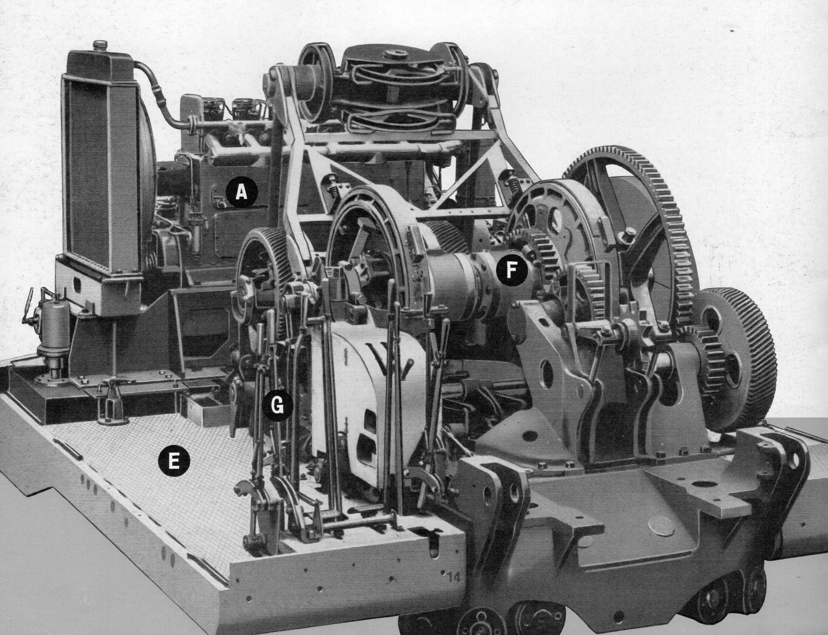
38-RB shovel machinery deck showing crowd casting and gearing

Sorry I was forgetting, you’re’ only just getting started with everything. Here let me show you,” he said and took me over to the end of one of the storage racks pointing to a bottom shelf with various dollies. “These are our engineering dollies we use to knock in all the various bushes. Those large circular plate looking ones are for knocking larger ones in, like the bottom of the centre post here,” he said, taking me back across to the frame and tapping the casting with his hand,” and this one behind it is for the bottom of the swing shaft with another bush that you’ll have to knock in from the top with a smaller dolly plate. All the ones we use we keep around here. If you can’t find what you are looking for just ask me, if I’m around, or one of the boys. Okay?” The dollies he was referring to of course were not the sort my big sister used to play with. All they were was a piece of reasonably thick round plate or short length of bar material machined with a lip allowing it to rest snugly within the diameter so you could knock the bush into place against the resistance of an interference fit. Thus I started to play with my new dollies inserting the largest, the centre post bushing first, using a lump hammer to line up square to avoid jamming and then it banging it home. Using similar technique the lower swing bush was next. Top bushes would have to wait until the frame was turned upright and with all this happening it was soon time for petrol!
Having already met the crew casually over a few months it was tea break without inquisition. Names I can just about remember were Keith, Simon, Richard, Stanley, Ronald and Phillip with ages ranging from mid twenties for two of them, one in his thirties and two aged around forty. Phillip, one of the older ones drove in from a village called Scopwick six miles south and Ronnie from Saxilby more to the east of the city. The Saxilby road had the nice little gravel pit with good sized Tench swimming around in it and not too far to get there by bike. Conversation was usually just general chit chat about what was going on in Lincoln but this morning for a change there was something interesting to talk about. An air show was taking place the coming weekend at Waddington RAF station. Posters had been placed around the town for some time and it was only being reminded about it then prompted me to ponder who amongst my chums might be interested in attending. At the time I was working on a college machine shop project with Bobby Saddler. So Thursday night class later in the week I mentioned it to him while not paying full attention to the current lecture. Although it was at short notice he was not he said doing anything particular that weekend and receptive to my invitation. Having been to his home a few times I knew it lay alongside the main Waddington road so for him the route would be familiar. We would not, he told me, need to make use of public transport. We would travel astride his motorbike and on Saturday morning just after 10.a.m. we set forth on the back of his whispering Velocette.

It was a good show blessed with good weather and we were both highly impressed by the flying display given by a number of aircraft but in particular one of the resident Vulcan Bomber fleet; a much bigger aircraft close up and extremely noisy when taking off, and what a take-off? Shorter than we would have imagined it seemed to only just clear the ground before rotating vertically skyward thrusting its seventeen ton mass into the clouds. We were not expecting that. WOW! The memory lingers on. All this was to happen a few days hence but now just before the end of tea break when the hooter would normally blow, the emergency alarm went off instead accompanied by the sound of running feet from No 2 Bay and the far end of ours from the direction of Stan Simon’s gang on 54 build. Could have been an accident or fire but we never found out so nothing serious.

I had just knocked in the various bushes when Charlie asked about my experience with an air winch and then proceeded to demonstrate with the drum casting. “What you do,” he said, “is hang the drum in the well of the casting like so.” It was already slung alongside so raising it with the winch he swung it over, lowering it to line up with the holes for the shaft. “When they all line up you can push the shaft straight through. But! Remember Two Things!” he emphasized. “Do not use your finger to line up the holes. Do not forget to put the key in the shaft.” I understood exactly. Then he looked at me dropping his chin, eyebrows raised his eyes wide looking directly into mine and said,” You remember Alf the slinger retired a few weeks ago? Did you notice his right hand?” As he said this he wiggled a forefinger in front of me with the ghost of a smile on his face and the penny dropped. Alf had the top joint of his right forefinger missing and my chargehand mentor was subtly telling me how. I just said, “Ooh!” At this point in the narrative you may well ask if he was treating me like a complete idiot. Well he certainly wasn’t. I understood he was covering himself. Even in my short time at the works I had met the ‘mechanically inclined’ individuals who had no actual mechanical instinct for safe working at all even for some of the simplest of tasks. So he was doing it right. Anyway, it looked pretty straight forward to me so I pressed on, remembering to bash the locating key for drum into the shaft before shoving it through all the holes to complete the procedure; the shaft being retained with an end locking plate secured by two wired locking screws.

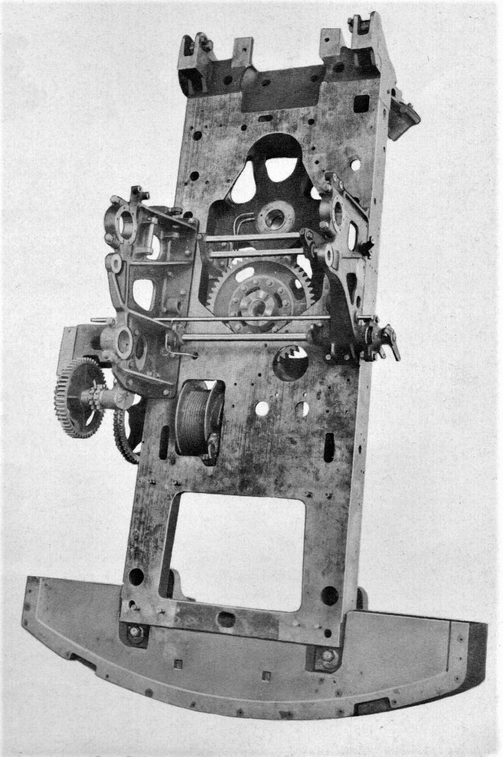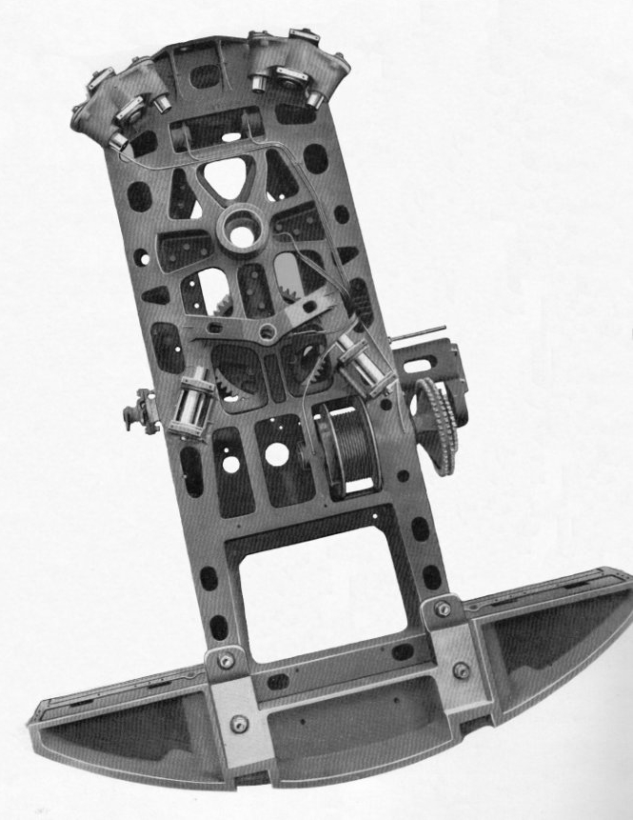
Revolving frame casting showing top view with side frames bolted and boom hoist drum and underside showing hook roller lugs at rear and front twin bogie castings

While contemplating the next task a rumble overhead drew my attention, bringing sight of a crane hook coming in to land opposite our patch of territory across the gangway where a lanky individual with high forehead, thin swept back hair and Van Dyke style beard was lining up to catch a set of dangling chain slings. Lenny Leicester was in charge of equipment assembly for 38-RB machines and a shovel boom was ready waiting to be fitted to the Friday machine. As he stood there two slingers, Bob and Beano, also arrived on stage to direct operations. The assembled boom with bucket handle floating in the saddle block wasn’t the easiest thing to sling but long experience had taught them how to chain wrap it to float into the boom feet “like a glove on a lady’s ‘and,” was how Beano described it. I wondered how he got his name and asked his mate who just laughed and said his family name was Batchelor, which prompted the responding query “What’s your name then?” He grinned back looking amused and chuckled, “My family name is Elkington and my first name is Stanley.” Seeing my puzzlement as I slowly asked, “Why Bob?” he replied, “It rhymes better.” What they called Lincoln humour but it worked.

While their recently acquired junior gang member was still faffing around the rest of the crew were making quite a bit of progress. Starting shift Keith had been’ working with Phillip, AKA Phil’, bolting on the right hand side frame. Phil’ had been called away temporarily but was now back and they were working to finish bolting down the left; a longer frame officially labelled the transmission frame because it had to carrying both primary transmission as well as boom hoist machinery and operating cams. Having mounted machinery frames the operator’s side platform was next, assisted by Phillip, manoeuvring it into place with an air winch.

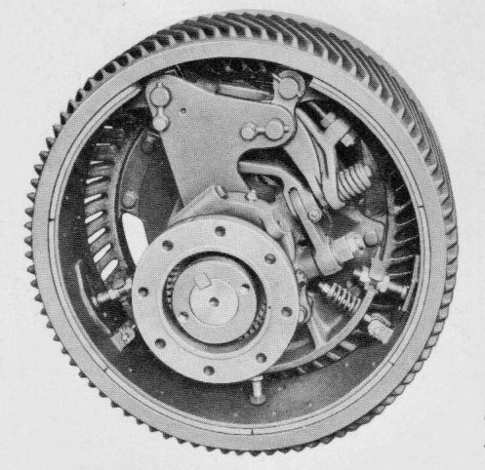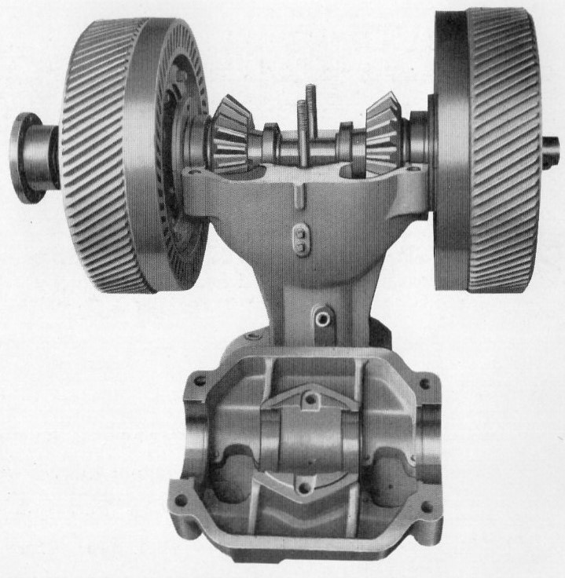
Left hand reverse clutch 38-RB reverse clutch pedestal housing

The lonely operating levers clustered in the corner were now commandeered and threaded into position along with brake pedals and Keith meanwhile was working on the swing/propel and digging lock levers mounted in a side cabinet. Everybody was busy doing something. Chargehand Dixon was floating around keeping an eye on things with Cyril borrowed to help the ‘cabbies’, a man down on the 38-RB across the way, Ronnie was busy working on boom gears and clutch shafts, the transmission pedestal having arrived from Sid Lucas next door now being sedately lowered into its allotted hole behind the centre well. This would mesh up with the two floor gears Richard was busy grappling with, bolting centre bosses to the toothy parts, a time consuming process with the two bushes still in need of fitting. Whoops! That reminded me. I must remember to fit the top swing bush now the frame is right way up or Rich’ will have my guts for garters.

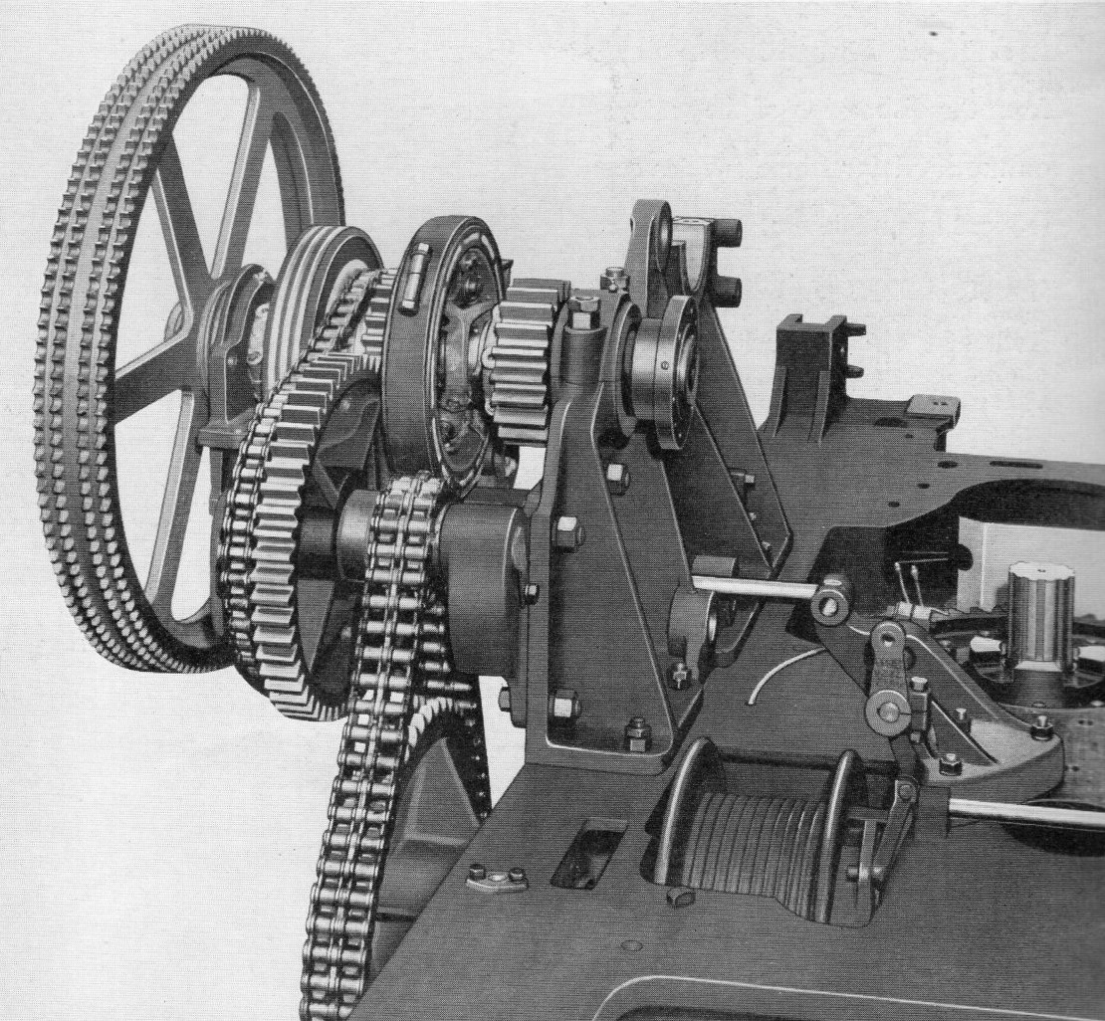
Primary transmission, boom clutches and drive pinion

Phillip, finished with the side frame, had moved on and was now wrestling with the primary transmission shaft assembly and would soon have that fixed? Sometimes geary things can be tricky. Once in place one half of the transmission shaft would connect to the large double chain drive sprocket on the end of the boom hoist; the one I was now playing with providing an approximate 4:1 reduction ratio. It was big and heavy needing the air winch and while sorting that out I was almost oblivious to the crane rumbling overhead until Charlie Dixon’s voice announced,“ We’re going to move this up a space so watch your fat arse Ginge or you’ll get that slung an’ all.“ “Oh! Am I in the way?” was all I could think of to say. I hadn’t even begun to look at the hook rollers and it was nearly lunch time. “No, no, your OK Taff. We move preps up early if we can. You’ve not much to do on that one now have you. Only the rollers and we’ve got a lube guy coming across from the cage after lunch to do some pipe work along with the next prep casting that should be arriving.” There’s nothing like being really busy that makes time pass and it made me feel like I was really doing something.

With the distinct feeling of needing to accelerate my work pace I still only managed to finish with the chain wheel shortly after lunch just before Bob and Beano arrived again moving it all making space for the replacement. A half hour after lunch it arrived on the back of a well knocked about three axle Atkinson flat bed, reversing smokely up the service road from the clocking hall end to where the slinging duo off loaded it all dancing a polished quick step with the boom feet to lie it recumbent on its back. The standard practice was to prepare rev frame roller pins and front roller carriages so everything was ready for when marrying machinery deck to the lower works, loosely screwing them in place with shims but excluding rollers. These were only introduced when actually mounting onto the turntable when roller shims could be adjusted for correct running clearance.

So that was my next job; fettling the four lugs, mounting front carriages and then temporarily bolting all the pins in place. In the middle of all this Vic’ Downey from the lubrication cage team arrived towing his bits and pieces trolley to work alongside me fitting copper piping and brass elbows into all the important little places before the frame was righted ready for deck work. But I wasn’t finished. Keith had got the idea into his head that I had forgotten about the swing lock and he was right - but I didn’t tell him that. “Oh thanks Keith. That’ll save me having go and find it all.” “That’s okay,” he said, ”let me show you how we install it so you’ll know next time.” I was grateful for his help. He seemed the friendly type. It was just a short rack of engaging dogs shaped like gear teeth that swung down on a pivot shaft to mesh with rack teeth on the inside of the turntable. With the frame right way up the assembly could be linked up to the platform operating levers. And so the rest of my first day passed with the odd few jobs as they came along, not paired up with anyone in particular as I had been expecting. To add insult to injury I was not really able to skive off anywhere for half an hour either; one thing I did miss about working out in the machine shop.

Tuesday
Tuesday morning was fortunately a little quieter. Trying to avoid working on the latest prep casting just arrived and waiting for the one I had just finished to be turned over for moving up to No 2 position I got involved on the frame at No 3 reaching completion. The primary transmission drive shaft along with boom hoist clutches had been put into place and Ronnie was busying connecting roller chains while Simon, having now married the two coupling halves, was able to dog down the pedestal casting with everything now in line. While observing activity around the boom hoist I remembered the safety pawl still needed installing on the one waiting to be turned over, but it wasn’t accessible so get on with summat else. Storage racking was just about everywhere, open shelving for the bigger stuff and divided multi box type for smaller pieces but where were the pawl bits? Five minutes trying to look busy and concerned and then I found them. I needed a break. I knew work was good for the soul but still I needed some respite. The boss must have been reading my mind because he suddenly took pity; seeing me looking a little bit panicky? ”Eyup Taff! Go and see if you can find the slingers to turn that rev frame over,” pronouncing the word ‘ovver’ with O as in orange, a trait I had noticed in Lincoln speech along with phrasing. They didn’t say haven’t you but have you not? Could or would you not or do you not? Changing the meter of the spoken words I was used to but still making sense.

Guessing Bob and Beano were probably at the top of No 2 bay and taking my time having a bit of ‘craic‘ on the way, I found them at the bottom of No 1 and grovelled for their immediate assistance. They duly obliged and followed me back just for show, my mission accomplished, Charlie watching but saying nowt. After the usual routine with chain slings and four shoe shuffle my own personal rev frame stood awaiting a swarm of fitters which disappointingly did not arrive. Everybody’s attention was focused on getting the lead rev frame airborne but with departure delayed due to the power unit still not coupled ready, two gears for swing and propel awaiting installation and one other things. What was the other thing? Oh yes: the primary transmission chain casing. So still much to do and as I cast a look north over the service road they were just pushing the two mighty doors aside, Albert Smith from test department, standing behind his magnificent handlebar moustache on’t duckboard of the recently completed shovel while his companion inside tried to wind up the engine. Coughing, spluttering and chuffing out clumps of smoke the Paxmans always seemed to clatter and clonk in protest when ever you tried to wake them up, and using starter cartridges even when new was not unheard of. In a few minutes however, once warmed up and running, the 38 would be ready to launch down the legendary slope of No 3 Bay and out into the world beyond. Hopefully one day perhaps that would be me taking it out through those doors.

So what was the situation regarding build and catch-up. We had one rev frame not far off finished; one prep’ yet to be started and another one just turned over. Albert had just tipped his 38 onto the slope to leave room for perhaps two truck castings, one just being put into place on its side for a propel shaft bushing. Perhaps that’s the way it went, just the ebb and flow of catch up until the panic started but we had plenty to do while lower works caught up with rev frames so keeping calm we carried on. The 38 nearing completion was going to be rigged for dragline, confirmed with a glance across the gangway to where Lenny on equipment was putting together a lattice boom with a fairlead ready and another one lying nearby. The fairleads for both 38 and 54 machines were assembled here as well as shovel and lattice booms and at the moment he was doing a roaring trade.

A strategy was needed for me to get involved in the different jobs without being too obvious. Perhaps just float around between the various activities and ask if anybody needed assistance? But the boss was telepathic and again must have read my mind materialising alongside to solve my dilemma.” You can go help Phillip for a few days and pick up some tips on how we do things okay?” So I teamed up with Phil’ and found myself installing the vertical swing shaft through one of the gears Richard had been wrestling with the day before. Both now in situ the one we were concerned with was at the back where with the main drumshaft and brakes now in position there wasn’t a lot of room to manoeuvre, even using the air hoist Phil’ had organised with a wire sling and eyebolt screwed in the top to hang it from while I lay beneath watching it come down through the pinion; Down a bit, ‘ang on, ‘ang on while I turn the pinion a bit, okay, okay, still out of line - just slipped past, back a bit. That’s it! Lower away. “ From my own perspective I was not too happy lying under all that cast iron but I had faith and was feeling a little smug at having completed a technical task lying on my back to do it. If you wanna look good the best thing a bloke can do: lie on your back beneath something technical, rattling a spanner while ensuring you are seeeen. Filling the gap between the underside of the frame and bottom bearing boss the pinion looked great. Almost done and the shaft secured with a retaining plate I lay there admiring my work for a few seconds until a heavy judder and impact sort of sound from above shook me out of my reverie. I could have sworn the casting moves sideways! In such situations one moves. Boy did I move? Scrambling hastily out from under and as my nose drew level with the top of the platform Phillip was sliding the dog clutch into place over the shaft and the source of my fright was seen to be the Paxman engine just landing in position.“ Did we make you jump Taff? “Stanley chortled as Phillip laughed along with him. “Bastards!”

With only a few other things needing to be done: cross shafts for bellcranks, cam levers and dropping the A frame into place, it would be ready to take flight. The A frame was quiet an unwieldy piece with the fabricated structure pinned to each main side frame casting behind the drumshaft with back legs anchored in the deck on a line set to the rear of the boom hoist drum. I think it took three of us and the crane to assemble. Two of us feeding the cross shaft through, jiggling and rattling legs and frame as, with the pulley yoke frame suspended from the crane, Charlie the boss fed various spacers and shaft pulleys on in turn until it refused to line up on the last hole; for no apparent reason other than sheer cussedness. I loved it when things like that happened. It was the golden opportunity to show true leadership. The chargehand fiddled, jiggled, juggled, glared and cussed it to surrender. Once in place Mr Muggins was appointed to secure frame legs to the shaft with T bolts and then install the two horizontal boom suspension yoke pulleys, also referred to as sheaves. With the frame in place an additional bracket was bolted to each front leg for mounting spring loaded pull off bolts to assist with brake release.

Since Albert Smith had take its predecessor through the Beevor Street doors the next 38 was slowly taking root and growing. The truck frame casting seen earlier on its side was now standing on sleepers with the attending fitter busy preparing to bolt on the axles, two bundles of track pads rolled up behind it. Some times they were already pinned together but not always. I didn’t envy him if he had to bang that little lot in. Its new cab, mounted on the mobile build frame, already had two sides up and part of the roof. More progress being made this afternoon. Meanwhile the rev frame I had so lovingly prepared had been commandeered by some other gang members already bolting on drumshaft side frames. But it was time for tea and a bit of craic with Phil’ finding out what was goin’ on with conversation soon morphing into supposition regarding three large packing crates delivered on the back of a loader parked outside No 2 bay on Monday. Now they were stood opened agape opposite the apprentice school to reveal major parts of a large machine and its control cabinet in which could be seen a number of tape reels with card looking stuff wound on them. The news soon got around that it was a new programmable tape controlled horizontal boring and milling machine. Not operational yet we waited to observe its first cuts.

All too soon the hooter sounded and back to business when Charlie informed Phillip that we would start on yesterday’s prep frame destined to be rigged for shovel along with the next two machines. Two crowd/backhaul castings would be delivered within the hour to be fettled and assembled ready to just drop on the new builds as needed. All fittings, shafts, gears split gear lagging sets would arrive at the same time. We were going to be busy. Fettling that little lot and bushing all bores could take us up to lunch and beyond into infinity into tomorrow. Meanwhile back at my old prep rev bits and pieces were steadily amassing. No longer on the floor but resting easy on build trestles both side platforms had been added with control levers already installed on the drivers side and boom hoist reverse primary transmission shaft ready for connection. Once the drumshaft was in place sometime maybe tomorrow morning perhaps brake bands could be fitted, or was I just getting ahead of myself. It all took time and I hadn’t really got a feel for the job yet. That was going to take a while. Simon and Stanley were working with Ronald just finishing off the almost completed the frame at No 3 destined for dragline while Richard was working solo on position No 1.

Two bright red mesh palettes arrived each with a set of components to assemble the backhaul units, the castings also arriving within a few minutes. The ground we occupied was cramped enough as it was but Dixon’s team was tough. We could take it! We got one out of the way straightaway by mounting its bare casting on my newly turned rev frame since it would be just as easy fitting the working pieces mounted in place. The only bushings involved were easily accessible and assembly of shafts gears and sprocket detail pretty straight forward. One thing that Phil’ drew my attention to was the bolt holes in both backhaul unit and rev frame castings. When the rev frame was drilled it usually left sharp edged swarf around the holes on the underside to give fingers a nasty gash and occasionally prevent proper seating of bolt heads allowing them to work loose. It was a very good point so before doing any more I slid under to clear away any swarf residue which turned out to be not much. I should have checked that when it was upside down. Oop! So we made a start bolting down, myself feeding the bolts through from beneath with Phil’ up top lining up holes and attending to nuts and lock washers. Here’s a Make You Feel Good Story: My last year of apprenticeship I won a Saturday morning’s overtime working for a particular foremen who approached me late on Friday afternoon, calling me up to his office in 18 Bay. ”Something’s come up Taff, a bit urgent. How do you fancy doing a new machine conversion on Saturday morning?” Meaning four hours work at time-and-a-half pay rate; an unheard of gift blessing for any apprentice. “Oh yes Fred. Very much I would like.” or words to that effect. “Where will it be parked?”
It was waiting for me next morning just inside the doors at the Beevor Street end of No 18 Bay where I was then attached to the 22-RB erecting shop. The job was to convert a 38 set up for dragline to shovel, a fair bit of work for a morning but made more accessible by Fred having arranged for the front corner of the cab to be removed before trundling around from the shipping department. The first job had been to remove the left rope lagging which would be changed to a split gear shovel set. With the overhead crane on hand we were soon lowering the backhaul unit into position and discovering the problem with swarf on the underside of a number of bolt holes. With cramped working conditions working up through the truck frame somewhat limiting movement I was able to clear the worst with a sharp edge chisel allowing the anchoring bolts to be pushed up through with Fred threading nuts from the top till I was able to climb up and dog them down with a long spanner. It was still an enjoyable morning none the less and after a bit of a slog changing laggings from the dragline to shovel, thankfully I wasn’t asked to put the cab back together. “We’ll get one of the cab boys to do that,” Fred said. Considering that job over the following week I began to wonder if it had been some sort of unofficial initiative test.

Back to the present, just before knocking off a message came from Charlie Everitt at HQ to go and see him before clocking out. Didn’t like the sound of that summons so made my way directly with some concern. We didn’t normally get a summons like that unless ‘we wuz in bovver’ “Ah! There you are Taff. Thanks for coming. How do you feel about being an ambassador?” he said with a friendly grin. He was OK was Charlie. None of this I’m the boss - jump to it. “Turn up tomorrow usual time but come here in best casual wear okay. You’re going to act as a tour guide for a bunch of students and take them around the works.” All I could say was “Oh! OK.” Expecting to be chewed up for something it was a pleasant surprise turning out to be the first of several such guide expeditions over the next few years, only on the second one realising it was a compliment to be asked. I would look forward to that. It would also give me some well deserved respite for a couple of hours. And with that thought I returned to my rev frames and backhaul castings. They were used to apprentices disappearing at short notice. “No need to worry about Charlie Dixon,” he’d said. “He’ll be told where you are by the foreman but you can still tell him before leaving tonight as a courtesy. He’ll appreciate you doing that. “

On return to my Lodgings in Swanpool that evening there was some bad news. A family problem had arisen making it necessary to seek new headquarters again. In
one sense it was not a complete surprise since my landlord had been out of sorts for a month or more. He just wasn’t his usual self but I knew why. Although officially retired he had been offered the job of night watchman for the main Lincoln Post Office across the way from the YMCA. He had been Watchie for about three months when at 4.a.m. one morning there was a very heavy banging on the rear door of the premises and loud voices telling him to open up. The knockers said they were post office engineers and some kind of emergency required their immediate access to the building. Relating it all afterwards he said that although they were persuasive he still had some nagging doubt about it and there being no directives from management on such circumstances he held his ground. It was fortunate that he did and that it was a very strong door with heavy locks. It was indeed an attempted robbery as he discovered when reporting the incident to management on their arrival. I got back from work later in the day just as a couple of Post Office security officers were leaving. He was commended for keeping his nerve but it had upset both him and his Mrs enough for him to turn in sentry duty and retire full time. He was by then I think in his mid sixties and being that age sixty years ago was different from to today. He like most people that age had lived through two wars and although perhaps they had not realised it had taken its toll. It was a sad blow for the three of us. They had been very kind to me treating me more like a son than a lodger so I would have to ask around, but without getting the company involved again. It was better to find your own anchor first and if good cling to it. Asking around on the job at tea and lunch break could sometimes proved a helpful source so next day I sewed some seeds.
Wednesday Morning
I arrived all togged up in tweed jacket and cavalry twill to lounge around the apprentice school waiting for my charges while trying to look suave and sophisticated. Having been at RB now for some time I was struck by how young some of the new apprentices looked. How the time had flown. The gang of four from some ‘Uni’ college arrived by car to park alongside Becor House at 9.a.m. All aged twentyish but too long ago to remember anything else about them other than with the weather being dry we walked up to the test field first to introduce our equipment in a work setting, viewing from the fringe because there was a 54 working dragline over on the far side and a 38 shovel busily working a bank of dirt alongside the Beevor foundry road. They were surprised at the extent of the works so I decided to make it a really memorable visit, more than intended, taking them for a quick peek in 22 Bay, down through all the activity in 18 Bay which really grabbed their attention, on through the fabrication shops welding cat frames and most of the machine shops. Gear production got them quite engrossed particularly when I took them to see the machine hobbing a ten foot spur gear for the 150 size shovels. They were all tired by this time but we pressed on meandering down from the south end of No 2 and 3 Bays.

Here the beginnings of a 110-RB got their passing attention and then assembly of a 54 where they were happy to stand and watch in awe for a while as a machinery deck was delicately floated and lowered into position for marriage to the lower works. With the interest shown there it was a bonus for me to take them further along to see a 38 drumshaft being put together with Cyril and Sid and onward to rev frames for another three progressive stages of assembly laid out on Charlie Dixon’s floor. While they watched it all happening I glanced across to see a new cab almost ready and a truck now repleat with side frames. With only tracks needing to be added a marriage was in sight. It was going to be a busy afternoon. Getting tired by this time and in truth anxious to get back to my normal duties I was ready to lead our guests back to HQ. It had been a long morning walking the factory and they too were obviously pretty knackered by this time, although diverting on the way for a cuppa in the canteen. Walking back to the apprentice school they noted the activity around the new tape machine which seemed to be setting up for some test cuts but declared only a passing interest more concerned with getting back to their car. An edifying diversion from normal duties the chief allowed me to go back to my digs to change into working togs for the afternoon shift. Still a six mile bike ride on my schedule so I took my time as I devoured a fish and chip lunch wrapped up in yesterday’s news.
Afternoon
The unexpected guide duty had been an interesting interlude in which I had found myself to be quite at ease but could not help feeling to have left Phil’ in the lurch and was anxious to get back. Even though desertion had not been one of choice my return, as expected, was met with derision: “Skivin’ off again? Here comes the part timer,” along with one or two more rudimentary comments, with the emphasis on extremely rude. All I could do was suck it up and say, “Doin’ my best” or reply in an equally smart arse manner. But it was all good fun and back to work with Phil’ on what was left to do with the backhaul units. Although floating around helping things generally he’d made good progress assembling one of them but with the Charlie’s agreement leaving the other for me to complete on the frame. It wasn’t until actually assembling the unit from scratch I realised how many bit and pieces there were: Thirty seven for the clutch assembly and thirty six separate fit bits for the casting with one of them being the twelve foundation bolts now clamping it all to the frame. The parts for assembly to the casting consisted: two solid looking shafts, one long one short, one with splines one without, two pinions, one combined gear and sprocket and one free wheeling orphan.

That was the big stuff along with bushes, two ball races, clutch housing, clutch band, driving spider, shaft key and other worky pieces. It was a fair bit to get my teeth around on my third day but not a problem although my lack of familiarity didn’t help. As anticipated the drumshaft had arrived and with the split lagging gear matching up with the backhaul unit it could now be bolted on with the assistance of our air hoist. Meanwhile other things were being planned, Charlie in animated discussion with Ronnie and Stanley. It was getting near tea break and they were intending to lift the now finished dragline frame occupying number No 3 slot and marry it to the crawler frame also now ready on the other side of the service road. Dick Doudell the fitter responsible, a stocky, determined looking individual with closely cropped fair hair, sweating profusely, just like Sid, had been hard at it. Earlier that morning I had been surreptitiously watching as he locked the drive tumbler, poking a heavy bar through each side in turn before dragging a track pad belt over the top rollers to meet their opposite ends for pinning together. The tracks had now been adjusted and Mr Dixon was eager to pounce with Ronnie and Stanley carrying across the set of six turntable rollers ready to fit once the pins had been pulled with the rev frame in position.

But before that other plans were afoot and before I knew what those plans were Beano turned up with a temporary companion I had seen before. It was Nureyev the slinger who became a pirouetting ballerina when directing the next hook into place. What was happening was another rear end casting arriving on the back of the same flat bed that brought the rev frames. Taking advantage of crane capacity available they would just have time to drop it in position ready for bolting to the frame at No 2 spot before tea time now creeping up on us. So the main event would have to wait. Some quick pre brew preparation work was required. We couldn’t just park it on the back end without support it was fippin’ ‘eavy and could overbalance everything. So we had to rush around putting out extra trestles to lay it on for rapid line up of bolt holes, dropping temporary ones through to anchor ready for our full attention. During break the boss said he’d organised a nice little job for me after they had finished doing the business across the way. I looked enquiringly at him but he responded by tapping the side of his nose with a finger. So I waited for the call wondering why the mystery and went to find the tea trolley.

Just after resuming activities Beano and his ballerina mate set too with both cranes to work the tandem lift. With Charlie, Ronnie and Stanley assisting No 3 was soon gliding across the road for uniting to its undercarriage; Dick lending a hand calling crane instruction while Stanley positioning a ladder against the hovering frame climbed onto the deck for spotting the propel shaft. Procedure then was to lower away, positioning and moving into line until gear interference between swing pinion and rack required him to step on the side platform for rocking into mesh with a swing clutch housing. A small lurch and the rev frame continued to seek its level until roller pins could be pushed into place with shims and adjusted accordingly. Job done, one crane rushed back to Simon’s gang on 54s for a quick lift and then returned as we secured No 2 rear end before the tandem lift to move it onto the now vacant trestles next to the service road. With that frame now move up to No 3 position Keith began getting operating levers linked up with reach rods, bellcranks pinned, yokes and collars in place etc and Stanley organised the transmission clutch housing; bolting in place but not dogging it down. The crane had also just dropped off a fuel tank. We had been waiting for one of those on the previous build before putting the power unit in place.

The upturned prep Richard had been working on was ready and would shortly be moved up to the newly vacated No 2 spot with another fresh arrival very soon. I could now see the action slowly unfolding before me in my minds eye but also a couple more steps ahead. Guess who was going to be fitting another swing shaft. And I was right, except that I would also end up bolting centre hubs to the well gears. Well at least I wouldn’t be sitting twiddling my thumbs as my mum used to say. Timing was just right and the boss was alongside just as I was finishing off. “Come on then. Let’s go and talk to Lenny.” and with a John Wayne gait and swing of his right arm we walked across the gangway, just avoiding being run down by a fork truck, to talk with ‘Lenny equipment.’

Most of the gear well deck guards had been put in place at this stage but the front one left off to allow lining up procedure for the crowning ceremony. Consequently the upshot of our meeting was my being tasked with fitting the standard front dirt guard on the newly anointed 38 along with the dragline rope tray. Lenny was going to fit the boom but first I would assist him installing the fairlead. They made it sound like I was getting the Queens award for industry but I definitely wasn’t complainin’. With shovel equipment there wasn’t any forward guard or rope tray, the backhaul unit taking up the space instead. Charlie instructed “Leave em finish final adjustments for a half hour, take the guards across from over in the corner by the crane rail stanchion, and Stanley will show you how we fit them. Lenny will probably do the boom early tomorrow OK?” It was definitely OK with me.

The rumble of an overhead arriving heralded the delivery of two more sets of side platforms laying them lengthways in a small plot of empty space next to the dividing wall. We were ram-jammed packed but with another rev frame now moved up to No 2 spot the replacement would surely be arriving any time soon. In the meantime Stanley had also been briefed about fitting the guards with me so we crossed the gangway to collect them from Lenny’s place taking them down to the 38. Fitting was pretty straight forward and with all the deck fixing holes being in the right place dirt guards covering the gear well went where they were supposed to go. The dragline tray, because of its length, was more involved and a little unwieldy but after manoeuvring into place around the back and underside of the drag drum didn’t present any real problem when lining up screw holes. We were literally just finished with the last screw when it all went quiet, so absorbed that time had swallowed us and looking around everybody was making for the washroom at the bottom end of No 1 Bay. Hells Teeth! It was lunch time already. The morning had gone so we headed that way as well where Tony Crane was loudly giving vent to a rendition of the Four Seasons ‘Sherry’ as he scrubbed up. In a rush and anxious to be on his way as soon as the hooter went he gave me a quick soaking after arranging to meet next day at Ruston’s canteen for fish and chips with gravy before making his rapid laughing departure. Thanks Tony.

Afternoon
With the guards now in place I was at last able to return to my previous task on assembling the backhaul unit. Where to start? How about putting the clutch together? Yes I’ll do that, gathering all the bits and pieces on the bench to build the spider and then mounting the clutch band. All I had to do now was assemble the bushings, bearings, take up sprockets, drive gear and sprocket etc, insert all shafting and then mount the clutch housing; finishing it all off by mounting the assembled clutch. A nice steady job making it last a good part of the afternoon beyond tea break. With no let up after the break Phil announced that he had another little job for me to do. “I’ve bushed both the centre hubs for the two well gears but you can bolt the gears on to them okay. Remember they are fit bolts so be sure to line em up and tap em and not just poke em through and bash em,” he said laughing. He had a way with words on the quiet had Phil. So I made a start fettling them both to make sure they were clean and timing the job just right for end of shift. Not a lot to write about but don’t let that fool you. A lot of stuff had been going on that afternoon with getting things done and I had been extremely busy.

Thursday Morning
If it was as good as yesterday the morning should start well and indeed it did. Lenny on equipment rearing to go Charlie sent me over to check on the plan. He was going to be fitting a sixty foot boom with pendant suspension anchored to a front mast and it was lying in wait for us on’t floor. All the draglines I had ever seen on site till then had used continuous suspension with booms not longer than fifty feet so this was going to be interesting. We would be installing the new fully rotating type fairlead described in the sales catalogue thus: The fairlead frame is mounted on ball bearings in a trunnion sleeve so that the slightest off-lead of the drag rope causes the fairlead to rotate into the plane of the drag rope pull. It is also mounted off centre to the revolving frame opposite that part of the winding drum where maximum loading occurs. The unit was secured at three points.

Walking over to the machine we climbed aboard making ready to line everything up for guiding into place. A simple arrangement it had a two inch support pin passing horizontally through the mounting bracket with sufficient length to accommodate the plumber blocks either side, secured with bolts and the off centre position established by a spacing collar. Seeing the fairlead support pin extending beyond each plumber block I remarking on this to Lenny who said it was to accommodate the mast leg mounting. Oh yeah! I had forgotten about the mast. We were going to fit that and the boom together weren’t we or so I thought, but no. He was only going to fit the boom. Pushing the foot pins through would present no problems and my help wasn’t really needed although volunteered at yesterday’s discussion. Once it had been fitted the roping up crew actually took over with somebody from test department present to drive it for them. They were not allowed to start it up or operate the machine. Only the test fitter could do that, adjusting the clutches first and then putting the red mesh safety guards in place. While waiting for all this to happen the boom was put to rest its head on a trestle. The rope crew were due within the next hour apparently he said so it looked like I could go back to my rev frame and get on with the gears. Richard was now working on the No 1 position frame with Ronnie. I thought I had smelled that old Atki ’again while fitting the fairlead but Lenny said he could smell the tea trolley so all operations were suspended for more manfuel after which I was thrown back to the wolves on Dixon’s gang.

Keith was doing bench work sorting out boom hoist shafts for the next machine, Stanley and Philip were at No 3 moved up yesterday with much to do while nobody was working on the new prep except for Vic Downey from the lube cage. They always descended like locusts whenever a new frame showed up and I was getting some bad vibes. Luckily the boss had other ideas and told me to go and help Phil so he could take Stanley and put him to make a start on that. So it was me and Phil against the world again; well that was what he said when I arrived on scene and for some unaccountable reason it brought back a happy memory of an unofficial site visit now well over a year past as I started assembling two more gears and hubs for the next machine. I’ll tell you about that shortly. And just as I was doing that a sixty foot boom sailed past on it way to the 38 by the big doors, over flying Dick Doudell busily engrossed dropping the bevel gear drive shaft into place. We wouldn’t be making friends with that truck till Monday at the earliest. Meanwhile my slowly developing skills were again requested to install another swing shaft through the rear gear assembly. On the previous frame Phillip had already put the pinion in place ready to receive the shaft. Doing it for myself, he said, would help me appreciate the weight of components and how to manoeuvre them in confined spaces.” There’s plenty of room to sit up behind it and steady yourself against a trestle. Whatever you do don’t let your head get beneath it. Massive headache if it slips okay?” He was right. It was a really heavy lump for its size but as long as you got the weight right you could slide it in between the frame and the under slung bushed housing without any problems.

This time I didn’t lie back admiring how it looked, retreating from beneath to go up top as soon as the shaft had located. The impact of the Paxman power unit on the previous machine still haunted my memory setting off fleeting anxiety. Sensing my unease Phil told me to take five while he went below to secure the shaft with the locking plate. He was proving to be a good mate. Same as before he’d organised the wall crane to hang it from and we were able to adjust the pinion easily till it lined up with the shaft passing through the gear boss and pinion splines with no problem. All that was left to do was slide the dog clutch over the top. Adjustment of the shifter yoke lever would have to wait until the propel gear was installed later. The drumshaft had been installed with me briefly lending a hand earlier. As usual it had arrived less hoist laggings and the brake bands still in need of fitting. Before it had landed Phil slipped his hand into his overall pocket and extracted two stubby steel cylinders of around ¾ inch in diameter. Holding them out and giving a smug grin he asked, “D’you know where these go?” I did know where they went and smugly told him they were dowels to locate the drumshaft due on the next flight in. Hey fella - I was no dummy. “Here you are then just go knock em in and that’s another job done.” Tomorrow morning would see primary the transmission shaft in situ along with chain casing; the power unit standing nearby waiting patiently. So there was plenty to do, or try to do before lunch and we would need some more help to get it done. Did I mention the A frame? So when the lunch hooter went off it was a very welcome sound.

Tony had beaten me to Ruston’s canteen and was with Richard Hall another chum I’d not seen for a while, a student apprentice currently spending time in the drawing office. Fortunately he had a driving license and we would soon be getting together driving down to London visiting Public Works exhibitions where all the equipment manufacturers displayed both indoors and in the open. The competition was usually there and NCK Ransomes always seemed friendly particularly so when talking about the 304 at South Wales Sand & Gravel. The fact that we were RB apprentices didn’t matter at all. Priestman always had a presence and occasionally Marion, either represented by Blackwood Hodge in the early days or Babcock. I cannot remember seeing Smith but perhaps that’s my memory. On the P&H stand their representative was a real sourpuss highly suspicious and almost hostile; very reluctant to part with any information especially when I asked him about their ‘Magnetorque’ clutch system. I think that’s what they called it - based on opposing magnetic fields. I’m sure he thought we were spying for RB. They were good days and we were full of enthusiasm. One occasion was particularly memorable in 1963 when we had arranged to stay at my sister’s flat in Wimbledon. It was the evening of the day President Kennedy was assassinated and we were greeted with the news on arrival with a very upset George Brown, the labour politician, giving his views on TV. They say you always remembered where you were when that happened.

Nick Gostic also showed up looking gloomy just as we were sitting down so there was a bit of catching up to be done. Tony was working over in No 17 Bay on Archer’s gang doing fairleads for 19s and 22s. Quite a good gang to work on he said and quite enjoyable also being just across from 22 build. Nick had found himself on the Noble & Lund which he really hadn’t been expecting and not that happy about it. Remembering what Sid Lucas used to say to me I told him things would soon buck up. Not wanting to stop long and anxious to get back to his fairleads...? Tony clocked back on with me and we set off to walk alongside the works parting at No 2 Bay where I entered catching up on the commissioning of the new tape controlled machine. There was already a small gathering of onlookers watching as the swarf flew off the casting secured to the bed of the machine. As well as watching progress along X & Y they were also noting the tape slowly feeding through from one reel and spooling onto the other. Everybody was thinking the same: Things to come - where is it all this going? How soon before they have robots taking our jobs? It was noticed that it always worked during the lunch period perhaps deliberately getting us used to the idea. Being parked there fore a few weeks interest gradually waned and then it was gone, maybe moved elsewhere in the factory but it was not my department so soon forgotten.

Afternoon
Vic from the lubrication team had done his contribution and the boss wanted some more activity on the prep frame. Having already done a couple of boom hoist drums I could do another one and don’t forget the key! So knowing where he kept all the bush dollies I made a start with the boom drum shaft first and then bashed away at the centre gudgeon post and swing shaft bores. Then having prepared the drum key I decided to see how the shaft turned in the bushes before mounting it. Sometimes, I think it was Phil who said it, they could be a bit tight but there was no such problem with this one so I slung and hung the drum from the air winch with a strop, jiggled the shaft through, lining up the key as before and after pushing it all the way home secured the retainer plate. The large reduction chain wheel at the end went on next hanging from the air winch to line up the end key, knocking that home in the same manner as the inner end with a capping plate. I had every confidence it would work. Charlie had popped across just as I was finishing to give it the once over which was after tea break and said to have a look at doing the hook rollers. The cab lock also needed doing but he would get one of the other lads to do it first thing in’t mornin’ when the frame could be turned over. So I made a start getting the roller pins and carriages together for fettling knowing they would still be there to finish tomorrow.

Friday Morning
Not a very exciting start to the day but steady up until tea break working alongside Stanley relegated to fitting the swing lock arrangements, timing it all ready for the swinging slingers, or should it be the slinging swingers? They preferred that name beano told me one day and when I asked why, because I didn’t really understand the logic, he smiled and said it was the juxtapositioning of the preposition. It was of course a pile of rubbish but he just likes saying it. It was surprising the number of intellectual minds that we had at RB. They were going to do another revolving frame turnover and accordingly attached and wrapped the chains around the back end cross beam to slowly lift off the ground and spin it around. Skill of the crane operator was paramount at this point, lowering the front end onto the deck to almost balance point and then dragging backward to fall under control and settle standing on its four hook roller lugs. And so the ritual began again bodies slowly clamouring around in a feeding frenzy of spanners, hands, nuts and bolts, side frames, gears, shafts and general componentry. There was nothing like it and now those days are gone forever.

Afternoon
The last afternoon of my first week on 38 build and it had been interesting. Nothing like I was expecting but then reality is always different from expectation. A busy week and now back from lunch looking forward to carrying on from where I left off Phil interrupted my plan and asked me to bolt a bellcrank bracket to the floor just in front and to the side of the boom hoist drum. When you’ve done that he said we can complete fitting the operating yoke for engaging the inside reverse clutch. Now that sounded really technical the way it just rolled off his tongue. I must practice phrases like that to drop into conversation. There was a definite buzz this afternoon. I don’t know why. Perhaps it was just me. The boss wanted to get a power unit dropped into place before the afternoon was over and it was getting near tea break again.

So when the hooter went I check with Charlie he wouldn’t mind me visiting the Noble & Lund ‘to see a mate.’ “Yeah. That’s okay. No need to rush back. You’ll be alright.” Wasn’t expecting that but made up my mind not to be late anyway. I was getting an instinct how to play things. Nick Gostic was surprised when I showed up. He was more the scholarly type and unsuited to playing in dirty places like this. They had another 110-RB side frame to set up and not being a physical sort, and also for the moment without Clayton currently visiting the progress office, he was finding it hard going. There was nothing I could really do to help him unfortunately. Hopefully his leader would soon return so we just chewed the cud for a few minutes and when the hooter went off I made my way back to join the excitement at position number three next to the north end service road, on the way remembering to make a quick detour checking 54 build to see what progress had been made since the marriage of top and bottom witnessed by my student group. The high A frame was standing loftily above the nearly completed cab with a shovel boom poking from the front ready for roping up. Soon it would depart, probably first thing on Monday when a strong breeze would blow down the bay as they opened up the big doors. Earlier this morning I had felt a breeze when the Beevor Street doors were pulled back for Phil Turner and Mr Smooth, of fire station infamy, to collect yesterday’s 38, now newly equipped with dragline, and taking it to park up on the test ground.

Ello, ello, ello! What’s Nureyev doing here again? It transpired that he was to direct operations dropping the power unit onto the back end. Once that’s done we’ll be well on the way to be looking for Dick Doudell’s bottom half but we still have to pin an A frame in place and we won’t be doing that today. It will have to wait till Monday when he should have one ready. A thought just crossed my mind. What will the arrangement be with the rope gang? Will they be fitting the backhaul roller chain to the boom foot drum? Is it going to be Dick, or perhaps one of the magnificent seven members of the Dixon gang? I of course include myself in making up that number. I asked Phillip. “It’ll not be us,” he said, “but perhaps Charlie might be able to have a word and you could assist on the next one; the one we are standing on. Let me have a word. Can’t see there would be a problem. You could also check on having a word with Lenny to put you in the picture about equipment build. He can show you what he does with his side of things.” It sounded good and not a bad way to end the week.

I was looking forward to the next couple of days. Saturday at the Drill Hall there was going to be a guest band and there were all sorts of rumours. Sunday morning I would be rising early for a trip to Saxilby pit with my Carp rod. There weren’t any Carp there but some very good Tench so it could be an interesting morning. I had recently acquired a new ten foot Dick Walker built cane rod with Mitchell fixed spool reel thanks to an unofficial raffle organised around the machine shops for three older rods I owned. One was a short seven foot fibre glass spinning rod, the second one a ten foot green heart, and the third another built cane rod of around eight feet. The green heart wasn’t really up to much but I took them around with me to show the lucky prize winners what they would be getting and it all went OK; nobody complainin’ except a few weeks later. Then Mr Officious who were on’t werks committee got to hear about it waggin’ his officious finger under my nose because he wern’t informed etc, etc. Life’s a bitch innit? But as I said, no raffle participants had complained so his gesture was futile. Ow’ wer’ I to know about things like werks committees?

Monday Second week
My second week continued in much the same way as the first getting even more settled in my surroundings. Charlie had initiated a regular swap around of the jobs that everybody did so apart from preventing boredom creep everybody became familiar with the whole machine and could be dropped in to take over if somebody was sick. It was a good system because that way everybody could help each other knowing exactly what was required. This way I also found myself occasionally changing partners and getting more familiar. Like putting together the boom hoist system which was interesting because it was so compact. Last week I remembered seeing Keith working on one and now Ronnie was so I got to helping sorting and assembling with him and while we did he explained how he liked to go about things.” As you will have observed,” he said,” we usually have a run of three frames in various progressing stages of build with a number of sub assemblies involved. One of the best ways to keep things going without hitch is to concentrate on getting sub assemblies ready for when required. Sometimes we have a swap around depending on what Mr Dixon wants but the system works well so we don’t normally need to change it. You were doing that last week were you not?” He looked at my blank face as I tried to grapple with his meaning. “The two big gears with the bushes and fitting the bosses. Yeah? Well we class those as sub assemblies as well see?” “Oh yeah right.” “You may have noticed Keith working on one last week. That one went on the last prep frame and the ones we are going to do here are for one of the next of three frames.” He looked to me as I nodded my head to indicate my understanding.

The boom hoist shaft was the other half of the reverse clutch transmission unit described earlier. Starting from the inner coupling end was the coupling flange, left side frame bearing, main transmission pinion, hoist and lower clutch assemblies - clutch spiders and housings, the outer bearing race and large diameter four track chain wheel. When received the short primary drive shaft already had its coupling flange pressed on. We would be getting three complete shafts ready to park up for when required; starting by building the six clutch mechanisms, two per shaft, and after harvesting bits and pieces from the storage racks along with clutch bands we set to work. By way of an encouraging diversion Ronnie also suggesting that by the time we got the first one done there would be a rev frame waiting and we could take time out to install the first one along with the countershaft it was paired with. So we pushed the oil bath warmed left hand side frame bearing on the shaft and up against the coupling flange. The pinion that meshed with the drumshaft gear was next located by key; Ronnie let me do the key. In fact he insisted saying he’d heard me quietly bragging about my key fitting ability?

Should have kept my mouth shut. Fair play it was a nice snug fit. The clutch spiders had the same sprung bellcrank toggling principle as on the bigger swing and propel clutches but were a lot smaller with the whole spider light enough to bench assemble individually and since Ronnie had stubby fingers muggins did the fiddly bits while he got the shafts and housings ready. Then for some reason changing his mind he offered to file up the small spider keys as well relieving me of that job; “For continuity,” he smilingly joked. I was beginning to like Ronnie. Both clutch housings were counter bored for bearings each side so he also knocked those in as well and with everything in position on the shaft we tested clutch operation by working the yoke sleeves. The last item was the end bearing and housing making it all but ready to install on the frame sitting waiting at No 2 position, but there was still one more item to be fixed first. Bolting on the left hand side platform had been purposely delayed to allow room for maneuvering the last piece of our three dimensional jigsaw into place. Lying on the floor alongside was a complicated box like casting; the jig machined auxiliary bracket ready for bolting to the left hand side frame and on which the boom hoist machinery shaft would run. Not a large piece but heavy enough to warrant use of the air winch and once we had it hanging it was an easy job to maneuver onto locating dowels and secure with precision fit bolts. We could now install the drive shaft we’d assembled and slung and swung it into position, the side frame bearing cap clamped on and the end bearing bracket bolted and secured.

“What next?” he said looking at me questioningly. With the side platform still to be fitted there was plenty of room to work. “What about the roller chains,” he asked. Now I’d not really given them any thought and he took me over to where the two types were stored in the far top corner of our patch. “There’s the single strand one for connecting to the intermediate shaft and that’s the duplex that drives boom hoist,” he said pointing. “I’ll give you a hand carrying the duplex. The short single one you should be able to manage for yourself. The links for joining them are in these compartments here.” So between us we linked everything up and after completing it all Ronnie gave a satisfied nod telling me that the large four track chain wheel would not be fitted by us but by somebody else after the side platform was bolted on, perhaps in the next hour or so. We in the meantime would carry on preparing sub assemblies from where we left off. While tackling that job I mentioned my desire to have another crack at all the cam linkage with the boom hoist clutches and brake. Some of the stuff I had done on my first week but not the setup which was the main thing to understand particularly in conjunction with the brake spring. “Oh we don’t do that, “he said. “We leave it all to the test department after the rev frame has been dropped on the crawler frame. You can have a go if you want mind you. Nobody will stop you. Test may fuss a little but it is all part of what you are trying to learn isn’t it?”

My interest was in the settings required for releasing the brake with cams as a clutch was engaged to either hoist or lower, so it was an interesting arrangement to fathom and I was able to spend a reasonable amount of time establishing just how deep; by which time Ronnie had made an executive decision to make it boom hoist shafts four since Charlie hadn’t put him on anything else. It was a busy day and to make it even busier I had only just got to grips putting the cams and rollers together with mysteries of setting when the overhead crane rumbled above and Keith told me to shift my arse because they were going to attach the side platform. Since we’ve knocked you off your perch he said you can give us a hand so that’s what I did for half an hour lining it all up. Apparently they needed it done before the afternoon expired because tomorrow first thing they were going to fit the back end casting on. So with that distraction sorted I went back to finish off the cam setting thinking I’d need to keep an eye on what the test boys did when they arrived on the job, just in case it needed some refinement?. The rest of the day after lunch progressed steadily doing much the same thing building up clutch shaft sets ready for the machines to come and occasionally helping on other jobs. Good for getting familiar with all the bolt holes and a busy enjoyable day.

Tuesday Second week
The morning began as planned re arranging and moving some additional support pedestals into position ready for the back end casting as it arrived, once again on the Atki flat bed. In no time at all the chain gang member known as Beano had it slung and dancing to his instruction as it was picked off, floated across, lowered, lined up and bolted in position. As I may have indicated before, being involved in the building of machines in this way I found to be a very satisfying experience; very macho and a little later in the morning the other half of the transmission would be arriving for coupling up to the primary shaft and bolting down to the machinery deck. No2 Position was roaring ahead. By the end of the afternoon we might even move up to No 3 position to allow another prep frame in and maybe perhaps targeting late tomorrow for crowning another truck frame. The transmission housing with the reversing clutches would soon be accompanied by another drumshaft; this one another shovel. In the middle of last week Keith, at my request, had got me involved in doing control lever linkages and reach rods. Yesterday checking toggling of the boom hoist clutches I was reminded of methods used on main winding drums which used an external toggling mechanism and not the conventional spring loaded bellcrank. Instead, opposing spring loaded over centre links kept pressure on the control lever as it in turn applied pressure to the servo friction collar. Once the two mating links had gone ‘over centre’ they then had to be physically released by pulling back the main operating lever. To understand this better you really need a spare parts book or instruction manual.

And so the week went by, keeping my head down, working at a steady pace trying not to screw things up too badly; changing partners every couple of days but also taking an unexpected opportunity to visit Lenny across the gangway on equipment build. I had discussed it first with the gaffer so my absence for an hour or so was no problem. It seemed like the sensible thing to do anyway, not officially scheduled for equipment but also a good time because Lenny was just about to start knocking together a couple of shovel booms. He’d been mounting a set of head pulleys on the top section of a dragline lattice boom when I arrived and carried on with it for ten minutes or so before abandoning it to get more engaged with me as I looked around. Dipper handles, pulleys, bushings and other bits and pieces were just being delivered along with saddle blocks and every thing else. Seeing them all spread out on the floor before assembly indicated a lot more than a completed boom and bucket would seem to suggest. One thing I noticed was the crowd/backhaul rope drum already fitted at the boom feet position. It would have been an interesting little project to put together and as I speculated about it the overhead gantry rambled its way back up the bay coinciding with Lenny as he ambled across to me, obviously with something on his mind. “Mornin’ Taff. Glad you finally made it over here,” he smiled. “Er’, um, actually you’ve come just at the right time. Under a little bit of pressure this mornin.’ If you’re willing I could actually do with a hand putting this lot together. I can square it with Charlie if you’re okay with it?”

I couldn’t see any problem, but first we needed a bit of meaningful banter. Visiting just to harvest useful information was one thing, having to unofficially and physically assist in production was something else. A bit of vocal negotiating tennis was called for: First Service. “That’s okay Lenny,” I smile showing all my crocodile teeth, eying up my prey, “I don’t mind helping somebody out but it could cost a Sunday lunch at the White Heart. That okay?“ Bouncing on the balls of his feet and raising his eyebrows he looked back at me appraisingly: Return of Service: “I can possibly go to a stale cheese sandwich. You like cheese yeah?” Backhand Return: “I suppose that’ll have to do.” Forehand Return to backhand With Top-Spin: “I’ve only got a fresh one but I can leave it out on the bench overnight and if a rat doesn’t get it you can have it for breakfast.” Game set and match! This guy was funny. I couldn’t stop laughing, mentally christened him Chuckles; Lobbing Back: “Where do you want me to start?” It really was a game. The usual nonsensical factory banter that made it all worthwhile, quickly helping to establish working relationships. He took me to survey his battle ground. “You can start by knocking bushes in some of the running gear if you like. Boom head pulleys should put you in the mood - and then there’s the shipper shaft drum and crowd one on the bottom. After tea break,” he said, “you can……” he broke off laughing. Oh yeah! Another wind up merchant. I gave him a ‘F-u-n-n-n-y’ sort of look and went to seek out his dolly collection.

We more or less shared the work with two sets of four boom hoist pulley bushes first and then the larger hoist rope sets. The smaller ones were quite solid, the bigger ones a little less wieldy. Whilst I made a start on those Lenny began fitting wear plates and packing shims for the two saddle blocks. Mounted on the shaft and running between wear plates the shipper shaft drum had three grooves for the digging ropes with a narrow twin grooved pulley running freely one side for the bucket door trip tagline. I ended up working with him till sometime after tea break when he started to get a bit worried that he would fall out with Charlie. He’d seen him looking across a couple of times so after having a last look around I thanked him for his indulgence and sneaked back over to materialise next to a rev frame without anyone missing me at all! The tricks you have to learn as an apprentice Yeah?

It had however been time well spent and Lenny had pointed out a number of things while there like the small diameter take up drum securing the backhaul rope at the base of the handle with adjustment held in place by a pawl and ratchet. What I was wondering was how they held the boom for mounting the bucket handle. Without realising I had been looking at the answer leaning against one of the crane rail stanchions. It was a custom made trestle frame around eight feet long; looking something like a portable ladder. After the large boom head bucket hoist pulleys were fitted the shaft was arranged to poke out either side. Normally carrying the smaller sheaves for setting the boom these had been left for fitting later leaving the shaft ends free to rest on the trestles. Thus the boom would be set at a suitable angle for receiving the bucket assembly into the saddle block. Later in the morning I got a fleeting glimpse of the procedure through the gangway racking. Billy and Beano, together with Lenny and a long chain wrapped around it all doing an agitated boom dance as the crane slowly rolled the top end toward the saddle block. Keith had also caught sight of what was going on sidling up alongside quietly snickering, “It gets’ more like a bleedin’ stud farm here every day.”

While working over the past few days for some reason my thoughts kept drifting back to an unofficial site visit during that first holiday as one of their apprentice fitters. It was 1960 my first year summer break, called trip fortnight. I didn’t stay in Lincoln because the place would be dead. All industry shut down and seemed to go to the seaside resorts around the east coast. A return to Swansea was on the cards but was going to be different. Now out of touch with friends not seen for over a year and most of who would be working I had also not seen my big sister for a long time and would have to catch up on her life at university. There was no holiday pay; arrangements for money being by a stamp contribution with the payout rather meagre. Travelling by bus turned out to be a long journey calling in at Melton Mobray, Coventry, Cheltenham, Newport and Cardiff the nine hours duration seeming to last forever. Although warmly welcomed home and being spoilt rotten by mum it was bound to be boring after a few days so thinking of something to do I contacted RB Cardiff depot, and, introducing myself as a first year apprentice questioned the possibility of going out on site with their service fitter. It was a crazy notion but worth a try. Surprisingly Bob the manager was eager to help and after a word with his fitter named Peter arranged to collect me from Cardiff Railway station on a date then to be organised. How to get to and from Cardiff from Swansea was solved by dad’s railway connections obtaining a Railway pass with the aid of a management colleague.

The upshot of all this was ending up at Birds Scrap facility on Rover Way next to GKN at Tremorfa. There was a 38 there with well gears almost razor sharp and in dire need of changing. Peter, already working on it, had paid a visit the previous day having to remove the swing shaft prior to dismantling the rear gear. Working a long day he said he had been able to just finish replacing the shaft before knocking off time so today I could give a hand to do the other one. He went on to explain the only way to dismantle the gear from its hub was to remove the two assembled parts completely because the bolt heads were on top of the hub flange with the gear bolting face and nuts beneath. I could give him a hand with the front which was easier to get at. Just the sort of job that, if you are like me, makes your ticker ‘tock’. So I arrived at Birds, Tremorfa in the van introduced as his apprentice where, as we entered the gate, he said quietly, “For pity sake don’t elaborate or tell anybody you’re really on holiday or they’ll throw us off site and the union will play hell.” So the rest of that day got me initiated on how things really happened out in that place they called the field. I had enjoyed every moment of it. An interesting and worth while day then and a real culture shock when compared to the cleaner working conditions of my present environment. But the romance of a field engineer’s job would have to wait a while longer. For now I was on Charlie Dixon’s gang, pallet trucks passed up and down delivering stuff, gantry cranes relentlessly rolling to one end of the shop and back again and the days passed by until it was time to say farewell to Dixon’s Dell and cross the Rubicon, the great divide of the north end service road, and join Dick Doudell on 38 truck frames. Once more Charlie Everitt came to collect and deliver me to maintain protocol. I was going to be with ‘uncle’ Dick for the next month.
Trucks (Tuesday)
The foundation and stability of the machine rested upon the combined truck, turntable and the belts of track pad feet on which they sat. The complete entity was mobilised by a vertical drive shaft mounted bevel pinion from the machinery deck engaging with a larger bevel gear mounted on a horizontal drive shaft. At each end of the shaft castellated dog clutches engaged with their mating lobe driven counterparts mounted on short splined shafts having at their outer end heavy chain drive sprockets. Pressed into engagement by spring loaded yoke levers the driven dog partner sliding on the spines permitted disengagement of drive as required, imparting skid steering of either one or the other track. It was not sophisticated but a well tried proven method.

Building a truck, though not as varied in detail and assembly work as the main machinery deck was nevertheless still interesting. The lower works, caterpillar frame, call it what you will, was the base on which the revolving frame sat to complete the universal mobile working station and anchor point around which it worked. Assembled as a unit from three main components it comprised the revolving frame with power unit and machinery, the front end digging equipment and the combined track mounted truck frame turntable casting with enclosed propelling gear and steering clutches; this lower part of the combination having two axle mounted side frames around which the crawler tracks ran on top and bottom rollers. The lower truck was put together, usually with a two man crew, on a build schedule parallel to rev frames. I was looking forwards to the change of environment. However, though my health had always been good that weekend my stomach unexpectedly decide to play up rather violently and I was not able to start again on the following Monday as intended but the day following so my first week building truck frames began on the Tuesday.

Crowning Truck No 1
My time of arrival was fortuitous as they were just about to mount the recently completed shovel rev frame so it was a good start to the day. But where’s Beano’s regular mate Bob? Was there a bug going around? Apparently he too had had a restless weekend and was now snuggled up in bed with the flu or something so we’d just have to cope. It was 8.30.a.m. and things were happening already with the suspended machinery deck looking to score a bull’s eye over the propelling shaft while the temporary team of Nureyev and Beano supervised. Simon was up top doing the aiming while on the ground, Phillip, Stanley, Charlie and Dick steadied front and rear. Attaching myself like a limpet to Phil and armed with the roller pins we waited to line up front carriages to push them home while Stan’ the man worked on the back ones. The shimming of the roller pins allowed adjustment of running clearance between upper and lower roller paths and reduced centre post loading. The procedure seemed to have left an indelible imprint on my mind because whenever on site to look at a machine in later years it was one of the first things I always looked at.

I got to thinking on. With Dixon’s gang I had learned quite a lot over the last eight weeks, helping to knock out fourteen or fifteen machine, an almost equal number of shovels to draglines……. perhaps a couple more shovels? Looking at the present situation we seemed to be on schedule with nothing now waiting at No 3 position. We’d just lifted that one and a shovel at No 2 had just had the tail end casting attached. The upturned prep at No 1 was just having its boom hoist drum dangled into place, the slings we’d used to float the rev frame across were now flying back through the air to be stowed ready for the next time while a knocking coming from within the bowels of the machine indicated somebody putting the propel dog in place while gently cursing. My mind wandered and was fantasizing about painting this as an industrial scene when Ronnie walked purposefully down the gangway carrying gear well guards as somebody behind coughed interrupting my reverie. It was Dick reminding me of the present and about to put me in the picture regarding what he wanted done on his patch, and he had a plan.

Alongside the dividing wall a new cab was just about ready for dropping into place after adjustments were completed with floor guards. Been there done that several times in the last few weeks but now it was no longer my concern. This morning’s new task on lower works and crawler frames was knocking in the propel shaft bushing from the underside of the latest truck casting standing balanced on end with turntable front lip on the floor. To maintain safety Dick had called the crane over wrapping a chain around to steady it as we worked. Bushings were knocked home, the vertical propel shaft inserted through the centre post; bottom thrust washer and then the bevel pinion mounted and secured with end plate and screws. Actually it took bit more effort than just pushing the prop shaft through. We had to pick it up off the deck between us and manhandle it. Sheesh! It was piggin’ heavy. Then looking for a bit of a breather we knocked in bushes for the drive chain sprocket half shafts each side.

After which came the tricky part because the casting, standing on end, needed to be lying flat, underside uppermost, and resting on timber balks for a comfortable working height. Procedure for achieving this was quickly demonstrated. Both sprocket drive shafts were assembled and secured then temporarily pushed into place before calling the crane. With Beano supervising chain loops were hooked around the boss of each sprocket and the weight taken ready for lifting. On a signal from Beano the crane driver hoisted smartly off the floor a couple of feet the casting pivoting around the sprocket shafts and settling level. With everything clear it was then laid on the timber with the vertical shaft poking into a strategically placed purpose made hole in the floor. Having stabilised and after removing the sprocket shafts we were able install the combined bevel gear and dog clutch drive shaft, dropping it with the overhead crane into split phosphor bronze half shells already in situ.

Combined top caps and shells were located over their retaining studs, lock nutted in place and then a quick check to ensure everything turned freely. As long as it wasn’t really tight it was let go, bearing in mind that before any machine was released down the ramp from the erecting shop Wally the greaser would bring his high pressure trolley into action and attack every nipple he could find his philosophy being if wasn’t jammed solid it would soon bed in. I was already familiar with the horizontal bevel gear drive shaft and integral steering clutch assembly. A masterful piece of engineering marvelled at on my first posting with Bob on his Ward turret lathe while in No 4 bay. At the time I wondered how long before I would get to put one in a digger and now it was happening. Well into the morning by the time we finished that part of the job but Dick checked his watch and noted it was nigh on lunch time. Time for a break I thought to myself. We had done enough to justify a more languid approach till the afternoon shift and Dick seeming to be in tune with my sentiment also easing up. I got the impression he was more used to working on his own than having a regular mate or apprentice.

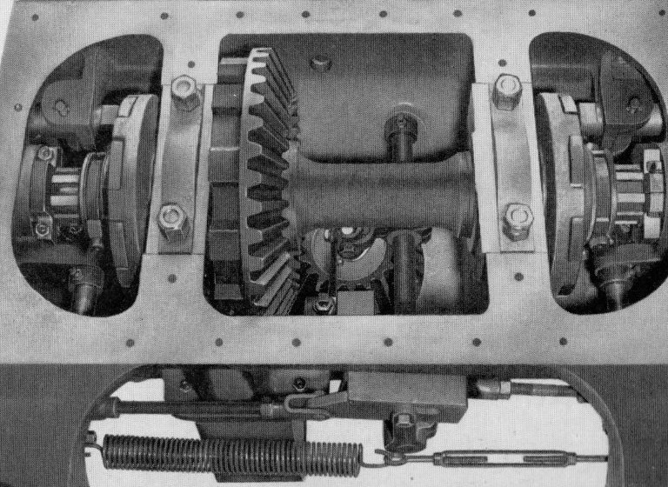
Ball bearing three plate interlock assemble

He wasn’t unpleasant or anything just quiet and not talking much but almost telepathic when working together, on some occasions testing my instinct for the next move but we still got on okay. I think he said he lived outside the City in Saxilby village. After lunch we got on with installing sprocket half shafts permanently, pushing them through and placing a clamping collar immediately behind the casting wall to retain their position after first mounting each dog clutch, sliding them over the splined portion with the reduced diameter locating in the main shaft counter bore. You can see this assembly in the picture below. He wasn’t unpleasant or anything just quiet and not talking much but almost telepathic when working together, on some occasions testing my instinct for the next move but we still got on okay. I think he said he lived outside the City in Saxilby village. After lunch we got on with installing sprocket half shafts permanently, pushing them through and placing a clamping collar immediately behind the casting wall to retain their position after first mounting each dog clutch, sliding them over the splined portion with the reduced diameter locating in the main shaft counter bore. You can see the undercarriage assembly in the picture below.

Clutch movement was by finger levers extending from a cross shaft directly linked to controls at the operators position with a combination tube and centre rod passing down inside the vertical propelling shaft; the tube for steering and the rod for digging lock pawls locating in circumferential locations on the main bevel gear. Even now the remarkable simplicity of some of the mechanisms used in arduous excavator duty never ceases to fascinate me. Every day brings a greater appreciation of what could be achieved with the simplest of arrangements. Here in front of me was a typical example. Both tube and rod were in two parts, able to transmit leverage from the operator’s station to the point of application, whatever the relative position of the upper and lower works, by using simple rotary tongue and groove connections between their two halves; a truly elegant example of mechanical inventiveness. The only disadvantage for us putting it all together was that if already in situ when assembling the rest of the truck it all poked out the top to snag on something so we left that magic bit till last. Talking of clever bits; the steering clutch operating linkage included a very clever device as part of the mechanism between the two yoke levers; a really neat feature. This was a ball bearing interlock of two plates sliding either side of a centre one having a communicating hole allowing the ball through for only one to engage at a time. The interlock assembly can be seen above the tension spring in the lower part of the picture immediately below.

While we had been working on mechanical detail the cabbies had completed their latest project. Now I had somewhere to hide. The service crane once more rumbled overhead, a shovel boom gift wrapped in a chain sling slung by the slinging duo slowly floating past to find its feet. Sometime soon, maybe late tomorrow or if not Thursday morning, another new shovel would be taking the plunge and out into Beevor Street. For now the smokey old flatbed had arrived again, this time carrying goodies for the truck frame division: two crawler side frame castings with Bob the slinger once again on scene to off load and park alongside.

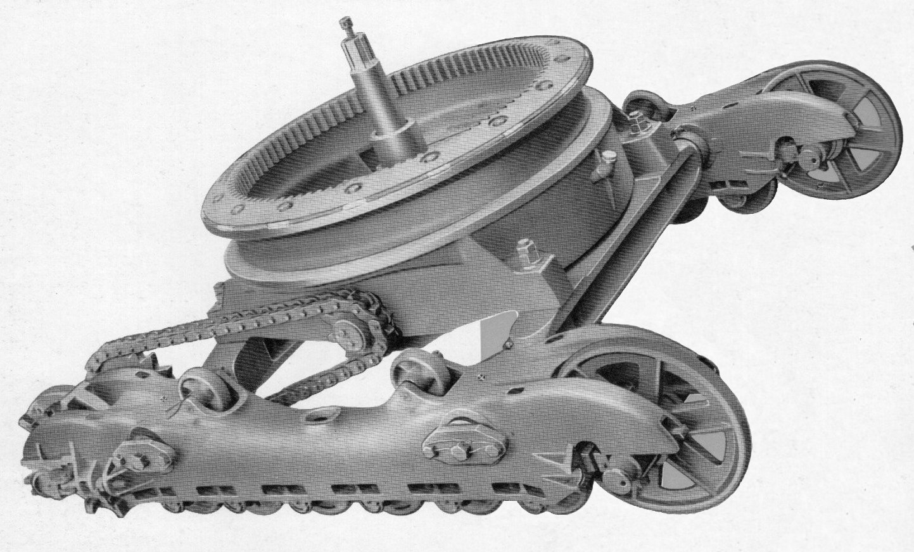
38-RB lower work undercarriage before mounting tracks

Before the first side frame was released however Dick directed them to be turned over with their bottom face uppermost, ready he said, for mounting on their axles when the time came and making installation of bottom rollers easier. Also on the flatbed were two take up and two drive tumblers and my mate winked and gave me a knowing smile as the smokey old Atki’ pulled away. “After tea break I’ve got a nice little job for you mate,” he said grinning broadly, “And here comes some of it now,” he added laughing, “Couldn’t have been timed better.” Just turning off the service road into our gangway was a stand-on pallet truck containing the bottom rollers. I looked at them and then accusingly at Dick who simply said, “Don’t worry; I have your welfare to heart. You’ll enjoy doing those, and don’t forget that God is watching you from on high.” As he said this he looked upward to the office fifteen feet above where lay the workshop superintendent's domain, Frank Phillipson. The brick built office block was next to the gangway and stretching for about thirty feet with offices only on the floor above. Below was all brickwork and I seem to remember a large louvered door as if for airflow. It might have been the compressor house but there was so much noise it was impossible to hear if any compressor was within. Partitioned into two halves access was from No 2 Bay leading up to a side door with the guvnor’s office backing on to Beevor Street and Allen and Sam, the clerks, overlooking into the works. Wearing a darkish style suit or sports jacket erecting shop superintendent frank Phillipson was always affable like everybody else in bay management. I found it to be a genuinely friendly place to work with plenty of easy banter. Even insults were tongue in cheek.

“Why only one Pallet?” Dick exclaimed. “There should have been another one with roller bushes.” It seemed he had been expecting me to bush and fit all the rollers as well as drive and take up tumblers. “They should actually come with bushes ready fitted,” he added, “but the last lot didn’t and we couldn’t fit them because they’re one piece and go all the way through. We’d need a press. Knocking them in by hand would take forever and a day so I had to send then back. Obviously,” he added, “a cock up which they put right. Okay that’s one problem we don’t have to check. What about dirt shields and U bolts. Do we have them?” I hesitated. “Err!-Dirt shields and U bolts? Not been delivered mate. Not here.” “That’s truly wonderful,” he said exasperatedly.“ “Do me a favour Taff. Go and see Allen up in the front office. He’ll give stores a chase.” So I climbed the stairway next to heavens gate where God was ensconced behind his desk and went for an audience with Gabriel next door. God was on the phone as I passed acknowledging my presence with a quick nod. Gabriel, AKA Allen, chased up our problem asking what had happened to out stuff and was told it was the truck drivers fault, pulling away in a rush before they had finished loading. Muttered words from somebody heard over the phone along with apologies and a message that the same driver would bring shields and U bolts around in the next half hour. With positive information to impart I went on my way. The stairway, a steep climb going up, was even more exciting on the way down after tripping half way and having to make a quick grab for the handrail. It also made a lot of noise bringing both Allen and Frank to their respective doors. Allen laughing just mouthed “Stupid sod while Frank enquired, ”You okay?” and then they both went back to their desks to re engage with the job before all the excitement.

Making my way back I wondered if they had been looking out the office window and seen the palaver at Dixon’s patch two weeks previously. More to the point had they realised who had been at the centre of it all. The bad fairy had been about that same morning and had it not been for the quick action of Arthur, one of the burner crew, things could have worked out very badly. It is over sixty years ago now so details are a little hazy. What I do remember is that I was manoeuvring a drumshaft gear hanging from the end of an air winch. A large gear looking around six feet in diameter and I was trying to lay it down. What has confused me is that the gear for the drumshaft was in reality five feet diameter. Why did it stand so high and look so big? It might have been partially standing on a board or something because there were gear teeth above my head that were slowly descending to meet my forehead. The winch mechanism worked by pulling on one of two handles hanging either end of a rocker control lever which had jammed and not returned to neutral when released.

The down handle was out of reach leaving me fighting the weight of the gear and losing. Where the Hell was Superman when you needed him? Couldn’t even think to shout for help but a shout did come suddenly from behind, the sound of heavy work boots clumping across the floor and a scrawny hand reaching out across my shoulder to grab the other handle. And then there was pandemonium and an urgent gathering with Arthur my torchy boiler suited hero making comments that this wasn’t their first time for jamming and the millwrights should be contacted urgently. The burner crew, of which I think there were two at our end of the works, patrolled the bays providing adjustments by oxy acetylene services as required and I was extremely grateful for his intervention. Charlie sensing my concern over the narrow escape had said to, “Leave the air winch alone for a while. If you need it have one of the boys do it for you.” No matter how I try to remember exactly what I was doing with that gear it still eludes me to this day. The only time we usually saw it was when it was mounted on the end of its drum shaft.

The tooth fairy had called and delivered our two track pad bundles while up in the office chasing dirt shields and U bolts but there wasn’t a lot could be done until they arrived apart from inserting pins into rollers so we called the crane over again, pirating it without an official slinger. Dick brought out his measuring stick to ensure they were rolled out the correct distance apart; we cut the strapping and then stood aside as gravity took over with us giving the odd nudge to help them unravel. A fun job because they had been bundled without their link pins, totally different from roller pins. I think there were thirty two track pads to a frame making 126 track pins in all to knock home with a heavy hammer. But as luck would have it the day almost done pin duty would have to wait. That afternoon had passed in a flash and people were beginning to pack up for the day the hooter sounding just as everybody was rushing to the washroom.

Wednesday
Thunder storm in the night so the roads were wet this morning and full of splashy puddles. Clocked in just as it was starting to rain again. Weather totally different from yesterday but at least we were working in the dry. Where did they put those track pins when the bundles arrived? In that pallet over there. After laying them out in rows ready for both sets for some stupid reason I decided to see how fast they could be knocked in. Less than half way through the first side already soaked with perspiration having to adjust my pace. Jimmy the roping up ganger just walked past on his way to the 38 with Charlie Creasy in tow, a fellow apprentice starting so long ago. They were supposed to have done it yesterday? Somebody else's plans had obviously gone awry. If they got on with it straight away it might roll down the ramp later in the morning leaving a bit more room for us to get on with the lower works on this one. Think on lad, think on! Bashing away at track pins and physically exhausted I came to lean against the upturned truck. Dick having declared himself satisfied that his part of the job was done the next phase of the operation was to attach the axles on which to put the side frames. He was outlining the plan when the hooter blew. So we downed tools and munched our way through breakfast sitting on a couple of empty wooden track pin boxes lubricating our thoughts with RB tea courtesy of the trolley lady.

The truck casting had four machined flats on the underside of each mounting lug to locate the axles. Put in place with crane assistance, and, with each sling chain being relatively long it was an easy matter to fold the throat of each hook back over on itself to make and slide a loop over each end to lift evenly into position. Foundation bolts were then inserted from the underside exiting at the top to be secured with heavy nut and lock nut; quite big bolts around 1 ¼ - 1 ½ Inch from memory. The idea was to pick each side frame in turn and slide it over the axle ends but not, Dick said, just yet. The truck was still resting on the timber balks and therefore, he said, a bit shaky for that kind of operation. Dropping it directly on’t floor would give better stability. We needed a sky hook. Nureyev was just finishing the delivery of a new prep frame for Dixon’s gang and looking around for another customer. Of Bob there was no sign so we called him over to lend his expertise and he was soon pirouetting, standing on tippy toes in his hobb nail boots directing operations, slinging chains loops to embrace the four corner lugs, taking the weight just enough for removal of the balks to repositioning with turntable flat on’t floor.

As well as making things more stable for sliding on the frames Dick, slyly eyeing me, announced it also made them just the right height for installing bottom rollers and end tumblers. So we hung on to dancer while we had him, slinging and steadying as we mounted each side frame in turn, chain wrapping to stretch over each end, taking the weight to manoeuvre and slide on; helped by Dick having previously anointed each axle with grease. The good fairy dully obliged our endeavours with both frames soon in position seated against dirt seals to be retained by custom shaped end plates bolted and wired secure. “Is it not it lunch time yet?” “Another half hour mate. Why? I thought you were enjoying yourself.” “I am Dick. I am.” “Get on with those rollers then and stop soddin’ moaning.” “Yes Dick. I’ll get on with these rollers shall I?” Then Dick had a thought. “Aah - just before you do the rollers let me show you something.” So joining him to peer into the truck he pointed out the propelling shaft end where the combination control tube would poke out when installed to link with steering and digging pawl locks. “I’ll do these when we turn it all over and you can feed the tube in from the top. Okay?” Next time we’ll swap and you can connect them.” It sounded okay to me so having agreed on an afternoon strategy we provisionally made a start on rollers and tumblers for the next half hour not putting much effort into it but planning our major attack for later and while we had been planning our attack the 38 by the doors started up, chuffing out clouds of diesel smoke ready to make its escape only to be thwarted by the wail of the lunch time hooter. Whoopee!

Afternoon
The return from lunch break always seemed very casual, with everyone just strolling back to their work station after clocking on but still getting there on time. There was nothing like working in a large factory. The 38 finally made its escape with Albert Smith at the helm, Phil turner assisting and Jack Scott the test department foremen walking in front but not waving any flag. They had sneaked in just as the hooter went off determined to ensure its escape this time. The usual clonkitty, clonkitty start up with rattlety, rattlety resignation accompanied by plumes of smoke before settling into a steady work rhythm as it rumbled down the erecting shop ramp and reached out into the world. Fortunately no longer raining it was a ten minute walk in the dry for Jack as it tracked its way to the test field. My own presence there was still some way off into the future as I surveyed the six heavy rollers before me. They could have been lifted manually but doing a whole bunch of them would leave me creased so I used the air winch. Task order was pushing the pins through before mounting dirt shields on the bosses and then winch into position to rest on the flattened pin ends I saw being machined some months ago in No 5 Bay. U bolts were then dropped over the dirt shield grooves and into their securing holes for ‘nutting up.’ While I was faffing around with that little lot Dick was having fun with take up tumblers one end and drive tumblers and the chain sprockets at the other. Mounted on circumferential splines both reminded me of their production method on an Adcock & Shipley horizontal machine. Drive tumblers were ten spoked wheel casting having side lugs positioned adjacent to the spokes to engage with vertical ones on each track pad. Press fitted onto the axles they ran in bushed bearing blocks each side which were supplied to us without bushes so we had to fit them ourselves. Another job bashing them in with our little dollies and I wondered how some time in the future they would be removed from the blind hole for replacement because they were completely knackered.

Working with everything inverted certainly made things easier for assembly, and with bearing blocks now ready on their axles along with drive sprockets my roller installation was temporarily abandoned for us to join forces, slinging first one side and then the other with a wire strop to lift into place on each frame end and loosely secure their clamping bolts along with eye bolt adjusters. Take up tumblers were next and a lot simpler, running free on a plain bushing. Slack adjustment for these was obtained using temporary jacking points, the tumbler shaft having flats on both ends sliding on the mating under side of the frame with working position secured using spacers between locating flats on axle and frame faces. By the time we were done afternoon tea break was a welcome respite. Resuming activities after the trolley lady had departed I pondered our next move which was a big one; wondering exactly how we were going to accomplish it. Having done all we could with running gear it was time to think about tracking up but everything was still upside down and as I stood surveying the scene Dick said, “I see you keep looking at the truck frame?” It looked like it was going to be tricky although of course he’d done it many times before in my absence. “It happens every time with apprentices when we get to this stage,” he said and then asked,” So - how are we gonna to do it Ginge?” All I could think of until inspiration struck was,” Very carefully.” Because somehow we had to lift either one or both ends to get the propelling shaft clear of the hole in the floor and then manoeuvre it the right way up. Dick saw my quandary and said something completely unexpected. ”You see that rack,” he pointed to the rack in question, “Third cubby hole down this end we keep the grease nipples. Dig a few out for the rollers and tumblers we’ve just done and any places we might have missed and I’ll go see if I can grab our slingers.”

We were going to use both cranes again and a few minutes later he returned to be followed, after another five minutes, by Beano and Nureyev. Before commencing he outlined the job ahead drawing my attention to the drive tumbler end facing south into the works. “What we have to do is use the two cranes to lift the complete truck and manoeuvre it to hang from the opposite end. When it’s suspended in the right position we release the other crane. Keep an eye on the way the truck hangs,” he told me. “It’s quite a delicate operation and we need to keep sharp and have our wits about us while we’re doing it. We haven’t had one go wrong yet and we intend keeping it that way. What you should do is stand clear and observe. From your point of view it should be quite educational. Manoeuvring heavy stuff like this an important thing to learn - if you don’t mind my saying,” he added and no I didn’t mind at all. I thought it very helpful the way he explained it all. This was going to be interesting.

Lifting & Turning Truck No 2
Nureyev was sorting out the crane hooks at the back of the truck wrapping large chain loops around each side of the axle, but away from the mounting lugs to allow rotation later in the operation, while Beano worked at the front in similar fashion. When Dick was happy with everything Beano took charge of crane signals, operators taking the weight both ends, the complete assembly slowly lifting from the floor with the drive tumbler end slung from the south end crane. On a signal both cranes slowly floated it across the shop to centre it over the tracks and halfway along their length. When both Beano and Nureyev were satisfied with the position Beano signalled for the cranes to do the operation they had performed many times before. The drive tumbler end was raised while at the same time opposite end being lowered so that it was just off the floor for the chains at that end to be removed. The single twenty five ton overhead south end crane was now carrying the full weight of cargo on its hooks. This was the crucial point because the weight of the truck and side frames combined made it hang tilting in the wrong direction canted with the turntable leaning south away from Beevor Street. Somehow it had to be persuaded to lean the other way. Both slingers now got a hold of the hung end and spun it through half a turn. They had a well tried plan easing it down to engage with the track pad grooves and drive lugs, with a bit of weight and a little bit of lean and then the pulling it over the balance point with the crane to tip and lie it down in the right direction, drive tumblers south, helped along by placing bars through the spokes of each tumbler to stop it rolling.

I have to say I was impressed; the operation being accomplished quicker than expected with the whole shebang sitting comfortably in place in very short time. It made me smile seeing Beano remove the second chain sling, momentarily thinking that we could now pull the tracks on but hang on a minute, half a mo, the upper two rollers still needed fitting so that would have to wait till morning. Dick also reminded me the combination control tube still needed to be poked down the centre drive shaft and connected. But time had beaten us for today Dick making the comment we were still probably running just about parallel with the rev frame crew for a marriage some time mid morning tomorrow. He would no doubt have been surprised to find me also thinking on the same lines with ‘thinking on’ occasionally leading me to look in the direction of rev frames to establish what stage of build they had reached. Yesterday late morning they had been putting the Paxman power unit in place and were now making ready to fit the A frame. However! Those top rollers? Not as big a job as the bottom ones but still needing to be done; easily left till the morning there was no rush. Dick wasn’t pushing but somehow I thought it would be good and ’tidy’ as we Welsh like to say, to finish off the day with them out of the way and if I put a spurt on I could just about do them before clocking off. Not load bearing like the bottom ones and not having any bushing it was a quick job to mount them, sliding the pins through and securing with T bolt locks. Tomorrow’s going to be other day. I’m off. Tara! See you tomorra’. Que Sera, Sera!
Thursday
It was smokey first thing but it wasn’t that old Atki’ delivering stuff, it was a Leyland with a couple of castings for No 2 Bay machine shop. Blue grey smoke and it stank; needed its piston rings sortin’ or sumat’. They were for the 19s and 22s. The revolving frames for them arrived on a regular basis. I was going to ask Charlie Everitt if we could do a trip to the foundry in the Midlands where they were made but just never got around to it. That would have been worthwhile. The same vehicle also delivered 38 and 54 castings collecting them after machining. I assumed that with regards 22 stuff, so many were being built that rev frames and trucks went straight to No 18 Bay from the machine shop. It was now the first half of 1961 and records show 22-RB production for that year was 587 and even the year before it was 498. They were almost going flat out with even higher figures to come. 30 and 38-RB production was also doing well with 55 machines built in both 1960-61 for the 30-RB and 60 and 76 for 38-RBs in 1960-61. I was there helping and never knew it but somehow my stint on rev’ frames only seemed to take place on 38 and 54-RBs. It was only on the drumshaft gang that I had time with the 30 but even then not on the rev frames. 54s were being built in healthy numbers at around this time: 26 in 1960 and 46 in 61. I just assumed that because they took longer to build and their castings were so large that they were stored in the yard till needed.

It was time to mount the track pads and I was interested to see how this was done. After working with Dick first thing to install the combination control tube through the prop shaft there was one more job while the crane was organised to give us a pull; the sump. I hadn’t given thought to such a thing as a sump but of course gears needed constant lubrication the main bevel gear was always semi immersed in the appropriate oil. I’d only just got it all lined up ready for bolting when the crane rumbled overhead again upsetting progress with my carefully arranged wedging. Nureyev’s real name was Wilfred, commonly referred to by others as Wilf’. It was only me who’d re branded him thus although mostly keeping it to myself - mostly. The side frames, now with top rollers fitted, stood with the drive end pointing south into the shop so on his arrival bringing the crane we abandoned my lovely sump, pulled the truck back a couple of pads worth, poked a bar through the pin lugs of the pad we were going to pull, then looping the chains around it dragged everything across after blocking the spokes to prevent truck movement. Not quite as straight forward as it sounds because what the crane driver had to do was lift the track belt off the floor so that it was nearly all hanging and then slowly bring it across the top of the frame while lowering off at the same time. If he got it wrong and didn’t release enough the action would move the whole truck even though it was blocked so it required more than a little concentration.

Once laid, with plenty of slack in the tracks, it was an easy job to knock pins through the ends to join up and after treating the opposite crawler belt the same way we were almost there. All we had to do, apart from the sump, was fit drive chains which too heavy to handle manually made it another task for the crane. I could swear I’d seen somebody using a hand screw device for lining up the pins but Dick just shook his head and showed me his own trick of looping string through mating link ends and pulling them together. Gave me a funny look when I asked him if he’d done any knitting. Pinned up we carried out preliminary adjustment to chain tension leaving the best part to Test Department for their more practical tension analysis and having completed our bottom end build relinquished ownership to hand over to rev frames for the topping off. So as we stood admiring our handiwork Dick took the opportunity to fill me in about our next batch of crawler bottoms. They would be another standard shovel with the two machines following extra long draglines. He’d spoken to Charlie Dixon earlier hoping for the topping off shortly before lunch so in the meantime started to organise things for the next truck casting already delivered and standing on end. It had been a busy start to the day with everything going according to plan and already time for a brew… but something nagging at the back of my mind. Told you Dick was telepathic. As we sat down to sup he suddenly pointed looking at me, squinting with eyebrows raised above a quizzical facial expression and said, “Sumpthing bothering you?” Sump, sump. Hell’s teeth! I’d forgotten the piggin’ sump.

Crowning Truck No 2
After break and whilst correcting my oversight Philip and Simon wandered across bringing the hook rollers and pins, laying them on the front and rear of the tracks while Beano, along with Bob his regular partner in chains now recovered from sickness, accompanying him as the rev frame floated boom feet first across the service road. From somewhere nearby the anointing ladder appeared and was put up against the gently swaying side platform for Phillip to climb aboard and take up aiming position over the propelling shaft hole. Charlie followed to ensure everything went according to plan and take the blame if it didn’t but it was a well rehearsed procedure. Lower, lower a bit more, Phillip calling opening and closing his fist and then a very firm snap closed STOP! Rollers rolled, roller pins jiggled and pushed home with clamping rod through the pin centre screwed in to the lock plate at the end of the pin to keep it in place. As soon as the crowning operation was completed the lifting tack was swung away to be stored ready for the next time and everybody went about their allotted tasks toward completing the base machine. I was on hand to give them my willing assistance and ready for lunch at the Ruston & Hornsby canteen with Dick who surprisingly decided to accompany me and give his own verdict on fish and chips with gravy.

We didn’t normally have much of a conversation during tea breaks. He wasn’t one much for talk, I think he preferred telepathy, so I was just trying to think of something relevant to say when he took the initiative asking if anything interesting had occurred over my last weekend. Well yeah! As a matter of fact - with the event still fresh in my mind - I enlightened him about moving from Swanpool to find new lodgings at West Parade, just a couple of hundred yards or so from the old racecourse. “Aah yes!” he said, nodding sagely. “The Lincoln races used to be a regular thorn in the side for RB with people taking time off. You wouldn’t believe how many funerals and weddings occurred while it was on. There was a rumour that management were asking for photographic proof of the weddings because so many were taking place outside of Lincoln. They couldn’t do anything about the funerals though,” he added. His comment reminded me of an incident during my first six months in apprentice school not long after starting.

The last farewell to the Lincoln Race meeting had been taking place and one of the apprentices had called in sick. It was unfortunate that a company director, also a horsy fan, had been watching it all broadcast on television, a memorable event for the City whilst also sad. The apprentice in question was the son of a local customer owner of a 22-RB working in his gravel pit and by sheer bad luck the director’s eye alighted on his face in the crowd which he knew quite well from contact with daddy. A question was asked and quickly passed on to Mr James the apprentice supervisor at the time. Jacko was summoned to his office for a dressing down but the way he told it afterwards he said it was for an autograph since he was now a local television personality. Everybody knew about it but not whether daddy had voiced displeasure at his son who didn’t care anyway; a rather carefree character who soon acquired legend status amongst his peers. The story seemed to go down well prompting Dick to open up about his own background living just outside Saxilby village. I thought he’d lived on the hill near the Cathedral but it transpired that it was in an old country style cottage with his wife of around five years in their spare time running a small holding business, with chickens included, which immediately explained his fondness for the hard boiled eggs that he regularly cracked open for morning tea break. He was just about to elaborate on the chickens when the hooter went off and we had to make a run for the clocking hall.

Thursday Afternoon
The cabbies had put a spurt on dropping the new one into place the machine almost finished, Simon now working on top fitting the exhaust system just as a shovel boom arrived with Lenny from equipment following as we started build procedure all over again on another truck. I was beginning to know shovels intimately, but just how many had I built now? However, it was the extra long draglines scheduled for one or two machines ahead that I was interested in. The longer crawler frames had to be handled in a slightly different way when turning them over; the two additional rollers on both top and bottom helping to alter balance. It would be interesting but for the moment we had to make a start on the latest truck casting standing on end waiting in front of us. This one was going to be another standard shovel?

Legend has it that volunteering does not always turn out well but at the time I foolishly considered it ‘the right thing to do’. Dick had done the job last time and fair’s fair I considered it the right thing to do now. I should have had more regard for legends but even so still volunteered to install the cross shafts with tension levers, shifter levers collars, reach rods and steering levers. Importantly along with these items must be added the turnbuckle and tension spring stretching majestically next to the slotted three plate assembly with the ball bearing. That spring wasn’t just any old spring. It was quite large in diameter with tight coils that gave it a too tired to pull appearance, looking like a big dead caterpillar. Its appearance was deceptive and in fact to hook it up to the end of the turnbuckle Dick had to loop a spare piece of rope around one end and lean back on it while I guided them both together. But before we got that far I was leaning over the upturned truck fiddling with the slotted plate assembly which for some reason seemed to have jammed.

Nothing else for it but to disassemble; just sliding them apart when the cotton pickin’ ball made its bid for freedom, bouncing once on the hard floor and rolling to a hesitant, taunting halt on the very edge of the prop’ shaft hole before making up its mind to disappear into the void below. Dick saw it all happen and didn’t stop laughing for a full five minutes. “Ha-ha-ha-ha-how are you going to get it out of the ‘ole then Taff?” he gurgled. But I was too occupied in my dismay to answer as two important thoughts entered my mind. First: Had we got a magnet? Second thought: The hole was at least couple of feet deep. Not a chance even if we had a magnet. “There should be more balls left in the rack where you got the one you just lost,” Dick chirped grinning. He’d actually been doing some kind of stock check when disaster had struck. Then he imparted the information that up in the front office in one of the desk draws was a magnet tied to a long piece of string; something management called forward planning. It was good to know these things but for the moment ball recovery would have to wait for another day. We were just about finished putting it all together and waiting for the axles to be delivered when Sam stuck his head out the office door and called down asking for Dick; two fork trucks with pallets just coming down the gangway as he answered the summons from on high disappearing up into the office to return a few minutes later. Was it good news or bad? “Change of plan mate. There’s a panic on for the two draglines so the side frames arriving next will not be standards. They’ll be long’uns.” I liked the sound of that.

Complete Truck Build No 3
Then the wagon came with our two axles, extra long side frames, and additional top and bottom idler rollers and pins. Bob showing up instead of Beano quickly setting about offloading, positioning things remembering instructions the last time as he upturned each side frame ready for mounting. Sam’s message had come like a gift from the gods, maybe from Frank Phillipson himself I thought, and we were ready for any programme change. Apart from my runaway ball bearing putting it all together had been without incident, just a repeat of the previous truck, although now more familiar and knowing what to expect. It was only on these extra long crawler frames that things would be different with the additional rollers and overall length.

So once again it was addressing each axle, spreading the chains to fold each hook back on itself making a loop to slide over end journals and lift into position, foundation bolts pushed up through and lock nutted secure. Slings were then re arranged with separate loops spanning axle ends and hooks running back onto the main suspension ring, weight taken, timber balks removed and the upturned truck turntable allowed to kiss the floor ready to receive side frames. Did we have all the bits ready for the side frames this time? We’d had a pile of rollers delivered quantity now correct at sixteen for the long ones. Yes! All the dirt shields and U bolts with nuts were present as were the eight top idlers and pins. Dick was looking at end tumblers and nodded. We were under starter’s orders but so was the tea lady just coming down the gangway so we sat down, supped wp and girded our loins. Like the side frames the set of chains Bob was using were also extra long. He had a saying, “Be kind to your chains and they will be kind to you.” The guy was a poet. With axle seals and packing already in place and frames already upturned Bob wrapped them around each end of the first one, getting it to lie level before guiding over the axle ends. As before; Dick had greased them so all seemed to go according to plan even working with the extra length. The second frame however, although manoeuvred in a similar manner, came under attack by sods law deciding to jam when half way on necessitating a big hammer and lump of wood along with much industrial language before it gave up the fight, but we still needed the crane. Dick wanted to use it for drive and take up tumblers while muggins used the air winch on bottom rollers. And so we slogged away helping each other when necessary right up until the hooter at the end of the shift with one take up tumbler and three bottom rollers still to do.

As far as I was aware, although he hadn’t said anything directly, Charlie Dixon was not best pleased with the change of programme. They had been well on at No 3 position with a shovel backhaul unit in place. This was the machine due to be mounted on the truck we were now building. “! Wonderful,” said Dick. It won’t mess us up but Dixon’s mob will have to remove the backhaul unit and change the laggings back to dragline. That will really put the cat amongst the pigeons with their schedule for at least another couple of hours. I bet Charlie’s really pissed off about that”. With my limited experience I didn’t think the time involved was going to matter that much but it had slowly begun to dawn on me that there was beneath the surface an intense unspoken rivalry between truck and rev frame sections. There was no animosity however. It was just professional pride in being able to deliver on the schedule given even when it threw in a few googlies. Neither gang wanted to be seen to be holding the other one up when it came to uniting top and bottom and Charlie was keeping a close eye on the trucks while Dick was doing likewise with rev frames. The current machine build was now a race that both gangs would hopefully meet together at the finishing line.

Friday Morning
So the morning began with concern. There were just the leftovers from yesterday to complete: bottom rollers and then we could put the truck right way up. But where were the track bundles? Hopefully, although they were late, perhaps the nightshift fairy could work overtime and still bring them? It was practice for the assembled trucks to be dropped straight onto them and Dick was concerned. “This needed ‘sortin’.” It was really going to put our own build schedule off and thus with square set jaw he walked purposefully over to bottom of the stairway that would take him to the OK Coral at the top. Should I tell him that he walked like John Wayne I wondered? Oh this was so embarrassing. Just as he reached the top that smokey old Atki’ reversed up the service road again with his track bundles. He was he told me afterwards, stood at the door just about to enter, hand on the knob, fingers twitching about to swing it open, anxious faces looking back at him from within. Things could get dramatic at times.

There was a lot of work to do. With extra pads the frames were almost four feet longer than standard with forty more cotton pickin’ pins to knock in. Oh this was going to be fun. Then surprise, surprise, while we had been slumbering the good fairy had been really busy. As we rolled them out we saw that they had in fact all been pinned. Dick was definitely relieved. Still, it seemed, going to be on schedule he briefly glanced over to rev frames as he brought out his spacing stick ready. Now we could turn the complete caterpillar frame right way up. However the altered the centre of gravity had changed the dynamics just a tad so hanging and manipulation methodology would maybe undergo modification. The crane was more likely to pull itself off the rails if things were not done right so a revised method of slinging perhaps?

The north end crane, under Bob’s direction having laid out the two track bundles, was now parked with chains wrapped around each side frame at the take up tumbler end. Further up the bay Beano had been supervising a lift on 54 build and having been tipped off about our operation arrived with the other crane in tow, chains dangling ready for action. Beano now slung them around the drive end axle at the south end and working together the complete truck was lifted well clear of the hole, higher at south end, to suspend vertically just clear of the ground. North end chains were then released allowing the assembly to be spun 180 degrees before re attaching to level up and float across to rest in the roller paths. It was indeed an interesting operation demanding the highest level of concentration from the crane drivers, an essential part of the team and I considered it a privilege to be there, the skill shown not going unappreciated. All that remained to be done now was fit the four top rollers before pulling the crawler belts over. That too would be interesting but first get on with those top rollers; Dick working one side with myself on the other. But there was still something that should also have been done before we turned things up the right way up???? Nipples, nipples, nipples. I hadn’t done the cotton pickin’ grease nipples, a ghostly voice quietly whispering into my left lughole, “Promise meeee…..” So before Dick could remind me, because as sure as eggs is eggs’ he was going to remind me, I went over to the rack and got a couple of handfuls and did what I should have done before I forgot to do them; looking over to Dick responding with an exaggerated smile as the hooter announced it was lunch time.

Friday Afternoon
We were ready to wrap the tracks but now, sods law, there were no soddin’ cranes available. Preoccupied with business our end we’d not been looking to see what was happening at the other with Stan Simon’s crew on the 54. They were just then preparing to lift their latest frame and marry it with the bottom half. Bob had gone back there with Beano to sort out the purpose made rope harnesses for the rear end and loops for the boom foot pins. So it was going to be some time yet and we would have to be patient and wait while hanging around. Dick therefore was not happy, looking a bit nonplussed, frustrated even until a eureka moment when either he read my mind or I read his and we both had the same idea. Go and get ‘The combination tube.’ Having already assembled the four pieces to make it a complete unit Dick was almost a blur recovering it, returning hot foot to poke down the propelling shaft while muggins slid beneath to grab the other end. As I said earlier: looking good is being seen crawling out from under something heavy and technical with a spanner in yer’ mitt. Ducking down lying on my back beneath the truck, fiddling with the connections was a good move. The outer tube for steering was attached to linkage each end with dowel screws set in a surrounding outer collar having cut-outs permitting finger levers to pass through engaging mating slots in the digging lock rod within. I reached up to receive the bottom end of the tube, fiddling and faffing around to connect the lower collar with the dowel screws. Then a bit more messing around to get the digging pawl finger in the control rod slot and we could think about the sump.

The dowel screws reminded me of No 4 Bay. They were the same ones as made by Harold on his capstan lathe, was it almost two years ago? I hadn’t seen him for a long time and wondered how he was getting on. Funny how those little things stick in your mind. Finally linked up Dick operated both from the top to check and then I was able to make my grand exit crawl from underneath. A few weeks previously on rev frames, when fitting the swing pinion the crew above had dropped the power unit into position very heavily causing the whole lot to shake. Underneath something when that happens is not always good and as if to remind me, just as my crawl began, there was another tremendous crash just a few feet away; almost banged my head in reaction. It was from the cabbies this time. A sliding cab door they had been attempting to put on rails had missed the target, pivoting on its bottom edge to swing out from the cab and dropping some distance flat on the floor. “Sorry about that,” they said. “Err sorry.”

So that was done and dusted. What now? Hey up Dick. It’s time for us brew. So we brewed up, supped up and went back to work. Should we fit the sump Dick? “Best leave it till we’ve got the tracks on. We’ll leave that till very last,” he said looking around obviously frustrated that we couldn’t get on with things till we had a crane. Suddenly without prompting my mouth asked if he would mind me going for a walk up the other end of the bay to watch them dropping the 54 rev frame onto the crawler base. “No, no. That’s okay he said there’s not a lot we can do around here till we get the crane back.” My out of control mouth now replied, “I’ll ask for our crane while I’m there and on the way back look at how rev frames are doing.” A puzzled frown began to crease his face, a question about to be asked which was never uttered because Taff was already on his way. The 54 took up a lot of space and with the amount it overhung the tracks at the rear it gave the impression of tipping over with very little persuasion. Its rev frame had been lowered into position with hook rollers being attended to as I arrived and stood watching. Stan Simmons the charge hand was stood alongside and acknowledged my presence with a quick nod.

Charge hands could often employ cruel wit with apprentices as Stan now did with me. “Oh gawd no! Here’s trouble. Take cover everybody.” he yelped looking deeply troubled. I responded in kind. ”Too late Stan I’m here.“ ” You lost Taff or are we about to enjoy the displeasure of your company permanently?” Stan’s idea of easy banter. A couple of fitters standing on the machinery deck noted both my presence and Stan’s quip laughing in response. “Just came to see the lie of the land and if you needed my expert assistance.” Having now been there a couple of years it was quiet an acceptable and inoffensive reply and typical of the sort of working banter an apprentice could enjoy with some of the senior personnel. There was no lack of respect intended and all said in good fun. It was also a fact that I would soon be joining his gang so there was no harm in sewing a few good natured seeds. He also had a sixth sense as to my real mission offhandedly saying, “You can have the crane when we’ve done here. That’s what you really came for isn’t it?” He saw me trying not to laugh at being found out and dodging the gentle barb telling him that my visit was in preparation for joining his team and wanting to see how they handled a 54 coronation. He nodded his head knowingly, sticking his tongue firmly in cheek saying with a wisp of humour and looking me in the eye with a half smile, “We will be sure to give you a very warm welcome on your arrival.” With that he turned around chuckling softly as he made his way back through the detritus and racking of 54 machine build to his ganger’s desk.

Beano busy at the rear end unhooking, and an unwitting but keen listener, soon got the gist of my visit asking if we also needed the rope harness. “Just a set of chains mate; we’re pulling the tracks on. Only need the one crane.” So his buddy Bob brought our crane back five minutes later after parking the harness in exchange for the usual chain set. It seemed that B&B had their own little team working arrangement. Every other job or so they would change authority and swap command. At RB for the best part of their working lives they had developed an easy relationship and obviously got along well. “O’w’s that truck looking mate. Is it rollin’ yet? Phil asked as I passed him on 38 ground on my way back. “It will be. The crane is on its way and we’ll be pullin’ tracks on very soon. You ready to fly your kite?” “Don’t you worry young fella we’ll be there.” he replied with a grin. I expected the kite he was working on would be taking off tomorrow morning……..? But of course it wouldn’t. Tomorrow was a Saturday. I could see Charlie watching and listening out of the corner of my eye so gave him a quick “Hi Charlie Y’alreet?” before drifting back to my own gaffer at truck frame land to tell him what had transpired. Our crane arrived chains swinging in anticipation with Bob eyeing the two ready laid out track sets. The standard length had thirty two pads these extra long sets had another ten. A hundred and sixty six pins to knock in but thankfully we didn’t have to.

We got down to business straight away blocking tumbler spokes to prevent truck roll and attaching chains to drag them across the top. With eighteen pads sitting under the frame the twenty four remaining were picked up as before but not so freely. Twenty two feet worth now hanging with limited headroom made things tricky, the additional weight affecting manoeuvrability with potential for displacing the truck assembly. The answer was to limit the lift height and drag them just clear over the end in short paced movements, nudging over the top rollers with pinch bars and one final tug to assist pinning together the end pads; an even more interesting operation than the standard truck and satisfying to have been present during the exercise. Fitting and adjustment of drive chains and initial track tension completed the job, apart from the sump which Dick was then happy to fit. Delaying it might have been due to his belief that doing it before full completion would be presumptuous and bring bad luck? But the truck was done and apart from it being nearly knocking off time how were we going to fill the rest of the afternoon? The coronation wasn’t going to happen until Monday.

But we had not been forgotten. Sam suddenly came out of the office and called down to tell Dick that another truck casting and some other bits were on the way and should be with us shortly so we could get them parked up ready for next week. Dick nodded his head in response and, seeming to remember something else, walking over to a section of racking stood against No 4 Bay dividing wall. He poked around for a minute and then turned to me with an instruction. “Go and catch Sam up in the office before he goes off and ask him if he has a piece of string?” The penny didn’t drop. “We seem to be short of a ball bearing?” Again there was a question mark and a glimmer of light began to shine in the furthermost recesses of my memory. Dick began to chuckle. “You know the piece of string don’t you. It’s the one with the magnet hanging on the end for recovering ball bearings.” As he said the last of the sentence with emphasis he moved over to and looked down into the floor hole. ”That one there; the one that you lost yesterday afternoon. You’d forgotten about that with all the excitement we’ve been having around here.” “ Oh! Okay then. I’ll go and ask Sam if he has a piece of string in his draw with a magnet on the end of it shall I?” “Yes go and see Sam.”

A daft conversation yes but I think we were both feeling a little light headed after finishing the latest truck. Sam thought I’d gone to see him about something else saying, “That was quick. Is Dick okay about it?” Confusion? “Okay about what? I just came here to see if you had the string with a magnet.” More confusion and he shook his head. “Say again. Yeah, yeah. We have a string magnet but I was on about Charlie Dixon wanting to borrow you and was he happy about it?” “Err! I don’t think he knows about it. Shall I ask him and why does he want to borrow me?” Sam was beginning to look even more confused. “Charlie was a man down this afternoon and somebody was supposed to have asked Dick this morning............” he trailed off. “Never mind. It’s too soddin’ late now anyway. The afternoon is almost gone. What did you want anyway?” He had already forgotten and then with me remembering why I had come as I turned to go I mouthed Magnet to him and he pulled a bottom draw out from the desk to rummage around and place said magnet and string in my hand with a questioning look on his face to which I responded by mouthing, “Ball bearing.” But he still didn’t seem to understand which gave me a small satisfaction not having to explain’. To save one’s reputation some things are sometimes best left unsaid.

Monday Second Week
Crowning Truck No 3
Coronation morning had arrived and the slinging duo Beano and Bob were rearing to go. Within a short space of time arranging the latest rev frame, now re fitted for dragline duty, slowly gliding across the great divide of the north end service road. Watching it I was trying to sort out confusion in my mind. Was the backhaul unit they had removed for converting to dragline the one I had put together while it was on the frame or was it one of the other ones? Things had been swapping around a bit and I wondered about Lenny. Things were getting confusing. How was he coping with dragline booms? Dick had quoted some industrial poetry at one point and said, “Poor sod probably doesn’t know if he’s on his arse or his elbow.” Well read wer’ Richard. The crawler frame with tracks and drive chains fully adjusted was now waiting with its vertical propelling shaft poking into the air searching for its target gear. Keith was acting as spotter this time calling out alignment steadily lowering to level for pushing the roller pins home and adjusting. Not invited to assist in the ceremony this time I volunteered my participation anyway as an affronted member of the truck frame builders crew; me and Dick will see about that! Collecting the last hook roller pin a lone apprentice wandered purposefully across to join the action, hiding beneath the rear end until he could shove it home. As usual there were other things to finish off but nothing to do with me.

As soon as the remaining adjustments had been made with the rev frame crew the cabbies would pounce and then Lenny would arrive from the equipment section to mount the fairlead and install the boom. At the moment before all this had got underway Dick was stood in conversation with Charlie so I asked what they had planned next on the agenda. They held my future in their greasy hands. I was it seemed going to be lent back to Charlie to remain till lunch by which time truck frame section would have more components at hand and more space in which to play with them. It seemed my immediate challenge was to assist rearranging the group of pedestals carrying the next dragline frame standing at No 2. It was now ready for bolting on the rear casting after which it could be moved to position No 3 and soon the big hooks would arrive. I do hope you are following all this. You’re going to be with me for the rest of the afternoon. If you had anything else planned forget it. You’re with me and you can watch over my shoulder while I get on with the rest of the afternoon.

The rev frame crew were down a man again and Dick said he could carry on without me for a while until the rest of his stuff arrives. Charlie reckoned they were behind schedule and needed to claw back the lost time lining me up the job of fitting centre bosses to transmission gears for swing and propel shafts after doing the pedestals. What’s all this huh? Suddenly I’m in demand. He asked if I minded helping out and I actually I told him, “No problem Charlie. Desperate problems require desperate action. But if you need my help you must be really desperate.” Try for humour whenever you can. Then while rooting around for bolts my old mate Phil’ sidled up and asked, ”Charlie set you on doing the transmission gears has he?” “Yeah, Why?” “Well there is other stuff that needs lookin’ at on the prep as well. Just thought I’d let you know in case you get bored,” he snickered trying to stifle a smile. So the rest of the morning they just left me alone to carry on and carry the can and then after dinner Dick said he couldn’t let me help out any longer or he’d be getting behind as well as Charlie. So! Suddenly I was a key player. I’d have to write a report to myself reminding me of the date for the future.

So at this point I will just sum things up. My first week had been an enlightening experience and one that I had enjoyed. This week would be a repeat but more relaxed than the first and that was how it panned out. Late on Wednesday afternoon I think it was we were ready to mount the next dragline rev frame. Charlie’s missing fitter now back fit and healthy and keen to make up for his absence last week was making his presence felt during the operation presiding over it like the Archbishop of Canterbury at the Queen’s coronation. My stay with Dick lasted around a month during which time we shared out the work like for like and I believe we became a good team. The next few machines after the two draglines were four shovels so it was never boring. When the timer came to move on I had assumed it would be to Stan Simons gang on 54 build. Oh how wrong can you be? But let’s have some light relief. Let’s talk about Lincoln itself and how things were in the wild and woolly days of the sizzling 60s. It’s mostly been about work so far and I’m sure you feel like a bit of a break from it all.

Days Of Freedom
It was a good time to be a teenager, the new classification of youth for age thirteen to nineteen, possibly; from aged twelve? National service had been cancelled in 1956 so your education could be completed with a university degree without interruption. Even better for the less academic you could perhaps get a trade or apprenticeship without having to do compulsory time for two years in the army, navy or air force. With more youth now having jobs with cash a new kind of music had grown in turn spawning teenage Skiffle or Rock groups with guitars as their main instrument leading to its own recording industry and dance fashion. Lincoln had a number of bands and I was pleasantly surprised by a local one that came to play one Saturday night at the YMCA which I discovered quiet by chance after a visit to play a game of snooker. At the time it was not a game that grabbed a lot of attention. Certainly not the kind which came later in the 1980s with matches being televised. Below the snooker room located upstairs on the first floor was a small concert hall used for various events and where the group would practice, totally at odds with the legend of misspent youth reputed to have been spent in dark and dingy downstairs snooker halls!

The vocalist, while not having a strong voice, did have stage presence and all the movements with the backing group in tune supporting with drums, bass and lead guitar. Played with enthusiasm I was particularly struck by the casual skill of the fair haired lead guitarist with a similar looking instrument to the Fender played by Buddy Holly. Getting to know each other over time we seemed to be on the same wavelength and on one occasion he kindly lent it to me for a weekend. With an enthusiastic bass guitarist they soon regularly featured at the Drill Hall Saturday night hop. Over time well known recording bands came to visit there, memorably Vince Taylor, The Hollies, Johnnie Kidd & The Pirates and other up and coming ones. When well known groups came I always tried to arrive early, with Johnny Kidd and the Hollies being two groups with whom I chatted as they were setting up. Vince Taylor had made a number of television appearances and by the time he actually came to the Drill Hall a couple of friends and I had already visited his local playground at the by then famous, 2i’s Coffee bar at Old Compton Street down in the Soho district of London.

A few lads had their own guitars by then with three of us on one occasion taking a trip down to London and touring the music shops in and around the Soho and Charing Cross district, our favourite one being Selmer’s on Charing Cross road. You could look around and show interest and get to handle the same Fender Stratocaster model as Buddy Holly had used. The price then was a mere £149, or was it guineas? Dave, a full time student and friend I had acquired along the way was really into Gibson guitars, owning one but not able play well, although he had ambition. He was a brainy sort of guy in Physics and eventually moved down to London to become an actual real life rocket scientist sadly losing touch when I also left Lincoln. I often wondered how he faired in life. Carnaby Street was in full swing nearby giving me my first taste of a genuine Wimpy beef hamburger just as a big fight had broken out between locals sending uninvolved pedestrians scattering. ‘Nuffin’ to do wiv’ us mister.’ We had gone down for the day with borrowed leather jackets making all eyes turn in our direction, particularly the boys in blue but fortunately non of the combatants…

Was it three of us or was it four? There was Dave, Ken, myself and I’m sure there was another lad but I just cannot remember who. Whatever! While in Wardour Street we visited Ivor Maurants guitar shop, tried a couple out and I sprung for a guitar music course which I found unintelligible. So we wandered around aimlessly for a while and found ‘The 2i’S’ Coffee bar where Tommy Steel, Marty Wilde and few others had started out not that long ago with Cliff Richard and The Shadows. Bruce Welch had not long ago served behind the counter with Hank Marvin before they hit the big time. How were we then to know that not long into the future the three of us would sit supping tea with them? It was when things had really started happen and their record FBI was high in the charts. I had got together with Ken and Dave again for a coach trip to Hunstanton where THE SHADOWS were playing a gig at the local theatre. After disembarking our coach we took a longish walk into the town from the outskirts to reach the theatre on the way spotting another group ahead turning into a café. Looking familiar in his French style midi leather coat we recognised Hank Marvin and followed them inside hoping to get acquainted. Indeed we did, very easily, finding them to be very personable chatting over a cup of tea. As we drank Jet Harris fed a juke box to play ‘Man Of Mystery’, ‘Apache’, ‘FBI’ and a few others. It made the gig afterwards an even better experience. Also accompanying them into the café and on the show was the new yodeling Australian singer Frank Ifield soon to become very popular with: ‘I REMEMBER YOU.’

So there we were in the 2Is late in the afternoon having a coffee and a bite hanging around not knowing what else to do. What time was our train? Don’t worry about that Vince Taylor’s show going to start any time now said Dave so we followed everyone else trooping down to the cellar, in reality far too small to be called that. From faded memory it only measured around fifteen feet square if that, part of the space taken up by a six inch high stage only just sufficient to squeeze a small band onto with compact drum set, two guitar players and the vocalist who suddenly appeared. Can’t remember there being a bass player. The instruments were blonde cutaway Gibsons with two macho gitar pickin dudes, also with blonde hair dressed in black and wearing high heel cowboy boots. Most of the groups coming up to Lincoln seemed to be wearing them. Hmm! Dem looks reall cool like y’know. - The boots the boots. I wonder if they’d give me an extra inch extra street cred? Thing was they wore narrow fit black jeans that sort of set then off. My country gent cavalry twills wouldn’t reall do anything for them or me.

Suddenly bursting on scene in black leathers, wearing white plimsolls on very large feet came the star of the show Vince Taylor. Wow! What a show. It was almost missing worth our train. They gave an electrifying performance, magnified by my right ear hole being tickled by good vibrations from the very large Fender amplifier stood alongside. Maybe that evening sewed the seeds of my deafness. It was really loud. With guitar solos having a very distinctive style to them I had never seen or heard a performance like it, helped tremendously by the crushed atmosphere of too many bodies being in such a small space. Dave was enjoying it tremendously as he squashed closer to another blonde, whispering sweet nothings into her ear and whose arm he engaged with affectionate massage for quite some time; still whispering endearments when we finally had to be leaving,” Just when she was warming up,” he said.

We missed the train by about ten minutes and had to hang around the station for at least another two hours when we were able to catch what the guard said was the milk train. But it didn’t go to Lincoln only stopping off in Grantham for a few minutes. So we watched the dark night pass on by and it was just getting light when I fortunately woke up to the sound of slamming doors as the train was making ready to leave Grantham station. Dave, also awakened by the noise, was staggering for the door while I almost got into a fight with Ken trying to get him conscious enough to pull onto the platform just as the Thompson B1 engine made a very loud chuffing noise as it pulled away. Took Ken about five minutes to get completely awake and then we had to find the night porter and ask which way to Lincoln. He was fortunately quite helpful despite our by now rather bedraggled appearance, not helped by leather attire seeming to imply a subconscious threat. So he pointed the way and we set forth generally in a Northwood direction. It wasn’t too cold but at that time in the morning it wasn’t warm either with the only highlight being the discovery of a tramp lying in a roadside ditch trust up in newspaper which Dave said they did to keep warm. Knowledgeable chap was Dave. Not too long afterwards the driver of a heavy goods lorry kindly stopped to enquire if we needed a lift. A genuine knight of the road and we gratefully accepted his offer as we climbed aboard and that is the last thing I remember about our London adventure.

It was some time after that when another 2i’S player came to the Drill hall for an evening with Lincoln youth. If the story told was true then it didn’t end well. Vince Eager was from Grantham and it seems there was bad feeling just because he came from Grantham and that apparently was good enough to start a fight. It was a good job I hadn’t briefed him before his performance because I always told visiting bands that they would have a good reception! ‘Johnny Kidd & The Pirates’ was another act I was able to have a chat with before they went on stage and of course sad to say he was killed in a road accident some time later. Today as in many towns of the 1960s era much of the Lincoln road geography had changed. The old railway yards each side of the narrow Ropewalk replaced by a University Campus and modern shopping area, old building alongside Brayford Pool also modern with a new road system surrounding it. Where the new road starts alongside the main railway station level crossing, St Mary Street merging into Wigford Way, there used to be a block of buildings now long since demolished that enclosed an alleyway alongside a youth club run by ‘Skip’, a pleasant but formidable fiftyish lady who was more than a match for bolshi teenage youth. It was also practice centre for the group I was familiar with. The alley then linked directly to the Brayford Pool. I can remember when Joe Brown the Cockney guitarist had played at Lincoln theatre one night and the morning after was obviously trying to find his way back home or the next gig. He was obviously lost because I was just about to step off the pavement to cross the front of the passageway on the main street when Mr. Brown shot out of it in his 3.5 litre Rover saloon almost knocking me over. I don’t think he even saw me. Joe I hope your ears are burnin’.

Skip’ was also a very enterprising lady and informed us one Saturday that the following week she had some special guests coming to see us whom she said we would be sure to recognise from the movies but with no more information than that. We were intrigued the next weekend to recognise both Paul Massey, a Canadian actor, and pin up poster girl also in films Carol Lesley. Paul was in a smart pin stripe suite and Carol was wearing a white dress. Don’t ask me details. I couldn’t tell you about the style. If she’d been wearing a boiler suit or smock I could have told you more. She was though wearing a ready smile although a little shy but still quite chatty. When some body put on a record one of the lads did a twirly jive routine with her. Paul was a little more subdued but still quite personable. They were, he said, doing a general tour of youth clubs at that time promoting the industry and raising their profile. In retrospect it is sad to think that relatively only a few years ahead Carol would be unceremoniously dumped by her film studio and both her film career and life come to an early end not that long afterwards.

In 1962 Lincoln got an even bigger connection to the film industry when the Castle and Cathedral were used as a general background for ‘The Wild & The Willing’ starring Samantha Eggar, Ian McShane and John Hurt. It was made all the more interesting when a number of fellow college students from the tech’ were selected to play jury members for courtroom scenes. Though not personally witnessing any of the shooting a lot of the unappreciated tricks and techniques of the industry were related to us by our participating class mates. One of the deceptions being where actors entered a well known hostelry in Lyndham Way supposedly to exit from the same building at the rear, but in reality doing so from at a totally different location in Steep Hill on the other side of the town.

If it was the era of the new teenager and pop star look alikes for Elvis Presley and Buddy Holly then Lincoln had them both. It was also the era to introduce a new kind of spy by the name of James Bond, alias 007. In Wales it was Dublo Bevan. Talking about it now brings back fond memories of a fellow student at the Lincoln Technical College during those halcyon happy days. I’ll call him Keith and he was the son of a company director with his cousin Graham also a class colleague. They were both devotees of James Bond a name having tremendous influence on young gentlemen of a certain age residing in and around the City of Lincoln. Although Mike was very pukah in his speech there was just no side or anything superior about his manner. The thing that impressed him most about Mr Bond was his shoulder holster and over a period of a couple of weeks he had fashioned one for himself out of shammy leather with leather straps. He was rather pleased with it as well as the enclosed armory; a genuine starter pistol firing blanks. It was surprising really because he was a pleasant gentlemanly type not an adventurer taken to hanging around shady places.

I had no idea at the time just how many starter pistols were being carried around in shoulder holsters by City of Lincoln Bond wannabes. I don’t think the police did either. There were reports of the fire brigade having been called out to instances of small kitchen fires that in truth were inexperienced youthful attempts at Bond style lightly toasted breakfast having dire results but nothing involving police. So one morning I asked Mike when and why he wore one. His reply was wonderful in its anticipation of attack by agents unknown. “Well I wear it when I go out at night. “Yes Mike but why?” His reply; typical in its puka content: “For my protekshn of course Taffeh; for my protekshn.” He was however such a mild individual it was hard to imagine anybody wanting to attack him so I asked about noise, the inquisition taking place just before a lecture was about to start with his Cuz’ in attendance and they burst out laughing. “Well we hadn’t actually fired it,” Mike said, “only tried it out last weekend when Graham came to visit and my parents had gone out for the day. We didn’t want the neighbours to hear so we fired it in my wardrobe. Oh Hell! It made such a bloody racket it shook us rigid and we thought they might have heard it anyway. It was far too loud and I’ve decided not to carry it any more.” Ian Fleming creator of Jimmy Bond had a lot to answer for. Mike was not alone as a shoulder holstered teenage wannabe agent walking the shady alleyways of Lincoln.……..

Gear Hobbing Section
I couldn’t see the natural logic to it but my next move took me to another gear producing section of the works. Situated at the South end of No 6 Bay but divorced from the main gear area where I had worked earlier. It was not such a long bay as the first four because the dismantling and packing shop ran across the top of No 5, ours and the remaining four alongside upto the stockyard. It was therefore right next to us and had in previous years had been another working visit for apprentice fitters but now discontinued. However that didn’t stop me having a little skive there where on occasion they also did some additional spray painting. It was here that my phobia of lying under heavy castings re emerged as they were suspending a completed 54 revolving frame ready for dispatch with a painter stood beneath walking around touching things up. Was walking under it really that necessary? I shuddered and wondered. It was when about to sneak back to the hobbing bay that I met Tony Crane coming through. “Ello, ello, ello Tony, where’ve you been then? Havin’ a skive over Joss’s place?” This was the oil store where anybody who wanted to disappear for a while sought refuge. Typical Tony he just laughed. “No mate. Been over the foundry,” he said and that puzzled me because I didn’t know there was one. “I didn’t know we had one,” I said,“ “What foundry are you talking about?” “Oh it’s not ours. It’s a Ruston foundry where they do engine parts, you know like cylinder blocks and that.” There was a bit of a gap in the fence apparently, next to the oil stores leading to a set of railway lines you had to cross to reach a longish manky looking red bricked building. This was the foundry he said. We discussed it some more and he arranged to take me into the shop when the opportunity arose. Being a bit circumspect I thought it might be an idea to mention it to Terry my foreman. He could see I was basically just kicking my heels and said it would be okay as long as I was not gone for too long but he would also, he said, disown any knowledge if I was captured by enemy management. Hmmm!

We arranged to meet up at the beginning of my second week while returning from lunch at the canteen. Any temporary absence then would not be so noticeable. Tony came on section and we let Terry know on departing. Then in true spy style we slipped through packing shop across to the oil store, through the fence and into another world with no escape plan and only our wits. It was very musty inside and about thirty feet wide and three times that or more in length. There was dirty grey molding sand on the floor everywhere with two of the dust covered windows also broken. I thought the others could have done with a wipe over but it all added to the industrial ambiance. Tony took me through the main shop first and down to the south end of the building where they had what they called the pattern shop. Some very skilled carpentry work went on there where the wooden negative forms of components to be cast were made for the mould boxes. These would be placed on a flat surface inside the boxes and the sand packed and rammed around hard over the top and levelled off before turning over to be matched up with the other half for pouring the molten metal. I had never given much thought to how cast components were made up till then. The only thing I had ever cast had been in the school metalwork shop where we had poured molten aluminium for a screw driver handle. This was on an entirely different level.
We moved on into the actual production end of the building where it was divided into a number of bays where all around men were working at ramming the grey coloured sand around the wooden forms shaped to the negative form of the item for casting. The top box was called the cope and the bottom one the drag. Some of these were pretty plain and uncomplicated while others had a hollowed out inside into which was placed a preformed and baked core made to the shape required. When both halves were clamped together they formed the complete shape into which the liquid metal was poured. We stood watching the sand packers for some while and moved further along to watch some actual poring taking place. There were about ten men all told and it looked like there were three small furnaces on the go with the same number of poring crucibles suspended from overhead rail runners We stood quite near one as they poured into the top of a mold box. “Watch it doesn’t spit boys. Don’t stand too close.“ It was fascinating to watch but time was getting on and we thanked our hosts and departed before any foremen started asking awkward questions. It had however been a worthwhile and instructive visit relating it to Terry while thanking him for allowing the opportunity to see it.

My time on the small hobbing section was not a really enjoyable one; more of boredom. I did try a bit of setting up but soon lost any enthusiasm. Terry was helpful where he could be and showed me how to do a few things but after my stint on rev frames my heart was elsewhere. Digital calculators did not exist then it all had to be done with logarithm tables or a slide rule. I didn’t have a clue about using a slide rule so my gear calculations were rather time consuming. Terry was patient and tried to help but there are those born to calculate and others born to use spanners. In the same area of the factory were other large keying and broaching machines and when not busy he was quite amenable to my having the occasional skive off to chat with other machine operators, except for Grenville who with his greasy hair, shinny face and leery creepy manner was forever was trying to initiate creepy conversation. I avoided him like the plague when ever possible. Terry saw him trying to accost me one morning and actually waved him off afterwards telling me, “Keep well clear of him.” To which I replied, “Oh yes Terry I try to.” It was while on the hobbing cell that I let my fishing enthusiasm lead me astray getting up at around 4 a.m. one Wednesday morning to go fishing for Tench in Saxilby gravel pit. They were biting very well surrendering two good sized fish, I got chased by swans which were also keen to bite and I got back to my digs just in time to change for work. On time everything hunky dory…..but then at around 11 a.m. spots were beginning to appear in front of my eyes and things were beginning to float. My morning fishing expedition had caught up with me and I was no longer fit to be around a workshop so I went to see Terry and confess my sins and stupidity. I don’t think he’d ever heard an apprentice admit to being stupid let alone unsafe to work. That was really new. Trying not to laugh he was very good about it. “Okay then Taff thanks for letting me know. You did the right thing in telling me. You’d better piss off home. We’ll see you in the morning.” And as a parting shot – laughing, “We start at 7.30. a.m.” He really had been very good about it with the rest of my stay passing without incident.

54 Build Simons Gang
Machinery layout for 54 excavators was basically the same as the 38 with two main drive shafts from which everything was derived. It was however a considerably bigger machine with a capacity of two and a half cubic yards against the 38 having one and a half. Everything was much beefier having externally contracting drumshaft clutches instead of internally expanding. Unlike the other times when Charlie Everitt had taken me across to make introductions at my new workplace, on my last afternoon at the hobbing cell Terry called me to the office at the end of shift and told me to go see Stan Simons on Monday morning. At last I would be on 54 build. Having already exchanged some leg pulling banter a few weeks previously my arrival was not a surprise allowing me to greet him with a cheery ‘good morning’, groveling straight away asking what he wanted me to do. He was a bit preoccupied by his manner, a couple of men down, one hospitalised with appendicitis and the other just failing to show that very morning. By way of reply and casting a look around, he said, ”You can go and see Edwin putting transmission stuff together on yon side of gangway and he’ll be having a drumshaft next. So how about that till lunch time? He likes to be called call Eddie by the way.” At least he still had a sense of humour. Then as a parting shot he said,” You’ve been here a while now, just remember to keep your wits about you and watch what you’re doing and you’ll do fine. ”And with that he gave me a weak smile, nodded his head briefly and walked off back to his desk behind the racks. So I went across and met Edwin.

While making my way over I tried to asses what was happening around me and with more experience under my belt able to look at things more objectively. The pattern of build progress for the 54 looked to be similar to that of the 38 but in this case working both sides of the gangway to produce the three stages and adding a forth for marrying up to the lower works. At the front of the patch almost ready to rumble was a 54 Ward Leonard electric shovel. Cabbed up with its equipment already fitted to the front end electrical engineers were giving final checks. Only just married to the undercarriage, truck or caterpillar frame, call it what you will - last Thursday morning the assembled truck had been brought across from the other side of the gangway where it had been built and placed in front of the rev frame line for a completed machinery deck to be lifted, floated forward and lowered onto the turntable. Today the finished machine would pass out through the doors, and two earlier stages of rev frame build would be moved up. This was now taking place as I watched with the two 25 Ton gantry cranes transfer No 2 stage onto the now vacant build pedestals at No 3 position. The prep frame at No 1, now upturned, would be righted and moved up to No 2 stage with a replacement soon to follow......and here it comes just backing in through the south end doors on the bed of the old Atkinson, loaded and smoking its protest as always. The morning had barely begun and it was all happening. A nearly completed 150 shovel stood facing the big doors taking up a lot of room so maneuvering past was going to be tight but to regular participating personnel it was old hat. They had it all worked out and now having seen it for myself I’d better go and give Edwin a hand or we’ll be off to a bad start. He’s going to have a lot to do for the rest of the morning. The rev frame now at No 3 stage position was waiting for both transmission unit and a drumshaft.

So I stood by a transmission casing and met Edwin, call him Eddie, for the first time. That wasn’t his real name but I’ll call him that for convenience. There are far too many
names to remember from so long ago. He reminded me of Lenny on 38 equipment. Lean of build and rather gangly, possibly a little taller with a longish face, receding hairline and almost hookish nose but like most of the crew very easy to get along with. I think he was also related in some way to gang members on the 110 and 150 electric shovels which seemed to be a family affair. “Hi Taff, Stan said you’d be coming over. Have you worked on 54’s before?” I responded telling him of my experience to date and in particular with Sid Lucas. “Oh right, your basically familiar with transmission layout then?” Nodding in agreement at him we started on the main casing standing in front of us. Both bigger and meatier than for a 38 it already had the lid removed for access and all the other bits to be added.

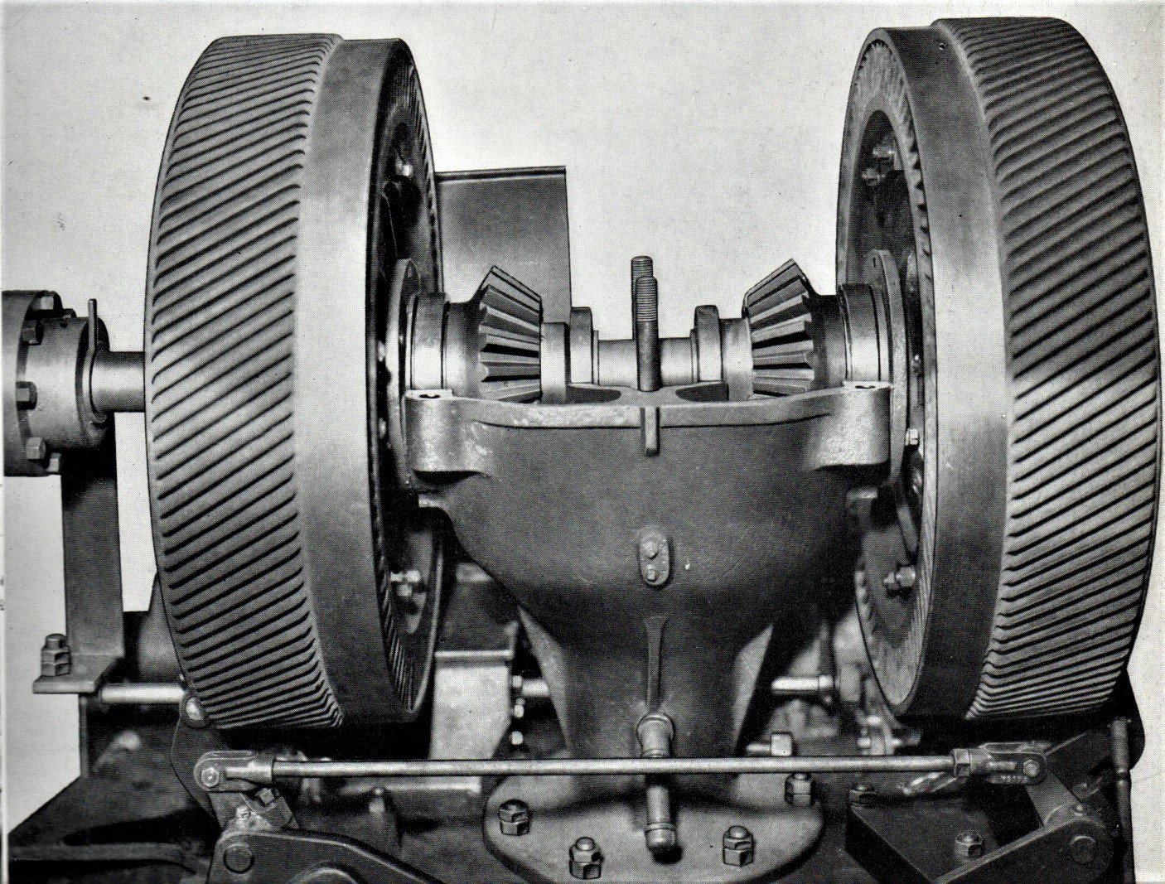
Reverse clutch pedestal housing

So I stood by a transmission casing and met Edwin, call him Eddie, for the first time. That wasn’t his real name but I’ll call him that for convenience. There are far too many names to remember from so long ago. He reminded me of Lenny on 38 equipment. Lean of build and rather gangly, possibly a little taller with a longish face, receding hairline and almost hookish nose but like most of the crew very easy to get along with. I think he was also related in some way to gang members on the 110 and 150 electric shovels which seemed to be a family affair. “Hi Taff, Stan said you’d be coming over. Have you worked on 54’s before?” I responded telling him of my experience to date and in particular with Sid Lucas. “Oh right, your basically familiar with transmission layout then?” Nodding in agreement at him we started on the main casing standing in front of us. Both bigger and meatier than for a 38 it already had the lid removed for access and all the other bits to be added.

The main bevel gear was already fitted at the top of the vertical shaft with bearing and adjusting collars also in place. I was pleased about the bevel gear. That was also bigger and probably just as, if not, more awkward to maneuver. “You can start finding the bits for the clutch housing if you like,” he said waving his arm around to the lines of component racks surrounding us. “I suggest you bolt the clutch sleeves to housings first and then fit the bevel gears after.” He emphasised after. ”They always seem to arrive disassembled after machining but while you make a start on that I’ll put the pinion on.” It sounded pretty straight forward so locating the bits and bolts I did my
job and he did his fitting the pinion. Having examined the task in detail the easiest way to assemble was first bolt the sleeve to the actual clutch housing, feeding it from the inside after having first placed the sleeve itself onto a wood block raising it sufficient to kiss the inside bolting surface of the housing when placed on top. Who said diggers aren’t romantic? Having secured the marriage with appropriate fit bolts an oil seal was fitted over the sleeve rim followed by an outer bearing. Next was the bevel pinion keyed firmly to the sleeve followed by an inner bearing. Writing about it makes it sound simple but what needed to be born in mind was the housings being a three foot diameter iron castings. The sleeves also weighed hefty awkward to maneuver so when finished with the pinion, getting it secured, my mentor was able to help with handling; the weight of things always had to be born in mind. However we steadily progressed and after both sides had been done it was time for my first 54 morning tea break after which things began to happening down the north end of the workshop.

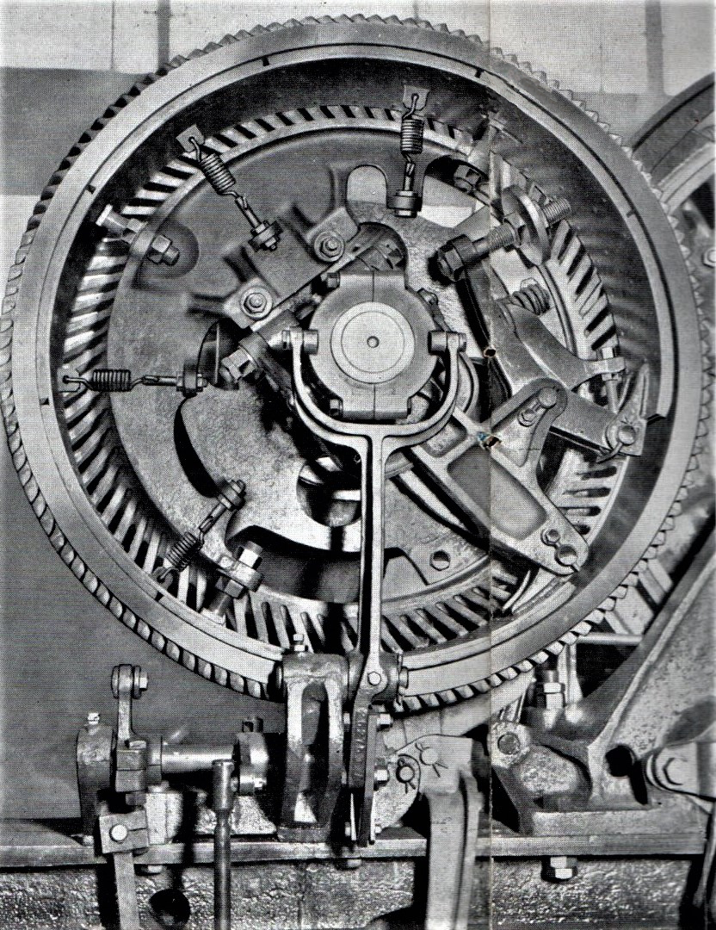
Right hand reverse clutch

A long dark green object delivered on the back of a flat bed truck had already been offloaded and was now coming sedately in our direction suspended from their gantry . It was a shovel boom less appendages and accoutrements recently completed in No 8 bay where flame cut patterns of steel plate would have been jig mounted together for welding the finished masterpiece. Fabrication was a specialist skill all on its own that seemed to know no bounds. It was in No 8 Bay on a visit some time previously that I had first seen a ten foot dead straight line twanged onto a steel surface with chalked string. Another little engineering trick unknown until observed. Some things are so simple. In a couple of minutes the newly manufactured boom would be parked near where we were busy, although there didn’t seem to be anybody around to work on it.
But there was more to come. Another flat bed had arrived loaded with goodies and soon after the bucket ensemble lay alongside to be followed over the course of the morning by boom head pulleys, various shaft pins, bushes and other components for somebody to play with. The section still seemed deserted however so I mentioned this to Eddie who just sort of grinned. “Arnold! He laughed has not been seen since first thing this morning. He went to the progress office and hasn’t been seen since. He’s gone missing. Probably having a good skive by the looks of it.” Hardly had he finished speaking when there was more north end activity as he exclaimed, Aha! “That’s our truck frame by the look of things and not before time either.” Following his gaze with interest I could see the object of his desire.

A heavy looking casting had been slung and sent on its way with those who saw it making sure they were not standing under its flight path. Chasing it at ground level was Beano soon to be accosted by Eddie showing him where to park and stand it on front edge alongside where we would be assembling the drumshaft. A parting exchange between Eddie and Beano elicited the welcome news that two side frame castings would also arrive tomorrow morning before lunch. But like the truck they would just have to wait, we would be up to our eyes with the next drumshaft. As Beano walked back down the bay Arnold reappeared and as Eddie had said you couldn’t have missed him. He had presence. Just over six feet, heavy built but not the surplus fat kind, hands even bigger than Charlie Dixon, with a thick neck, round face, a mess of unruly hair and overgrown black beard. But he was all good humour, slightly out of breath from having had to chase equipment around for the machine now being built. He also brought a bit interesting news about an order that had just come in for two 54-RB stripping shovels. With extra long tracks and forty five foot boom together with a rope crowd system instead of chain they sounded most interesting.

We now had to put two trannie clutch housings onto the shaft. “Don’t forget to put the spider on the coupling side first,” Eddie prompted. “The coupling’s a press fit like the 38. We don’t want to have to dismantle it all if you forget. Don’t mind me just reminding you. It has happened in the past.....and make sure the live end for the clutch band is facing the right way. Okay?” “Uh, uh, I replied in a positive fashion.” Neither of the spiders had been fettle checked so we did one each Eddie inviting me to prepare driver keys for each side before mounting the clutch and bevel assemblies, placing a piece of wood between the two inner bearings to keep them apart when lifting, as I remembered doing for the 38 transmission with Cyril. The pedestal housing forgotten in the rush was still lying prone on the ground. But Eddie was on the ball pointing to a circular thing on the floor that looked suspiciously like a sort of manhole cover. There’s the hole you’re looking for Taff. Just give the cover a tug and it’ll come easy enough.”
I tugged and it surrendered while Eddie waved his arms at the south end crane driver busy looking for a client. Inside the hole a short pipe was an easy fit for the pinion to sit in and keep everything stable. The casing top removed earlier was now temporarily refitted an eyebolt allowing for a wire strop to be attached, lift the assembly upright, swing across and place in the hole. The shaft assembly was then dropped into place with bearings sitting snuggley into machined recesses and using a dial gauge on the tooth flanks backlash was adjusted, about 15 thou, and locked. With casting replaced and secured we started assembling the clutches around their drive spiders. When finished the unit would be whisked away immediately for installation on the next 54 to

I had been keeping my head down minding my own business but now noticed things getting busy over there with power cables being coupled up. There was some obvious anxiety about getting delayed by the 150 taking up even more space when making a race for the door and it looked like they were already getting starting chocks in place. The hum and whirr of generator fans sounded and something within started to stir. Almost imperceptibly the heart of the 54 started to beat, a control lever was pushed the boom started to lift, as the boom lifted the hoist brake released rope to position the bucket ready to move the machine forward. The mechanical monster gave a quiet lurch and started its escape with Les Brown, rumoured owner of a field on the Newark Road, at the controls Albert Smith following on foot as it rolled and rumbled towards the big doors weaving around the bigger digger on the chocks not quite ready to have sunshine fall upon it. And then it was gone, grinding a noisy clockwise pirouette while dragging the supply cable behind leaving a big empty space for me to help fill. What it is to have ambition. Every so often on its way to the test field they would run out of power cable length having to unplug and drag the now dead length to the next power point along. It was a heavy cable and I swear I saw them hitch it to a tractor.

We had yet to start on the drum shaft but that was going to take a day at least. The line was definitely going to be behind schedule. Another question I asked myself was who was going to be building the truck frame? I asked Edwin. “Oh you noticed did you”? Things do seem a little awry at the moment but arrangements have been made,” he said tapping the side of his nose with a forefinger. You haven’t met Mike and Dave have you?” I shook my head and trying to be witty asked, “Who the heck are they, Batman and Robin?” ”Not quite - but somebody has nicknamed them the spare parts.” I just laughed and asked again, ”Who?” He joined in my laughter and excused his comment saying, “That’s not really a fair reflection on them. They’re actually a couple of field service fitters that have been borrowed while awaiting another job. You’ll probably meet them after lunch.” And that was all I could get out of him before he changed the subject saying,” I know we’ll not finish before break time anyway but lets make a start building the clutches up.” So we made a start raiding the component racks for bits and pieces, putting things together for half an hour or so just before the lunch time hooter went off. They worked exactly the same way as the 38 but much bigger and heavier, especially the two spider castings looking rather graceful with their oversized looking toggle lever assemblies. So big that to my unfamiliar eyes I thought there may have been a problem with dynamic forces with part of the lever assembly including a long adjustable bolt and balance disc. As we ran for the washroom a short while later I took a quick look to where they were building the 150. It seemed almost ready to have the top half of the boom fitted but I knew they would not be able to run through the doors with it fixed in position. It was much too high. Interesting? How were they going to solve that?

After Lunch
On the way back from the canteen I decided to return a little early to take a look across the gangway at the leading rev frame to see what had been done so far. Both side platforms had been attached making it a lot easier to get around the machinery deck. If all went according to plan the transmission unit we were building would be swung across for bolting in place with the pinion at the bottom of the shaft then meshing with a floor well gear in the same manner as on the 38. Machinery side frames already mounted the left frame casting in particular was a robust piece of work extending up to the front, mounting the drumshaft with the left end bearing outboard; significantly different to the 38 where the drumshaft gear was positioned outboard of the bearing. The six foot diameter main gear for the 54 was inboard and once installed you could not help but appreciate the visual impact of the whole left side of the deck. It was immense and nobody could ever be in doubt that this was an excavator that was going to move dirt come hell or high water. It also carried the primary half of the transmission along with boom machinery but before that could be installed the chain casing had to be put in place which Nigel was currently getting to grips with. It was not a small item; quite heavy even with the top having been removed to lighten the load for bolting to the platform it would not be easy to hold in place. The first thing needing attention was the intermediate shaft and running components but if the casing was bolted in place access for inserting it would be blocked. I‘d spent some time looking at all this and the crew were now returning from the canteen.

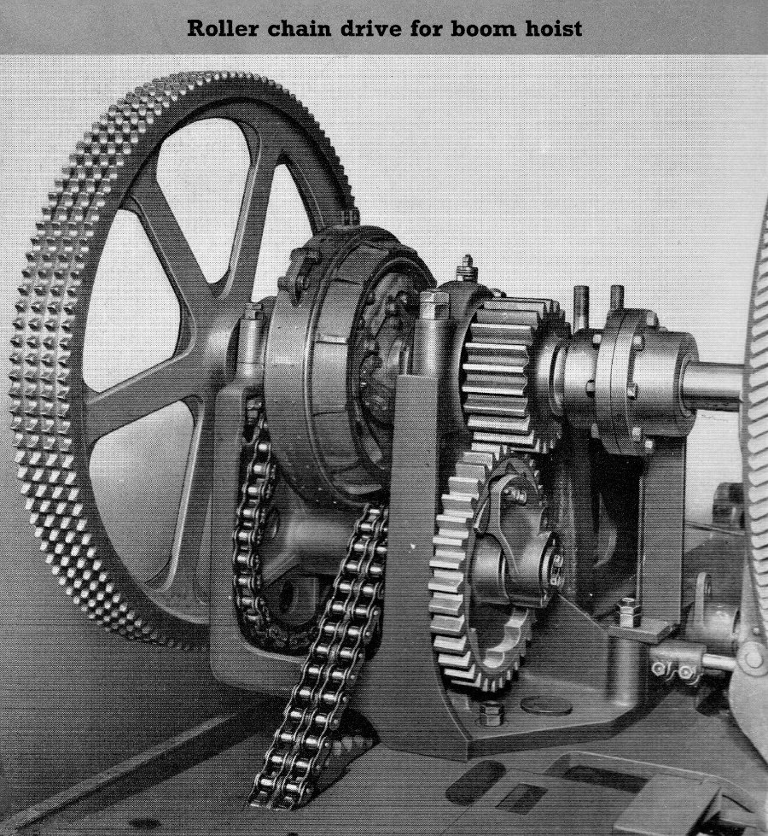
Boom hoist clutch drive chains and lowering speed
Over-run pawls mounted to ’inter’ gear

Nigel was amongst them showing willing and already gathering his thoughts he saw me looking and asked, “How be Taff. You wanna give a hand?” but I had to deny my expertise, my duty to another master yon side’t gangway. So laughing he carried on what he was doing as I returned to my official chores. But while I’m back over there a few explanatory comments about machinery might be helpful because it l looks like he’ll be attending to that while I’m on transmission unit with Edwin.
Located on the primary input shaft when installed: The boom hoist clutch coupled
to an intermediate shaft below by single roller chain which in turn connected to the boom hoist drum shaft by duplex chain. It was the intermediate shaft which was to be installed. As illustrated above: At its inner end a free wheeling gear, in constant mesh with the hoist pinion, had its inner rim cast in the form of pawl cavities. Keyed to the shaft alongside it a drive spider carried two loosely pinned pawls for engaging in them. If the boom hoist brake was released, without setting the hoist clutch, the duplex connecting chain on the rope drum shaft drove the intermediate shaft and thus the inter shaft clutch driver keyed to it. With the speed of rotation increasing the pawls flung outward to engage the pockets thus governing speed via its engagement with the hoist pinion; a very elegant closed circuit gear system. It was simple mechanics, non digital and relying purely on gravity. It was these components along with the shaft that Nigel was going to install with the aid of an air winch.

The shaft had to be pushed first through the outer casting boss feeding through the splined bore of a speed reduction chain wheel, a splined duplex sprocket and then the bushed inner frame casting wall boss. The free wheeling gear mounted on its inner end, meshing with the hoist pinion, was held in place by the keyed drive spider. A fiddly job to do and I saw another fitter assisting. Some time later they stood to stretch for a breather looking at the chain case now leaning against the platform. On its underside were three case-wide fabricated feet, one supporting the rear end, two beneath each side of the centre portion, a large oil drain plug between them. After assessing the task they carefully wrapped a sort of long webbed strop around it maneuvering for bolting to both platform floor and the machined annular face of the inter-shaft bore. Where it was secured to the casting was a slightly bigger hole than the bore surrounded by four screw holes. A circular blanking plate with gasket placed on the inside wall of the casing blanked off the bore with a matching access disc also screwed to the outer casing wall allowing shaft withdrawal for repair. There was still however more to be done, the next item being installation of the primary half of the transmission shaft with the boom hoist - but I’ll have to get back to you on that. Eddie can see my mind is not where it should be. Oops!

Across the gangway our field department temps Mike and Dave showed up to assist on the lower works not really answering to their unofficial tag of spare parts at all. One of them taller and of heavier physique than the other but that was their only apparent difference. Both weather beaten but fully in command of the job quickly getting stuck in: putting the truck together, knocking in the centre post bush, balancing the propel shaft in a wire strop to hang it horizontally and push through ready for fitting the bevel pinion. No fiddling and faffin' about just getting on and doin’. This would be for the next machine off the line and their input would certainly be welcomed. In due course when the present situation had calmed down into routine it would be Edwin in charge again and me helping. Mike and Dave would wander in the workshop wilderness looking for work, or perhaps not. Suddenly it just got rather busy. A backhaul base casting has just been delivered by the north gantry and landed on the lead rev frame with a couple of fitters now getting ready to bolt it down. Part assembled and grouped in series were four separate sprocket gears, two of them next to drive pinions with the most vicious looking teeth. Watch out for those I tell myself. They could give a nasty bite...But I’m going a bit of piste again and you’re going to be telling me the opposite if I don’t get back on track. Sorry! Cut a long story short: We finished our trannie unit towards the end of the afternoon when after assembling and mounting the spiders, we got the overhead crane to swing the completed unit across onto the lead frame for one of Stan Simon’s crew. Greeting its arrival was a pleasant individual, slim build and a friendly manner introducing himself with, “Been waiting for this but it all went crazy this morning.” His name was John and he told us things had gone off kilter because, as already indicated by Stan Simons earlier, a gang member was hospitalised with acute appendicitis leaving them a man short with another failing to turn up this morning. My presence would help Edwin but not them. So we handed it off the trannie considering our next move which was to organise the drumshaft.

I had been watching the proceedings across the way deciding to temporarily skive across to watch some more. Edwin didn’t complain so nowt said. Ross the fitter who’d assisted Nigel earlier had got hold of the other half of the transmission shaft with the boom hoist clutch. A simple layout with the minimum of parts: integral clutch housing, brake and single sprocket, booster clutch and driver running between two bearing housings; the primary chain wheel drive to one side the hoist pinion and the reverse clutch unit half coupling on the other. He assumed I wanted to get involved if only for
a brief respite so I didn’t protest hoping Edwin wouldn’t mind my disappearance for a short while. At least he could see where I was.

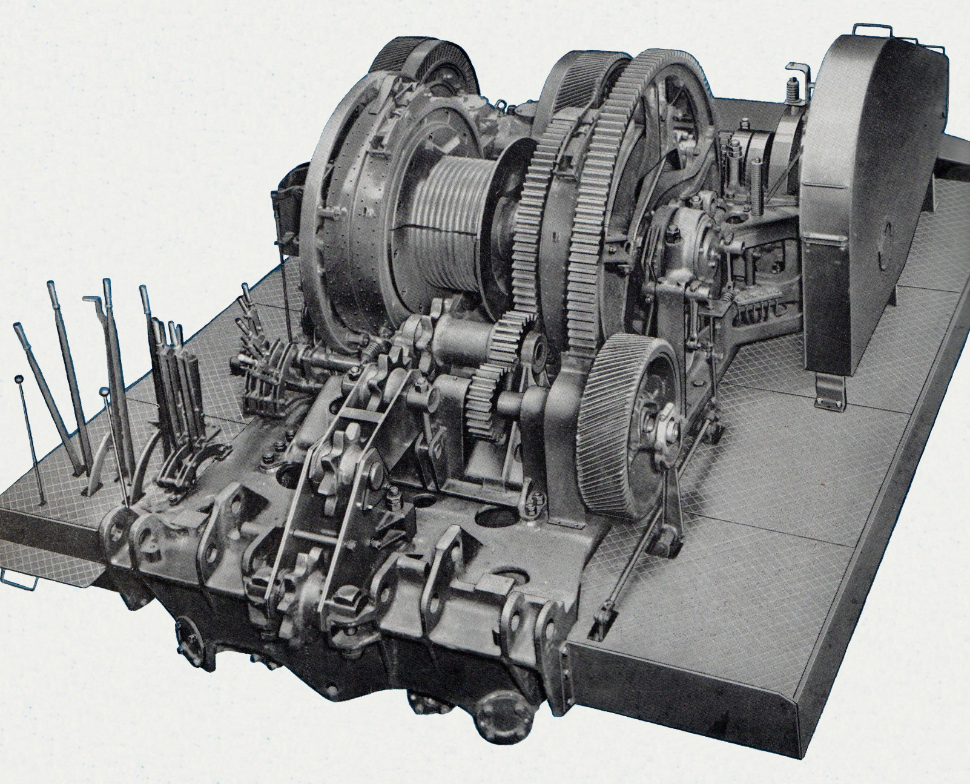
54-RB Shovel machinery deck layout

With the assembly lying before us my temporary tutor turned to me a challenging look on his face. “We’re ready to do this then are we?” It was a test question. “How do we drive all this then”, he said. Is it with an elastic band?” and it suddenly dawned on me what he was talking about as he tapped the very large primary drive wheel on the end of the shaft dramatically raising his eye brows. “Transmission chain?” I replied. “Oh! You are on the ball aren’t you.” Sarcasm? “What we have to do is drop the chain sets into the casing before we mount the shaft. “Come on we’ll start unrolling them.”;
The transmission chains were wrapped in large packs of well oiled heavy brown paper and were quiet heavy being much longer when rolled out than anticipated. To cut a long story short we unrolled them draping over both casing ends as they grew longer, piling the excess each end as tidily a we could on the deck. We now had to consider the six track chain wheel which at a guess must have been around four feet in diameter so the easiest way to handle might have been to hang it through a gap in the spokes. It was an unbalanced assembly however so it needed more consideration and Ross had obviously done some considerin’ before because he produced a woven heavy webbing strop of sufficient length that we were able to wrap around both chain wheel boss and inner clutch shaft to obtain a reasonably level lift and float the assembly near as dammit to where it needed to be next to the end of its other half. So we just rocked, wiggled and jiggled bolt holes, bearings and transmission coupling, lowering it all into position and securing, bolting the coupling halves and then dogging down the reverse clutch housing. Yet another piece of the jigsaw to remember and Edwin was now looking across with pained expression on his face. I was becoming a pain in the arse? Perhaps I was.

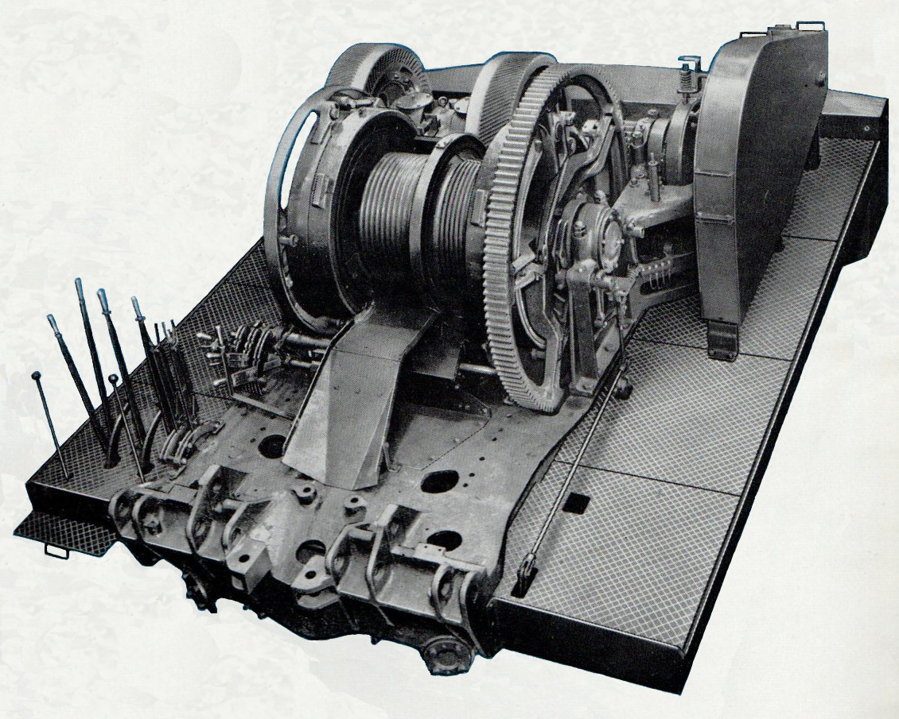
54-RB Dragline machinery deck layout

The 54 drumshaft was markedly different from the 38 in that it utilised externally contracting clutch bands carried on drivers running next to the housing rims. Clutch and brake bands ran and acted on the dual width surface of the clutch housings with the drum shaft gear also acting as one of the drivers and incorporating the function for left side clutch operation. The drum shaft itself was massive at around eight inches in diameter with several shoulders; six at the drive gear end and seven the other with a raised lip in the middle; there to ensure correct position of components either side. It was similar to assembling the 38 drumshaft put together using two build stands but because of size and manageability they were arranged to slide in T slots with additional free supports to swap around and prop where required. A bigger job it did look rather daunting, sometimes needing a moveable wooden platform to stand on. Size was also impressive, awkward and heavy but impressive with its six foot diameter main gear lying ready on the floor, timber support strips under the rim. Eddie said things that big could always find a way to fall over so he always took precautions. Other stuff like clutch and brake bands just leaned against the partition fence to No 2 Bay.
Two friction housing assemblies for my first 54 drumshaft flew down the bay, with barrels and housings bolted together saving us a lot of humping around time lining up holes, All we had to do before mounting them on the shaft was fit inner and outer bearings races with spacers and retaining cap and then play a game of musical chairs manipulating supports and stand fixtures. To carry out the lifting a special stirrup arrangement was used cupping and supporting the friction housing combined with a second harness working alongside under the barrel holding each module level for sliding into position.

We had maneuvered the drive gear side housing into position without trouble and were just finishing the opposite one when my attention was drawn to the brake and clutch bands leaning against the partition. Eddie had said something about them earlier and I reminded him. “Yes,” he said grinning. “You worked it out yet?” Unsure I asked, “Clutches next?” “Yeah,” he said slowly - almost! and went on to describe the procedure. I knew the brakes had to go on as did clutch bands but in what order? “What we do is hang them both on the housing ready at this stage. The clutch driver
is bigger than both clutch and brake so that has to go on afterwards and we put the brake band on first. It’ll not fall off because the clutch band goes on the outside and holds it in place with the weight of it helping things to remain in position while we finish assembling every thing else.” He carried on, ”The brakes you should notice, because of their weight, are in two halves coupled together with what the instruction book refers to as an adjustable splice. A neat description it’s almost poetic yeah? The adjustment is done with a left and right hand threaded bolt between the two guide bars where they join. Those bands are bleedin’ ‘eavy and also soddin’ awkward to maneuver. I’ll say again, the best way to fit them is the way we do it.” I confirmed my understanding once again. He actually seemed rather excited about explaining it all. “Normally at around this stage we would fit the hoist rope lagging but they want us to leave it off for spotting the frame onto the truck; easier to line up.” So having been instructed and informed, huffing and puffing we began to manhandle and join the brake halves, pushing them over the housing rim to the far edge first then doing the same for the clutch band up against the brake. Whereupon Edwin exclaimed “Right fella, you can get a key filed up ready for the driver.” So having all this fun I got a key ready with the big twelve inch file I’d forgotten to give back to Cyril and Sid. Just keep Ssssshtwm. Okay!

Before mounting the driver we added the huge clutch bellcrank to one of its three wide webbed driving spokes ready for linkup, and then lining up the keyway gave it all a hard shove. Sliding smoothly over the key, coming to a stop against the inner sleeve of the drum barrel, we finished off mounting the booster drum, attaching clutch band to bellcrank and dead end and everything in sight that needed attaching before Edwin said, “Just make up the end bearing housing and we can go back to the gear end and do it all again for that side. “Doing it this way saves struggling with the brakes after the drum shaft has been installed. And by the way,” he added,” that extra length sticking out over the end is for the dipper trip, but of course you knew about that didn’t you?“ So answering like I did I nodded my head and confirmed, “Yes! I knew about that,” smirking at the same time which made him laugh. “You’ll be fitting that when you get yon’ side with Stan’s crew,“ he said as an afterthought.

I felt it was time for me to pull a few legs to see what kind of reaction it would get saying, “You know they’re not paying me enough for all this work I’m doing Edwin!” His jaw dropped in mock horror. “Whaaat? Do you mean the company’s actually paying you? Hey up Dave, Mike, Taff just said they are actually paying him.” As expected Dave insultingly responded with. “Utterly ridiculous. Just what does he actually do? If they paid him nothing it would be too much.” Oh these guys were fabulous. I just couldn’t help laughing along with Edwin as Mike stuck his knife in saying, “If I were you Edwin I’d go see Frank Phillipson and tell him we want it stopped.” Some of Stan Simon’s gang opposite had caught on to the conversation with more light hearted insults as things suddenly became rather quiet, with the arrival of the tea trolley.

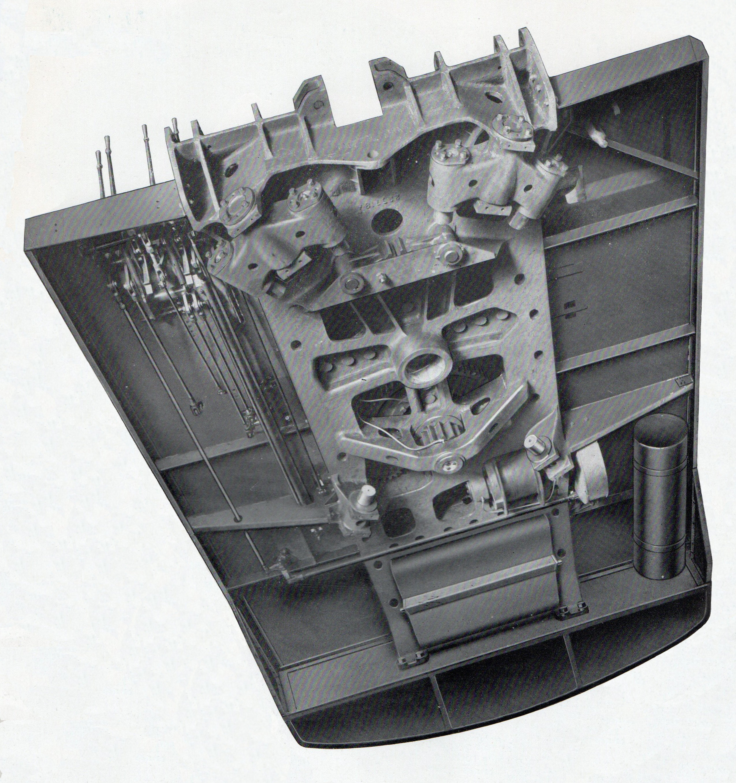
Underside of 54-RB Revolving frame

The plan to fit the gear end driver and the rest of it changed just as we were sitting when he suddenly announced, “Before we do the other side we must remember to bolt on the crowd gear,” and as he did things got a bit more populated as both Mike and Dave came across from working on the truck to sit with us for their brew and give the low down on how they had suddenly found themselves under our factory roof. It turned out that they’d been working on a 150 mining shovel somewhere in Germany. The job completed they had come back looking for a new assignment, which Mike remarked rather pointedly, “was not a stint in the Lincoln factory workshops but I suppose it does makes a change,” adding a shrug of his shoulders as he began to talk about the truck and what remained to be done.

Eddie handed me a pair of canvas gloves telling me that the split gear teeth were exceedingly sharp. “Cut your hands to ribbons on the gears without these. Put them on. I don’t want your blood spilt on my nice clean floor.” He looked at me intently with just a trace of humour. So I looked back at him, pulled them on and asked if they were from the tooth fairy which drew a blank look, a shake of his head and we were all square wit wise. Bolting them was actually a two man job but still taking longer to do than expected, the two halves being both heavy and awkward to hold in place while securing using six fit bolts for each along with the tangential bolts at the split. We were not going to finish the drumshaft that afternoon, just doing what we could before tidying up and getting the friction band stuff ready for the morning and joining the rest of the workshop as they made their way to wash up, except for Mike and Dave the two spare parts. Apparently they would be werkin’ ovver trying to save the build schedule while tomorrow was another day as yet unborn.

Tuesday Morning
The first thing we noticed on arriving at our patch was the truck frame with good progress. Mike and Dave had made up and installed the two half shafts, pushed them temporarily into place and then swung the casting on chain loops to suspend inverted and place on timbers for the rest of the innards. The main horizontal drive shaft with its enormous bevel gear was also in place along with the two steering dogs while the clutter of remaining parts to complete steering and digging locks were laying on the floor. Dave seemed anxious that other component like axles and side frames were not yet in sight his mood shared by Stan Simons who could see further backlog occurring if the two members of the drumshaft gang didn’t soon start on another transmission unit. Edwin told me not to get distracted. The current drumshaft was needed first so let’s press on with that, get it across to the waiting rev frame crew and give Stan a break. After that was done it seemed plans had been made to loan me out and assist with the undercarriage. They might want my services to mount bottom rollers!! Well....good luck with that. The undercarriage axles and side frames would be along soon and then they would, Dave said, be workin’ like stink to get the whole thing completed. As things turned out it wasn’t till Wednesday afternoon that the crawler truck was actually ready.

Our first job to complete my first 54 drumshaft utilised the overhead crane swapping around supports for working the gear end. That done we check both clutch and brake bands, huffed and puffed getting them into place with brake on the inside. Clutch band next and tackle the six foot diameter gear/driver mounting it on the shaft. Of course he already new the answer but had to ask, “Have you done a key for this thing yet?” Really on his toes anxious to get the job done and hand it over to Stan. “Er - no Eddie not yet. Give me a minute” So I set to work again with my purloined twelve inch. The six foot drive gear, bigger than the friction housings at only four, was emphasised as we mounted it on the shaft: knock key in slot, wave hands around wildly to catch the crane driver’s attention, wait till he sees our plight and rumbles to the rescue. Just a small lift for mankind, no need for slingers. Suspend the gear, knock a steel wedge in the split, line up keyway with Edwin turning the shaft with the driver at the other end. ”Lined up. Hold It!” Bash the gear hub home against the shoulder with sledge hammer and solid lump of wood. STOP! “Remove wedge, make sure you dog down that gear boss bolt so it don’t shake loose?” Mount booster drum on gear boss, fit end bearing and housing, have a breather, secure clutch band to bellcrank and dead end pin. I was knackered again. Edwin could see my condition and just laughed. Another reason to laugh was the afternoon had sped by with only a quarter of an hour to go. Was it ready? Yes it was ready. Let’s get rid of it quick and put a smile on Stan Simon’s face.

Other things had also been happening while all this was going on. First thing this morning there had been a buzz of activity around the 150 by the main doors. The generator motor and fans were making their characteristic electrically busy noises as fitters worked under the gantry. With the top section connected to its suspension ropes it was just too tall to go through the doors so the arrangement was for the bucket to rest on a heavy wheeled trolley something like a railway porter’s with cast iron wheels that rumble across railway platforms. With the top section allowed to rest across the front it rumbled out of the workshop. A waiting crane-rigged 38-RB would then lift the parked section into place for suspension ropes to be connected. Still a tricky operation but I was not a witness so cannot really make further comment. However the situation set me thinking. RB had a Suggestogram scheme which paid out cash rewards depending on adoption and benefits achieved. I prepared an isometric drawing of a crane suspended beam with quick release pins for holding sling loops around the boom head shaft. After a couple of slow months the suggestion received acknowledgement along with an award of seven quid. WOW! The project had been submitted to specialist mechanical people for pricing and manufacture and that was the last I ever heard about it? Que Sera, Sera. But a new purpose built No 22 bay for the big machines was on the way anyway; maybe that would solve the problem. At least I was seven quid better off.

It wasn’t actually till just before morning break that we finally gave up our drumshaft to the gantry, swinging it across the gangway for the waiting rev frame at No 3 spot. At Eddie’s behest I went with it and met Rosser, call me Ross who had been helping Nigel yesterday, I guessed him to be aged around twenty five. Fair haired and about my height he had a much more solid physique with roundish face and a laid back attitude. We hit it off straight away and would soon become working buddies. He had a driving license, an Austin Somerset car and was an avid Little Richard fan who several weeks ahead would drive us both to Sheffield to see the noisy little man himself on stage. But I digress. Having previously assisted with putting a backhaul unit together he now had a drumshaft to marry it up with. Carefully lowering it onto locating dowels he said to be sure that brake band lugs lined up to their mating pin connections. Unlike the 38 clutches using friction disc initiation the 54 drumshaft used shoes to straddle the booster drum surface so things were left hanging loose to line up before pinning up. The thing to remember with brakes was the drag they created on the drum surface just by their weight, increasing wear on the linings if allowed to rest while just winding in. To alleviate this condition pull off springs were attached at three points around their circumference on a separate framework attached to deck brackets, cab work and main A frame; the latter to be Installed as soon as the front cab panels were in place; but that would not be for a while yet. I was mulling these sort of things over trying to act responsible and all that sort of stuff when Ross looked at me, grinned and casually asked, “Are you gonna’ fit the dipper trip then? Oh soddit I thought. “Oh yeah! I was just thinkin’ about doing that......Ahem!” He grinned even more widely and replied, I thought you were so I’d better show you where to find the bits and pieces or you might wander off and get lost?” Sarcastic sod. “Yeah, yeah. You’d better do that.” And we both laughed. I liked working on 54s.

Things were progressing: side platforms in place, main and auxiliary function levers mounted, linked up to related clutches including the transmission installed yesterday. Looking at the boom hoist arrangement it was interesting to note the use of rotary cams and rollers working together to release the brake at the same time as engaging the clutch through booster type setup. It was the array of control levers that first fascinated me about excavators and on both 54 and 38 there were plenty of them along with their screwed clevis ends and reach rods. All these took some time getting to know their layout and which cams or booster brakes they set; which on the 54 was cam for swing and brake for boom hoist and main drumshaft clutches instead of toggling. Another feature with the boom lowering was the pin mounting of the two pawls hanging closely together on the intermediate shaft clutch driver, just brushing over their rim pockets because of a weighting bias when raising the boom but slotting home to control the speed when starting to free wheel in the opposite direction. Brake setting adjustment for all this Ross told me had to be done using a particular test department procedure to get it right. “Not really our job to do it,” but he showed me anyway. “They always get their grubby little paws on them afterwards and do it again,” he said laughing, ”So no safety issues for us to worry about.”

John arrived at the back end getting ready to install the fuel tank just as the Paxman power unit was arriving to be parked next to the prep frame. After he finished sorting tank attachment details and got it into place for bolting under the frame he slid from beneath to set up the air winch; pulling it up with a wire sling for securing. The thought of crawling under tons of rev frame again gave me the shudders. It was of course perfectly safe but I was beginning to get a phobia. At the far end of our patch now stood the upturned prep frame at No 1 position with on the opposite side of the gangway the parallel stretch of ground dedicated to equipment build areas for the machine slowly growing into ‘the beastie’ as once described by a poetic Scott. The fitters on prep were doing the same sort of thing as I had done with the 38 rev frames fitting bushings, boom hoist drum, hook roller pins, cab lock and fettle work etc. At second position two other fitters were busily engrossed. Yesterday they had bolted on the left and right hand machinery side frame castings transforming the landscape of a flat casting into something more dynamic with future purpose.

Other static and rotary pieces followed: doing preparatory work on a clutch booster at one of the benches, sorting drive chains for the boom hoist drum, one of the large well gears had found its place and today it looked like they would also add the side platforms. If I remember correctly there were six fitters working in the gang: John and Dennis, Ross with whom I was already working, Reg, Clive and Nigel. It was Clive and Nigel working on the prep while Reg had just put one of the swing and propel gears in position after sweating over it since first thing. Back on the truck the two side frames that Mike and Dave were waiting for had arrived, being offloaded from a Bedford flat bed reversed in through the big doors. Axles had come along with the side frames, tumblers, pins, rollers and U bolts so very soon a flurry of dust would be set in motion as they were all assembled to the inverted truck. It was not a five minute job however and it would be some time during tomorrow morning at least before it would all be ready for lifting and doing a turnover upright for lowering onto the track belts; also planned for delivery first thing. There were five bottom rollers, one less than on the 38 but bigger so it would be another air winch job.

I had a sneaky feeling from having looked at the rev frame at No 2 that I would be tasked with doing another transmission unit and so it came to pass. I had seen Stan talking to Edwin a few minutes ago who was now conferring with Arnold on front end equipment. Things were in the pipeline and after lunch I was to go back with Edwin who would hopefully be taking delivery of more transmission components, and probably another pile of stuff for the next drumshaft. About a half hour before lunch another rumble from the south end gantry crane drew my attention as the long awaited parked up power unit for the lead rev frame glided through the air towards its new home. Beano was in hot pursuit in the gangway while Clive and John stood on No 3 machinery deck to receive it. The Paxman engine came attached to its own tailor made mounting skid hanging from the South end crane. Once it had landed the rest was easy; just hooking up services for fuel and other detail work. Fatchettes would be their next customer needing a lift on the 110 again steadily growing in size. The crane was soon going to be busy with Fatchettes on the next 110. Hey! The place was buzzin!

After Lunch
Edwin was having a bit of a tidy up and sort out. Our speculation over component re supply had been rewarded sooner than expected when the transmission case casting, gears, clutch housings, shaft, spiders, springs etc arrived while we were at lunch. So too did the second pair of large friction housings for my second drumshaft but without the actual shaft to put them on. There was panic in the air because they did not come ready attached to their drum sleeves. Oh it was going to be fun putting those together. Eddie had returned a little before me and had been in deep discussion with a fork truck driver and somebody I guessed to be from the progress office. The rest of it would be arriving soon and realising we really were in a ‘catch up’ kind of situation I sacrificed my need to lie down and got stuck in, deciding to sort out the spiders for the trannie shaft before having a go at the casing, easing my way into the shift that way. It was the right decision. Edwin started organising things for the drum shaft with clutch and brake bands, sleeve spacers, the right hand clutch driver and main gear but as yet still no shaft. He told me to suspend what I was doing and give him a hand instead, bolting up the friction housings. They were heavy, a puzzle and a challenge as to how we could hold them together while doing so. We seemed to be busier than yesterday somehow but perhaps it was just me being more focused. Mike and Dave meanwhile had fixed the truck axles on through the corner lugs and were attending to drive tumblers and rollers. Once again it was all ‘appenin’.

We found the best way to assemble drum housings was to place the front rim edges on thick timbers allowing access for inserting bolts from the underside and up through the barrel flange dropped into a shallow recess at the back. Bolted together as an assembly they could then be made ready for slinging and sliding onto the shaft. It was only at this point however that Edwin realised that given the present circumstances it would be more expedient to complete the transmission so we left plannin’, slingin’ n’ slidin’, decidin’ to concentrate on that. The rev frame in No 2 position would look better with more machinery on the deck, perhaps sometime tomorrow morning. It might also give a boost to moral so it was back to my two pet spiders with Edwin making a start cleaning up the housing unit and preparing the swing shaft bits. All this excitement in such a short space of time. How could I cope? By the end of afternoon shift our gang was looking good. Mike and Dave were in the last throws of sliding the second undercarriage side frame castings onto the rounded axle ends which for once seemed to be going smoothly. He who dares ....etc. Just a slight skew in lining up and they would jam quite easily but this time..... Once the end locking straps were bolted in place bottom rollers could follow which fortunately came ready bushed. Truck section was lucky they had two experienced fitters like Mike and Dave to help out, obviously working well as a team knowing literally what the other was thinking as they went about their business and I again wondered if they would stay when the job was done.

My curiosity getting the better of me I queried it with Edwin. “Well he said they won’t need to stay because we’ll have a full team next week. Dennis, who was a no show yesterday, will be back tomorrow. You haven’t met him yet have you? And Harold who’s been in hospital will be back on Monday. He normally works this side on truck frames. That’s why everything has been so screwed up. I don’t know where the ‘Spare Parts’ are going to go,” he added with a chuckle, referring to Mike and Dave. “They’ll probably find something else to do or may have a field job waiting for them.” Thus in a few sentences Edwin had answered a number of thoughts that had been churning around in my head and with a clearer picture of what was happening I ploughed on with Edwin while Mike and Dave did their own thing on bottom rollers and finishing take up tumbler adjusters as the hooter went for end of shift. There had been some debate about them working a bit of overtime again but with money at the factory more tightly controlled than on site it was not to be. Tomorrow would perhaps see the lower works turned the right way up with a marriage to the top half now on the horizon. Edwin’s two man team, me and him, would finish transmission I was sure, and I was hoping, and then there would be more progress on our drumshaft and I was thinkin’ roll on tomorrow. Now it was time to hit the washroom?

Wednesday Morning
Transmission clutch housings already bolted to their sleeves there’d be less messing around than the last time. Just needing back seals, bearings and bevel gears before mounting to the shaft. Making good time with Edwin I was about to take a breather when Mike walked over to him and asked if they could they borrow his slave? Oh, Oh! Here we go I thought. “Just a little job,” he said, “fitting the grease nipples before we turn it over.” Meaning their upside down truck fame assembly. The request was loudly proclaimed and directly aimed for me to hear. So some kind of leg pull or mickey take; those two were notorious for it. Edwin saw me give a quizzical look and played along. “What do you want him for he’s not a lot of use?” Thanks mate. I’ll remember that I thought looking back at him, also playing along. “We just haven’t got time to put them in.” Edwin call me Eddie’ responded, ”He should be able to manage that. Tell you what though I’ll sell him to you. How’s that? Make me an offer.” I in turn responded to them both mouthing, “Bastards,” graciously acknowledged as they both laughed heartily. More sarcasm and typical apprentice abuse. It was just their way of asking impolitely to be given my assistance.

Edwin grinned, I shook my head and said, completely on the spur of the moment, “No wonder they sent you two home.” It was the right thing to say. “I can spare a few minutes but it’s going to cost,” I said looking at him directly, adding innocently without thinking about it ,“Okay Mike show me your nipples then.” Completely misinterpreted by Edwin who immediately started to giggle like a silly schoolboy. Mike then joined in sniggering, leaning against the upturned truck frame assembly for support as Dave giving an artificial look of horror, shook his head and walked across to grab my arm and lead me to a rackful of them. It was just one of those lighter industrial moments that you could relay to other people afterwards but at that moment a draught from the south door being opened signalled the arrival of a rather raucous Commer flat bed wagon heavily laden with a set of track pads for one side. A full set for both and it would have been well over loaded; looked like it was sagging now. The other set was on the regular Atkinson maneuvering to reverse down the bay after the first lot had been deposited in place ready for unraveling. That little ceremony would be occurring shortly after morning break and it was almost like launching a ship. Morning tea break came an went and then it was time to make dust.

“Right Taff watch your arse, keep well clear and we’ll cut the ribbon.” It was Dave standing behind one set of rolled up track pads. A little earlier they had spaced them out with a piece of wood as on the 38 with Dick Doudell. The metal bindings snipped the pads rolled out with a deal of clumping and thuddering that only track pads can make. As the second bunch unfurled Mike suddenly appeared alongside to christen them with the remaining contents of his tea mug. “That,” said Dave joining him, “is the way to launch a new set of track pads.” I hadn’t seen that done before and neither had Edwin by the expression on his face; or perhaps anybody else for that matter. Was it something just peculiar to Mike and Dave? But here come the slinging duo Bob and Beano already espied by those in their crane eeries. Having rolled and prised the two sets to lie the correct distance apart the rumble of two twenty five ton gantries sounded overhead as they jockeyed for position. This was a much meatier crawler frame than the 38 and it was going to be interesting to compare handling methods, proving to be very similar: With the truck front facing south chain loops were slung over the axles front and rear, weight taken and supporting timbers removed, truck raised with emphasis of height being on the front with chain loops on the rear axle being gradually released for removal, truck assembly left hanging allowing it to be turned facing the opposite direction, free chain hooks re attached to drive tumblers on each side frame, pulling back as the other end lowering to bring level, moving the now up righted truck assembly across to place in the track grooves. One last job and that was fitting the four remaining top rollers. When that was done the track sets could be pulled over the tops and joined up. Way to go!

Yesterday morning the 150 Shovel had finally rolled out through the big doors and now just as Mike and Dave set about dragging the track pads over the left hand frame a much heavier vehicle with low slung trailer, maybe a Scammell, backed into the bay with a newly fabricated truck base for the 110. Just the basic box but there would be a number of sub components arriving soon for the mechanical power train concealed inside the structure as well as the side frames. Space would again be at a premium. My own interest however was the crowning ceremony. Everything ready, last remaining details completed yesterday afternoon, except for fitting the high ‘A’ frame which would be one of the first things done after top and bottom had come together. The marriage would take place after lunch today with the cab crew pouncing on it soon afterwards. It was a large structure and with no nearby space to first assemble on its own frame it would be built in situ probably at the same time as attaching Arnold’s shovel boom. One of the main distinguishing features making the 54 so recognisable from a distance was the high ‘A’ frame but installing it before locating the front panels would impede things so it was only after those were securely fitted, part of the roof over the top for rigidity, that it would be mounted. With front panels bolted in position it allowed brake pull off frameworks to be arranged with eye bolt and spring sets anchored through and onto each leg.

After Lunch
But my job was still on the transmission now badly needed as was the drumshaft. Maybe later this afternoon when the completed rev frame had vacated space No 3 they would move up the one at No 2. Edwin still on the trannie had now sorted the bevel gear on the vertical shaft, fitted the pinion and bottom plate and was ready to move on with the rest of it. So we paired up to complete the clutch spiders, putting them on the shaft and finishing the whole thing some time the other side of tea break when, to the joy of Stanley’s boys, we took it across for them to install onto No 2 in the queue. If things went okay we should also be able to also give them the drumshaft, possibly by tomorrow late afternoon. I was getting an idea of how long things took to put together and looking at the truck frame. After joining and adjusting both track sets along with drive chains at around 2 o’clock the lower works had been declared ready for marriage to its new life partner. The Welsh pigeon was sent to find slingers Beano and Bob who returned in quick order, looping the four leg chain set around each axle and corner lug to lift and transfer the completed unit across the gangway, both chain men following slowly in its wake steadying its position to land in front of the revolving frame queue.

Hook roller pins placed ready on the tracks, rollers in approximate position held on the turntable path by strips of ciggie packet card, shims nearby ready for the marriage ceremony; chargehand Stan Simons presiding. Alongside No 3 and 4 Bay partition wall a framework stand was set into the floor for storage of lifting tackle. Two heavy duty custom harnesses were retrieved and attached to each crane. One set with end loops for the boom foot pins and the other for hooking under the counterweight rear end. Busy with transmission away from the main attraction I couldn’t get involved with hook rollers and would have to wait a week or more before eventually doing so but at the moment Edwin did not object to me taking a keen interest in the proceedings as each harness was secured. The north end crane also assisting Beano giving directions the two cranes worked as one lifting the machinery laden rev frame off the pedestals, then forward over the top of the waiting truck with a fitter standing in position ready for spotting the top of the prop’ through the propel gear which featured an inbuilt slipping clutch arrangement. Ross had pointed it out to me earlier when I began to realise my almost total lack of attention to detail remembering only vaguely having seen its components somewhere but paying them little heed.

The 54 was a heavy machine to move at 73 tons and though designed accordingly there was always the possibility of propel gearing being overloaded at some point. However that was not the reason it had been designed. Overload yes but in particular to absorb shock loading in the event of accidental engagement of the digging locks. It had been machined to incorporate a twin shoe slipping clutch system the centre boss of which formed the driven member. Some time later I talked with Albert Smith the test foreman asking him how it was set up for adjustment. It was he told me a rather trial and error method which was to first set the locking lever against movement in either direction and then gradually engage either forward or reverse clutch with adjustments sufficient to hold full engine torque but slip slightly if sudden excess loading was applied. It would have been an interesting exercise but unfortunately it never came my way to perform. There was a lot of stuff with the 54 which sadly never came my way - like driving a shovel. Only a few years after leaving the company a dragline at Hoveringham Gravels in Newark came to my attention after the said clutch forgot to slip while in mushy ground and the prop’ shaft sheared instead! Whoops! A very awkward thing to access, remove and replace, particularly when maneuvering the bevel pinion back onto the new shaft in the dark confines beneath.

Ross had secured the prime position for landing the rev frame and was signalling with one hand held aloft. Bull’s eye first time but a hang up as the pinion encountered the internal swing rack. Undeterred he swiftly moved around the drumshaft onto the driving platform giving the reverse clutch housings a quick rocking motion to release allowing it to settle and then with John in front, Mike at the back and Stan Simons overseeing it all, roller pins were inserted, running clearances adjusted and locked. Harnessing was then removed and returned for storage until the next time. Tomorrow the front end shovel equipment would be fitted. From piloting the rev frame Ross turned to adjusting change levers yokes for swing propel dog clutches and having completed that did the job he thought I would be doing, not that I had dodged it, but events had overtaken us and now he was fitting hoist laggings instead of me because the cabbies were waiting and he was in their way. But, he was handy where he was, could be exploited and they took full advantage to get him involved. I could tell he was having fun when he looked across at me working on the next drum shaft as they began putting panels around the platform starting at the driver’s corner. The brake release frames were installed next with additional floor mounted roller brackets to support the front lower quarter of each brake band. As all this was going on there was action on the other side with the two ‘spare parts’ Mike and Dave, a crane hook just swinging the next truck frame casting into place, parking its turntable front edge on the floor with half shafts, dog clutches, drive sprockets and other ancillaries delivered alongside. That should keep those two out of mischief for a while. Myself and mentor Edwin were not yet ready to hand off our drum shaft. That would be tomorrow; probably after the next rev frame was moved up but not today, which ended with Arnold’s front end equipment ready and waiting for an early morning flight.

Thursday Morning
It was going to be an interesting day involving a set of shovel equipment being installed. Not involved myself I could only look on from across the gangway but I think it would be an opportune moment to say a little about front end shovel arrangements with twin racking arms straddling the boom to carry the bucket. The 54 was the last machine to have this style, in particular the chain driven digging action. Its predecessor the 52-B had also used twin arms but with the shipper shaft powered by a platform mounted electric motor through gear reduction. Chain drive standard arrangement on earlier excavators this was now obsolete like on the 33 and 43 seen many years ago parked in a lay-by on low loader trailers. Other RB chain driven excavators like the 37 built between 1932 and 1948 had also been superseded by more up to date single bucket handle rope crowd as on the 38 first built in 1948 and only ceasing production on closure of the excavator factory in 1985.

With chain driven digging came heavy boom construction the bucket attached to racking arms either side of the boom, each arm meshing with a pinion. The shaft on which they mounted was known as the shipper shaft and was driven by a large centrally keyed chain wheel: the shipper shaft sprocket. A common arrangement used by most chain drive manufacturers at the time. The chain on the 54 however was not conventional straight link transmission type but having offset half links of 4 Inch pitch giving it a real no nonsense look and generating the most fantastic working rattle. Long and heavy it had to be threaded around all the sprockets on the crowd/backhaul unit, up the boom around the shipper sprocket to complete the power loop. Oh boy!

A good start to the day with Dave and Mike making more inroads on the recently delivered truck. Since we would still be a man short on our side till Harold was back on Monday it made sense to keep them around. If they made good progress, which was expected, we could very well be back on build schedule by the middle of next week, certainly rolling out another unit and making a start on the next. Edwin having noted my interest in the shovel boom suggesting I pop along, as he put it, and have a word with Arnold. The worky bits of his current project were strewn artistically on the floor as he picked his way through them looking for the next one needed. The boom arrived as a naked fabrication and was lying on the ground pointing north to south in front of us. Both head bushings for the cross shaft already knocked in, two bucket hoist pulleys looking to be around three feet or more in diameter also bushed lay waiting to be installed along with two pairs of different sized pulleys for the eight part suspension reeving and a dissembled fairlead; evidence of a forthcoming dragline. He obviously wasn’t the type to break into a sweat and just carried on working continuously at a steady plod.

The foot of the boom was quite narrow but strengthened by fabricated gusset plates welded along each side; anchor points at the top for bracing rod adjustment. Arnold was looking at it all like a mother hen with her chicks. An amiable individual sliding the pinions on as I arrived greeting me with a broad grin that could just about seen through his thick beard. “Eddie told me you were looking for some excitement,” he said. “Well here you are. Life doesn’t get much more exciting than this,” he said laughing. There wasn’t really that much to see but he did have the bucket arm handles with bucket attached taking up a lot of room parked nearby which he said they could only install once the boom was fitted. He was also a bucket dentist having only a short while before my arrival finished inserting four rather long and pointy looking teeth into its cast lip. Looking at them reminded me of the load of teeth that had nearly killed my career and me some while ago when a rope sack had failed just after passing over my head in the dispatch department. I shuddered again at the memory.

Shipper shaft bushings had been knocked in along with the shaft, mounting and keying on the drive sprocket at the same time. I could only wonder how he’d managed that on his own. As I looked on he explained that the pinions splined to each side were held in mesh with the bucket arm racks by saddle blocks clamping over their top face with running clearance for digging operation as it crowded out and back-hauled in. - Don’t you just love some of this digger terminology? - He didn’t mention the pulley that was sandwiched between the side of the boom and racking pinion. This was on the operator’s side and I mentioned it to him because he hadn’t and it must have been there for a reason.” Oh yes, I forgot about that. I wondered if you would notice it”? He gave a false cough and smirked. Was he testing my powers of observation or just avin’ a laugh? “It’s for the dipper trip cable,” he finally said. You best have a look at it when the boom has been fitted. It’s easier to understand then because it has twin grooves and the cable runs over it twice. “Oh right, I will” I acknowledged and as I did he kicked at one of the saddle blocks on the floor. “We have to put them over each end with the clamping collar temporarily before we ship the boom. Makes sure nothing falls off in transit to give somebody a nasty surprise. The boom is shipped across first and then the bucket assembly will follow. Best way to understand the procedure he said would be to go across and watch them putting it all together when ready. ” Taking a breath he said, ”Now! If you’ve found out what you wanted to know I gotta get on yeah? But I’ll have a word with Edwin for you okay.” So with a plan of action I ambled back to my mentor. But was Edwin glad to see me?

Yes he was. I think he was starting to panic as well but our drumshaft was certainly looking more complete and with a housing module now sitting either side things were going in the right direction. We set to and got stuck in sorting out the brakes first. For some reason both sides arrived dissembled with centre adjusting screws at first unwilling to share equal amounts of right and left thread when pulling together. But we were persistent and soon won the battle to get them in position; clutch bands alongside and the right hand driver with its booster drum going on trouble free followed by the end bearing. All this done before the morning tea break when we swapped general chit chat with Dave and Mike. Back to our labours we began working to complete the other side with the gantries above shuffling and moving rev frames as we did: No 2 forward to No 3 position then arighting the inverted prep frame at first position to move along to No 2 leaving an empty space for the next one. I could see both Bob and Beano breaking into a sweat with all the running around they were doing and again marvelled at how delicately they seemed to handle the heavy casting as it obeyed their every command to lie flat ready for components large and small along with sub assemblies; put together by the team at the ready and standing by. Some time after morning tea break we had the drumshaft ready to move across. All they had to do was ask; the primary transmission shaft already coupled to the reverse clutch transmission unit lobbed across yesterday and a light was beginning to shine at the end of the tunnel for the next machine.

Back at equipment section after having assembled the boom head shaft with hoist and suspension pulleys and everything else to make it ready Arnold stood alongside awaiting slinger expertise to gift wrap with two extra long chains and move across to join the front end of the base machine. Then working as a team he and Ross pushed foot pins home before resting the upper end on an erecting stand making ready to incorporate the bucket assembly. Both temporarily secured saddle blocks were then removed ready to receive it, captain hook returned to collect it, Arnold ready to meet it, and, as the ensemble floated past our drumshaft section he called across and stirred up a hornets nest. “I know he’s a pain in the arse but I’m only borrowing him. I’ll bring him back I promise.” “No, no. Don’t bring him back. That won’t be necessary,“ says Edwin/Eddie - my best mate and mentor sticking the knife in yet again. “He’s not that much use. Mike and Dave didn’t want him. ... You can ‘ave im. We’ll sell ‘im to you.” Dave’s voice broke in wafting across,“ He’s very rude.” Mike started laughing and I thought Uh, Oh! Here we go again. I’m never going to be allowed to forget those dammed grease nipples.

Before bringing it across the chains had been carefully arranged for maneuverability and balance. Now as I watched Arnold and Beano guided the two arms to straddle the boom, bucket just forward of the head, lowering it to mesh and pivot on the pinions allowing the bucket end to slowly kiss and rest on the ground. Arnold then replaced the saddle blocks, holding them in place with split collars and having thus seen how the job should be done I returned to my drumshaft where Edwin feigned exasperation. “ Oh! Rejoice. The prodigal apprentice hath returned. Are you just visiting?” Then just to rub it in said, ”It’s okay. I finished it while you were gallivantin’ yon side with Arnold.” Oh! Great. That made me feel really good. But he was only pulling my leg again, grinning like a Cheshire cat again. However before I was able to display appropriate anguish he said they were coming for the completed drumshaft any time and also wanted another one with the next transmission for the rev frame newly arrived and standing at No 2 position. It would be my third set and another notch to be ground onto my spanner.

What happened with the rest of the operation was related to me later by Ross. After the boom and bucket got married up Norman from the roping up gang had arrived with Bradley his assistant accompanied by Alan Johnson an apprentice who’d started the same time as me. I would have to make time for a catch up chat as soon as pos’ after they finished reeving up. Not the easiest of jobs because it was eight part suspension on the boom along with having to contend with the high ‘A’ frame now in place having been installed earlier. But best laid plans of mice and men ‘oft gan agley’ as indeed they did again today. Alan and Bradley had been busy for a few minutes checking out how to best attach the chain to a rope strop while Norman inspected the backhaul casting. However? Organisational wires had obviously been crossed when two regular members of Stan Simon’s gang, Clive and Nigel, arrived their mission to install the crowd chain. It was the bundled bunch of joined up half links swinging through the air that alerted me and although I couldn’t see much from my position it was a job they were obviously familiar with as they set about unraveling them to poke and feed down inside the boom. Fortunately, an internal tray assisting the endeavour along with some well honed jiggery pokery the first link eventually emerged followed slowly by the rest to complete its tortuous journey; while on the way mangling stray fingers around the quadruple backhaul casting jockey sprockies and tension adjuster on the boom. All this of course was hidden from our patch but from anguished yelps overheard along with descriptive cursing that wafted across we had to conclude it was not an easy job. By comparison reeving the bucket hoist rope was more direct, Johno’ and Bradley making reasonably short work of it along with the trip cable running from the end of the drum shaft to the relay lever release on the boom. The actual trip cable arrangement for the bucket was simple enough with it being attached to the latch at one end and the other anchored at the top of the bucket handle; on the way diverting around the shipper shaft sheave and pivoted pulley trip frame on the bucket handle. The rattle and closing clang of the bucket latch and chain is an all time favourite sound long ago thought to have been lost in the mist of time. But do not despair because you can still see both a 54-RB shovel and dragline in action at the Trelkeld Mining Museum on working days in the Lake District.

Boom suspension was not so easy. The giveaway was when I saw Alan cresting the front of the cab roof balancing on the ‘A’ frame ladder after pulling the third or fourth hunk of rope through the top horizontal yoke sheave. He was in poor condition from his exertions, perspiring profusely. Norman who’d stood by giving directions found it highly amusing. I told him afterwards that he should pay no heed to the comments since it was pure jealousy of youth. Just remind him it was 350 Feet of three quarter inch suspension rope with the hoist at over an inch! It had started to rain heavily outside and was nearly lunch time by the time they completed the job. You could hear it hammering on the glass roof which fortunately didn’t leak; looking like it would be ‘in’ for the rest of the afternoon. “Heyuwp! It has’na rained like this since, Oooh! - the last time it rained like this,” said Wally the greaser while stood nearby anointing yet another nipple. Albert Smith and Phil Turner from test department had arrived earlier to give things the ‘once over’ while also running the machine up to operate boom and hoist functions for the rigging team. There wer ’a good chance they would drive it out later this afternoon. Whenever? They would wait until rain stopped. It would now be pretty muddy on’t yon test ground. Oo,’er!

All the activity to fit the crowd chain was in direct contrast to my first morning when that Ward Leonard electric shovel was run off the line. A totally different animal with crowd and backhaul powered directly from its boom mounted electric motor no chain involved. It was also completely lacking in conventional clutches, side frames, reach rod connections, bellcranks and the usual long operating levers. Instead a generator set provided current for just two separate electric motors leaving an uncluttered deck. While one motor was used solely for swing the hoist motor could also be utilised to operate boom or propel through appropriate selection of auxiliary controls. At the operator’s station foot pedals were used for swing or travel with short pedestal mounted Ward Leonard electric hand lever control to interpret hoist and crowd requirements for digging. I cannot remember getting involved with any of the Ward Leonards. The only thing I knew about electricity at that time was that it made my lights and wireless work along with my Dansette record player. By the way……What did you say the fuse was for Edwin?

Behind the newly rigged machine stood the next revolving frame that would to come off the line, moved up yesterday with much of the installation already completed. At No 2 position where the ex prep frame was now sitting John was bolting a hub to one of the large floor well gears. The pinion at the bottom of the transmission unit would mesh with it when installed; as would the front propel gear on the hub that Nigel was working on alongside. Teaming up they would install the pinion shaft, hanging it on a wire strop as I’d done on a 38 several weeks ago. Not anticipating well gear work they had ended up doing so because part of one of the side frame castings at No 2 position was missing. Sometimes when things didn’t run to schedule there was a quick cover up by finding something else to do like now which deviation from plan seemed to give things a correctional jolt, and, as Nigel was telling a big wheel with lots of teeth exactly what he thought of it the missing side frame part arrived and the worried frown that Stan Simons had been wearing quietly slipped away. Late delivery of the side frame component had not prevented a backhaul casting being plonked on the front end however. It had arrived first thing, or had it been delivered overnight by the good fairy? Starting the day bolting that down first was a good move to make when trying to get a work ethic going for the first hour. Bits could be steadily fitted as and where necessary if and when a time filler was needed.

The pinion that would mesh with the internal turntable rack ‘down below’ was resting on the back end of the frame ready for John, who had volunteered, to duck beneath the mass of cast iron to hold in place as top man Nigel lined up splines to feed the shaft through. Perhaps I would soon overcome my phobia and have another go myself on the next batch. Both side platforms had also been delivered Ross arriving on scene with another fitter to bolt them up. Once they were in position control rod levers, fork ends, clevis pins could be added along with deck brackets for the boom safety pawl etc. A major piece to be attached was the back end counterweight casting, duly arriving to an accompanying rumble from the north end crane twenty minutes or so later. A little bit inconvenient then because everyone had to temporarily abandon what they were doing and generally assist in getting it lined up and secured. But - hey, hey, hey! All our wishful thinking was beginning to bear fruit and everything was coming together nicely. I really don’t know how I’m keeping track of all this. Are you?

A quick look over the fence to No 2 Bay and the Noble & Lund planer busy shunting back and fore. On the bed was a 110 track frame and watching the curly metal shavings grow and bounce away Terry Wigsall, from publicity dept was discussing the action with three smartly dressed individuals I supposed to be future or existing customers. The piece being machined was obviously for the shovel they had just started building on the Fatchett family’s patch next door down to us. They did all the big stuff. It was legend that if you wanted to know anything about the big ones then you should ask a Fatchett. I would be spending time with them in the future.

Just after the latest prep frame had been turned over and moved up to No 2 another skid mounted Paxman diesel unit had been delivered. Parked alongside racks next to the service road it was ready for the frame at No 3. With radiator and cooling system ready piped it made installation a lot quicker and simpler. The only thing missing and yet to come was the next rev frame for prepping; most unusual as they were normally on the ball with that sort of thing. It wouldn’t matter too much but could leave at least one fitter kicking his heels. Must be some explanation??.....Mike and Dave also made good progress by the end of the morning just about getting the inverted truck ready for axles. I could see Dave looking down the bay for them. Were they going too fast? One of the progress chasers had been following things up doing what progress chasers do and had apparently promised them for right after lunch. Oh Yeah?
After Lunch
True to his word though they appeared within half an hour of our return along with all the side frame running gear and arriving a short time later the empty space at No 1 was filled with another 54 rev frame. Apparently this one was going to be a dragline so deck machinery would be a bit different. It came with the rumour that the following one would be for a 71 and a new machine to the company. Already built on the other side of the big pond it was now coming to Lincoln. There had been whispers Edwin said but no details. The odd pallet of stuff had quietly and discreetly appeared on the other side of the gangway in the last two weeks but no one talked about it. - All Hush, hush! - There would be a lot to learn and it would be interesting to see how production was adapted to it. Our transmission case casting, clutch housings, spiders, main shaft with pinion and bevel gears had also turned up. There was going to be no respite and just to indicate how busy our crane drivers were, shortly after dropping off our stuff the fuel tank for No 3 lead frame was delivered unto John. If things ran smoothly he could have it coupled up to the power unit well before the end of the day. Mid afternoon came our drumshaft, two main housings ready assembled to barrels, the six foot main gear, clutch and brake bands and a pallet with some of the smaller components all delivered on the back of a new Morris commercial vehicle not seen before and craned across to us from where it had parked by the doors. Edwin seemed more than a little perplexed. He was evidently feeling the pressure. Was Frank Phillips having fun with us?

So what were Eddie and I doing now? Well we were enjoying every minute of our labours with the transmission when at around 3 O’clock a funnel of exhaust smoke and diesel fumes broke adrift from the back end of the newly commissioned 54 as two labourers rolled back the exit doors to a better afternoon than Phil and Albert had been expecting. Before the final roll out from the shop they would have completed clutch and brake settings and also ensured all machinery guards were in place before winding up the six cylinder engine. Rain had stopped replaced by gusty winds as it finally rumbled outward to sprag westward and fieldward to testwood and the railway line that surrounded it. Was it only me or did the fitters, machinists and inhabitants of the south end also feel a sense of loss when a big machine went out of through those doors because suddenly the only thing that could be heard was the sound of silence and the whole place seemed dramatically empty.

John was ready, so was Beano and so was the crane driver whose name I didn’t know. The three of them met down by the Paxman diesel unit where chains were slung around lift points and the skid took flight. Arranged thus the unit dropped smoothly into place, Ross nearby assisting keeping things steady, slings released, anchor bolts then loosely established. The multi strand drive chain ends hanging out each end of its casing were then swiftly brought together, as were end links quickly joined, positional alignment and tension adjustment made with the jacking rod coupling the case to the skid. Things were looking good for a fun day Friday by which time the casing lid would have been fitted. It wouldn’t be long before somebody thought about adding chain oil. While all that was happening Dave and Mike got axles bolted onto the next truck and were preparing side frames for mounting. Bottom rollers would go on next and then drive and take up tumblers but they would not finish much more before the afternoon was out. Well that was the intention but then Dave disappeared for just over an hour and the schedule fell back again. Edwin hadn’t actually seen him walking away but sensed his lack of presence and commented that he and Mike were probably planning their escape and he was going to see the service manager. Only speculation he’d added. “It’s obvious they don’t like being in the factory but let’s actually see what happens next week.”

Friday Morning
A bright morning and we were off to a good start with strong possibility that Mike and Dave would actually finish the second truck. The notion seemed to have been born when Dennis returned from sick leave. Coming back and going to his normal job he’d been ambushed and redirected by chargehand Stan to give Mike and Dave a hand. “Thrown in at the deep end without a life belt were you Dennis?” Dave quipped. Dennis was medium build, not stocky but wiry, and I sensed agile with it. Fair haired clean shaven with sallow rectangular face I don’t think he was too happy about it as Dave asked him to finish off the bottom rollers while explaining the reason for the rush. As he spoke Dave was holding the top section of the steering control tube in his hand, part of the combination assembly that poked down through the propel shaft with the digging lock rod.

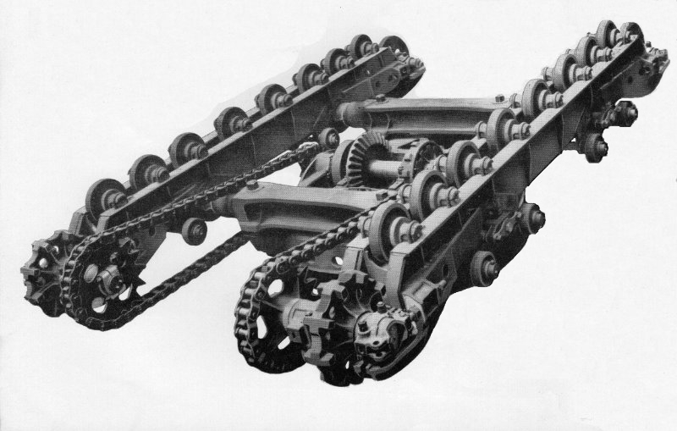
Inverted 54-RB undercarriage

After directing Dennis he waved it at Mike shaking his head and then looked at me inferring that Mike had forgotten about it. Mike looked across at me with false shock horror as though acknowledging he had ‘screwed up’ in leaving it out. So I returned their little display with some tragic acting of my own, shaking my head sadly while laughing at the same time. What it was really all about was reimbursement for the mickey taking suffered by me previously at their hands. The tube could and would be fitted when the truck was the right way up with no harm done.

Dennis was not having a happy time with rollers. Nothing had been done for prepping them, heavier and dirtier than he was used to. Normally working with rotating machinery he was messing around with dirt shields and U bolts. But he pressed on using the air winch while Dave and Mike completed sub assemblies for take up tumbler and drive sprocket end bearing blocks and shafts, only being interrupted by morning tea break. Now having checked everything before arranging to turn it over at around 11 0'clock they needed the track pad sets which should have already been delivered. These days delivery schedules rely a lot on something referred to by the acronym JIT - Just In Time. We didn’t have that back then and Mike was getting annoyed. Before he could put a chase on them however they did arrive albeit JABL - Just A Bit Late - on the Atki’ flat bed. One after the other they were craned over to the truck for Mike and Dave to manhandle into a drop zone for unraveling where with bundle straps cut they kicked up dust as they noisily rolled out.

Along with the track bundles had come a little stranger; we hadn’t seen him for a while. It was Nureyev our pirouetting slinger come to assist with the caterpillar frame turnover. “Are you taking over from Beano and Bob? Is this a Cou-de-tat?” “I fought them off with suitable insults he said languidly straight faced.” He had a dryer sense of humour than we had expected. When asked where he’d been because we had missed him he simply announced laryngitis but was now good to go again with Mike and Dave slinging chains around the axles ready for operation turnover lifting to let it hang at the front end while spinning around to reattach at the rear, then maneuvering level and floating it sideways to line up and drop in the track pad groove as they had done just a couple of days previously. All of this was taking place just a short spanner throw from our own labours and I couldn’t help thinking that just then it would have been more interesting on yon side’t gangway; the grass always greener and all that. Plenty of time yet son; think on…..

As Eddie worked there seemed to be a half smile on his face. I was intrigued by his demeanor so asked him if he was going to share the joke. Smiling even more he replied “It’s no joke Taff. I was just beginning to realise how well this has worked out for Stan, seeing how things were at the beginning of the week.” “How do you mean? “ “Just have a look around you eh? What do you see?” So I looked around just seeing Clive and John still busy on No 2 rev frame, now joined by Reg, and the rest of the crew who had been just tidying up, doing sub assemblies and getting started on the latest frame. It was the first of the next batch of two draglines. John was fitting boom hoist bushings and winding drum with Ross fettling the hook roller brackets. “What’s happening is this” He said. “On Monday two of the gang didn’t show up; nobody to work on the truck frame but with a rev frame due. Stan has used the absence of his own fitters to advantage acquiring two other experienced field engineers to fill their place,” he paused, “on loan from The Field Dept and working to build the truck that didn’t have anyone to build it at the start of the week.”

He took another breath to gather his thoughts. “That truck has now gone out the door and they stayed on to build the next ones” He pointed to the truck being built. “By the end of the day we will have the rev frame over at No 3 sitting on the truck frame that Mike, Dave and our just returned Dennis are building at the moment. Dennis has been loaned if you like; extra labour to ensure it is ready. It makes sense. Stan has also been talking about a 71 which they will start working on perhaps next week. That’s why he’s been disappearing every so often going to planning meetings no doubt organised with Frank Phillipson. Maybe next week, but probably later, we will be getting the first transmission unit to build for it but there’s also orders for a couple of 54 draglines. The rev frame for the first one, which you’ll get involved with, has just arrived and Mike and Dave may well be staying a little longer to help stabilise production so it won’t have been a bad week for Stan at all. See what I’m saying? Harold will also be back on trucks so that’ll help keep things moving Yeah?” He took a much longer breath and just for a laugh I almost asked him to repeat it but didn’t
It was an interesting summary and very enlightening I thought having no clue that so much intrigue was involved in putting diggers together. “You have no idea what goes on, ”he repeated, concluding his analysis of unfolding events with a perfunctory nod of his head as we returned to our drumshaft. Yesterday the transmission unit had been a relaxing plod as we continued steadily during the afternoon mounting the vertical shaft in its casing with the usual struggle manipulating the top bevel gear. After that I’d ‘ given him a hand with clutch housing and the rest of it and now today towards the end of the morning it was ready for installing on the last frame in the line. Tea break had come and gone and it was getting noisy where the boys were sorting out the truck. After a brief respite we would begin on my third drumshaft, at the moment just putting things in order for a proper start after lunch. It was becoming a familiar piece of kit, and as we plodded along there was more drama happening with the truck.

It had landed fair and square in the track grooves. With chain slings un slung what were Mike and Dave doing now? Once again Dave had the top part of the steering tube in his hand waving it at Mike reaching out to take from him as he looked back at me in a helpless sort of resigned look. These two should have been on the stage and I don’t mean the last one out of Dodge City. Dennis was looking bemused, shaking his head as he fitted the top rollers. An hour at the outside and he’d have them finished, probably just after lunch looking at the time. Meanwhile Mike scrutinised the tube assembly lower member and internal digging lock rods before pushing it down the shaft for Dave. Recumbent on his back ready to attach the ends he called up, “One day if they ask me to say something nice about you in the ‘The Digger’ - this was the company magazine - I’m going to tell them he was generally a decent sort of chap but at times also a complete bloody plank.” Dennis, unfamiliar with this pair and looking for some transient joy, started to giggle, the drum shaft crew joined in and Mike moaned, ”I’m seriously thinking of putting in for a new partner. Working with you is like having a nagging wife,” drawing more laughter as Dave pulled himself out from under the truck. It was all pure workplace entertainment that didn’t cost a thing. If the public at large thought factories like this disciplined with management constantly checking progress against the clock they would have been pleasantly surprised. That kind of supervision was completely unnecessary. Everybody new what their job was and just got on with it. Periodic and ongoing point scoring banter was part of the relief, much of it also personally insulting but without malice sometimes directed to apprentices who just had to take it in good part as a bit of fun but giving it back when we could.
Friday After Lunch
The top rollers were done and Dennis was about to make his getaway back onto rev frames when he made the mistake of mentioning the absence of grease nipples in any of the roller shafts to Mike. Oops! Mike could be very persuasive, especially with Dave backing him up and suddenly he found himself volunteering to become yet another reluctant boy scout. There but for the grace of God I would have been knobbled for a second time. So it was later than he would have liked when he eventually did return to the bosom of the rev frame gang. While he was busy counting nipples Mike and Dave were doing something completely different fitting drive chains delivered just before nine O’clock. A heavyish job but they were assisted in joining the chain ends with the same mechanical puller I am sure I’d seen Dick Doudell use on the 38 trucks. The 54 chains were quite a bit heavier than the 38 and if we had the tool to pull the ends together why struggle with looping bits of rope twine? Now it was time to drag each set of track pads across using the same metholodgy and considerations as before, hitching crane chains to a bar poked through track lugs, blocking track roll with another bar through the tumblers spokes and relying on the skill of the crane operator as he hung and slowly brought each set across the top of the frame while lowering off at the same time. Teamwork was essential. Once laid with enough slack it was an easy job to knock track pins through and set adjustment both ends. While all this was going on with Mike and Dave a little further down the bay Arnold had been quietly beavoring away on equipment and was now waiting for somebody to take away the fruits of his labours: one shovel boom and its, separate for the moment, bucket with handles.

Preparations were also being made on the other side of the gangway for lifting the lead frame. But first the truck. This afternoon was going to be setting the foundation for a good start to next week. Mike looked at Dave, Dave looked at Mike and they nodded in unison looking down the bay for slingers. The truck assembly was ready. RB didn’t have ordinary run of the mill slingers. Ours were telepathic and as they looked down the bay a hand on the north service road seemed to materialise with upturned thumb from behind one of the storage racks. It was followed by Beano’s nodding head acknowledging the summons. It had to have been telepathy. I remembered the same thing happening in No 4 Bay when a machinist needed a lift, like Bob on his Ward Turret lathe at my first station who didn’t even look up just giving a quick Whooooop! This time it was Beano accompanied by Wilf AKA Nureyev. The north end of the shop had a chain and harness frame like the south so they could both arrive on the job ready tacked up without having to swap things around. This time they didn’t need the north end crane. That would join forces with the South for the crowning ceremony later already on station for the current lift and a short while later as it took the weight of the undercarriage Dave suddenly looked across at Mike and shook his head. ”The sump?” All this rushing about they had forgotten to fit the oil sump. For just a split second they both looked nonplussed until even standing a fair distance from their endeavors I saw the light bulb go on in Mike’s head. “Oi! Taff?” Oh, oh, here we go again.

The matter was quickly resolved with Edwin. On promise of unspecified return of favour I had been volunteered, again, for the job post crowning. Apprentices could it seemed be quite useful after all. So the operation went ahead without any further interruption, floating a mass of metal that must surely have weighed at least fifteen tons, probably more, across and forward to stand in front of the lead revolving frame. The transfer this time however seemed to include a curious sort of proprietorial ritual, Dave following with hand reaching across to touch one track Mike alongside reaching out touching the other; perhaps a subliminal statement of pride - or maybe goodbye? Hey people we’re the team who put this thing together. Those two had style. Stan Simons meanwhile had clambered onto the rev frame at No 2 that Clive and John had been busily installing the power unit on yesterday, or was it the day before? There was just so much going on it was hard to keep track of things, Stan being doubly anxious because he had another trick up his sleeve as yet unto us undeclared.

With the truck ready waiting for the upper works, the North end crane bringing the rev frame harness for lifting under the rear end tail weight casting, the South changed from chains to rope loops for the boom feet. People gathered, roller pins were placed and a stray apprentice loitered. The coronation was under way the rev frame hovered seeking its target. Nureyev was once again in good form standing on tippy toes in his hobnails pinching fingers to signal how much more to lower. This time it was John suspended in the air standing amidships spotting the propel shaft through the centre bush. Forward, forward, STOP. Left, left, left again. STOP and lower. Slowly, slowly, Nureyev signaling, until he dramatically spread his arms wide, hands extended. STOP! One detail not registered previously was the placement of matches or even torn up cigarette packets either side of parked rollers which at times seemed to have a mind of their own. Eight of them to shim between four carriages could often be tricky. This time no pinion hang up the rev frame quickly reached level, four pairs of rollers had their shims adjusted, pins pushed home and secured but, the sump will have to wait till Monday. Told that pair of jokers I’m far too busy on my drumshaft. Ain’t life TOUGH!

Beano and Nureyev were looking to return the harnesses but were thwarted by Stan and his new plan so after a hurried briefing cranes were redirected to collect the part built frame at second position and move it up onto the pedestals just vacated. Come Monday if things went well the newly delivered dragline frame would be moved up to be joined by a second so it would be all systems go for next week. We thought we had it all worked out. But no! Both Edwin and myself still busy on the drumshaft looked up again as the south doors parted to let another flat bed reverse into the bay with yet another truck casting for Mike and Dave. Nearly 4 0’clock and still delivering? Someone was keeping up the pressure even this late on a Friday drawing comment from Edwin that although he had been working in No 3 Bay for about 18 months he’d never seen so much crane activity so late on a Friday afternoon. Dave and Mike were not looking best pleased either, obviously wondering how it was they had surrendered freedom in the field for what they were rapidly coming to believe was workshop slavery. They’d put a good effort in today and mouthed something obviously very rude when they saw the delivery while Edwin, nodding in their direction, looked back at me and said, “Don’t be surprised if those two fail to turn up on Monday. I smell rebellion.” After that things finally started to quieten down as production came to a halt for my first week on 54 build. It had been an interesting and enlightening experience and at knocking off time like everybody else I was expecting just the usual kind of weekend…….but it wasn’t because it was on that Sunday that the train crash occurred.

As mentioned earlier with Lincoln being a Cathedral City Sundays were usually pretty quiet in the day with no overtly lively night life either. However in the early hours of June 3rd 1962 the inhabitants had a very different Sunday albeit with sad loss of life and many injuries when the 10.15pm sleeper train from London to Edinburgh, travelling through a diversionary route curve too fast, left the line in the early hours of the morning at 12.49am overturning seven coaches and derailing another. Sadly two passengers and a steward were killed with forty more injured. For the inhabitants of Lincoln an unpleasant surprise to wake up to and by mid morning many had arrived upon the catastrophe, viewing the lacerated debris from above while standing on the Pelham road bridge that straddled the scene. I was one of them, arriving later in the morning riding in on my bike having heard it on the television news.

It was an interesting experience for the viewer because we had all heard of and seen reports in the past of similar occurrences but now we the residents were part of the scene, the most interesting aspect for me being the number of bowler hatted railway investigators walking about with measuring tapes and clipboards sketching and noting what they found. It was illuminating from my mechanical background to see the two railway steam powered recovery cranes in action lifting and generally handling the mangled coaches as they lay on their side. Was it nearly ten years ago that I stood next to the Tawe River scrap yard with two other steam cranes? Seven overturned carriages with one derailed made an awful mess with twisted rails and broken and displaced sleepers stretching for some distance. It was also not a steam locomotive at the front end but diesel having been diverted from the intended route the cause of derailment being put down to too high a speed through a bend and the driver’s lack of familiarity with Lincoln and diesel locomotives against longer experience with steam. It was all the subject of much review and conversation for tea break time for several weeks.

Monday Second Week
“Trouble again?” Taff said Edwin. Once again I had been summoned to apprentice HQ. “Oh hello Taff. How do you feel about mixing it with the toffs at Oxford?” That’s what Charlie Everitt had said. Ten minutes earlier I had been humping metal on a 54 so now I was intrigued. Looking at my puzzled face he said,” You’ve been picked to go with another lad to represent the company at an apprentice conference in Keble College in Oxford. Congratulations! I was stunned. The conference of young alert minds, the cream of today’s apprentices, would last for a week and was scheduled to start Monday next week. There would be a number of guest speakers on various subjects passing on their knowledge to about a hundred of us including perhaps a couple of lads from France and Holland. We would have our own accommodation in the very same rooms as the genuine university geniuses so it would be quite an interesting experience. My student apprentice companion whom I will call Crispin, well why not, was currently working in the engineering drawing office, possibly alongside my exhibition visiting friend Dick. I knew Crispin, not very well but I knew him so that was OK. He was trying for his HND Certificate which was a lot more advance than I could cope with. Much to my surprise I had passed the intermediate stage of City & Guilds Machine Shop Engineering but dismally failed the final. The trouble with the final, the one that really mattered, was it required a lot of technical description and an ability to sketch engineering stuff which even if I could answer verbally and see it in my minds eye I could not articulate on paper. But how about that huh; a non academic Taff goes to Oxford.

It was very busy first thing that morning with everyone working like stink to get the front end shovel equipment in place and roped up. As it arrived earlier, floating across the bay, the boom had actually cast a shadow as I lay beneath the truck fitting the forgotten sump, a trade off previously agreed for unspecified favours between Edwin and the spare parts. It was certainly less trouble to fit than on the 38 which had been in three separate sections. Above me now as they pinned the boom feet there were disturbing clunky noises but I was un worried knowing exactly what was happening as they rested the boom head on the erecting stand. The 54 had a shaped fabrication casement around the main drive bevel gear and was easy to wedge in place with wood packing to secure it. With that sorted Wally the greaser filled it from an oiling bucket and then anointed a few more nipples so I made at least three people happy; four if you count Edwin. Once that was done I pulled faces at Mike and Dave as I passed them on my way back to join Edwin on the latest drumshaft. Harold the original truck gang fitter who’d been on the sick had also returned so it was another face to get used to.

A couple of cabbies had arrived to lean a few panels against the machine while they planned their first moves and the roping up crew had joined them waiting expectantly for the crowd chain. I could see it was going to be crowded on deck. There were still the odd mechanical bits to be done and I could see fitters and cabbies getting in each other way. Down at the ‘big fella’s ground, now minus the boom, Beano and Bob were making ready with Arnold to hitch the accompanying bucket arm ensemble as soon as the chain sling returned for gift wrapping it. Yup! It was all happening. I was to stay with Edwin for the best part of the second week while Harold re acclimatised himself before moving over to help on rev frames on the Friday morning when Mike and Dave, as expected failed to show up, instead moving on to undeclared fields in foreign lands. They had been good fun and I thought we would miss them. So Harold had his old job back; the labour situation had all been very well choreographed just like Edwin said. The 54 had finally rolled out of the shop late Tuesday afternoon leaving the No 3 space to be filled by the part built frame at No 2, the frame at No 1 moving up in turn. What was the new pep frame going to be for? Was it a 54 or 71? From then on everything was more or less going to be a repeat of the previous week but when I slung my hook at Friday’s end of shift I didn’t really care because I wouldn’t be seeing it all again for another eight days.

Keble College Oxford
The apprentice accompanying me in our quest for posh knowledge I will call Crispin. Not his reall name but it suited him; vaguely known through occasional contact around the works. Mum and Dad would be tickled, I thought, to know that I was actually going to Oxford to study as part of my apprenticeship, with the forthcoming attendance date and my name also confirmed in the local Swansea evening paper and they were really chuffed about that. However it is sixty years now, almost to the month, when we made that journey and I just cannot remember exactly how we got there. Was it by road or railway? A complete mystery. We would depart Monday morning by 11. a.m. arriving in good time to be ushered into a meeting hall for introductions and then led off to our accommodation in a totally different kind of world to what we were used to. Crispin had a study room next to mine in a building that was typical of how old colleges are presented in films with porter’s lodge as part of the entrance stairway off the old stone building leading up to our separate first floor accommodation. I expect many things have change there since those days but with self contained individual rooms it was obviously conducive to study and you could feel the aura bouncing off the walls. I don’t know how accurate that memory is but that is how it raises itself in my mind. Although given some kind pamphlet of events and lectures they were obviously discarded at the time so I cannot make direct reference to any of our discussion matter. But what I can remember is an MP by the name of Watkins who was something to do with industry and his subject matter for one of the lectures. We all listened intently to what he had to say with a question and answer session afterwards. I of course asked intelligently why an MP supposed to be representing industrial interests was not concentrating more on being an MP????? His reply has long been forgotten now but it was far more intelligent than my question.

We were split up into a number of groups each with a leader to keep us informed about lectures and anything else that we wanted to know. Our newly appointed chief was a very outgoing sort of fellow regularly having carried out the duty for other groups before. I can’t remember his name but it was a double barrel sort of thing at which he poked fun to help us relax. Having inspected our accommodation we then had lunch in the main refectory I think they called it or was it the main hall. Anyway it was a little different from the works canteen. Long, long and long wooden tables stretching from one end of the building to the other with matching benches served by a regular catering staff. It seemed almost Dickensian with echoes of Tom Brown, fags and prefects with plenty of atmosphere floating around. Out in the town there was some kind of fair going on so our leader took us for a walk around the streets surrounding the college and onto the merry gathering where the biggest attraction was a scantily clad young maiden with but two strategically place hands to protect her modesty while a rough looking character dressed as a pirate threw knives at her. Oh! Tisk, Tisk. Fortunately he was a good shot and the knives all embedded themselves around her form and not in it. However! One amongst our number was a visitor from Holland. “What was this barbaric treatment of young maidens about?” He was blonde haired with rounded face, slightly but only slightly overweight dressed more as the quintessential English gentleman with no vestige in his speech of Dutch heritage and he wanted to rescue her.

“My name is Peter,” he announced, ”Peter Schatt,” adding with grinning acknowledgment of our thoughts, “Yes. Not one you will forget is it?” We however managed to dissuade rescue attempts and avoid the headlines. Perhaps he had been trying to wind us up. He was a bit of an eccentric and good fun seeming to have that inner glow that some people have; very pleasant and amusing company while temporarily living in ‘dear old England’ driving a Morris Minor car. His pride and joy he took us to meet some distant cousin living in Aylesbury driving there on the very busy main road while he chattered none stop. I sort of saw the other car in the distance, bright red heading towards us, you couldn’t really miss seeing it, while he prattled on not noticing that he was drifting. One of the other lads in the car, there was four of us altogether, had the same instinct of forthcoming catastrophe and pointed at it saying with a note of urgency, “Peter that car?” Not a moment too soon he braked hard not quite swerving to the nearside while the other car didn’t seem to change direction much at all. It would undoubtedly have been head on, how we didn’t collide was a mystery. “Oh I say chaps I’m most frightfully so sorreh. Is everyone alright? “ “We are now,” somebody said. Not me though. I was still trying to recover from What if?

The rest of our stay carried on in convivial fashion with lectures and meetings designed to stimulate our minds with other meals and gatherings. These at some of Oxfords finest cafes and one or two other hostelries culminating in a farewell s dinner on the Thursday evening and one last of get together for Friday lunch after which we went our separate ways. Crispin and I also went our separate ways although we had not really stuck together during the week he having made friends with some other delegates and staying on till Saturday night. I was by prior design going to visit big sis’ and husband at Putney where she taught zoology at a Private school. Not conversant with timetables and train service she’d done the research providing full instruction for meeting brother in law at the railway station with his light blue A-35 Austin. It would be good see her after last Christmas but it was not going to be for much of a break because of the penalty clause imposed by cruel RB management. Quite stressing me out we had to write a dissertation, posh word for lots of words, about the conference. At least they gave us a fortnight’s grace to prepare it and knowing it would be a hopeless task back in Lincoln I made a start while in Putney.

Saturday was a day of rest but Sunday was slavery hunkered down over Biro and paper, no word processors and I hadn’t a clue how to use a type writer, trying to string enough intelligible sentences together to paint a verbal portrait of what had been exercising our minds over the past week. I thought I had done a reasonable job but made the mistake of showing it to Crispin, comparing notes at the end of the week following our return. But Crispin was devious. My writing, though not excessively small, filled a number of pages. He whipped out his to briefly compare and seeing my epistle had more pages than his promptly went way and rewrote it with very big stretchy handwriting to make it look more. His double effort and guile however was to no avail because neither of us heard any more about it. Whenever doing reports after that they were as secure from prying eyes as gold bars in the Bank Of England vaults.

Return To 54 Build
After first paying the apprentice supervisor the courtesy of a visit to tell him all about our Oxford days I made my way back to 54 build; a slight change of scenery from my departure nine days ago. There were two draglines in hand with the same basic deck machinery as shovel but without crowd/backhaul units. When the lattice boom was fitted a fairlead unit would be attached at the front to guide the drag rope. There would also be a change to rope drum arrangements with hoist lagging on the left replacing the split crowd gear and drag rope lagging on the right. The machinery deck in lead position was due for lifting onto its lower works very shortly; the one at No 2 was well ahead in build progress with the new 71 frame, delivered early in the previous week stood behind the second 54. This was now beginning to impose itself at the back of the queue normally reserved for prep work. It had already been getting attention from Charlie Dixon’s gang, a number of them visiting it while I was away, er at Oxford, to see what all the fuss was about. Its very large front drumshaft had been put in place along with the transmission unit and one of the gang was working on the planetary drive crowd assembly. On the other side of the gangway Harold, recently returned from the sick, had come back to a revolution putting together the 71 truck and crawler frame. The undercarriage for the 54 dragline was waiting patiently with its bride still sitting on the build pedestal about to be lifted. The scene would have mad a splendid subject for the likes of Artist David Shepherd.

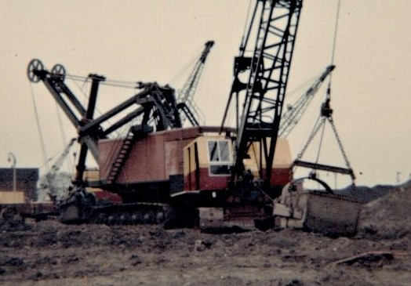
150-RB Electric shovel and a standard diesel 38-RB Dragline

As it turned out I didn’t really l have much to do with the 71 except for assembling one of their crowd/backhaul units which completely different from the conventional type with a planetary system using phosphor bronze bushing for the main shaft taking some time to scrape by hand till acceptable. On the two 54 draglines I got seconded to bolt main swing and propel gears to centre bosses and eventually conquered my fear of being crushed, assisting from beneath the heavy mass and lining up swing pinions on both machines. Adding to my satisfaction on the very same completed machinery deck I seized the opportunity to shove a roller pin home with shims as it was being married to its mating truck assembly. Earlier I suffered acute embarrassment getting wedged under the drum lagging while endeavoring to fit a drag rope tray. The details are a bit hazy now but the rather long dirt tray also acted as an apron to lie over the immediate deck front, abutting and bolting to the curved part running up the back of the drum. Trying to secure the abutment end from the top and leaning in too far I slid further into the gap getting wedged just after the rest of the crew had sat town for morning tea break. I could have been there until the cows came home……….

This account of 54 excavator build is purely from memory of sixty years ago backed up by reference to spare part and sales catalogues acquired at the time. It is as accurate in detail as I could make it given those constraints but in the writing I also wanted to impart an impression of the pace at which building took place which was not frenetic. If you follow the detail it would seem to imply two machines per week. Fortunately I have a copy of production records kindly donated by Derek Broughton of Ruston Bucyrus several years ago and have thus been able to make some comparisons. In 1961 when it was introduced three 71-RB machines were rolled out and forty 54-RB excavators. Discounting four weeks to cover holiday periods and other contingencies gives an average of just over one machine per week. In 1968 when eight 54 machines were built they also produced fifteen 71 and five 61 excavators; an overall total of twenty three machines; a production figure seeming completely compatible with the record already referred to. Allowing for the build pace ebb and flow associated with annual assembly and other factors in human endeavor, it is still a reasonably accurate maybe slightly optimistic portrayal. If my story has shown them valiantly improving the production so what? They were heroes and I was there in person encouraging and assisting them…….living the dream. But there is one sad fact I must now also recognise which is that after spending around two months working and learning how to put the thing together for some reason, quirk of fate, call it what you will, I never ever had any more to do with them for the rest of my time at RB. It just didn’t happen. Over the years of production until the last 54 came off the line in 1973 a total of 582 were built in their various guises. Where did they all go to? Today most of them have completely disappeared.

It was mid morning on my last Friday. Stan Simons said, “Frank Philipson wants to see you in his office.” Chuckling he added, “Are you in trouble again?“ Puzzled I shook my head. I was not aware that I had been in trouble as he put it. I was diligent, honest and hard working like all RB apprentices. But it was typical of the normal light hearted accusatory banter so I just laughed replying, “Not since the last time,” but at the same time metaphorically scratched my head and proceeded with trepidation down the bay to where Frank ruled his kingdom from on high. After an anxious climb to his eerie though I found him in good humour. “What do you know about fairleads Taff?” “Ah! Oh! Never given them that much thought really Frank, why?” “You’re probably going become an expert on them then,” he replied grinning. Why I wondered was everybody grinning this morning. “As from next week you’ll probably start dreaming about them. Roy Archer’s crew build them on his patch in No 17 Bay. You can actually see it from my number two office so I can still keep my eye on you over there,” he laughed. “Oh, wonderful,” I said sarcastically. “I’ll look forward to that.” Chuckling and smiling he waved me away. I wasn’t in trouble then and next week I would be movin’ a bit closer to No 18 Bay. Interestin’! I would certainly miss 54 gang camaraderie and atmosphere of heavy equipment. My time there had been enjoyable but when you had to move on you moved on; especially if it’s to somewhere good. I remained with 54 build for the next two weeks generally just moving around as the job demanded filling in and assisting or hindering anybody who needed my expertise. Fortunately they were all pretty easy going.
Fairleads
Totally different from the previous heavy equipment surroundings 17 Bay still buzzed with organised activity. Apart from fairlead build it was also set up for component welding and dragline buckets but I would be solely on the fairleads. The fairlead was the essential piece of equipment that bolted on to the front of dragline equipped machines to give a central point for controlling the bucket. It consisted of the bolted on body casting into which the guide pulley assembly was anchored and able to rotate freely while feeding rope out to the bucket or directing it tidily back onto the rope drum lagging. Roy Archer’s patch occupied around the same working space as Sid Lucas did with drumshafts and was on the east side of the bay almost opposite the gap leading to 18 Bay next door. There was the usual racking along their back wall with another row at a right angle into the gangway. As well as Roy the chargehand he had Jed his assisting fitter. It didn’t look high pressure but you could never tell. Muggins was going to be their shinny new apprentice slave.

The racking was full of components like nuts, bolts, spring washers etc along with their axle pins and Ransome & Marles bearing races for sheaves in their liveried blue boxes. Timken taper roller sets used for the body were in their own livery in another rack together with the completely cast rope guide cheeks. Stashed on the ground a number of fairlead frames and trunnion sleeve castings were ready waiting assembly not yet with guide plates on, a cluster of sheaves also taking space neatly aligned against each other on one of the longer stronger shelves. This was a busy place. Were they expecting me to get in a sweat? I expect so. They were nearly all for 19 and 22 machines but also, when the need arose, the odd 38 and 54 fairleads were assembled here. I judged Roy to be late forties, exuding a relaxed manner, quite pleasant with a ready smile seeming quiet content with his lot. He wasn’t tall, just average height and medium build with a roundish face topped with a good head of grey hair. There was a stand up desk in the corner by the partition and against which he often leaned with the paperwork. I don’t recall him doing a lot of the physical stuff making me think that he had his fingers in other pies in the bay as well as fairleads. Jed, his assistant and my new workmate, was of similar easy disposition in his mid thirties with a longish face, aquiline nose, bushy eyebrows and short fair hair. About the same height as Roy but perhaps a tad slimmer he too was easy to get along with and working together we soon started getting things done after his initial sweep of hand to show the vastness of their kingdom. “You can make a start giving me a hand here,” he announced dragging up a base casting with pulleys on it for the swivel bit into the middle of the domain.

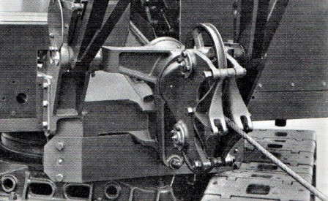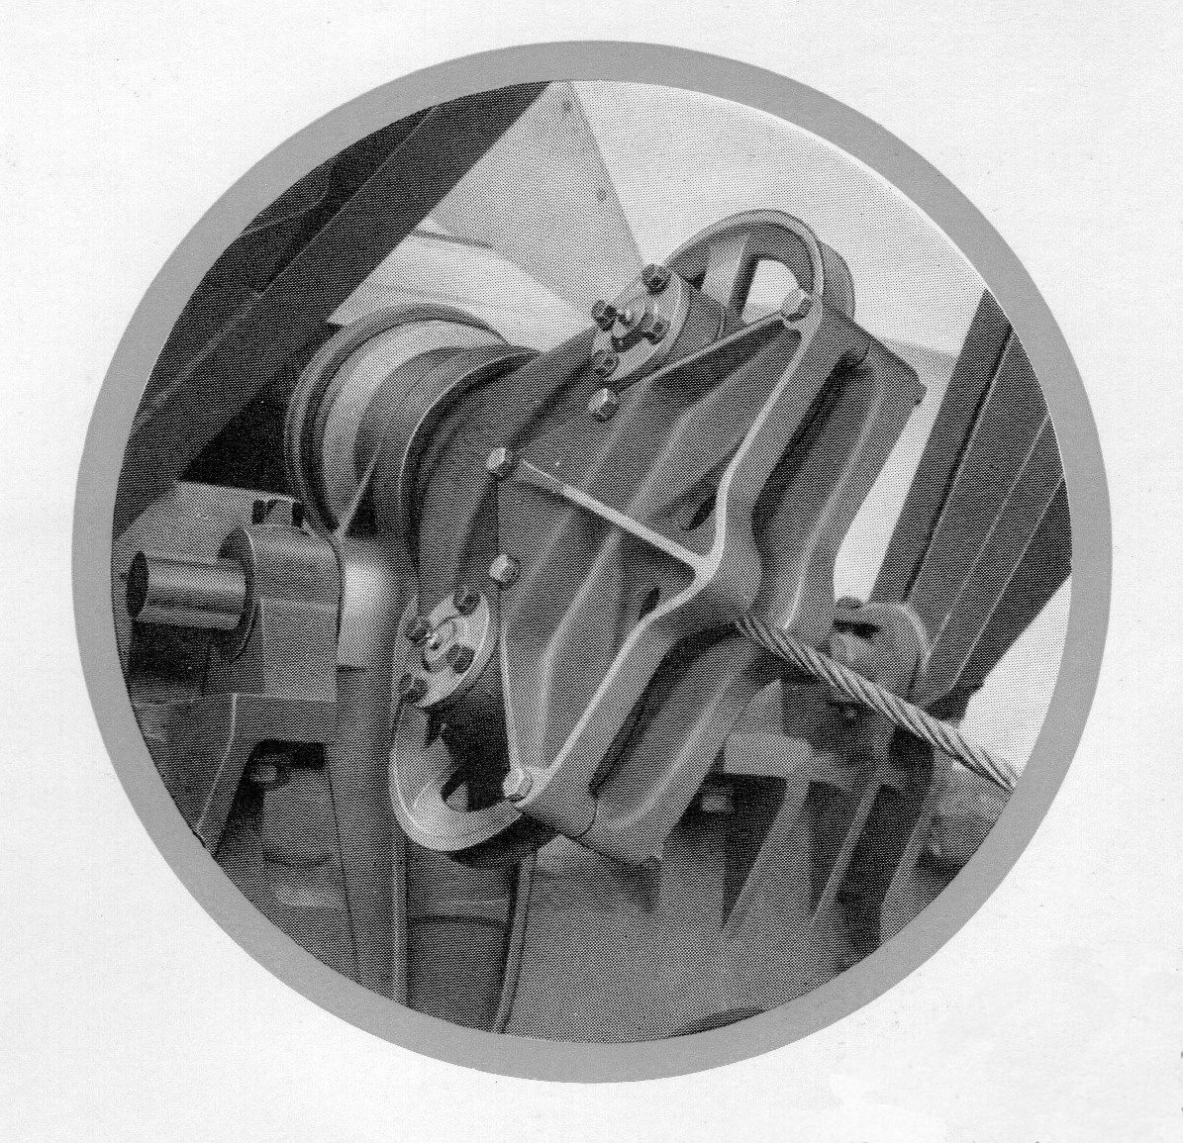
19 & 22-RB 38-RB

It was quite a lump having stubby arms each side angled at the end and bored for receiving boom foot pins. A longer heavier arm poked downward between them for bolting to the front of the revolving frame. “You’ve seen one of these before haven’t you?“ “Yeaah I drawled back like a smartass. “Actually got the chance to fit a couple onto 38 machines in 3 Bay when they were roping them up. “Oh right then,” he replied. Well this is the other end of the operation. The part with the pulleys fitted to, or sheaves as they are also called, is known as the fairlead frame. As well as the pulleys you’ll see reversible wear cheek guide plates each side. We have to mount it all in the main casting barrel, or trunnion sleeve to give it the proper name, so get a hammer and we’ll knock the two outer bearing rings into place. All we have to do is mount the front inner race on the trunnion sleeve first along with its outside race in the barrel and the shove it through to fit the other end bearings and secure the end cap. That’s held on with four screws you can tighten down.” he said, then adding “Everything should turn freely but not loose. If it’s tight or loose we adjust it by removing or adding a shim under the cap. Okay?” I told him that was okay. I was in fact quite familiar with most of it already but he was only being helpful. Better that than some other grumpy individual. As we were putting the last bits together there was a slight breeze and the dust licked up around us.

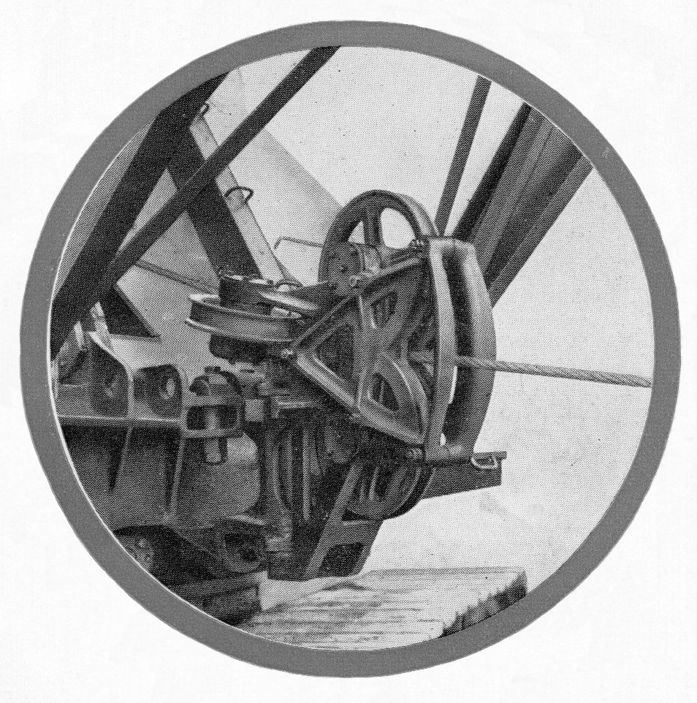
54-RB Swinging Fairlead
It was Bernard Sharp the dynamo foreman from 18 Bay next door. Almost a blur in his white smock I never saw him move at less than full pelt all the time I was there. Slim built, dark brown hair swept back from his forehead he had a sharpish chin and a nose to go with it. I do not say that disparagingly because it suited his character. A little abrupt but not unpleasant he was just completely focused on the job chasing many things and it seemed quite often chivvying for one or more fairleads; like now. “How long will that one be Jed? Oh! Sorry,” he said. Chargehand Roy had come up behind him and there was a protocol to be observed although no offence had been taken. “Half an hour Bernard?” “Oh that’ll be fine,” he said. “It looks like I’ll be needing two more for mid afternoon? That okay?” I hadn’t met Bernard to talk to properly before and Roy’s reply made me laugh. “I’ll get the whip out,” he said, Jed showing alarm in response pretending to cower. Bernard, sort of smirking half laughed, turned on his heel exaggeratedly sighing said, “Just do what you have to do,” and disappeared through the gap back into 18 Bay. Sharpie was a serious kind of guy but there was definitely some fun there somewhere. Jed turned to me and said, “And you thought it was going to be easy, like a holiday camp. He ain’t seen nuthin’ yet, has he Roy?” Roy chuckle snickered, shook his head and walked off down the bay to another little job.

We finished putting together the fairlead, everything rotating freely nothing loose. Roy had organised transport for it and we started sorting bits for Sharpie’s afternoon delivery. If there was anything I wasn’t sure of I just copied what Jed was doing. I left fitting the pulleys concentrating first on the trunnion sleeve bearings then assembling it to the main barrel. When assembled it was quite a heavy lump although still just maneuverable by hand. Next job was checking out the two pulleys, mounting shafts, lining up with top and bottom, pushing them through and securing in place. Only thing left was mounting the guide plates with a centre screw each side along with top and bottom clamping bolts then. There was nothing complicated to do and they were easily ready for Sharpie whenever he wanted them. I think that around this time they were rolling out around ten or eleven machines a week, a good proportion of them being draglines and not long after they collected our fairleads, at around 3’Oclock, a fork truck with a red pallet load of bits arrived for the next batch so we just plodded on steadily. Fairleads were just a steady undemanding sort of job unchallenging with no pressure. And then four weeks later Sharpie turned up one Monday morning and took me away again but before telling you where he took me let’s have another break from the technical stuff and talk about visits to some other places.

Lincoln College Visits
It must have been into the second or third year’s attendance at the Tech that our tutor Mr Davies organised some educational trips for us. The first one required a battered single decker touring bus taking us to a small remote company somewhere out in the Lincolnshire countryside producing plastic molded components. The particular point of interest was supposed to be the construction of the injection molding dies. For some of the visiting young engineers it was the manning, or maybe should it be womanising of the production machines that proved the more interesting with die design sadly coming somewhat secondary to lusting male hearts. Not a very exciting trip but at least it was a morning out from the sweat shop. Our next visit was local and more interesting with a touch of drama. It was actually to RB’s nearest neighbour, ‘Dawson’s Vee Belt’ works at the corner of Beevor Street and The Rope Walk. What a fabulous name for a road. I wondered where it originated. Just after lunch we parked up outside having driven down in several overloaded student owned cars from Monks Road, doors deliberately slammed for effect to let everybody know ‘The Boys From The Tech’ had arrived. I remember thinking at the time that to an unsuspecting onlooker it could have looked like a police raid the way a few of them strutted their stuff, standing more upright before getting organised to invade the reception area. Having been introduced to the Production manager, was it Mr Lesley Coombs? We were then taken through the ground floor rubber processing area. In some ways not very exciting, perhaps a little bland with the just scent of rubber until we came to the ‘rubber rolling machine’. A safety demonstration had been arranged to be given by Ralph its regular drama scene creator. The machines processed newly mixed gluggy product from the large blobs delivered from the mixing vat and squeezed any juice out as it squashed and drew it between two rollers, each about a foot in diameter. The blobs would be passed through a number of times until the resulting mat was the right thickness to be trimmed and eventually cut into the V form of the belting product. Well that was how it was described in simple terms but it there was actually a little more to the process which we would inspect a little later after the safety demonstration by Rubbery Ralph but known simply as ‘Rolly’.

These powerful rollers Ralph emphasised could easily pull a limb off he said, “so we have to have very sensitive quick acting safety systems to make sure that sort of thing cannot happen. As you can see we have to feed the rubber over this front tray where it is taken by the rollers. This bar roller standing up in front of me is my protection,” he said. Oh boy was this drama. We felt for him. He was a big fella and would make quite a mess if squashed. The production manager now standing square on at the end of the machine gave an imperceptible nod and as the rollers rolled Gordon dramatically collapsed over the safety bar. Actually it wasn’t so much of a collapse as a full bodied dramatic dive across the bar. We all gasped, the machine shuddered and stopped with a bang in mid roll, Ralph giving a self conscious smirk as he pulled himself off; erect and unscathed. Our gathering of geniuses looked on, thoroughly entertained by his over zealous acting ability, giving a spontaneous cheer making him all embarrassed and colour up as the production manager laughed. It was all good fun but we couldn’t help but wonder about the circuit design and outcome if the electrics had decided to fuse at the wrong moment.

Thanking Ralph for putting his life on the line we were led back out of the roller shop to the end of the building where we had to climb some wooden stairs a couple of floors up to the raftered attic. There we were confronted with a fairly small hatchway set into the end partition wall a couple of feet off wooden floor boards from which we had to launch ourselves, clambering through a hundred year time warp. That was truly what it seemed like because there were several rows of wood framed weaving looms crammed closely together stretching back into the factory maybe fifty feet or more and just as wide. To me the whole stuffy atmosphere was from another age with the girls attending the looms seeming to be dressed for the period. There must have been, it seemed to me anyway, around fifty work stations and I certainly would not have wished to be there myself in what seemed such cramped 19th century conditions.

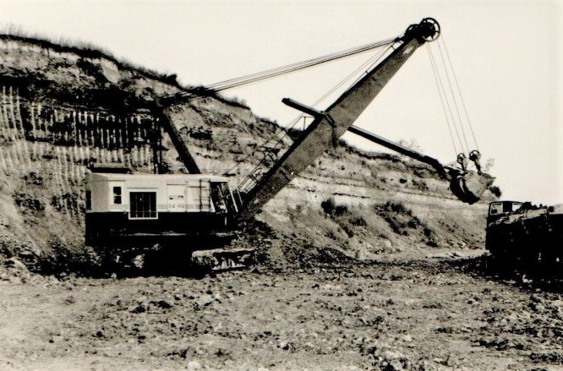
One of the limited production long reach 54-RB rope crowd shovels

Our party finished clambering through the time portal and oggled the talent. The whole thing was surreal. I’m sure they were wearing an early version of safety wear in the form of mop caps to keep flying hair safe from the belt driven overhead shafting. In the corner opposite the entrance hatch there seemed to be more concentrated activity with a couple of men in normal overalls working on one group of the looms. All but these few were busy clacking back and fore spewing out finished product but it looked like summat had gone wrong? The last of our motley crew had just finished clambering in through the hatch with the talent casting an eye, summing us up and reciprocating by ogling us in return as they giggles and nudged each other. It was a strange situation really and I could understand if they felt discomfited by it being regularly displayed in such a manner to complete strangers. We spent a few minutes stood there as our guide outlined what was actually happening and then rejoined the 20th century. It did leave an impression on me however finding it very reminiscent of the photographs depicting the early Yorkshire cotton weaving industry. So we made our way back down the wooden staircase and out through a side door into the street with more noisy car door slamming from the guys seeking to display masculinity climbing energetically back into their transport and we set off back to the college.

It was some while later when we went on the last trip I can remember which would probably been in my fourth year. This was to a clay pit or similar and it might have been every body’s last visit ever! There was a 110-RB shovel working in one part of the pit and at the other end one of the special long reach 54-Rb shovels referred to briefly earlier in the narrative. I have included photographs of both. I was the only apprentice from RB and had the opportunity to show off and talk about both of them.

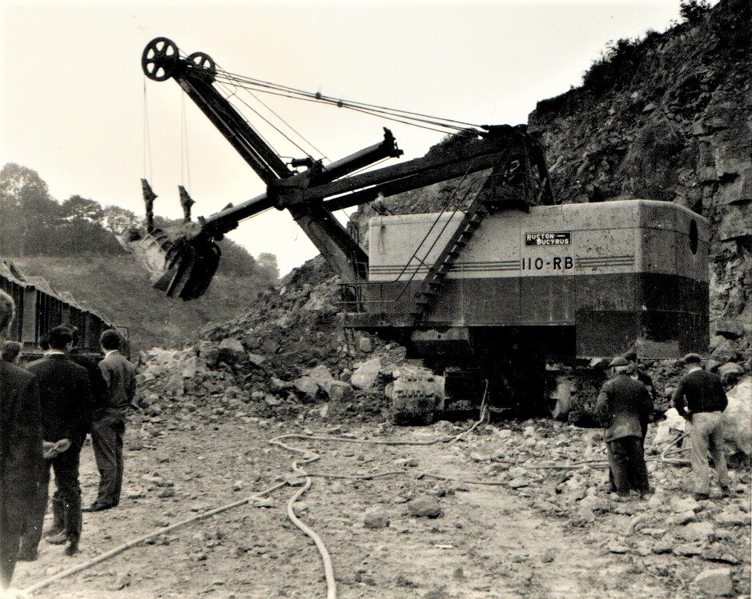
110-RB shovel waiting to discharge into railway trucks

I had started smoking again after giving it up in earlier boyhood this time thinking it would fit more in keeping with my status as a world weary apprentice engineer. One or two of my companions also had the habit but not indulging at that this particular point in our visit being shown around under guidance of the operations foreman. Perhaps feeing a little self important amongst it all I lit up a Woodbine to savour the flavour of the occasion standing to one side soaking up the industrial vibes. As we stood one of our more serious members asked about explosives and how they were used and after a short lecture on the subject the foreman ambled across taking us into the dynamite shed, boxes of the stuff stood around as we talked…. One of the crew outside approached the with a query for him which he briefly went back outside to discuss before once again turning his attention back to our lot still inside. This was just when I raised the ciggie to my lips sucking contentedly and bringing a glow to the wooden boxes surrounding us. That was when his pallor changed, his face slowly turning a greyer shade of white while looking in my direction as he raised one hand to point while raising the other with two fingers mimicking the grip on a cigarette. He slowly exhaled, going to say something: But all he actually did manage to say was: Haaaaaaaa……….! The picture above was taken by me about ten minutes before while standing not far from the dynamite store before we entered. That was our last visit.

Priestman Excavators Hull
As mentioned earlier when ever there was a Public Works exhibition in London I would hook up with Dick from the drawing office to pay a visit and check out other digger stands. Priestman was one such company whose product had so often been seen on Swansea building sites. It must have been into the fourth year of my time at RB that I decided to pay a direct visit to their factory premises in Hull. There had been articles in the engineering press about their new all air controlled LION excavator. Was it going to be fierce competition for us? Should I put my life on the line and go into their den? Well the mission would have to be carried out carefully. If RB knew what I was planning to do I think they would have taken a very dim view. I remembered the fuss they made over my just writing to their American division about their company magazine. So I played it straight and wrote to Priestman as a private individual, an apprentice no less working at their top competitor in Lincoln, telling them of my schoolboy Swansea days watching their machines digging holes. This was purely a private venture; I was interested in all excavators etc writing for the attention of the sales manage. To my surprise and within a short space of time a very pleasant reply was received inviting me to visit, just let them know when I wanted to come.

Hull was only 50 miles by road and when I investigated there was a bus direct to New Holland located across the Humber Estuary from their factory. Not a problem. There was a regular ferry crossing between Hull and new Holland throughout the year, Tattershall Castle, Wingfield Castle and Lincoln Castle paddle steamers doing regular duty on weekdays with a town bus service on the Hull side serving for transport to Priestman’s gate. On arrival the gate man got in touch with the sales department and a Mr Monagahan met me there with a very cordial welcome, which soon became confusing when it appeared that he thought me to have more status than I actually did. Whoops! He was not the person who received my letter and it became obvious that somebody had goofed when I explained things. He remained friendly however but instead of escorting me around the works himself introduced his deputy whose name is now lost in the mists of time. But no matter, he did a very good job of showing me around not in the least secretive discussing and showing the various stages of building the Lion in particular and other machines like the Wolf, with which I was familiar remembering foundation digging days at Marks & Spencer back in 1952. Tiger and Panther machines were also evident with the usual twin winding drum arrangement common to all their machines. Some years before they had introduced a very much updated Cub model having a custom made trailer for site delivery as an option for small contractors. It was very ultra modern for its day with modular all round vision driving cab quite revolutionary. I remembered the two Swansea Cubs from pre historic times with their lopsided looking wooden cabs on the Edward Heath building site almost ten years before. What was that machine on the line across the way from the cub build I asked my guide? “Oh that’s the latest Beaver model. It’s waterproof,” he said laughing. It’s our hydraulic version, doing very well for us.

The place was like a wild animal sanctuary. I was getting hungry. When was feeding time? The morning was flying by and my host took me to lunch in their canteen where we discussed the Lion. It was a particularly tidy and clean looking design becoming a very successful addition their range, one of its features being twin joystick type air controls combining disc clutch swing or travel function with main service utilities. They were he said intent on developing it into a crane for a variety of duties including that of a building site tower type. One of the principle differences to RB construction was their use of fabrication for main revolving frames with lower trucks cast only on the bigger machines. During the course of the morning my guide showed me their special cross roll bearing for mounting revolving frames to the lower works. They had he said been developing it together with the British Timken company. It was a very clever piece of design, interlocking rollers on opposing plains giving a very smooth action, already fitted as standard to the Lion and seeking to be applied where ever possible to other machines and other manufactures. It was a leap forward from your bog standard hook rollers but at what price?

In comparing the RB works at Lincoln to the Hedon Road site RB was much older in construction and with the high roof line of No 2 and 3 Bay perhaps compared to the newer factory at Hedon Road facility it deemed a little gloomy. There was I thought a totally different feel to it but of course RB with its 22 Bays was considerably larger. Passing on through the works after lunch we also visited grab manufacturing. They specialized in this particular product and supplied many dock authorities throughout the world occasionally building a complete floating grab dredger. It was a most interesting visit and well worth the journey. Whether there would be any management repercussions remained to be seen but there were none. So I bade Mr Monaghan’s assistant farewell making my way back to Lincoln completely knackered on reaching sleeping quarters but still very content to be at RB.

19 & 22 RB Build
Putting together the 19 and 22 was a different bucket of dirt and in one sense particularly special for a schoolboy Ruston Bucyrus fan having grown up in the post war years. Whereas for smaller capacity excavators companies like Thomas Smith, Priestman and NCK seemed to favour twin drum sets, side by side on a common shaft, RB built them tandem with one behind the other. The 19 was the first of their diggers that a schoolboy of reasonable size could clamber on to stand behind the driver looking over his shoulder as he pulled and pushed all the levers. The 10 was just too small with too many knobbley bits sticking in your back so putting together the 19 and 22 in the factory could perhaps be seen as the culmination of a schoolboy quest for the Holy Grail. There was a lot more to the 19 and 22 compared to the 10 and from fading memory I must have spent about three months with the various stages starting at the Beevor Street end on drumshafts. For brevity I will from this point solely refer to the more dominant 22. Like the smaller machine there was an assembly table having capacity to build two sets of two at a time if production demands warranted while also allowing flexibility. In 1963 for example the number of excavators built was 579. Allowing for holidays to give a total a manufacturing time through the year of 48 weeks this averaged around twelve machines a week with a defined system of assembly work carried out by several gangs of fitters all skilled at putting heavy components together on a continuous line as arranged as follows in the next section.

Drumshaft Assembly
Preparation of Upturned Revolving Frame
Side Frames onto Revolving Frame
Revolving Frame onto Build Pedestals
Installing Drumshafts Etc
Mounting Rear End to Revolving Frame
Engine Mountings to Engine Unit
Mountings Engine Unit onto Revolving Frame
Assembling Upturned Truck Casting
Assembling Caterpillar Frame
Assembling Truck Onto Caterpillar Frame
Tracking up
Fitting Revolving Frame to Lower Works
Spray Booth
Fitting front End Equipment

Basic drumshafts came to the gang already part assembled with their main drive gear already keyed on, pressed up against the left side end bearing race enclosed in its housing, and abutting against a shoulder. For narrative brevity I will refer to these as basic drumshaft units. Also delivered were two combined gear clutch housings, the gear keyed to the integral housing boss. When installed at one end of each drumshaft they were in constant mesh with an intermediate transmission gear set between them at a lower level. Mounted on the short length of shaft adjacent to the main gears and running on anti friction bearings these combined units turned freely alongside the main gear their position retained by the clutch spider; one or the other being engaged to control the direction of swing or travel utility.

The intermediate transmission gear fitted to a splined shaft running in a purpose designed bridge casting straddling the gear well and also providing vertical location and alignment for the swing shaft with its upper bearing located at the top of the casting. A bevel gear at the opposite end of the intermediate shaft meshed with a combination bevel/spur gear mounted on the vertical swing shaft running in the gear well along with matching spur gear on the vertical propel shaft. Both spur gears running in constant mesh were provided with dog clutches for selecting one or other utility. The bridge casting, being located by drilled dowels in the bed frame, was welded in position early in the manufacturing process to strengthen and maintain permanent alignment. Pictures of the base casting with the welded bridge are shown further into the narrative. As the week progressed I occasionally managed to disappear up the line for short periods stealing time to follow progress as the rev frames took shape and watch gears being installed in the well. It would be another month or so till I reached this build stage which I’ll talk about then when we get to install the swing pinion but someone is already looking around for me so I better get back before Henry starts making a fuss and sends out a posse. An interesting thing Henry mentioned when introducing the job was the front and rear gears not having the same number of teeth, the front having one more to ensure every tooth engagement was with a constantly changing partner thus reducing the rate of wear. It was all clever stuff and unless you actually did a tooth count you would never have known.

The regular crew comprised a gang of three whom I assessed to be in their mid to late forties and will call Colin, Vernon and Henry the chargehand all of whom had obviously been together there for some time hard at it working up a sweat. There was also a slave apprentice, Moi, whose job was to file up and fit spider keys, fettle drive spider castings and 8 links, remove excess paint from clutch band ends, assemble clutch toggles levers and any other prep work for the gang in order to speed up assembly. The basic design of the clutch for excavators was almost universal; just a simple sprung steel circle lined externally with Ferrodo material riveted into place to give the friction interface. Each end of the steel band had an eye for pinning to both the dead and live end of the clutch driver the live end expanding into the housing by a toggle lever when engaged. I believe it to be one of the cleverest and most reliable mechanisms ever invented.

We were kept busy. While there I also found myself in the company of two overseas visitors from Africa, one of them being an athletic looking youth of around maybe 18 years. He had an easy sounding name, something like Momsa, a roundish face almost always looking anxious, topped with complexion matching tight black short curly hair matching. His slightly older twenties something companion of much leaner build had a long face, combed parted hair and a reluctance to mix or give his first name for some reason? I think he regarded me as an inferior being……….but there was also another aspect to his manner. Whereas Momsa was amiable and not afraid to get his hands dirty his senior colleague was much less sociable and only there, reluctantly it seemed, to look down and observe his underling. Not a cheerful soul at all. That was what we concluded anyway after he’d been there for a while. There was obviously some sort of caste system at work. Idle sod just stood around all day. I did actually feel a bit sorry for Momsa and didn’t actually see him move from drumshaft section so he wouldn’t actually have learnt much. This being so I did on a couple of occasions after lunch break, when he was back early at the table, take him up the line to show him a bit more of the build stages and how things worked. The smallest thing sometimes is the key to initiating flagging interest and after demonstrating the mechanism to steer clutches underneath, and why it worked in any position of the cab, he was quite chuffed. He certainly went back home knowing more about our kit than Mr superior.

Today, first thing on a new blustery Wednesday morning, the work table space in front of me would normally have been empty but a sudden bout of enthusiasm from Colin last night, just before the rush to the washroom, chivvied me into spending the last few moments of the parting day more constructively, swinging a basic drumshaft unit onto a table bracket with the air winch to bolt it down ready for our early start. Now with him stood supervising I had to build the whole damn thing. But putting it all together was not quite like on the 38 and 54 sized machines. With components lighter to handle assembly did seem to be easier. More significant though was the difference between their transmission utilities. On both the bigger size machines independent stand alone reverse clutch units were used for swing and propel functions. On the smaller 22 the choice was to engage the clutch mounted at the end of either the front or rear drum shaft. A number of bearing races had been cooking in the oil bath since first thing this morning and there were four clutch and gear units on the ground just waiting to be espied by an eagle eyed apprentice. I was that apprentice eager to oblige and at the moment only needed one. So manhandling the nearest over to the table we retrieved two bearings from the oil bath and knocked one in each side. Then poking a wire strop through the housing threaded it on through a hole in the gear web and completing a loop to hang from the air winch. Suspended thus we swung it across to mount over the end of the shaft and pushed it home to rest against the main gear boss. It was on a rear hoist drum shaft and although this morning I’d not prepared any clutch spiders there were two built up ready from yesterday, one for the hoist drum and the other for the auxiliary clutch used for either backhaul on shovel or power load lowering for crane duty. But I still needed one for the transmission?

“It is the hoist clutch spider first isn’t it Colin?” No it isn’t you idiot! THINK! Put the shifter sleeve on first. You’ll look a complete prat if we have to dismantle the whole thing again when somebody tries to engage the clutch. Oooooh yeah! No I didn’t but many years ago they said there was a well known legend......... So we put the shifter sleeve on first, knocked a key into the slot and after bench assembling it were ready to install the clutch with two of us lifting, gripping at the top and on the band guide casting between us, to slide over the end of the shaft and along to the key at which point it stopped. I had forgotten to knock a wedge in to open it up just that little bit for some clearance. Colin my new friend and mentor obliged and we pushed it all the way home to clamp in place with the through bolt after removing the wedge. “Don’t forget to tighten the band guide casting in place now while you can get at it,” he said and you can connect the shifter links to the toggle yoke legs and fit the bushes and T keys. It was easier to do it that way because the main gear was in the way of access from the other side. The T keys he was referring to located in the vertical shifter sleeve slots to make the whole thing work. “Whatever you do don’t forget them mate.” The other end of the toggle yoke actually straddled the inside of the spider casting. With its top end sitting over the ball stud end of the spring loaded toggle lever the clutch could be set in place ‘over centre’ until deliberately disengaged. Having thus ensured everything was as it should be, or as Colin liked to say, ‘Ticketty-boo,’ the next job was to take bearings out of the oil bath, knock them into the hoist drum bore, lift it with the air winch and slide that, carefully over the clutch band, into position. At this stage I was beginning to feel a little pleased with myself. Not that I had done anything special but I was remembering my schooldays and one Saturday morning in particular visiting my friend Stan Thomas on his NCK-304 grab crane, telling him of my ambition for an apprenticeship. I knew if he could see me now he would have been genuinely pleased for me. But as I pondered these thoughts my reverie was rudely interrupted.

“Oi! Wake up Ginge’. Are you with us or are you dreamin’ about them Welsh hills?” a voice was asking. It was Colin bringing me back to the present just as the overhead gantry whisked a completed hoist drum set away from the front of the table. Five minutes earlier its front partner had been lifted and had gone the same way, both of them flying over the first stage of rev frame build where they began bolting everything together. They had been left over from yesterday and Henry watched briefly as it flew on down the bay to the next step for installing. He’d just finished putting that one together with Vernon. Hearing Colin’s chiding both looked back with amusement at my distraction. “Er Sorry,” I said. “What’s up?” “Do you need just a lie down or perhaps complete resuscitation?” he’d asked. “No. No. I’ll be fine,” I responded tuning back in. ”Just thinking.” “Oh heaven help us,” Henry exclaimed, “That’s the last thing we need, an apprentice that can think.” An unwritten part of apprenticeship training lore was answer sarcasm with sarcasm and I was getting good at it. Henry and Vernon were now also laughing so we were still good. My third day on the job and we had come to a sort of understanding. I would try and keep in tune with their needs and they would try to be sympathetic to my failures as they put it. It was in fact a quite enjoyable situation having developed a reasonable work ethic, understood what sort of pace was required and doing my best to fulfill it. Not really hard because keeping abreast of the detail work as well as putting things together proved to be interesting and time soon passed. The hoist drum shaft that I was working on was going to be the first of this morning’s pair.

With tea break come and well gone Colin said, ”Shall you stick a wedge under the hoist drum rim and we can put the auxiliary clutch housing on’t shaft. This was just to give it a bit of support and stop the end bearing taking too much weight. You’ve done a spider for this one haven’t you? I was able to confirm that a spider was ready when needed so hanging the casting through a hole in the sidewall by a wire strop we swung it into position, sliding it up against hoist drum, checking that the nearest bearing hadn’t come adrift in the process but it was still in place. Then thinking on proving my worth I knocked in a locating key ready for the clutch spider. Recovering the spider from the bench, after wedging it, we pushed it on to complete the remaining heavy work, removing the wedge, dogging down the through bolt and then pushed on the shifter sleeve to connect up the vertical links and T pins. After that we set to knocking a heavy bearing race into the end housing that secured the shaft to the side frame and then mounted it all over the end. The works order said the machine was going to be for a shovel so its design incorporated suitable bracketry for mounting the bucket latch trip cable drum. But that would wait until final assembly when the drumshaft was fully installed on the rev frame.

Just now there was a bit of a breeze. The north end doors had opened again which was quite regular. It was mid morning on my third day, tea break done and dusted and a fork truck was coming through delivering two bright red pallets for further up the bay. Much earlier, first thing, pallet handlers had delivered two full loads of clutch kit: two sets of driver castings, enough for two drum shafts, along with all the bits and pieces and clutch bands. Three geared up shafts with end bearings and housings fitted stood next to the outside end wall ready for action and another truck was returning from the top end of the bay intent on making its escape before the pesky doors closed. A very busy morning it was fortunate management had realised some while ago that draughty doors would do nothing to help production and had accordingly erected a suitable partition for our little enclave which was now quite cosy providing the comfortable environment for me to sort out a spider for the transmission clutch that still had to go on the other end of our drumshaft and which I thought I would still have to build. But then Colin pointed me to one supposed to be for Henry and Vernon and already leaning against the bench at the other side of the table. It was no good for them though he said; it was the wrong hand. They were either left or right handed depending on which way the shaft turned; easy to tell with the toggle lever always trailing the direction of rotation. “That one will do for us over there,” said, Colin grinning across at Vernon and Henry.

One other factor made it correct and that was the bore size, the transmission shaft end being smaller diameter than the main diameter. Oh we woz buzzin’. I had already made a key ready for it in one of my more clear thinking moment and walked over to the shaft end to knock it home while Colin knocked a quick wedge into the spider split. Then together we hefted it into place pushing it up to the bearing race and dogged down the centre bolt before fitting shifter sleeve T pins, links and collar. A quick check around confirmed another completed hoist shaft. The question came to my lips quite innocently. “Where do we do put it Colin?” He responded with a mute industrial expression; funny look and raised eyebrows. The intended machine on which it was to be installed had not yet reached rev frame second stage build; over subscribed at that time with two other of our drum shafts already parked on 10-RB land t’other side of gangway. So we added it to the queue to await developments. Gaelic shrug! It was not an unusual event. Hold ups on the line would ebb and flow for no obvious reason but always seemed to end on target. They had only moved the current frame up a short while ago but give it another hour and they would be looking to install drumshafts.

Surely it must be lunch time. I’m starvin’. Another quarter of an hour so I’ll just look like I’m busy for ten minutes and then we’ll all be making a dash for the washroom. The rest of the team had the same idea and just as we were making for the ablutions Tony Crane rolls up. “Y’alright then chap?” he says, his usual greeting. Never see him miserable. He’s always cheerful so we make for the RB canteen, tuck in to shepherds pie and some sort of custard tart pudding after queuing for ten minutes. Thought we’d be one of the first to be served which I was eventually by a lady called Margaret who thinks I’m a Geordie. It happens. Chat away with Tony, wave to Charlie Creasey and Nick Gostic at the other end of the canteen whom I haven’t seen for ages. Come to think of it I hadn’t seen George Simms, Colin Fanthorpe or Ray Hunt either. Last time I saw Ray was on the gear section. How long ago was that, and what about Alan Johnson and the rest of them? I really needed to catch up on what was happening with them all. The subject also briefly jogged Tony’s mind and having briefly recalled earlier days we made our way down to the clocking hall next to the R & H canteen. We stamp our cards and walk back up to 18 Bay Tony parting company at the door to go onto 22 Bay where he’d recently been planted on the big stuff. He’s been there for a month now he said and due for a move somewhere else so we go our separate ways and I walk back to my section.

Vernon and Henry at the other end of the table were working on another rear drumshaft like the one I’d just finished so I’d have to do a front one to make sure things didn’t get mixed up with too many of one and not enough of the other. I’m getting stressed. I’m not coping. I’m not coping… working under pressure like this. Those days with Sid and Cyril seem so far away now and I’m starting to panic. (Just a little bit of angst here for effect. You have no idea of the stress I’m working under.) Deep breaths…… Two pallet deliveries from the other end of the bay arrive hanging from the gantry. I don‘t want them. I don’t want them. Why they came from there was anybodies guess but Henry knew how to pull a few strings and now there was no need to worry about spiders and friction bands running short for a while. There’ll be more than enough spiders for me and Henry and Vernon to build as well as this soddin drumshaft. More pressure……….

Hello! Some kind of disturbance? Is somebody else feeing the pressure. There’s a ruckus occurrin’ on second stage rev frame build. Raised voices, more than a few profanities and a very annoyed about something wiry individual has just taken a swing at a fellow gang member. Unfortunately for him he wasn’t to know that he’d taken it at Judo Jack and it didn’t end well. I’d never heard of it happening before let alone been a witness but it soon settled down again just as quickly. The foreman arrives, has a word with the assailant but doesn’t take things any further. It was really most unusual unlike the declaration of a recent pop song.

So after getting two toggle levers done I made ready for assembling them and other clutchy bits onto their spiders, fettling three castings and three clutch bands thinking we had six; three for this build and three for the next but Henry must have nicked the other three bands when I wasn’t lookin’. I’ll have to keep an eye on him. It took a fair chunk of the afternoon preparing bits and putting everything together. And now there’s the boom hoist drum to do along with the booster clutch spider; a bit different to the other clutches because the friction bands don’t toggle like the others. Instead there’s what they call a booster drum turning on the driver boss with a straight link to the bellcrank for setting the band. When applied the booster brake turns the drum displacing it radially on the boss. Don’t you love talking technical? You can drop stuff like this in to any conversation and they’ll think “Now there’s a clever bloke”………If you can hang on for just a minute I’ll put it all on the shaft so you can see…Give me a hand here Colin…Just push the hoist drum casting up to the end of the shaft …..Whoooah! Right! Now for the booster drive spider after of course fitting the shaft key!!!

Now mount the drum on the driver boss, putting a little grease to make sure it turns easily, and pin the link to the clutch band bellcrank. The other end of the clutch band is secured to the dead end of the driver. Oooo-kay! From where you are; applying the brake to the booster drum will displace it in an anti clockwise direction with the link moving the bellcrank to expand the clutch and holding that position until released because the brake will keep dragging it on until you do. The operating linkage is set to release the boom hoist brake as the housing comes under clutch engagement. Just keep looking and you’ll see it. Okay? Right You better let me get the other clutch housing on now or Henry is going to get annoyed. It’s a lump to manoeuvre and quite heavy so we hang it from a wire strop through a cooling louvre. I thought I would have to bolt on the split sprocket lagging as well but he said no because they do that after they mount the whole drumshaft on the rev frame. Small mercies?

So on with the clutch housing on all the way home I can bang a spider key in the shaft and install the clutch unit. Push the shifter sleeve in place and connect all the links. ”And don’t forget to put the split brass collars on the sleeves. You left them off the other clutches,” says Colin. Last thing now is the drum shaft end bearing, then its retainer plate, wire the retaining screws and fit the housing cover. Lastly do the clutch and gear housing the other end and just as I was finished Henry and Vernon get a sling wrapped around their just completed rear drumshaft to take that way. And that was the last bit of work from the gang for the afternoon as they joined the rest of the labour force in the end of day waltz to the washroom and bicycle stands.

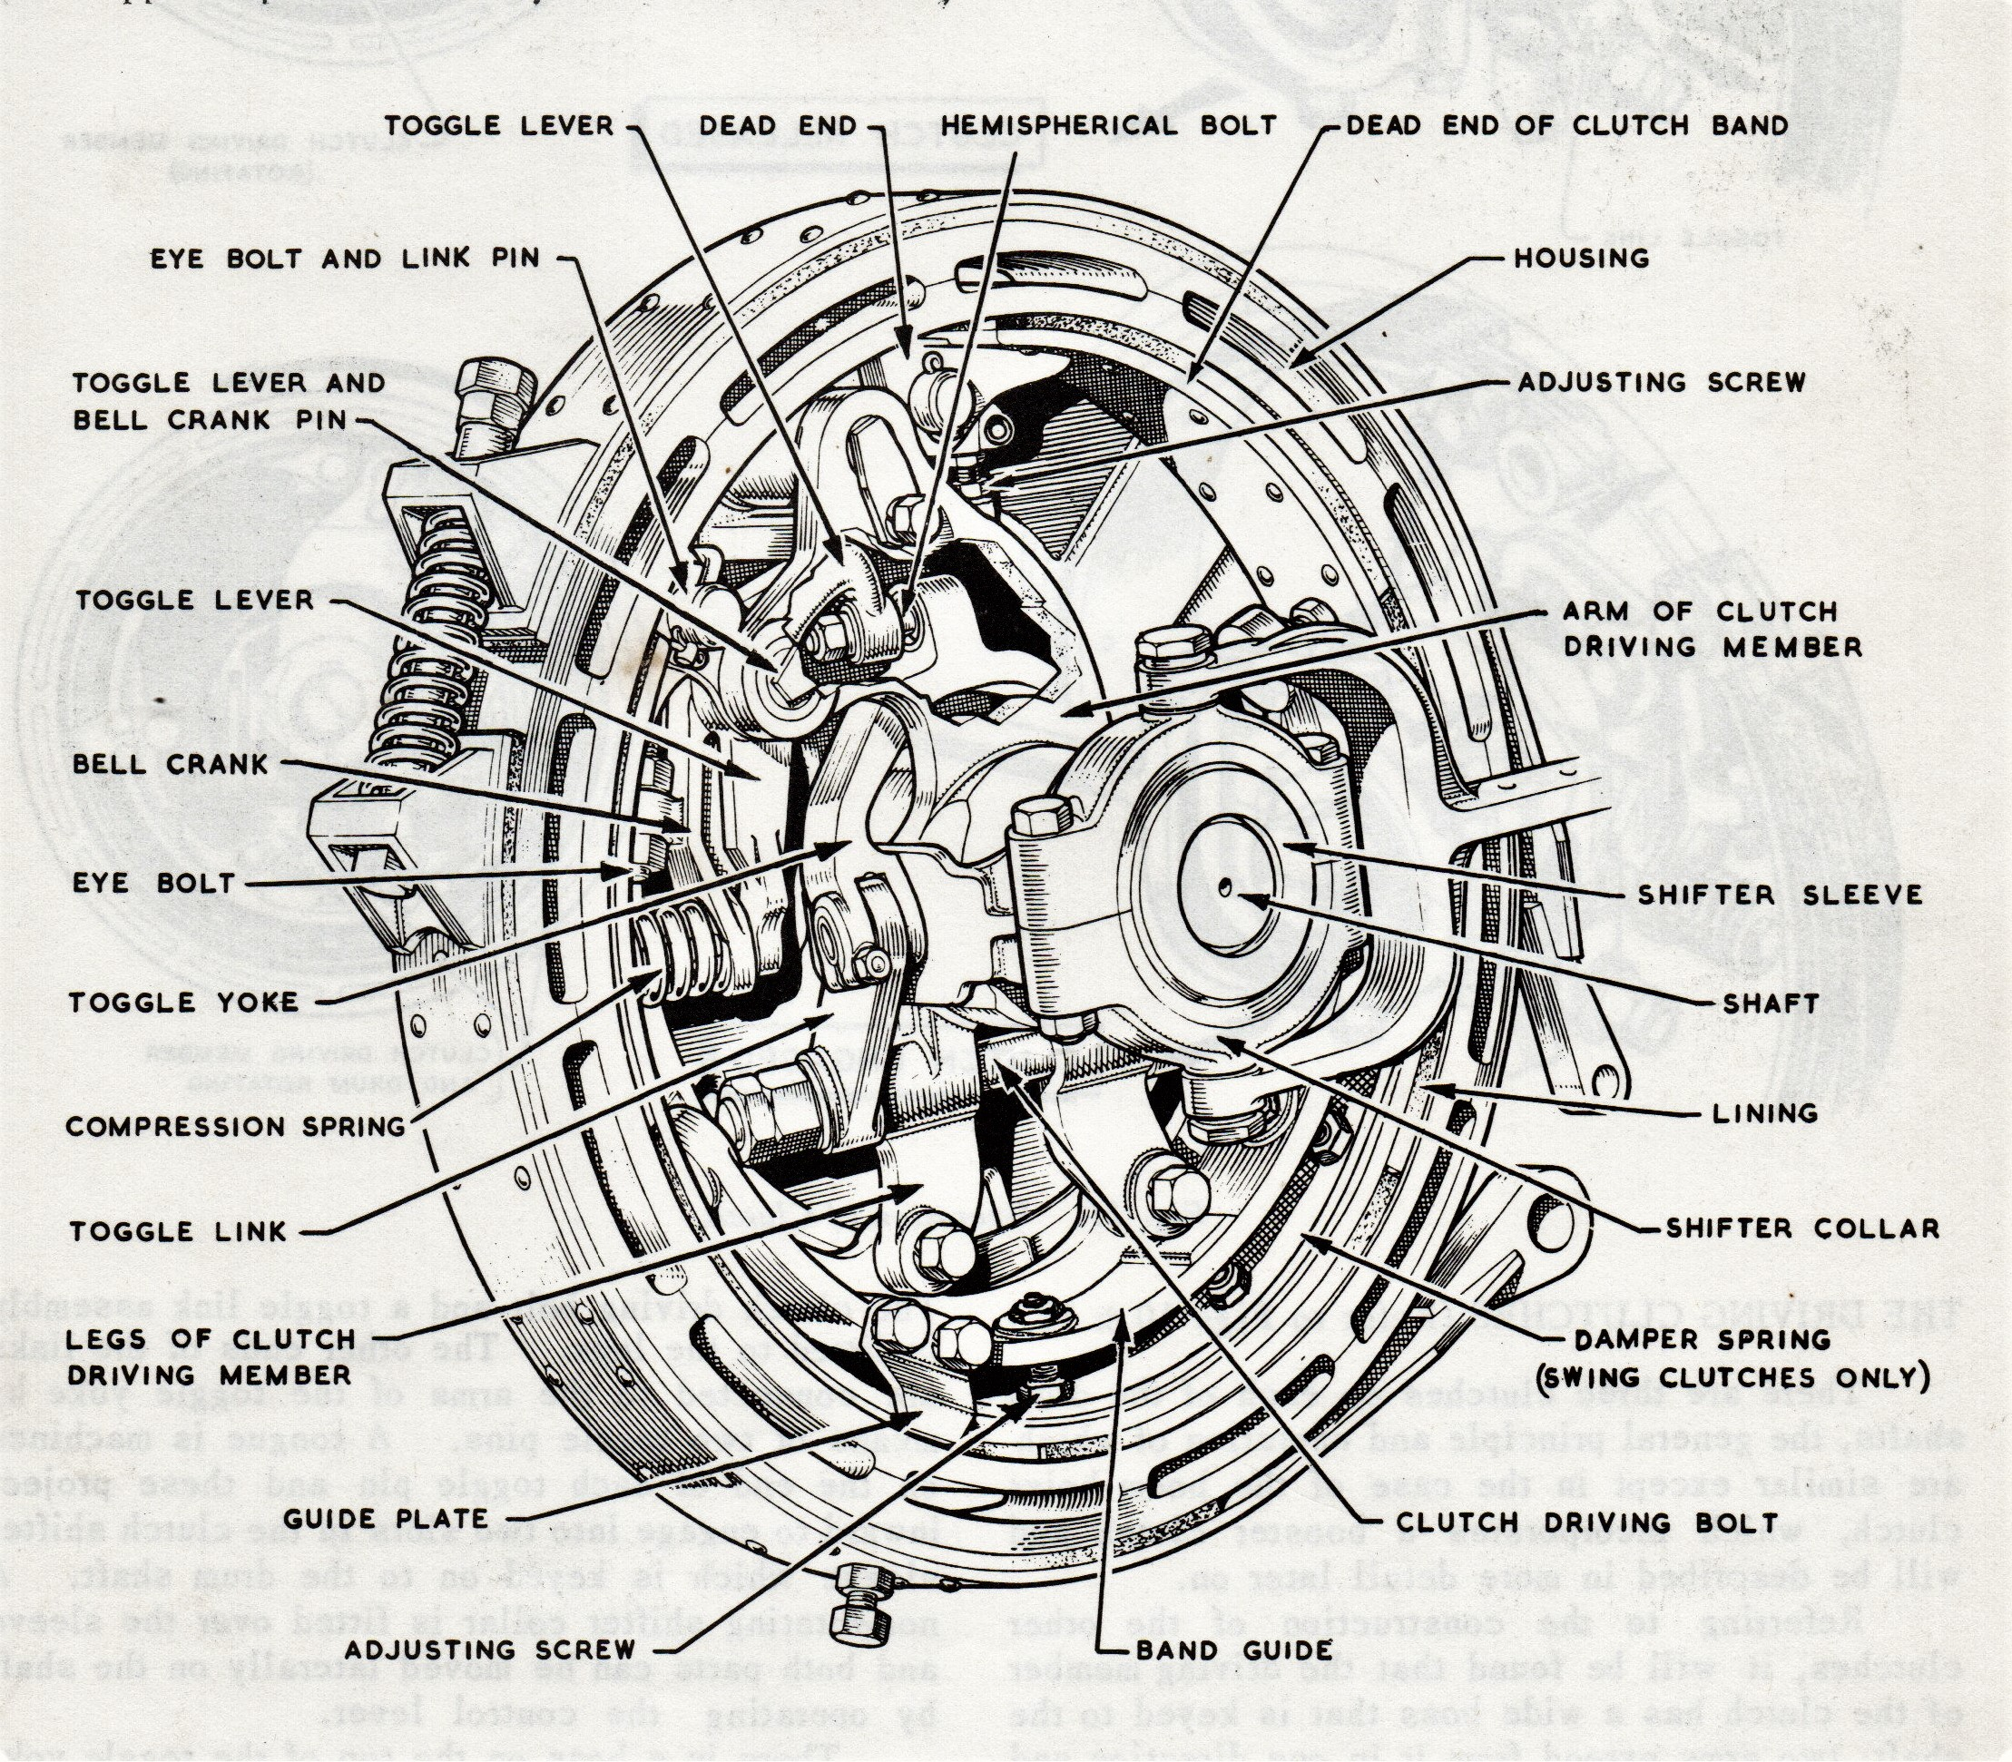
Diagrammatic drawing of duty clutch layout

Thursday morning looked brighter outside in Beevor Street but inside for me it seemed gloomy, perhaps working under a cloud because it had been suggested that we needed a more rapid supply of completed spiders and toggle levers than was happening at present. Henry’s original instructions had been to keep component racks topped up. I believed I was doing that but from his complaint he obviously thought I spent too much time building but didn’t tell me that himself. Instead, having only starting the job Monday, not familiar yet and not up to speed he let Colin do the dirty. So what Colin said was to leave building drumshafts until there were sufficient made up bits to draw on for at least two complete sets; two front and two rear. In that way we could keep topping up as we went along, there usually being a cushion of at least one set stacked across the gangway to feed the line as it progressed so I was unlikely to bring the things to a stop. “But don’t worry,” he said I’ll still be working with you. You are part of the gang and your main purpose being here is to learn how to put them together.” With my only having four completed spiders available then he suggested, “How about eight instead? You bash on with the small bits and I’ll start getting some spiders. ”Okay then! The longest journey son begins with the first step. So best foot forward, shoulder to the wheel and stop moaning. The honour of the drumshaft gang was at stake. What shall I start with? Toggle levers, they are quite interesting aren’t they? Let’s find out. Come and have a look.

Designed to break open against pressure the toggle lever assembly was mounted to the spider casting on a fulcrum pin with the live end of the clutch band connected by a combination of an adjustable eyebolt and 8 links. The dead end of the band connected to the other spider arm on an adjustable link to optimise alignment. Toggle lever and bell crank assembly turned on a common fulcrum bush, clamped together at their outer ends by compression spring. Pressure to engage and set the clutch was applied when a ball stud mounted at the live end of the toggle lever engaged with a bushing in the lug of the upside down Y form of the toggle yoke. The lever turning on the fulcrum bush pushing the yoke further upward, compressed the toggle spring, breaking their pressure faces open - causing vertical links on the shifter sleeve to go over-centre; spring pressure then holding the engagement until manually released. With eight of these assemblies on order things were going to be busy and that was just the start.

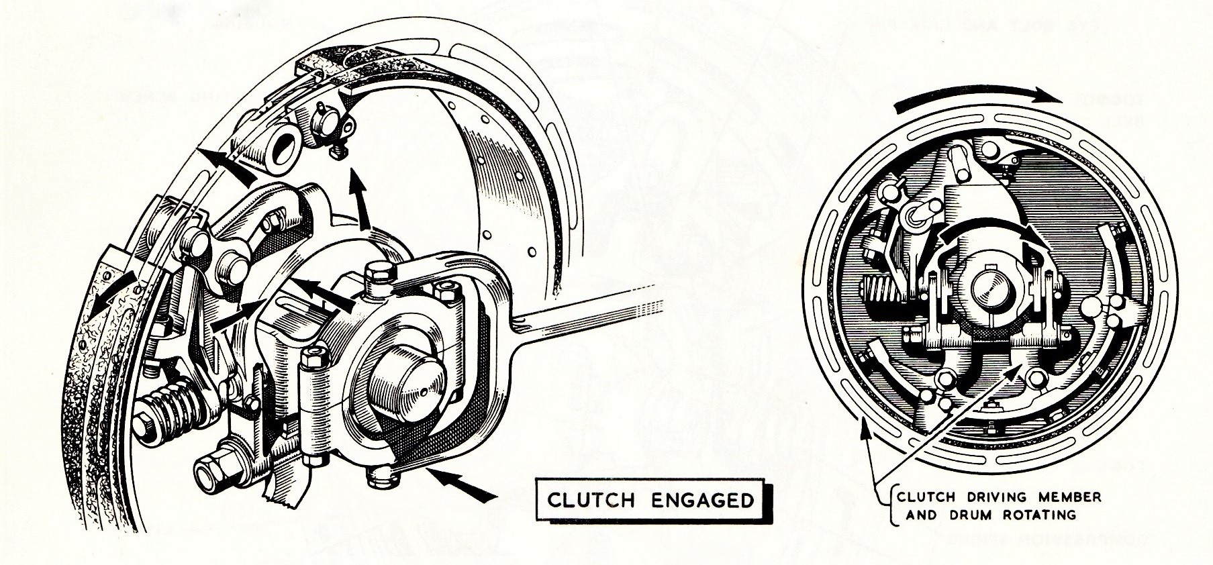

But where do I start? The 8 links seem to be a good place, anchoring, as they do the live end of the clutch band to the fulcrum bushing. Give me a hand then and pass me that file. There’s not much to do with them but a general visual check. These are stamped out and are consequently sometimes a bit sharp and easily draw blood. Not a lot but enough so I’ll just apply a small half round file to the edges and smooth ‘em off; all sixteen. Now what next? Might as well check fettle toggle levers and bell cranks. They are usually pretty smooth so they don’t take long. What we - that’s you and me mate - can do now is assemble them which is easy, peasy. Oh! Hang on I nearly forgot. The end of the toggle lever has got a ball stud mounted on the end. There’s a tapered shank that fits the tapered hole in the boss and needs to be hammered in. Colin suggests squeezing it home in one of the big vices instead of just banging them in making a lot of noise. Anyway it seemed like a sensible suggestion so let’s put the squeeze on the ones we’ve got, then lock them up with the castellated nuts and split pins before we move on to assembling:- slide bellcrank lever between mating toggle lever cheeks then line up holes to push bush and fulcrum mounting pin through. Now we can fit the heavy spring clamping the components together and fix with through bolt and split pin. Come on! Don’t take all day Colin wants this done before tea. Huh! Some hope of that?

Meanwhile as I was working away at that lot, Colin busy building up clutch spiders, Henry and Vernon, had finished the hoist drum shaft they started on yesterday afternoon and bolted two new basic drumshaft shaft assemblies on to a build bracket at each end of the table. Another batch of stuff with two clutch and tran-gear housings had been delivered which they immediately fitted with R&M bearing races mounting on to each shaft. They were not inclined to wait for me to build up spiders for them however because they noticed Colin working on them and conspired to pinch a set off him before building for some of their own for the project. They were still awaiting delivery of several more for stock. Henry I noticed kept looking around for something and seeing something wasn’t quite adding up made his way to the bay office to have a quick word with a progress chaser, on the way stopping briefly to chat with his older brother Jack who looked after rev frames on the build pedestals; an important place to meet because that was where we sent our drumshafts.

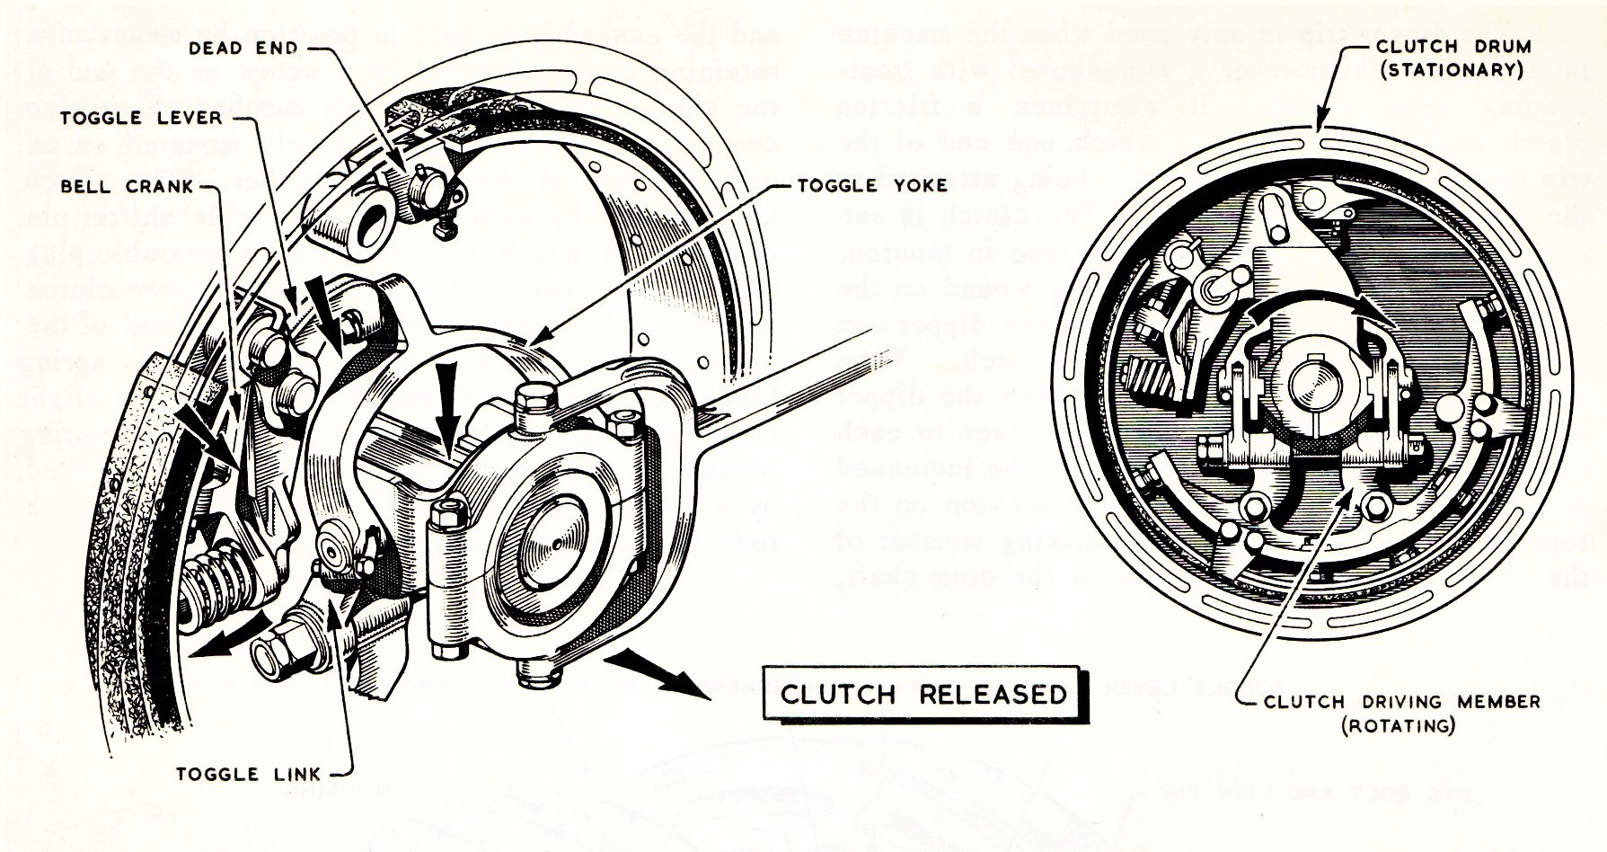

To build a clutch driver the first thing was to check over for any swarf or sharp edges even though it was a casting because it was a machined casting. Problem areas could be the brake band pin anchor holes getting paint in them and sharp machine cut edges. The pins were a tight fit anyway so that was the first job and you just had to basically look for any other potential snags. The live end of the band anchored to both toggle assembly and anchor pin, the 8 links holding the anchor pin with goal post pin pushed through both ends of the adjustable eye bolt mounting pin. I shall explain goal-post. This was simply a length of ¼ inch diameter black bar bent in the form of a goal post with a hole in one of the legs for split pin. As indicated above they secured the live end of the clutch band. At the opposite end an adjustable anchor optimised friction band contact with housing surface. Everything possible was adjustable to get the best engagement. The vertical links working with the shifter sleeve were, similar in their arrangement to the 38 transmission, mounted on the spider driving bolt to swing freely on hardened bushes pinned at their upper end to the upside down Y form shifter yoke. So it was bit time consuming and fiddly but satisfying. Once the driving bolt was in place the band guide casting could be bolted onto lugs at the lower end adjacent to the casting split. Four setting screws were then arranged to support and lock clearance with the inside surface of the housing together with two side guide plates.

Just completing the third of these clutch units I was ambushed by Vernon on behalf of Henry, mouthing sorry and looking sympathetic as he took them away. Well that was who I was supposed to be doing them for but I’d been looking forward to sneaking another shaft on the table. So I just carried on in like manner for the rest of my stay on drumshafts till the end of yet another month. And so the day and rest of the month progressed in like manner, soon passing with no real let up, just a steady unwavering pace. Although repetitive it was still enjoyable and I was slowly acquiring both dexterous and logical thinking skills that in time would stand me in good stead for the mechanical career ahead. The following week I went to work with Henry for a couple of weeks. He was a little dryer than Colin but also having a cruel humour which I eventually began to understand and appreciate. After that I shuttled between the three of them, helping out as and when on what was needed at the time till the end of another month. So working on 22 drumshafts was altogether a good experience. I could knock out a drumshaft in my dreams every night with no bother at all. The next move was one that I had waited a long time for.

Revolving Frame First Stage
Monday Morning
It was onto the main revolving frame build section, first to Ray Hall’s gang. This should have been for a month on the fist stage taking place at ground level, making the base casting ready for moving onto pedestals at the next stage. This would also have been for another month with another gang led by Jack Kavanagh. However for the sake of clarity and to avoid confusion I will describe assembly as a continuous flow following through on the one frame for both stages. Having seen the raw castings being processed on the Richards horizontal boring machines in No 2 Bay one was now lying upside down on the ground in front of me and I was eager to attack it.

As we began work on our a patch of ground next in line to drumshaft build so did the lower works crew directly in front of us do likewise on a much larger patch putting together the crawler track undercarriage assembly with a basic truck casting ready stood next to a newly fabricated caterpillar frame, each to be built up and conjoined to form a complete unit which when complete would herald delivery of the next frame and truck for the process to start over again. My timetable would include a move to build lower works after my involvement with rev frames.

There were a number of things that needed to be done to the basic revolving frame before moving up the line for machinery to be added: two heavy cast bosses on the underside needed bushing; the largest mounting on the centre post of the truck frame around which it turned and the second smaller boss supporting the vertical swing shaft. It was knock-a-dolly time again: for the main bore a thin walled bush supporting the propel shaft inserted through from the bottom, then the larger diameter heavy section bush for the centre post. The dolly for this bush was quite hefty and had already been placed on top of the bush for me by a thoughtful member of the gang. How kind. An oil seal also had to be fitted from the top to prevent leakage from the gear well and would be attended to once the frame had been turned over. The vertical swing shaft did not involve bushings. Instead a heavy anti friction bearing was fitted at the bottom with a second lighter bearing race in the bridge casting supporting and securing it at the top. Guess who got the job? You can stand and observe as I work with Roy to install it when we get to second stage build.

Adjacent to the main boss positioned centre front was the cab lock: a short section of swing rack mounted on a two part anchor, spring loaded and intended to ‘break’ clear of the turntable teeth when operated from the cab. Designed with a very strong over-centre spring mechanism it could easily give careless hands a nasty bite so when my time came to install one it was with due respect and the assembly unset. As with bigger machines hook roller lugs needed to be fettled with roller pin shimming loosely held ready in place screwed through pin flanges front and back before turning over. The revolving frame shown below shows three hook roller lugs, standard on earlier 19 RB but subsequently these were changed to four for both 19 and 22 models with twin front roller carriages common to both. Mounting lugs needed to be fettled like everything else. Any machined edge could easily slice open a hand so before front roller carriages were fitted these were also checked over as were all roller pins back and front. With underside prepared, roller carriages mounted and all pins in place it was turnover time. Not as dramatic as for bigger machines but it was still interesting to watch, hauled up on end, spun around and lowered back on to its roller lugs ready for mounting and securing machinery side frames.

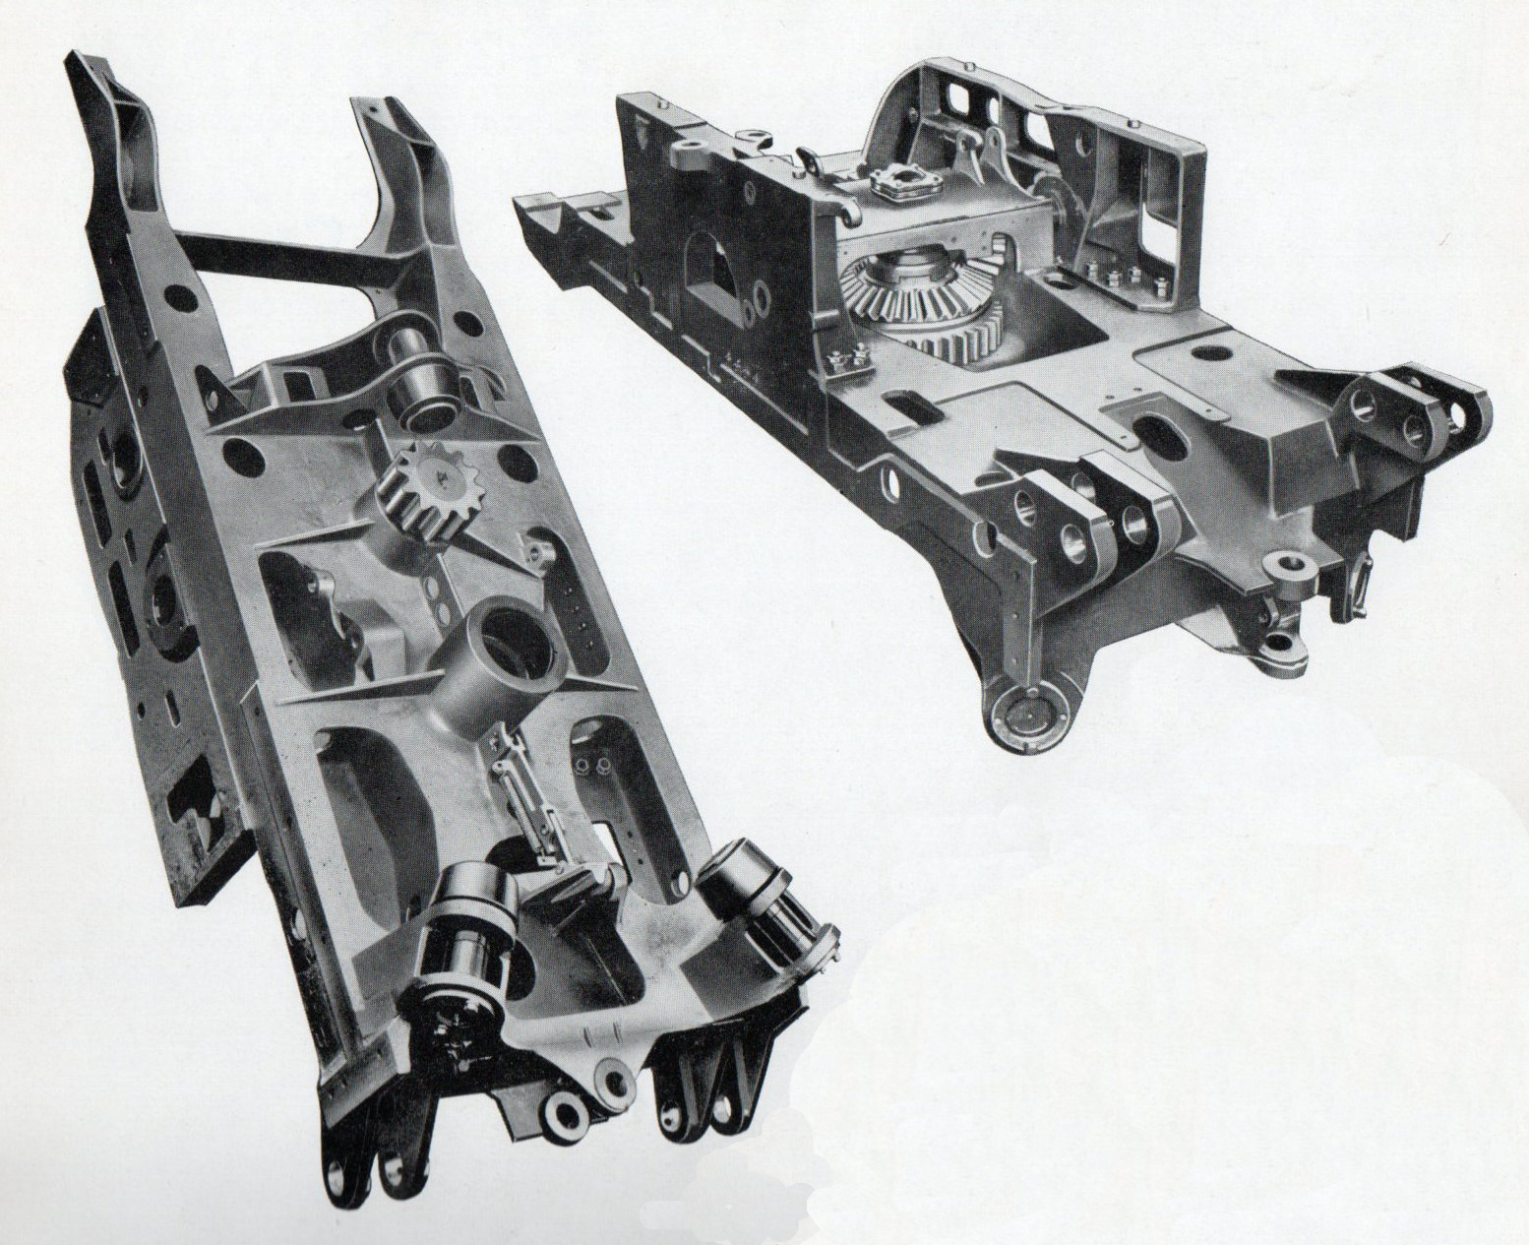
Two views of main revolving frame casting after machining

Installation of the side frames was an interesting procedure and it has to be remembered that although only designed for digging dirt the end product was still a highly complex, precisely engineered one. With rotating machinery running between precision bearings in separate housings some distance apart there needed to be a simple repeatable method of alignment. Bearing housings were therefore accurately located on each frame with jig drilled dowel positions also used for setting up the frames. With ganger Ray Hall directing operations Sammy, one of the crew, was busy swinging them into position. Age around thirty he looked a lithe individual with long rather greasy hair that kept falling over his eyes as he podged the left hand one into line while Paul, more stocky in build and another fitter on the job, dropped a couple of initial locating bolts in pre machined holes. The left hand frame was out of balance and took a bit of maneuvering because it had a side arm at the back end to support the main pinion shaft. Your future engineer stood and watched trying to look intelligent. With matching hole patterns pre drilled in the rev frame floor procedure was to secure and nip the side frames roughly into position with three or four trial bolts before knocking into final alignment with a sledge hammer. But with only one frame roughly positioned we also needed the other installed to properly line things up. Sammy was on it busy slinging that one ready and handing control to Clifford who dropped it into position the other side podging a couple of bolt holes into line to secure for the time being.

Pre inserted dowels for locating bearing housing facilitated the challenge of positioning the frames. Rod type setting gauges with a flat anvil at one end and clearance hole at the other to locate and turn around a dowel provided touch points that could be repeatedly checked for parallel and diagonal alignment across, front to back and between both sides; a very simple but reliable method. It was time to get violent. I was feeling cocky and having foreseen that a knocker would soon be required picked up a lump hammer ready. Clifford positioned the gauge on the front left hand dowel and nodded his head……..I knock the back end of the frame and he checked
between our frame and the opposite one; an exercise repeated several times across and diagonally on both. Once satisfactory the setting bolts were then dogged down to drill the remaining pre drilled holes all the way through using the air powered hand unit now braced against the body of fitter No 3. As he held on to it and an apprentice stood to observe the excitement. That was when chargehand Hall motioned for me to take over. Was he kidding? You really had to hang on and let it know you were boss or it could throw you over the frame. Were they taking bets? I grabbed hold, pressed the trigger too quickly and it flung me to one side and almost over the frame before Paul grabbed hold of me laughing. “Press the trigger slowly till you have command of the situation, brace your legs and get your balance right before you start Taff,” instructed chargehand Hall looking on smiling faintly with approval. As well as fighting for control the air drill also needed to be kept vertical with the pre drilled frame holes ensuring them to be tight and true. “Look at the vertical webbing on the inside of the frames,” he said. They will be your guide for alignment.”

Tapered holes were not an option. Once drilled fit bolts could be pushed up through both rev and side frames from beneath for nutting up using Coloc washers. It used to be lock nuts but Colocs were the new ‘in’ thing. What you had to be careful of was slicing fingers on newly drilled swarf and leaving traces of blood on the floor? Side frames were not identical, the left hand one bearing the brunt of organising the rest of the deck. A key element in achieving this objective was the arm bolted to its outer face at the back end and referred to earlier. Integral to this arm and at its outer end a forward facing extension supported the transmission shaft at its mid point. The arm, being permanently bolted to the side frame prior to machining, made it a one piece unit thus ensuring all bores and surfaces aligned square and true to the inner end bearing location in the side frame.

At the front end of this busy side frame sat a smaller more complicated looking casting used for boom hoist and lowering control, additionally providing a face against which to secure the front end of the gear machinery casing enclosing the combination swing/propel clutch and drumshaft gear set. The casing was wide, heavy and also reasonably unwieldy but Sammy and Clifford familiar with the challenge, hung it from the end of a wire strop to lift, maneuver and marry with three sets of holes; the centre of the casing locating on the rim of the bridge casting, the front onto the boom hoist casting rim with the rearmost location secured to the annular face of the hoist pinion shaft inner bearing housing. Front and rear fixings were basically screwed on to each face from the inside wall of the casing with appropriate sealing gaskets. The middle fixing however was sandwiched to the annular bridge casting rim face by an oil collecting hopper secured by hexagon headed screws. In operation circulating oil was collected and led back through the bridge housing, drilled holes in the transmission shaft and into the gear well.

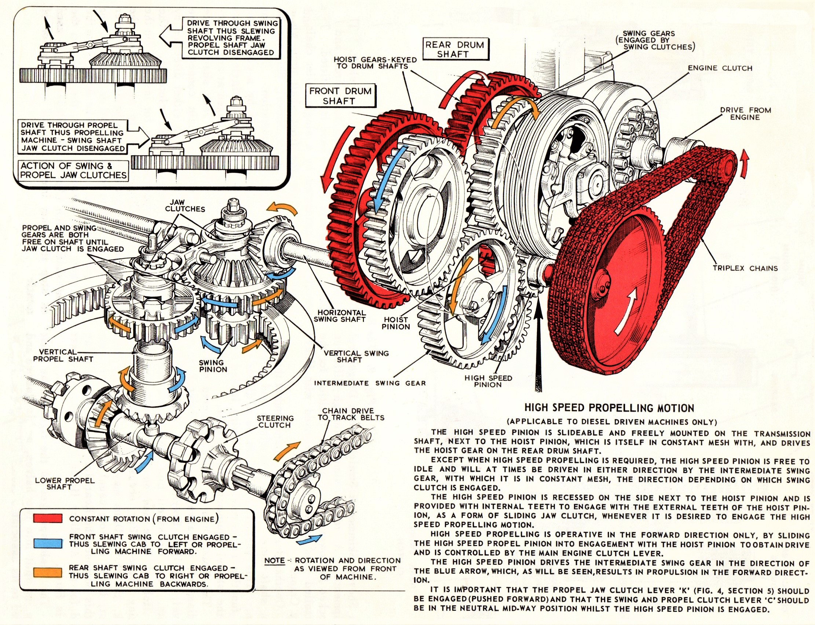

With the casing secured the first of the running machinery could be now be attended to. Trying to look eager asking appropriate questions inviting myself to assist with the transmission shaft Paul used the air winch to lift and hang the intermediate swing gear, floating it to position inside the gear casing. Then grabbing hold of the shaft he pushed it through the bore feeding enough of it for me to assist alignment for both trannie and bevel gear at the bridge casting end, pushing it home for securing with locking plates. But we were not done. He pointed out the primary transmission shaft ready on the bench with the two different sized pinions alongside. The smaller of the two was the hoist pinion that drove the rear drumshaft. The second pinion was a little larger and was able to fit over the hoist pinion teeth. I had heard of it but not seen it till then. It was the high speed pinion drive; schematic details of which are shown above.

HIGH SPEED PROPELLING MOTION
The high speed pinion is slideable and freely mounted on the transmission shaft, next to the hoist pinion, which is in constant mesh with and drives the hoist gear on the rear drum shaft.
Except when high speed propelling is required, the high speed pinion is free to idle and will at times be driven in either direction by the intermediate swing gear, with which it is in constant mesh, the direction depending on which swing clutch is engaged.
The high speed pinion is recessed on the side next to the hoist pinion and is provided with internal teeth to engage with the external teeth of the hoist pinion as a form of sliding jaw clutch whenever it is desired to engage the high speed propelling motion.
High speed propelling is operative in the forward motion only, by sliding the high speed propel pinion into engagement with the hoist pinion to obtain drive and is controlled by the main clutch lever. It is emphasised that the main swing propel control lever remains in neutral when using the high speed function

The primary transmission shaft therefore was a more interesting component than would have been realised from the basic description because as well as linking the engine power to the gear train it also provided high speed travel when selected. The bearing for the inner end, running in the side frame, was already in place so it was just a question of putting outer bearing on the shaft first, feeding it through the supporting side arm, then the casing outer oil seal plate. With shaft fed thus far, hand reaching up into the casing holding the hoist pinion, its hi speed partner was mated with it on the shaft before aligning splines for everything to be pushed home, the outer bearing into the support arm casting, the inner end of the shaft into the side frame bearing and then fitting the shaft end retainer plate. Having reached this stage of assembly it looked like it was ready to be moved up, confirmed by chargehand Hall surreptitiously raising his right arm noted by slinger Desmond promptly arriving with his assistant to lift and transfer our first stage assembly up the line. But for you to follow fully what is happening you need a bit of background as to where things are now physically placed in the shop relative to where we are moving because it will be just a stone’s throw from the spray booth where three completed base machines are already queuing to go through, the last one standing in front of the second stage build space having been placed there after uniting with its lower works a little earlier. Just keep that in mind.

Second stage build would be on raised pedestals positioned just north (towards Beevor Street) of where, when completed, the newly assembled truck and rev frame would be parked as above; entailing some shuffling and musical chairs sort of thing which you will understand when we get to that point. Watch this space. It was incidentally where I first saw the idiot trying to steer a 22 with flailing arms and legs, heaving on the swing and bracing a foot against the sprag pulling anguished faces as he attacked, completely clueless and a real drama queen. I think I mentioned before that even on the bigger machines the system was so mechanically effective that you could literally tickle the levers into position. But there we are I’m going off piste again…. So we were hooked up ready, the partially built first stage rev frame from Ray Hall now flying over the undercarriage assembly slowly taking shape below its flight path and arriving to rest on waist high trestles for more comfortable installation of below deck ancillaries like mounting brackets, bellcranks, clevis rods etc and in particular the swing pinion.

Rev frame onto pedestals
It was just after tea break as the suspended frame hove into position, steadying hands reaching out to guide it on to the pedestals with the four man crew gathering around to target their next jobs, one of which was to attach both side platforms. Under advice from chargehand Jack Kavanagh my first platform with all the control levers was hung from the air winch and positioned to stand with the outer side up making things easier to install the lever bosses, spacing collars, brake pedal and catch locks along with a couple of the under floor fulcrum brackets for redirecting connecting rods. The shaft on which the first four levers were mounted was relatively short and abutted against a much longer one passing through the main casting to operate swing propel clutch setting arrangements. Fed in from that side it also mounted the cab lock control, swing propel lever and the linkage for changing to propel or swing; the shaft being pushed through until it poked into the platform I was working on. More than a job for one individual and certainly one on which I got educated on how to poke, slide, curse and cajole mechanical things into working relationships with distant partners.

I had to wonder about the draughtsmen who drew it all up. It must have been a labour of love. Doing the driver side platform first allowed for installation of most of the levers by slowly feeding the fulcrum shaft through each of their lever bosses, sometimes grappling blindly to keep an eye on the bottom side while hand feeding on the top. There was a lot to think about with reach rod end pins, pivot pins and split pins but once completed the platform could eventually be slung to hang from the winch while bolting to the frame casting. A major item yet to be added was the combined rear end counterweight and mounting for the engine unit. This was being worked on positioned to one side out of the way with necessary pre drilling and fitting of smaller sub components prior to being united with the main bedframe. There was however the question of weight distribution on the build pedestals to be considered and more especially the subject of balance. If it were to be installed at this stage the whole thing would tip over. What was needed was a couple of drumshafts. But as I stood to one side thinking on, checking and evaluatin’ the vacant space before they arrived my attention was drawn to a new task by another gang member.

As indicated earlier a spur gear was splined to the transmission shaft at the input end. At the other, running in the gear well, a bevel gear engaged with a larger combined spur/bevel gear and dog clutch assembly on the swing shaft, this meshing with a second spur gear and dog clutch for vertical propel. Roy, a solidly built individual in his late twenties, Elvis style haircut with sideburns, stood on the raised machinery deck steadying a wire strop and grappling with the large combination gear. Seeing me stood vacantly gazing into the distance doing sod all he asked, “What are you doin Taff; looks like sod all?“ Well into my fourth year and getting cocky I replied nonchalantly, as befitting my growing arrogance, ”Sod all,” and he laughed and then asked, ”Are you afraid of heights?” Puzzled by the remark I looked back at him shaking my head. “Not particularly, why do you ask?” “Then stop standing there like a spare part, get your arse up yer’ and give me a hand..” He was laughing as he said it so he had a sense of humour. As I clambered aboard he added with sarcastic mock concern, “If you feel dizzy let me know straight away.“ “Oh I will, I will. Now what is it you want to know?” He grinned back. ”You can give me a hand installing this thing,” he adding pointing the bevel gear’s underside, ”You will note that I have already struggled on my own to insert the two bearings and spacer while you were playing with other things. So kindly observe and understand that perhaps next time I’ll not be here to help you.” He looked enquiringly at me with raised eyebrows and a questioning tilt of his head. But it was all in fun. This guy was a character and, on the wisp of the moment, I replied sarcastically, “Yes oh wise one.” He in turn blinked, shaking his head muttering, “Another soddin’ smart ass.” We didn’t work together much but when we did we got along just fine.

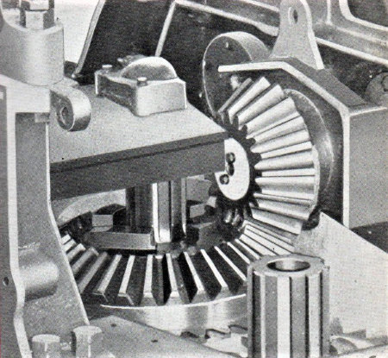
Transmission shaft bevel gear meshing with
vertical shaft swing / propel bevel gear

The combination gear shown above meshing with the horizontal shaft bevel gear was heavy and awkward to maneuver which was why it needed two of us but really he just wanted to show me how it was done so that later I could organise things for myself. With sharp teeth all around he had a rag in his hand as he lowered it into the well, yours truly leaning in from the back, welder’s glove on hand picked up from lying on the floor, giving a helping tug to lay it flat as he pushed toward the shaft hole between us. Then with a five foot crow bar, making suitable grunts, he poked it down through the top bearing location in the bridge casting, pivoting on edge into the top of the gear to lever into final alignment, at which time we were joined by Harry Cooper clambering onto the recently attached operating lever side platform. Another gang member, and the only one known to me socially because of the youth club that he managed; he was slightly built but nevertheless a lively individual living on Boutham Housing Estate not far from where I had originally lodged. His work mission was to thread one of the vertical shafts with the cam sandwich on top. They mounted in one of the two bosses integral to both faces of the side frame. On the operator’s deck side the sandwich plate engaged with rollers for one or other of the cams attached to the yoke arms; the outer boss supported the rotating shaft while the inner one supported both front and rear pivot anchor points for each yoke lever. Not yet in place these would be attached when both drumshafts were in situ.

Our next task was to install the vertical swing shaft which Roy said was already under the frame with the pinion secured. “Come on, follow me and I’ll show you how we push it up through. You can give me a hand setting it up.” So while Harry busied himself attending to clutch setting equipment Roy got down from on top to go - where?... I thought he was going underneath but instead he went over to the bench and collected the dog clutch that sat in the top of the bevel gear, passing it over to me to pop it in place. “You know where that goes don’t you,” he said also handing over a blue R&M labelled box; the initials standing for Ransomes & Marles, a well known bearing company their factory not far distant in the town of Newark. “It’s the top bearing for the swing shaft,” he added. “If you can knock that in place on the bridge then we can crawl around on the floor and poke the pinion shaft up the ‘ole,” he said laughing, reminding me very much of Ross on 54 build with his laid back attitude to life. I hadn’t seen him for some time and wondered how he was getting on. But in a big place like RB it was very easy to lose touch and I don’t think I ever did see him again except fleetingly.

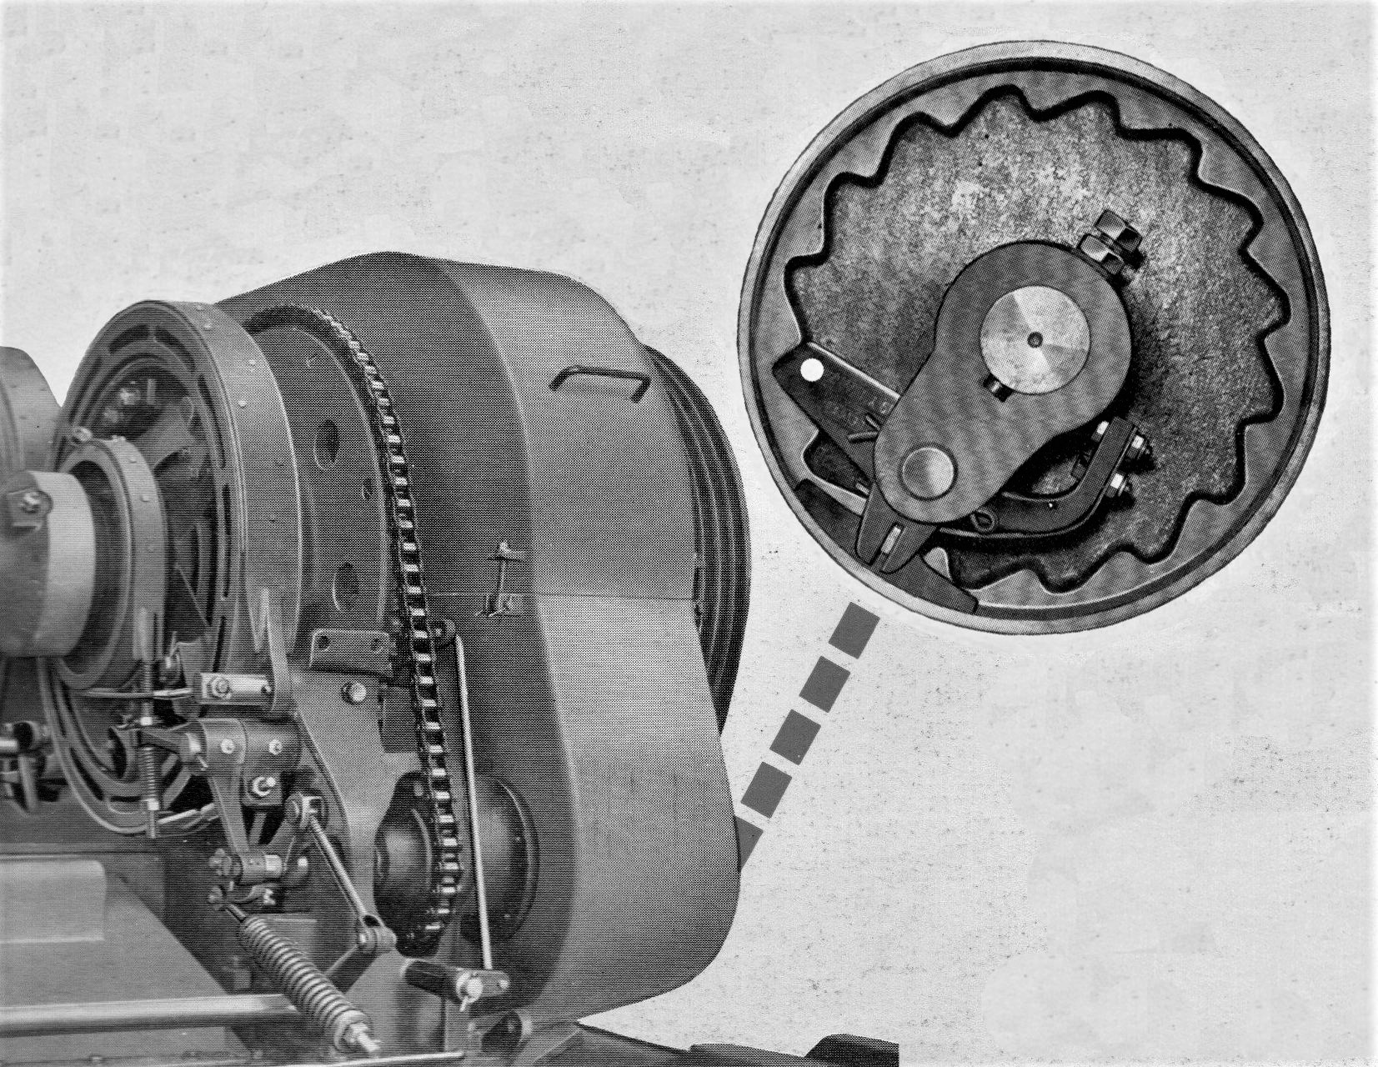
Boom hoist chain drive illustrating automatic over speed lowering safety pawl

Hello! We have somebody else joining the throng. It’s Oswald whom we call Ozz. I think that was his name but come on fellas it’s sixty years ago huh? Looks like he’s doing something with the boom hoist unit. There’s only the base casting there at the moment but he’s got the drive shaft in his hand with the engaging pawl mechanism as illustrated above. What he will do with this is push it all the way through the combined ratchet housing and drive pinion until the ratchet pawl is flush with the rim; the bore of the housing having non friction bearings allowing both to run together freely. This is then knocked through the main casting bore, a chain sprocket being keyed on the end for connecting with the larger rim chain drive on the boom hoist drum. I think Oswald is enjoying himself getting stuck in with this. There’s a lot going on at the moment; pretty noisy all around really. The overhead is quite active; there’s a machine just rolling into the spray booth and a 10-RB on the line the other side of the gangway is getting a lot of attention as well. In fact that line was still so busy that in 1963 they actually built 104 machines; and this quantity for a machine they were eventually to discontinue in 1968….. But that boom hoist casting with Ozzy? I’ll have to have a look at that later. He acknowledges my presence with a sort of sigh as though he’s having a heavy morning - not enjoying himself like I had assumed. I grin back at him knowingly and throw myself under the rev frame do deal with the latest challenge.

We held on to the assembled swing shaft arranging it to stand upright with enough clearance for our manipulations. He’d already acquired a suitable hydraulic jack and several wooden packing pieces so we sat straddling, lifting it sufficient for the splined top of the shaft to poke up through to where, after huffing and puffing, we judged the upper shaft diameter to have passed through the two gear bearings at which point it seemed like a good time to introduce the wood and give ourselves a breather. And as we did Roy looked at me to say that they didn’t always do things that way. “Sometimes we pull the shaft through with a wire strop hooked to the air winch instead.” My immediate response was to wonder why we were struggling with the soddin’ jack?

So I asked him. “Well, he said slowly, considering the question, screwing up his face and looking into the middle distance. “It makes a change and there are no direct instructions from management on how to do it as long as it gets done and doesn’t hold the job up. I’ll show you the special nut we use,” he added confirming the packing pieces were in place before letting go of the shaft and crawling out from underneath to find to his toolbox. He returned after a quick rummage with a standard securing nut for the shaft having a piece of U shaped bar with leg ends welded onto opposite flat faces. He then described the alternative installation. “All we do is screw the nut onto the top of the shaft, thread the strop down through the hole, loop it through the U strap back to the hook and winch it through. Once it’s in position we just block the shaft underneath like we are going to do now and then fit the proper nut.” “So!” I said, “why didn’t we do it that way this time,” and he just started laughing as he said,” Coz I did it that way on the last one.” He made me laugh as well as he said.” Consider it on job training from the expert,” and after that interlude of fun we got on with the job.

Roy then set up to continue using the hydraulic method; pushing it up and through the rev frame journal bearing, oil seal and internal combination spur/bevel gear bearings, stopping on the way to check on spline alignment with the dog clutch and then through the top support bearing at which point the top thrust washer and castle nut were fitted. Almost having reached its destination the combined bevel gear had nearly jammed up with its mating transmission shaft partner when both their tooth crowns met but a quick visit up top with suitable nudge quickly settled them into proper engagement. Still needing to be set for the correct amount of backlash we did so using a magnetic base mounted with dial gauge. I can still remember the fun tightening the top nut down onto the bearing race to get fifteen thou while aligning the slots for the split pin cross hole. With that sorted it was fit the top cap and Hey-ho-way-to go! It came to my attention many years later that the combined bevel spur gear came to be known as ‘The Wedding or Birthday Cake’, christened thus by the many fitters who had enjoyed the job of replacing it out in the proverbial field or workshop.
Harry seemed to like doing all the levers. Earlier he had been bolting on the engine clutch lever stand with the sprung hand trigger to hold it disengaged. From there he’d moved onto the quadrants for auxiliary function levers operating digging pawls and changing over dog clutches from swing to travel. The actual selectors could not be installed till both utilities were functional thus the shaft on which they would be mounted temporarily poked parked out from the side frame; real easy to trip over if you weren’t paying attention. While we had been busy beneath he had progressed through the controls until eventually, using a set of general purpose box steps, he clambered onto the other side platform continuing to sort the linkage for swing propel clutches and fixing a fabricated cam shaft stand mid-width of the platform for the cams at the end of each drumshaft. As before yoke levers would not be mounted until both were finally located in place. NB: Cam sandwich is perhaps a misleading description because the two plates actually sandwiched the rollers.

Was there now any reason that we could not install the drumshafts? No. We could start to make it look like an excavator. Jack Kavanagh the chargehand was already organising it and almost before I’d had a chance to answer the question there was a rumble as the overhead gantry cast a shadow over us and a panic ensued. Wotsup? Two bellcrank brackets on the bridge casting that anchored the brakes connecting them to foot pedals are still missing. It was much easier to pin the underside half of the brake in place before mounting drumshafts. How could this have been forgotten?..... Erm….did somebody ask me to do them ten minutes ago? I’m not sure. Don’t say anything Ok. Just in case. Corrective action was taken, assisting hands everywhere, brake halves sorted other hands surreptitiously slipping packing shims over each locating dowel; only a few thou thick the mechanical potion that made sure the gears meshed sweetly and free of indigestion. That was for the front shaft, done so deftly by the regular slingers that it was almost a blur. I had nothing to do with it, just standing to watch it happen for the second time when rope sling legs hung lazily swinging on their way back down the bay to Henry and his merry men. On this occasion their build schedule had coincided with ours but no congratulatory telegram was sent. It was all in a days labour. With a second pair of shims slipped into place the rear unit reverently lowered on top, end bearing housings were firmly bolted down and top brake halves married to anchor points for bolting together with their pressure spring between.

The rear end combined as counterweight and engine mounting and like the revolving frame was a beautifully cast and intricate piece of work which if made of stone would have done credit to artist Sir Henry Moor. It had been positioned off to one side for prepatory work to be completed but with drumshafts now in place could finally be installed. The sidewalls of the integral plinths to which the power unit anchored, having gaps and holes, made it an easy lump to sling with cable so Desmond was again summoned to duty supervising the squiggly bindings to lift, swing, guide, drop into place and secure with four large shinny bolts through the cantilevered rear extension arms of the main casting thus completing another piece of our engineering puzzle.

Earlier I described mounting the high speed pinion in place together with the hoist gear pinion. Control setup for high speed travel was a floor mounted foot pedal next to the driving seat. In the months ahead I would have the pleasure and satisfaction of using this option when moving machines around the works, finding an impressive difference to the norm. Not suitable for use with usual site conditions but ideal for solid ground when traveling in a straight line; if you had to steer it just meant dropping back into standard drive. When selected the pedal moved a rod carrying a bronze half collar shifter engaging with a groove in the high speed gear boss. The only fiddly bit came when trying to poke the rod through the lower part of the gear casing and lining it all up with the groove for securing. Lining things up! OH YEAH! You know how it can be? I mention the high speed travel again because of Harry!

The simplest piece of alignment can some times be very argumentative and so it proved to be for Harry who was volunteered for the task. Simple job - poke the shaft through the casing - mount the collar in the groove - poke the rod through the shifter and secure with locking screw. But would those cotton pickin’ holes line up? Maybe he was trying to balance causing him hold it awkwardly or maybe his arm muscle was in spasm because when he said, ”I think this shaft is bent. I’ll have to give it a bang.” Another voice chipped in,” Take it off and turn it around before you break something.” It was just banter really; taking the mickey sort of thing but he had a point. The other end was fitted with a clevis fork pinned to a short lever. Harry, always cooperative, decided to take the advice, unpinning the shaft to pull it free rotating it 180 degrees before replacing and trying again. Contented noises from Harry; no more cursing, group chuckles and a disembodied voice, ”You owe me a pint Harry Cooper.” But Harry wasn’t finished. While still submerged he scored a few more brownie points taking time to also mount the yoke lever for operating the hoist drum clutch. That one could be really awkward but he was a glutton for punishment. Completion of the whole machinery deck quickly accelerated with more flurried activity all around permitting connections to all remaining yokes and shifters. Then the main gear casing covers were added top and bottom as was the completion of boom hoist mechanism, braking and lowering cam setting and remaining details. Final adjustments ready for delivery would be made by the test department. It seemed to be a never ending task but we were getting there.

If you are watching closely you will have noticed that one item has not yet been referred to although essential. If you are a navvy man you must be wondering what happened to it - Yeah? The’ A’ frame. We haven’t fitted the cotton pickin ‘A’ frame. Come on fellas! The two side legs and the back frame. The side legs are the ones leaning towards the back of the machine and pinned into recesses set in each side. They are pretty heavy so we float them into place hanging from the crane, collect the rear cross braced support frame and swing that for pinning into the machinery deck, just in front of the front engine plinth. Next comes the fiddly bit pushing the heavy cross shaft through. We slide on the two rope pulleys either side of the horizontal pulley yoke as we push the shaft through and try to find the ‘A’ frame leg the other side to secure with a ‘T’ pin. It’s proving elusive taking three of us: chargehand Jack with a guest appearance, Roy teaming up with me once again operating the air winch.

The twin pulley yoke hanging from the crane not wanting to co-operate also makes keeping things aligned troublesome but when Jack waved the sledge hammer and a block of wood at the ensemble their resistance crumbled and everything cowered into place. At the rear of the frame the fuel tank and associated pipe work was put in place ready for the engine, a choice between water cooled 4YEN or air cooled six cylinder 6YDA.

The last job to be done was install the engine but RB had nothing to do with preparation of the power unit itself. It was a closed shop type of thing and only Ruston engine personnel and the electrical department got involved directly. Power units had all been run up prior to delivery so no priming of fuel systems was necessary. Starter motors were also in situ so all RB staff did was to attach engine mountings in a small floor section opposite the office block. ‘Wouldy’- Otherwise known as Stan Would, was in charge and I was seconded to him for a few weeks as his assistant.

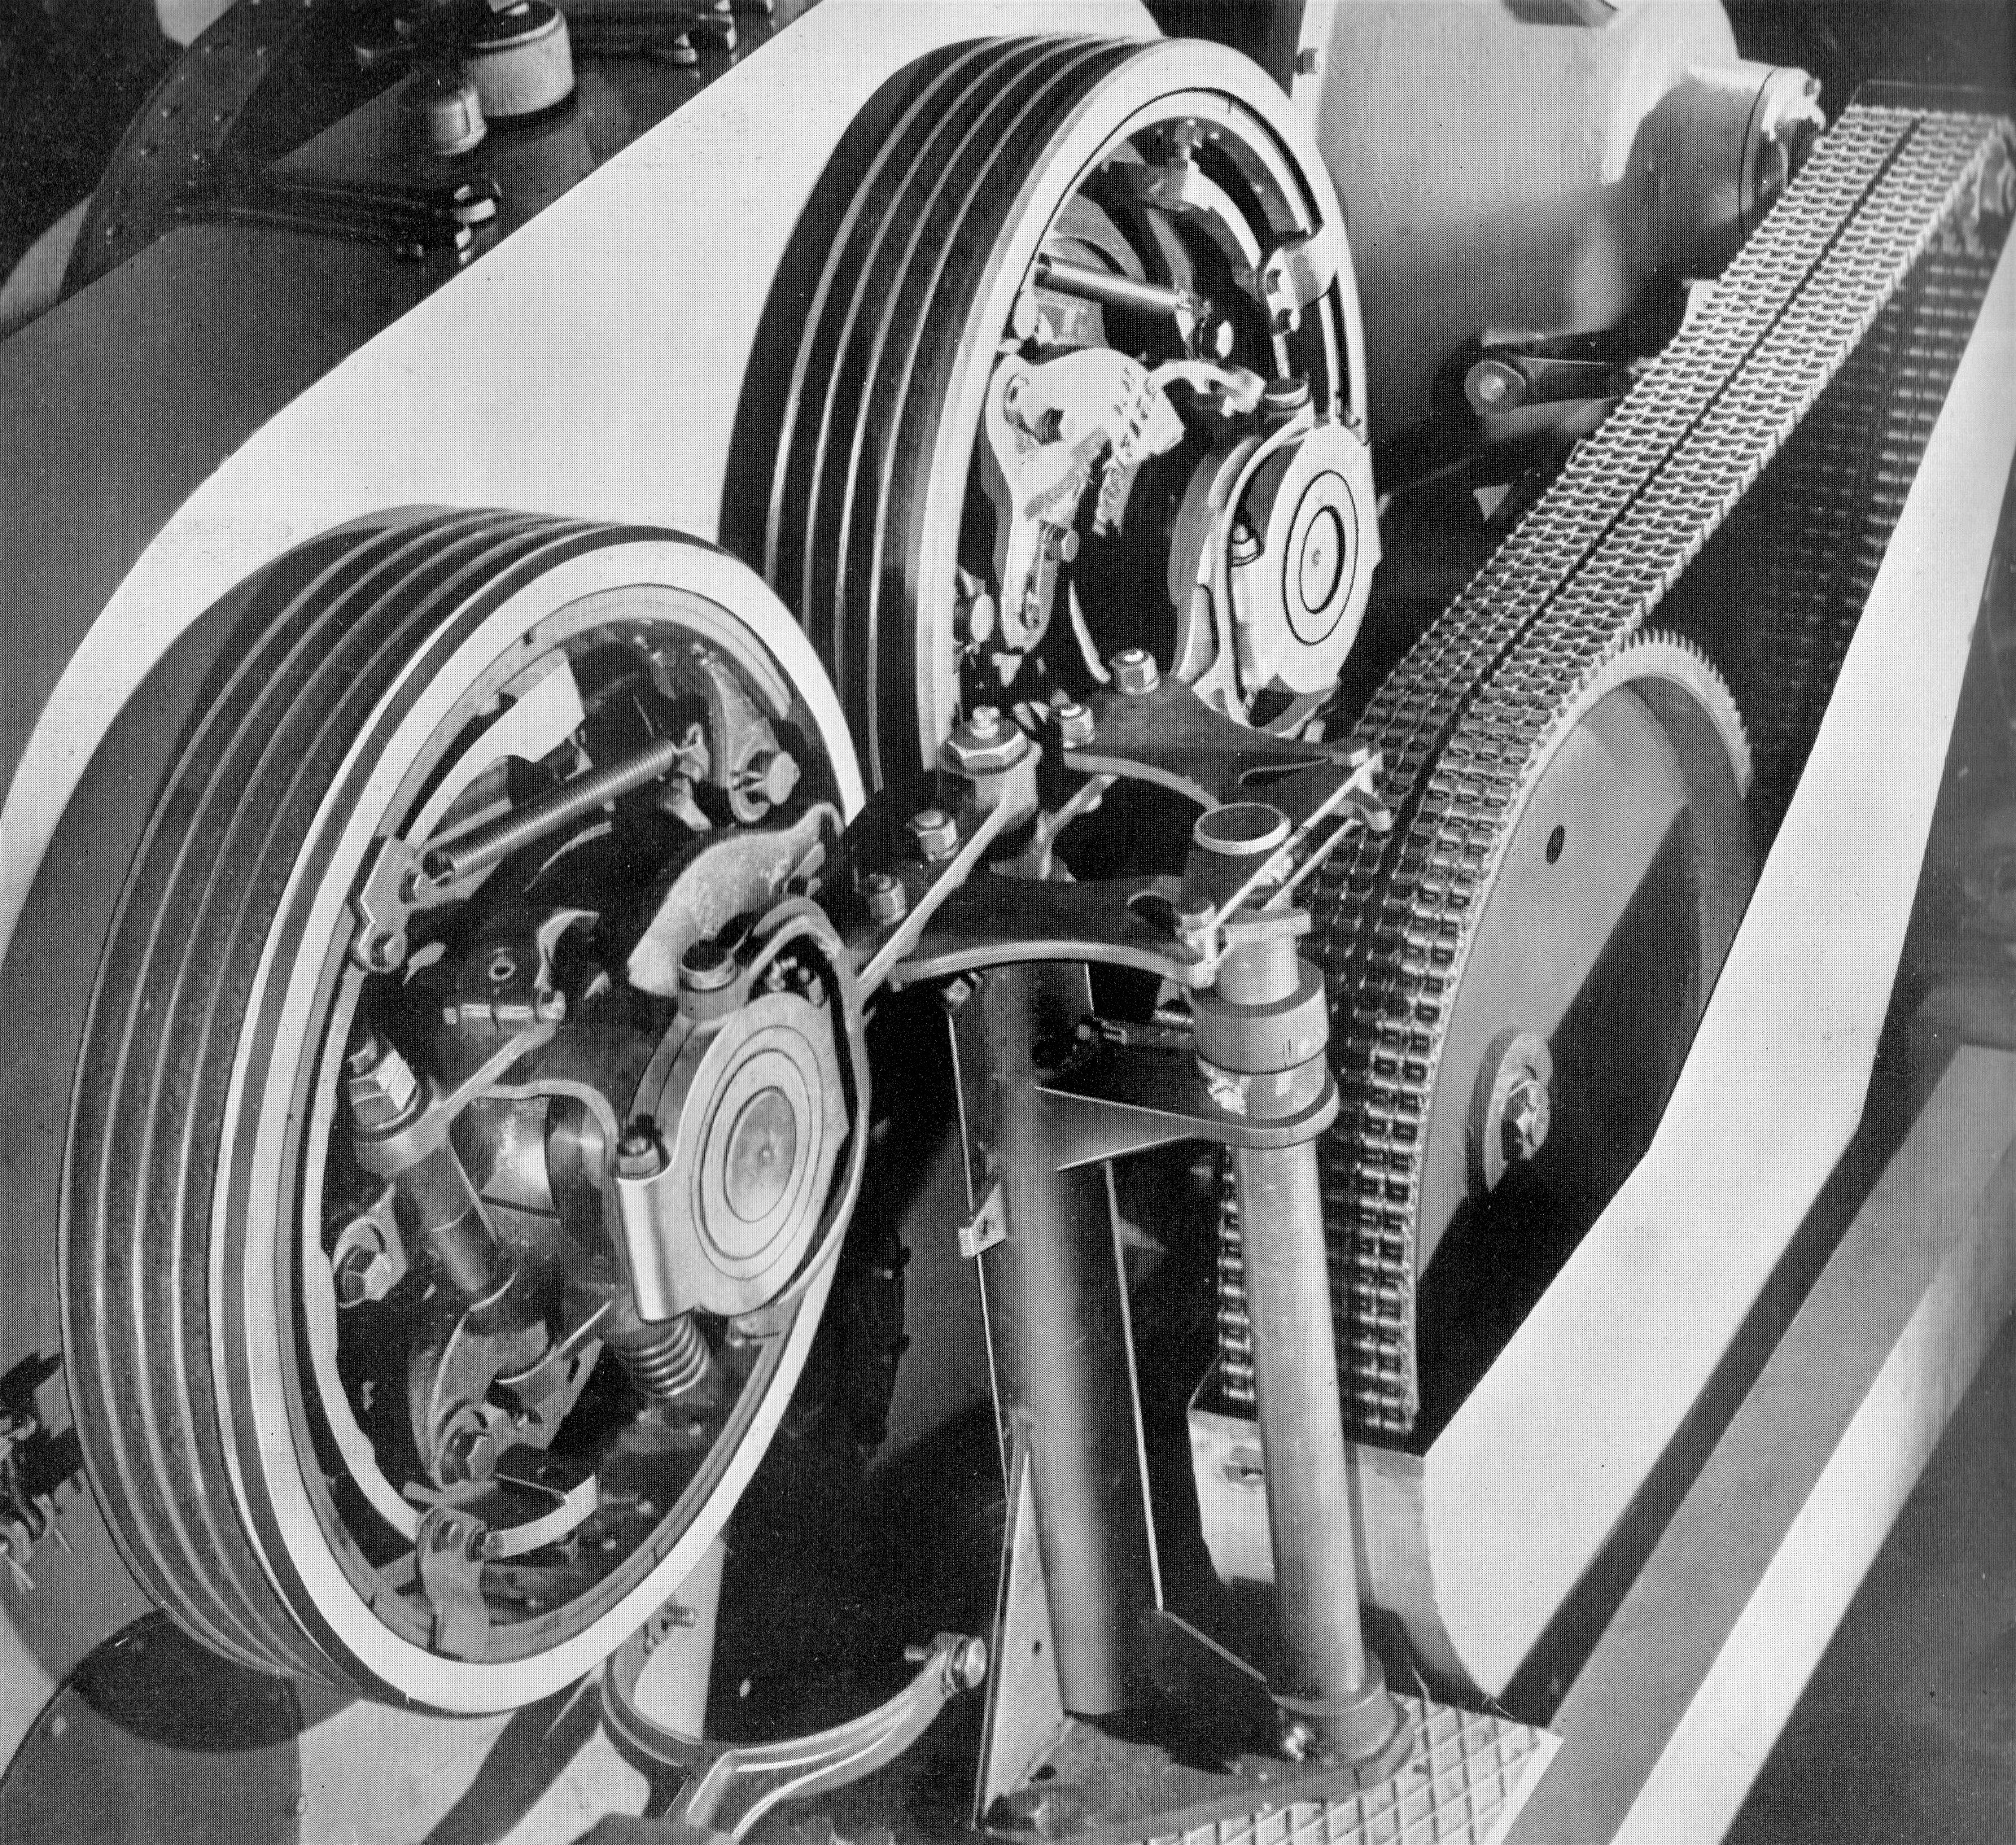
Swing / propel clutches and operating cams

An uncomplicated job; boring really, not mind challenging and he referred to me, like he did to everybody else as ‘Erb’. He was by no means an unpleasant individual he just didn’t having a lot to say and I can picture him now at the start of each day. Wearing a pair of heavy dark coloured work trousers held in place by a wrap around belt he seemed to epitomise the factory worker, walking alongside his bench, blue flannel shirt sleeves rolled up, cloth cap askew, he would apply barrier cream to arms held out high in front as he greeted me, “Mornin’ ‘Erb’.” Riding to and from work like many others astride his ancient Raleigh ‘sit up and beg’ bicycle he always wore a double breasted movie detective style mackintosh which he put on every night before departure, ritually threading its belt tail through the eyelets and tucking in the tail. Being unassuming and quiet of manner he was a popular individual and it was a great shock to all when he failed to turn up for work one morning having died suddenly in his sleep aged just forty just six. He would be missed.

Working with the air winch all I had to do was fit the mounting legs, hoisting each engine off its temporary parking spot to bolt on the feet. Sometimes I think we also did the air filter and that was it. When a rev frame was ready the overhead crane would collect an engine and swing it the short distance to the waiting machine. So it was as I was watching an engine being bolted down that I was once again accosted by Roy with whom I would find myself working quiet often while on this section. During out time spannering together he’d mentioned the fact of having been with RB a couple of years, formerly working as a diesel and transport fitter with one of the haulage companies used to deliver excavators around the country. Carrying on his trade he got interested in the customer’s equipment finding out more first hand with an older brother working in our drawing office. Moves were made eventually leading to his job in the erecting shops. It was a common sort of story with many families, sons and daughters being represented throughout the works and offices. All this flashed through my mind as he said I could give him a hand with the installation. “While they are bolting down the power unit we can get on with fitting the primary chain wheel drive and then connect up to the engine sprocket. So does that sound good?” Mirroring his enthusiasm I replied, ”Sounds terrific.” He had the chain wheel ready so we lifted between us, pushed it over the hoist pinion drive shaft after lining up the key slots and secured it in place with washer nut and split pin.

Coupling the engine by transmission chain at this stage was not possible. You could connect the chain but then there was too much hardware in the way to mount the chain casing so that had to be put in place first. What you had to do was feed the front end around the chain wheel, drop it through the gap in the deck then lift the back end to feed around the drive sprocket on the power unit. With that sorted the front could be positioned for the casing to be lined up and secured on mounting brackets. It was a job sort of reminiscent of what had to be done with the 54? Once accomplished the engine was ready for coupling up and Roy went across to one of the benches where multi strand chains were nestled in a stack of blue boxes. Ripping end tabs off two of them he slid a three strand set out of each, and, unraveling them as he walked across looking very pleased with himself said “Here you are then Ginge’. See what you can do with those.” With casing in place there was not a lot of finger room so it was a bit of a fiddle having to thread each threesome around the main chain wheel, pulling and then poking between us with string and stiff bits of wire to join the ends with coupling links. The power unit, last on our ‘to do’ list, had slotted holes in the mounting feet; very helpful and only required a little persuasion with pinch bar to adjust tension before mounting and securing the casing cover. Another job done!

Revolving Framer On To Lower Works
It was coming up for lunchtime and the target was to get a coronation before we ran for the canteen. Battery equipment and starter wiring ready but isolated for safety by the electrical department the completed rev frame was ready for marriage to the lower works. Well within the capacity of a single crane the four leg cable harness was used, two large thimbled loops for the boom feet and custom hooks for the back end. Its tracked up crawler frame partner now parked ready, team members standing by then: ‘airborne’ one man on board holding onto the floating machinery deck as it slowly moved north to find its target, waiting at the helm looking down the hole ready for spotting the propel shaft beneath, roller pins at the ready for sliding home and shimming to complete the procedure now so familiar to me. The rev frame hovered, the shaft spotter directing and then giving a quick clench of his fist when on target. HOLD IT ! The propel gear by now had also been placed in the well so he gave that a quick jiggle putting the dog clutch in situ while everything found the level for inserting shims and roller pins. The operation completed; home and dry the next move on the agenda was not.

The fully assembled unit now stood in the truck build section in the way and also much too heavy for a single crane. So this time when the rumble of sky hooks began it was with a tandem team, one crane in front for the boom feet the other with a custom sling for the counterweight. I watch as it lifts well clear of the floor with Desmond directing as it travels south, floating over where we had recently completed its top half, to park several feet beyond landing on a plot of ground from where a previously parked machine had just been moved one step closer to the spray booth. All clear so Harry Cooper now climbed aboard to finish off swing propel change levers, fumbling bronze wear slippers dropping them twice and emitting appropriate curses, Jack Kavanagh on the far side was adjusting the clutches for front and rear. What else was there? Somebody was bent over the main gear casing poking a nozzle in topping up with lube oil. Had they put the drain plug in first? A quick look to check and it was okay. Well I am a valued team member. No harm in proving my worth.

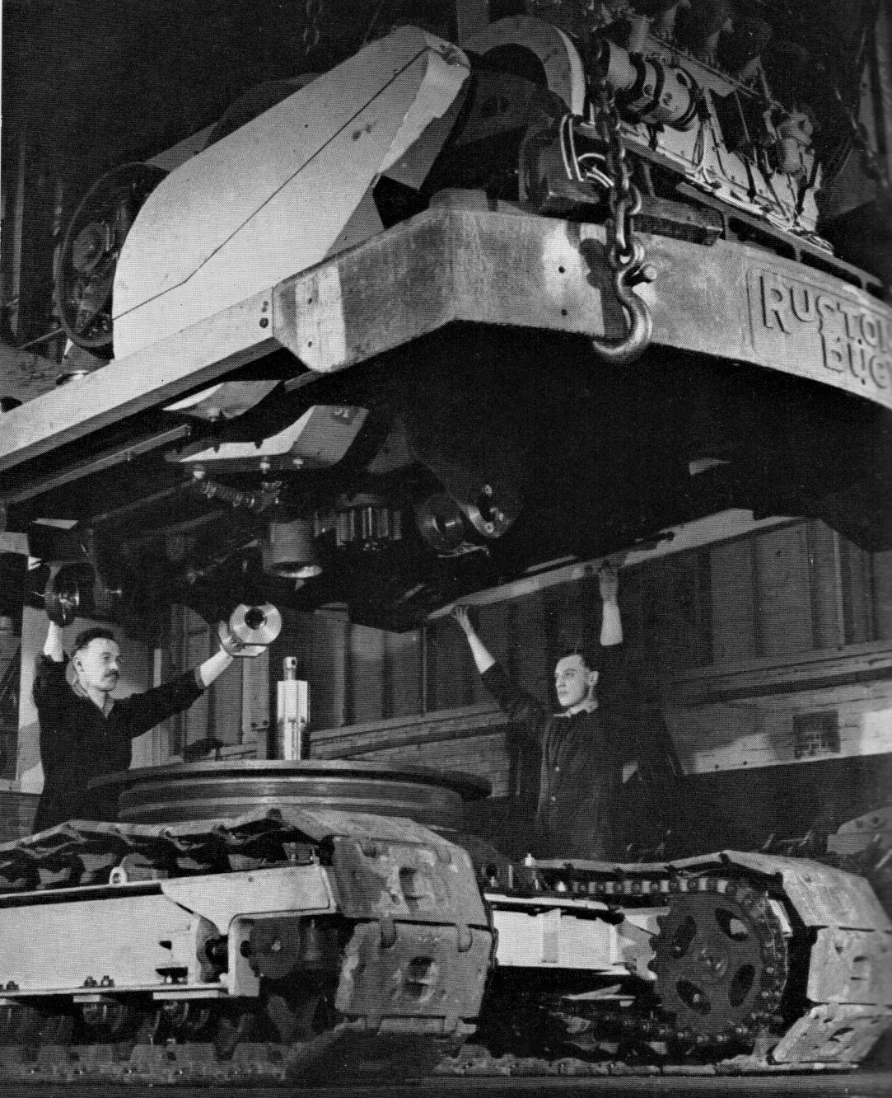
Crowning Revolving Frame Onto Truck

I hope someone connected up the return tube from the gear well? Mr ‘sparks’ connected the electrics ready for start up to move the completed unit under its own power when required; always left till last for the sake of safety. Wally with his magic pressure greaser was with us once again, starting on the bottom rollers to gradually work his way around the machine anointing nipples wherever they were to be found. I wondered why he was doing them now. The smell of diesel fuel wafts across as a fuel bowser rolls up to the back end, a hand pump nozzle dropped in for the first lot of fuel. Everything Ticketyboo it would then be moved one space forward and slightly to the left over a pit used for any final adjustments to the underside before entering the spray booth. I think they may have fitted the sump at this point. Never did it myself but it seemed the ideal opportunity. At the front end of the pit there were steps down to give working headroom where a couple of months previously I remember taking Momsa to show him the steering gear from the underside and how it worked. Somehow I don’t think his toffee nosed mate would have approved.

And then more activity clearing the tandem lift slings to replace with a four leg set for the first stage frame Ray Hall’s gang have been preparing. But that’s as far as things got because that’s when the lunch hooter sang out its happy song. I tell you kiddo-it’s all appenin’ today! Ain’t you excited? Huh? Now you are really in the thick of it so don’t soddin’ run away and hide the minute it gets busy. You can come and buy us all a cup of tea at the canteen. This kind of entertainment doesn’t come free. As we leave I notice a gathering of strangers in front of the spray booth along with Frank Phillipson. I thought something wasn’t quite right a while ago. That machine I saw going into the booth is still there and the queue waiting seems to be growing and nothing was moving; the machine we just parked isn’t helping. Plus Bernard sharp has been running around like a scalded cat. He’d been up and down the office block stairs at least three times in the last ten minutes. We’ll see how things are after lunch.

After Lunch
There are about four visitors there now all now clad in emblemmed overalls busy scurrying in, out and on top of the booth. The queue doe not look like is going to shrink any time soon and Kenny who I have just joined on the trucks has made the comment that we may be half a machine short of schedule. Can’t blame the spray booth though he said. ”I thought we were behind a bit this mornin’. And then he added, just as a bit of banter, “It’s only gone to hell since you arrived. That’s what I’ve been told!” “Gee thanks Ken. It’s nice to know one is appreciated.” Just snickered didn’t he? I looked back to the spray booth. Things are not quite back to what it was but whatever the problem they now seem to be getting on top of it. The space left behind by departure of the completed machine before lunch was now rapidly getting filled again.

A new caterpillar frame just delivered along with a truck casting and two red pallets with contents being transferred into gangway side racks. The truck stood on end ready for bushing, the cat’ frame only parked because everything was temporarily squeezed together. Back down the other end Ray Hall’s gang were making ready to transfer the stage one build up the line. It was non stop with yet another fork truck passing going back down the bay. After exiting the spray booth the next move for base machines was to drop ready assembled cabs on and rope them up. Built in one of the other bays and ferried around ready for the fitting crew I never got involved in that side of things and looking back I cannot even remembering ever seeing a cab actually being fitted or transported from where they were put together so I will not comment further. What I did do eventually was a brief spell with the roping gang, mostly on 22 machines but also briefly on the 38. I’ll say more about roping up time later. As mentioned a little earlier I would normally have remained with each section for a month before moving to the next stage of build but, as before to avoid confusion will continue the schedule following one machine. So I’m swapping over here to join forces with the trucking team as they start on the next one and will take you through the various stages while Jack’s crew receive their next project from Ray Hall and just arriving.

Assembly Of Lower Works
There was not a lot to formally introduce me to with the new patch of ground, just a few more racks alongside the centre gangway with nuts, bolts, split pins and T pins etc and two long work benches next to the bay wall separating the main row of 18 factory sheds from the adjacent open material stockyard. Putting the truck frame and crawler undercarriage together was under the direction of another cloth capped charge-hand whom I will call Albert, assisted by his regular mate Kenneth. Albert who I guessed to be late fifties reminded me of Charlie Dixon on 38 rev frames. Kenneth was mid forties, fair haired and boney looking with a longish nose and very bushy eyebrows. The build procedure was much the same as in No 3 Bay although with lighter castings easier to handle permitting faster assembly. So sufficiently familiar with the sort of work we would be engaging with I got stuck straight in with Kenneth, call me Ken, on the casting stood resting on its front turntable edge. It balanced quite stably as we installed the propel shaft bushing, knocked home through the centre post with a dolly plate. The propel shaft, being lighter than 38 and 54, was just about manageable for a man who’d had his daily shredded wheat ration. That first morning I had only had a fry up and was thus grateful for the extra muscle from Ken to lift off the floor and push through for mounting the thrust washer and bevel gear. Then a rumble in the background which had been steadily growing morphed into the airborne fabricated caterpillar frame onto which our truck would be bolted.

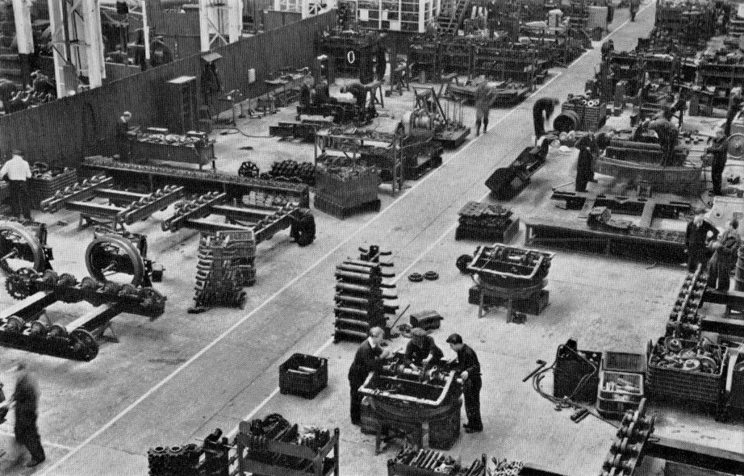
Lower works assembly
Steadied by Desmond and Albert as it hung overhead Ken spontaneously abandoned me to lend an additional hand maneuvering it to lie inverted across heavy timbers for more comfortable working when fitting bottom rollers. I had a feeing I might be doing that job very soon, but not yet because Ken quickly returned to prepare the two drive half shafts, mounting and securing the sprockets to install temporarily for the next step. Looping chains around each sprocket hub as done on bigger machines we lifted just clear of the ground, steadying hands allowing the truck to swing and settle level for placing on timber balks, turntable face down with propelling shaft inhabiting a strategically placed tube lined floor hole. A lot lighter than my previous trucks Ken had already assembled and poked the combined steering/digging lock tube down through the shaft, tying in place ready for linking up to the control levers on the underside Half shafts then partially withdrawn we were able to drop the combination main bevel gear and steering clutch shaft into half shell bearings. This was another component I had observed being made on Bob’s big Ward lathe in the machine shop. It was good to see it at the other end of its journey. However, there was an interesting feature when placing it into the bearing half shells and securing the caps. Turning the shaft with a crow bar could show some tightness but not sufficient for them to need scraping in. Wally’s wonderful power greasing trolley would soon sort that out. I certainly never heard any discussion about problems. Bigger journals seemed to mean a greater machining tolerance, or a looser fit; whichever you prefer.

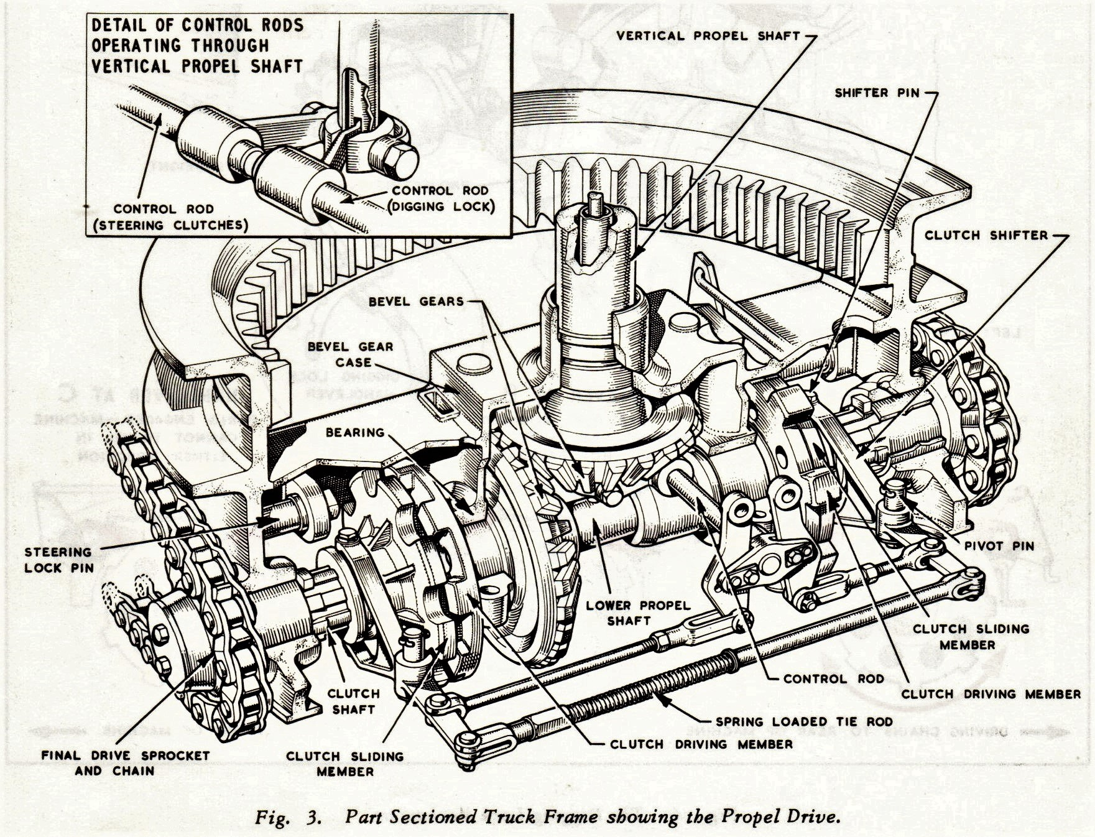
Three Dimensional Truck Frame View

Half shafts then partially withdrawn we were able to drop the combination main bevel gear and steering clutch shaft into half shell bearings. This was the first item that I had observed being made on Bob’s big Ward lathe in the machine shop. It was good to see it at the other end of its journey. However, there was an interesting feature when placing it into the bearing half shells and securing the caps. Turning the shaft with a crow bar could show some tightness but not sufficient for them to need scraping in. Wally’s wonderful power greasing trolley would soon sort that out. I certainly never heard any discussion about problems. Bigger journals seemed to mean a greater machining tolerance, or a looser fit; whichever you prefer. The 22 bearing caps by contrast were secured with adjustable packing shims consisting multiple sheets of alternate copper and brass wafers stamped together allowing each layer to be peeled off until sufficient running interference was achieved, to which Wally could then add his magic for complete satisfaction. It could be a bit fiddly at times seeming to achieve the desired characteristics with no adverse comments that I ever heard of.
So once the bearing caps were dogged down the next item on the agenda was to put half shafts back where they belonged, mounting the mating half of the clutch, poking the inner ends into bushed counter bores of the main shaft, and all held in place by split collars clamped in locating grooves. Clutch yoke levers were the next job. At this point Ken had gone to consult with Albert about something and then came back to observe. He knew I knew what to do but sometimes you need at least fifteen fingers and three thumbs, especially with springs involved and they were involved in the next job. Yoke levers for the steer clutches were pre loaded to engage by a reach rod in tube arrangement a spring applying the outward pressure necessary between yoke lever ends. After assembling the three pieces we pinned one end to the right hand yoke lever first and then did the trick that Ken used for the other end. Instead of struggling to compress it against the spring we removed the fulcrum pin, leaving the yoke lever loose to insert the clevis pin in the rod end and then, pushing, shoving and uttering mild curses maneuvered the yoke lever back into line to replace the fulcrum pin. Sneaky?

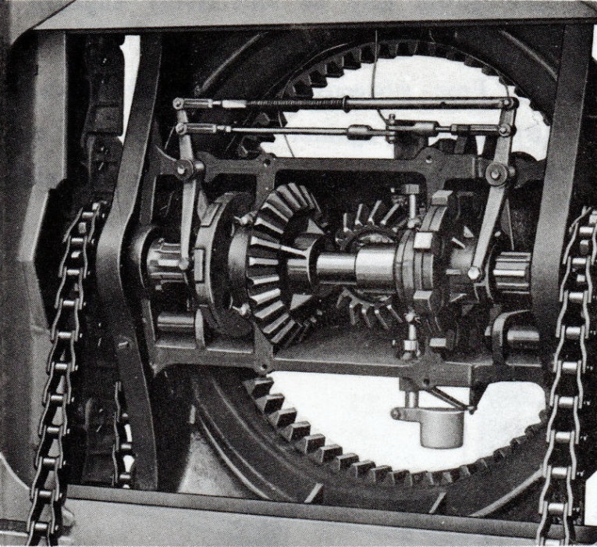
Underside of truck frame showing steering clutches and bevel gears

Earlier on Ken had taken it upon himself to install the two top pins for the cam plates to swing on. I was working on the cat frame at the time and distractedly noticed what he was doing. So I stuck my nose in to get away from bottom rollers for a couple of minutes. He explained that he’d been looking for some other parts in the racking. Finding just the two pins tucked in a corner he decided on a whim to ‘stick ‘em in’ and he said, with a grin that I’d caught him red handed. So now here I was playing with the truck with one less job to bother about so instead I tackled the linkage poking out of the vertical propel shaft tube. It was a simple but clever piece of kit the same as on 38 and 54 and an opportunity to do the counterbalance weighted digging lock and other bits by which time I was feeing almost smug but it didn’t last long because I had to get on with the cat frame.

There were six bottom rollers each side with the shafts on which they ran being clamped with U bolts. There was a slight problem with this arrangement however because the outside of the frame section was not flat across the width but tapered, making it necessary to interpose square shaped tapered washers to match and make the nuts sit right. Doing that however also made the job irksome with the square washers sometimes slewing out of place when tightening down. Bit of a pain but they had to be done so I persevered while Ken and Albert got on with bushing the take up tumblers, drive shaft bearing blocks and any thing else to complete ‘the cat frame’. Resting upside down both ends of the running gear were fairly easy to install and with Ken working the air winch were soon mounted, everything put in place both ends and each side, jacking and clamping bolts loosely secured ready for final adjustment when track sets had been fitted.

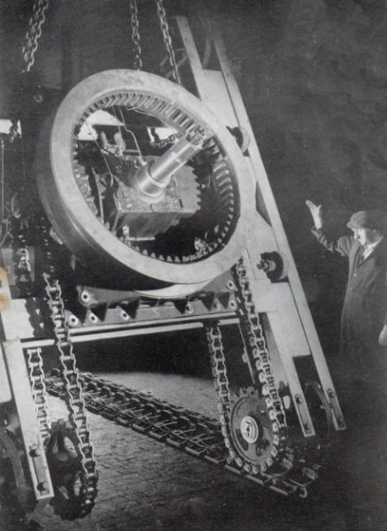
Tracking-up 22-RB Truck
Afternoon tea break had come and gone and it was ready for mating together with the upturned truck. All that remained was the hardened lock pins for the steering clutches when spragging; these just pushed in from the side of the main casting and T pinned secured. We are ready to confirm the partnership but where is Desmond our slinger? Before lunch break I had been wondering about track pad sets and where we were going to lay them down and asked him. Was there enough room? Well yes actually there was as I now discovered with a stomach full of chips. The picture was deceiving, especially with the cat frame taking up so much of it. Things would become clearer once they were bolted together and slinger Desmond was soon in his element organising two long chains diagonally corner to corner wrapping around the side frame at the cross beam weld. Then with everything checked, his clenched his fist signalling the crane driver, the fabricated mass was lifted and floated across onto the waiting truck base where, tapered podging bars in hand we levered and aligned bolt holes. Then spanner time once again with a long stud and three bolts at each corner and two bolts front and back centre. I don’t remember ever asked any of the gang members of crews I’d worked with if they supplied their own tool kit, presuming that they had acquired what was needed over a period of time. Collecting kit for limited applications I surmised that they would not have needed a large set. In contrast our happy band of apprentices needed to provide for all the jobs we would have to encounter. Our tool kits therefore over time grew to be quite substantial and diligently guarded so whoa betide anyone who forgot to return a borrowed tool; all very civilised.

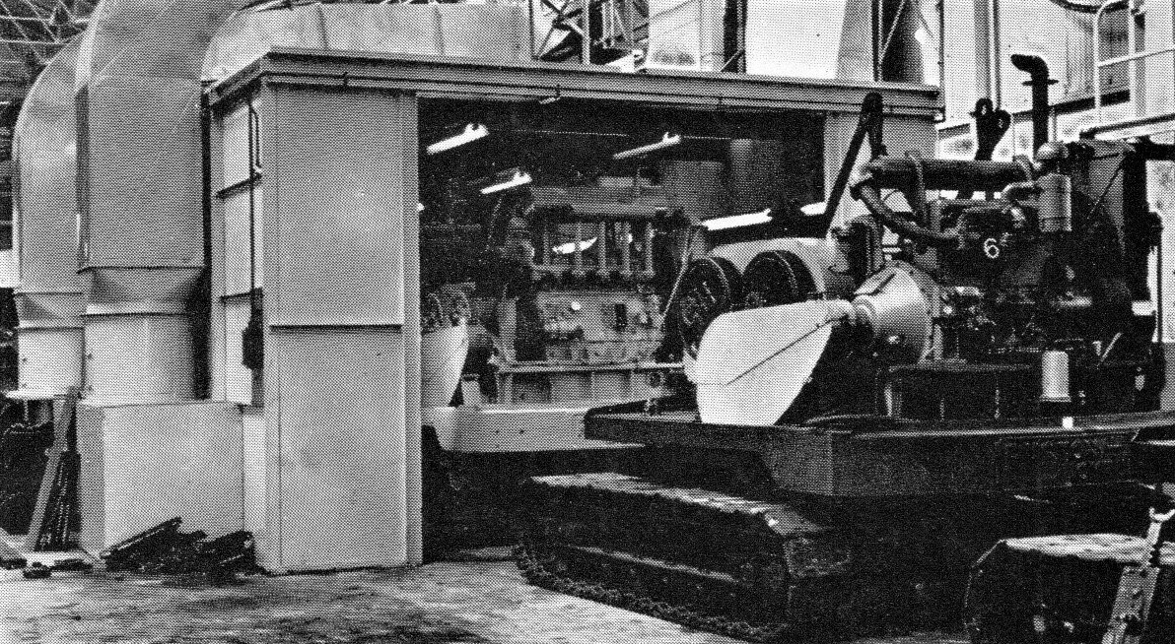
22-RB machines entering 18-Bay spray booth

Just as we finished putting in the first few bolts, the crane releasing the chains, the north end doors parted for a Commer flat bed to reverse through, heavy laden leaning to one side, with our track pad sets. No let up for us then; somebody organising in the background and poor Desmond was being run off his feet. But it would soon be over. The afternoon was coming to an end and things were winding down. Ken said that Albert had been hoping to catch up the schedule but it hadn’t happened yet. Perhaps tomorrow morning if we could get stuck in with new vigor we would be in with a chance. But for the moment our Desmond hooked up each bundle in turn and swung them across to place just behind the frame for a rapid start in the morning.

Tuesday Morning
It was raining again on the morrow but having worn my yellow cape once again I wasn’t too bothered. We would be working under shelter and after clocking in walked through the works with Jack Kavanagh and Harry Cooper. Once back on truck build we were slowly getting into our stride hooking up each bundle in turn to roll them out ready for tracking up. There was a well honed plan: With drive tumblers located at the north end, the upturned frame would be righted by lifting to hang suspended and spun a half turn and move across over the track sets before setting down in the roller paths facing the same way but the right way up. Desmond was ready and we were under his command. It was the same kind of manoeuvre as on bigger equipment, just smaller scale, chains looped around the drive end cross beam between the truck casting and side frames, steadily controlled by the crane driver with hours of experience coaxing and slipping the cat frame off its packing blocks, front take up tumblers contacting terra firmer providing a fulcrum point with propel shaft clear of the parking hole. Lifted just clear of the ground Ken and Des’ grabbed hold spun it through half a turn with the crane then moving forward to reverse direction and quickly traverse the length of the frame laying it into the track path with heavy pipe tubing jammed through tumblers preventing roll back. The assembly was now ready for hauling the track sets over the top and pinning together. Once drive chains and track adjustment had been carried out it was ready for the upper works and suddenly bodies were everywhere looking for a piece of the action. Ken asked if I had seen this procedure done before on any other machines and I told him of my time with 38 and 54 crews in No 3 Bay. “Yup! But they were much heavier to handle and probably a lot slower than this,” I had commented and he nodded knowingly in response.

The assembly was now ready for hauling the track sets over the top and pinning together. Once drive chains and track adjustment had been carried out it was ready for the upper works and suddenly bodies were everywhere looking for a piece of the action. Things had gone quite well morning tea would soon be served and at this stage I’ll go and pick up where I left of with the fist stage build. If we had timed it right they would be just about ready to pass it on to second stage as soon as the this lump had been picked up and parked near the pit. It had been a tremendous experience when I thought about it, just being here in the heart of heavy engineering manufacture but I was not done yet. Four months in all by the time I move on from the line to the newly built 22 Bay. But as well as moving around the different parts of the works all this time I had been periodically enjoying different accommodation moving around Lincoln and meeting different landlords.

Accommodation
I worked it out that over the five years spent in Lincoln I had lived at twelve different addresses moving around all parts of the city from one end to the other. The changes had been made for various reasons and the people met had been just as different, somehow managing to put up with me while mostly remaining patient, pleasant and easy to get along with. One family I remembered in particular were horse racing fans one of the sons constantly studying form and also trying unsuccessfully to get me interested as well. His elderly father had spent s good part of his working life chained to a bicycle shop business the name of which is now a hi-tech shopping mall and retail park brand. It was one of the original Currys bicycle shops incorporated in 1927 to serve the early two wheeled mobile community. Aged seventy six when he was my landlord he once fell asleep in front of me while eating a biscuit and reading the paper. Some while previously the lady of the house told me about their family. When the second son was living at home, the two boys would study horsy form together and regularly go to the races very successfully to literally pile their winnings onto the kitchen table on their return. It was a small house quite old without some of the modern amenities like a bath. Monday nights were memorable being reserved for me to take down the galvanised old tub hanging on the coalhouse wall while kettle after kettle of water was boiled to fill it for my scrub in front of the kitchen door. The last time I had bathed like that was as a child in the house where I was born in Swansea.

The younger son had become a keen collector of old British coins constantly looking out for Victorian pennies in his change. Decimalisation was a long way off. His enthusiasm was infectious and we were soon bartering with each other to buy or swap something promising that we though might be worth summat’. He could be very persuasive and me, being an easy sucker, he did very well. However I did manage to get a reasonable coin collection together only for it to be stolen, a fine Victorian half crown included, by my fellow lodger when staying at my last Lincoln port of call before leaving. The rotter had actually spent it all on petrol for his car to get to the family home on the outskirts of Lincolnshire. Seen leaving her room in the middle of the day by the landlady a telephone call was made, after which I discovered my own treasure trove was missing. When the police came a calling I accompanied him in the front of the car with him, the prisoner in the rear, and the detective driving to Lincoln central in the wee small hours. It was an interesting experience, all the details being written down as a statement by the detective for him to be charged. He was a fool and much to his horror received payback when his name appeared in the Lincolnshire Echo the same week for his family and village to see. I had lost my coin collection with no re imbursement but landlady, being a kindly soul, still took pity on the sod and let him stay while I was the one who soon left for pastures new in Romford. There’s nowt so queer as folk!

My most unpleasant experience however occurred some time before when joining about half a dozen fellow lodgers at a big imposing house just off West Parade. It was a comfortable residence but the food helpings were somewhat small and for some reason, although only a recent newcomer, I found myself elected to complain; and not having been an elected spokes person before and with the exuberance of youth perhaps not very tactfully! The exchange of views with the landlord did not go well as confirmed by the amount of snow and ice on the pavement outside in which I stood a short while later. It was pretty treacherous really and I think we did come to some sort of agreement before my exit that they would keep my suitcase and fishing tackle safe while other accommodation could be secured. It was of course a Sunday and not a good day to look. But I had a brainwave and cycled to Lincoln Central Police Station. They would surely help. We were still on good terms. I didn’t actually run over that copper on point duty. I suppose he did almost get tyre marks on his chest, only gulping with relief when I stopped just in time. I hadn’t been arrested yet anyway. Ah! Good morning officer I said politely at the counter to a different one and explained my predicament believing that the law would smile benevolently on this apology for an engineer and at least offer him a cell bed for one night, without the locking the door.

He had a sense of humour and actually laughed. I even offered to pay and while sympathetic he could not he said oblige but offered a list, a very short list of possible alternatives wishing me well and telling me in future not to complain. In all honesty, it was over sixty years ago; I cannot remember the detail of what happened after that. I had given thought to cycling down to the works to see if I could sneak in and dos down somewhere inside but realised before too late that such a bold approach might only complicate matters. I think what actually happened was while wandering lost aimlessly around the city centre wondering what to do I bumped into Roger a fellow apprentice. What a friend. You ain’t spending the night mooching around for somewhere to kip mate. “Come on, dad would love to help, you always get on with him don’t you?” Which was true for some reason. Although a different generation he seemed to genuinely understand my situation and Roger was an aero modelling chum and a fellow apprentice so the upshot of my debacle was to spend a couple of very pleasant weeks with Roger’s family, just a couple of hundred yard from where I had been slung out on my arse. It’s a funny old world.

Number 22 Bay
It was a bit difficult to fathom out the logic of some of the moves because after progressing through 18 Bay, first building drumshafts and ending up on the roping gang with shovels and draglines I suddenly landed further west at No 22 Bay. Completed in the spring of 61 and built to accommodate 110 and 150 size machines and possibly larger in the future, it measured 340 feet in length 90 feet wide and was equipped with two 40 ton cranes running on rails fifty feet off the ground. Entry and exit through a large side door at the North West corner gave ample head clearance for both 110 and 150 shovels fully rigged and standing proud. At times it also made the enormous space within very draughty. Pace of machine build compared to No’s 3 and 18 bay was extremely slow and seemed a lot more relaxed. Things were of course steadily progressing but components were so large in comparison to 19 and 22 machines it was natural that it just took longer. Size was emphasised by one of the saddle blocks which when stood on end alongside a work bench was six in feet height the same as Duke one of the gang members. At the time of my arrival a truck frame under construction from scratch, with just the bare base and swing ring mounted, had a lot more to do with external propel gear steering clutches to be mounted along with the crawler side frames and running gear etc. Possibly I might remember scraping a bush for one of the lower shafts but that’s about all. Like I said everything seemed to take so long. The main revolving frame was on the ground with its back end attached, along with main machinery side frames, hoist drum shaft, front crowd gear and motor with one vertical swing motor in place. Why did they need me? They had it all sorted. Somewhere amongst this little lot one of the crew was using a disc grinder because just as I was sucking up to my new comrades the disc shattered, whizzing past one of the wok benches. Drama always was a good way to make an entrance. What was disappointing was there being nothing that you could really get stuck into as on the smaller more popular machines so the next destination to crane calibration was a welcome contrast? I had as well been hoping to see my Suggestogram ‘Sling Release’ apparatus waiting to be used. Disappointingly discreet enquiries proved fruitless. It seemed the project had been abandoned. I should have chased it up but never did.

Calibration Gang
One of the things that had grabbed my developing schoolboy interest in cranes was the little plaque on the side of gibs declaring what load could be lifted and at what distance before it tipped over. The notice was usually a bland casting with raised print dark in colour hardly distinguishable from the background. Calibration work took place adjacent to No 22 bay on a concrete area opposite Ruston & Hornsby Beevor foundry. The machines we dealt with were more often than not 22 RB units and on the gib, also referred to as the boom, was a fabricated purpose designed safe load Radius indicator; nothing like the ones seen in those now far off schooldays. It was interesting work to do because we were forever breaking down gibs/booms changing their length and thus working radius at the time of year being fortunately well past springtime with mostly sunny weather. Usually about five of us stood around posing technically led by a fair haired overseas visitor, temporarily it seemed in charge, from South Africa whom we surmised was on some management course. It was all a very casual affair with a lot of mickey taking but quite absorbing with each of the crew members, apart from Notty our leader, spending time in the driving seat getting familiar with controls. From what I remember we used three part reeving on the hook block picking up a series of cast rectangular weights arranged either singly or combined one on top of the other. The Wylie SLI system worked on the principle of a sensing arm roller following the path of a cam. As the radius of operation changed the cam plate altered the position of a contact lever to sound an alarm if the suspended load exceeded the permitted radius. With prior knowledge of the suspended weight being used at each setting distance of the load from the centre of the machine was measured by one of the young boiler suited boffins with a tape; actually measuring from boom foot centre pin to the hook rope and then adding the distance to the centre of rotation.

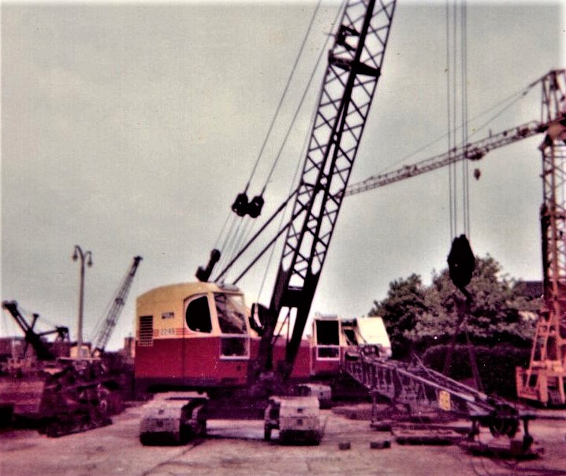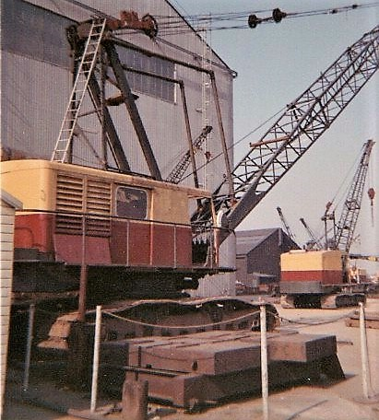
Calibrating 22-RB Wylie safe load indicator The 71-RB that threw the boom

Tangential force from one of the suspension ropes was applied to deflect a sheave and plunger as part of the preset interpretation mechanism in the control casing. With the cam mounting shaft linked to a fixed point on the framework from which the apparatus was suspended any change of radius could be marked and stored on the cam. The information was recorded using a cunningly devised strategy, our mission to trace a profile on the cam plates at each change by a process which although repetitive and time consuming was very simple. The cam path roller was installed mounted on a pin passing through the top end each side of the operating lever controlling electrical contacts. The lever profile at the pin was circular the same diameter as the cam roller permitting a blank cam plate to run in the gap when the roller was not present. With the cam casing cover removed a hooked rod temporarily clamped to the front was inserted into a slot in the lever for adjusting its position to suit each radius. Thus the cam pate could be marked around its edge at each setting. After roller positions at each radius had been marked the surplus was cut away and filed to form a smooth edge on which the roller could run. Procedure of weights change at each radius was repeated as an alarm check before the next boom length.

Pendent rope suspension by that time was the predominant setup and with all the extra labour stood around anxious to assist it made things a lot quicker when bolting and unbolting individual sections. I was to remember all those assistants stood around then many years later on site in the pouring rain having to put an extra ten foot section in a 30-RB and no assistance. It’s in such situations you learn to improvise and ignore the damp. Later on bigger machines like the 71 were calibrated adjacent to 22 Bay on another concrete patch as seen above. I mention this because of an incident in 1963 when a seventy foot boom flipped back over the top of the A frame and down the back of a machine one bright sunny morning. In his superb book about Lincoln’s Excavators 1970-1985 Peter Robinson refers to the incident and subsequent enquiry blaming poor visibility of the gib head from the driving position being a contributory factor. By a very strange coincidence I had actually taken a photograph of the very crane in question at lunch time the day before and spoke to the operator the following Friday after the incident who added another detail. What he told me was that the boom hoist clutch control had failed to disengage because of a piece of swarf in the control which they had dismantled to inspect. So perhaps there was a little more to the story. One other thing he said with pride was that he had ‘stayed with the ship as it went down.’ That must have surely been a terrifying experience. I dread to think of the noise and if he had time to wonder when the hook block would come through the windscreen and knock his hat off? For the company the incident may well have been construed as an embarrassment fortunately unpublicised not to mention the experience of the driver concerned. But some time previously there had been another notably incident in front of a group of prospective customers; the worst kind of witness. I will talk more of this in the later chapter under that exact heading.

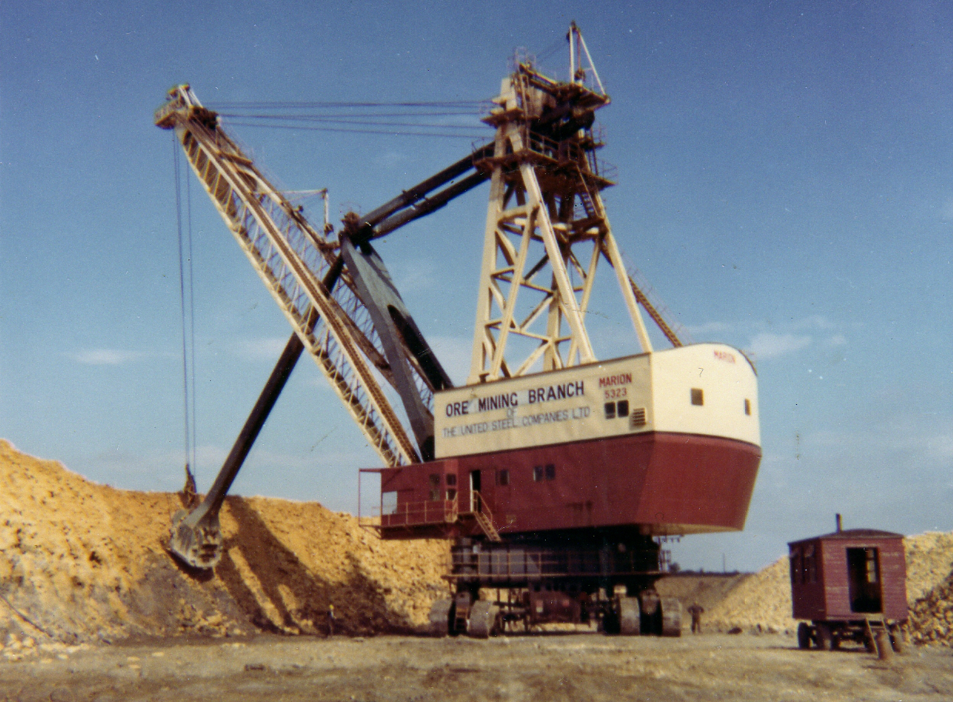
Above is a slight distraction. The Marion 5323 seen with Dick Hall
on our visit to Colsterworth trip undertaken not long after it had
been commissioned. Bags of room inside and quite warm.

While on the calibrating gang it was noticeable the number of foreign personnel that came to observe, and occasionally perhaps to look good and feel the vibes, donning overalls and observing for a few days. With other machines driving in the actual test field they seemed to come from everywhere. On one occasion we had a 38 dragline on test when it was a really miserable day chucking it down with rain. The 38 could on occasions be quite a warm inside especially if it was packed with personnel which on one occasion it was. Apart from Albert Smith driving there were several of us crammed in every nook and corner in front of and behind the engine trying to keep warm. A tale he loved to repeat whenever he had an opportunity. It was lunch break and since we couldn’t hear the hooter wailing Phil turner had come across from the test mess room to let us know and said it was like watching the ‘League Of Nations’ exiting with seven or eight visitors from different countries, as well as Smithy driving.

The actual location of the ramp where the work was carried out was opposite to and a little past the new 22 bay next to the turn off point at the west end of Beevor street for access to the test ground on that side of the works. With 22-RB calibration we were lucky with the weather being very kind to us for most of the time. And then a message came on the last Friday to report to No 18 Bay where Bernard sharp would be waiting to give me a warm welcome the following Monday. - YABBADABBADOOOH!!!

Marking Time
The test department was the last move before passing out as a journeyman fitter or whatever it was called. In fact nothing was ever mentioned by anybody the day you actually qualified. Things just carried on as before except there was no overlooking of any screw up because he’s still an apprentice. You could be snatched and seconded to anywhere at anytime just sort of drifting into a new situation with perhaps an informal approach by one of the foreman. For me it was something like: “Ayup Taff shall you go over and give Tommy, or whoever, a hand.” A couple of weeks or so before my own passing out I remember while working in 18 Bay just standing admiring the scenery when the production foreman Bernard Sharp approached very briskly; he was always pleasantly brisk, ”What are you doin’ now Taff?” Before I could think of a suitable dodge he carried on knowing full well what I would be doing very soon. “Come with me we’ve got a couple of machines you can rope up.” This wasn’t test department stuff it was the precursor; seeing if I could be left on my own because I was still officially attached to 22 Bay. Sharpy led us between the spray booths set out either side of the shop and across to the exit end of No 17 Bay, the next bay one over.

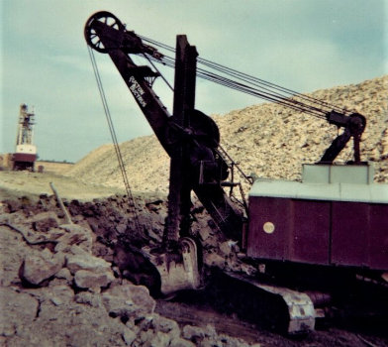
Also seen at Colsterworth was this parked up 100-RB
Not out of commission - just on standby.

A shinny new 22 stood facing the doors basic lattice boom already fitted with the head lying on the ground. Rope reels stood alongside with one of them mounted on a spooling frame running free. An initial length was already unwound lying on top of the lattice work with the end poking through the hoist drum wedge slot but abandoned and unsecured. “Shall you get on with that? You’ll also need to fit backstops lying over there and rope the bucket.” There was a dragline bucket nearby. He looked anxious, questioningly at me, or was it pleadingly, wondering is this one going to be any good? I could see it written across his face because somebody else had made a start and then for whatever reason had fled and already disappeared. But I was content. I had waited five long years for this moment and still remember asking if we had all the ropes there. I was thinking of the ¾ inch drag rope which I knew about from long ago memories of Singleton Park and a Saturday morning equipment change. I was also trying to show off my knowledge to impress on him that he wasn’t dealing with the average idiot he was expecting. No sir! I was above average let me tell you. ”Oh! No problem at all Bernard. No problem.” If he was expecting to see me panic he was going to be disappointed. Instead I was in my element while he seemed a little stunned. “Oh uh okay then, just think what you’re doing.” And with that he walked off and left me to it.

Fist job was to wedge the rope already lying through the wedge slot. Make a loop, push the tail back through, insert wedge, pull live end of rope tight with an addition sharp tug and inspect wedge. The reel still had some rope stored ready for transfer onto the hoist drum and Bernard had never said anything about not starting the machine. Oh dilemma? Would he make a fuss? He just wants the job done and I’d only just come off several stints operating a crane for calibrating safe load indicator cams so why would he? I pressed the button and the air cooled Ruston 6YDA burst into life. The engine clutch lever was pulled back so I eased it free and watched the clutches turn before releasing the brake lock, engaging the hoist clutch to slowly run the drum up, checking to see how the rope gathered onto it which was nice and tidy no problems because it had already been arranged to run from the reel around the boom head pulley. With the reel cleared clutches were disengaged and the machine once again shut down; the last couple of coils to come off being secured to the tipping sheave anchor which, along with bale bar suspension and drag chains that had already been attached to the bucket.

But who had started all that? Perhaps it was the somebody who’d disappeared but somehow I didn’t think so? I had a suspect whom I knew was not in his element with this sort of thing. All that wer’ required now - in Lincoln parlance - wer’ tippin’ and drag rope. The tipping rope found hiding in the bucket was fitted one end anchored to the bucket arch the through the tipping sheave and then on to the crow’s foot casting; an appropriately descriptive name for the anchor piece bringing together the drag rope, drag chains and tipping rope. The drag rope was next. It was an easy matter for me to pull away the bar on which the empty hoist reel it was running and then swap it for the ¾ drag after calling up the resident sky hook. As with the hoist an initial length was first pulled off by hand to poke through the fairlead for wedging into the winding drum and once secured the machine re started to gather the rest and anchor to the birdie foot.
The top of the adjacent shop where all the machines were slowly spilling out of the spray booth was both busy and very noisy with engines just ticking over or being started for fitting front end equipment. There was a 19 and a 22 being rigged with drag shovel while another 22 waited for a face shovel boom and bucket currently lying on the floor. The travelling rope crew were heavily engaged winding crowd rope onto the boom foot drum. Some months ago I remembered doing the same thing having the same fight with the same piece of rope; another ¾ Inch the same as the drag rope. It could be very stubborn. Others machines still in a state of undress were having last adjustments made to their newly fitted cabs and on the other side of the gangway a couple of 10RB machines were also undergoing attention. The assembly line for 10s at this time was still quite busy although declining in numbers due to ever increasing competition from hydraulic equipment. JCB and their equivalent were on the march. Even so from their peak output of 485 machines in 1954 their number rolling off the erecting shop floor for 1963 was still 104 and in 1964 a respectable 94. It was a busy scene at the moment still quite smokey the residue of two more recently departed machines for Wimpy and Parkinson also still lingering in the air. Where were the first two machines bound for I wondered?

We were now coming to the nub of the job. Hoist and drag ropes had been a teasing exercise. Now it was boom hoist back stops and eight part rope reeving. Oh joy of joys. This was going to be a mornin’ full of fun. Back stop tubes were in two parts with their lower tube component already mounted one each side of the cross shaft. These were bolted to the main tube carrying the inner shaft. As I thought about manhandling them into position another Crane arrived on scene carrying a big grin on its face; Tony Crane. “Hiya mate. Just saw Bernard Sharp - told me to come and give you a hand. I’ve just finished doing a job in the service shop. Which one do you want,” he added grinning. I’ve got a left and a right.” Another standard RB wise crack begging the reply, “I’ll take ‘em both Tony as long as they know what they are doing.”

By the service shop he meant the short bay next over from No 18 where odd jobs were carried out like roping up if it was too crowded in the main bay. Also, as it happened, the direction from where the breeze originated blowing fumes across from the machines being rigged in front of the spray booth. Toughing it out we carried on with the tubes bolting each half together and applying grease to each one before inserting and securing to the boom lugs. A few minutes later we had to unpin them, pull the shafts back out of each tube and slide on the cushion springs we had forgotten to mount the first time. Promise meeee…….The tricky part was to be the eight part boom suspension with floating bridle; the heavy fabricated assembly carrying two horizontal sheaves and a pair of vertical ones either side. Having himself completed the same job that morning on another machine and knowing it was too heavy to lift manually Tony had fetched a sort of wooden saddle he’d used to lie across the backstops and on which to place it using the shop crane. The front end of the bridle was connected to the head each side with heavy gauge pendant ropes. Securing them in position was the easy bit using machined pan headed pins.

The really fun part was threading the eight part ½ inch suspension rope around all eight pulleys - also referred to as sheaves - without getting our wires crossed - pun intended but true. It was quite easy to do but rope could only be pulled off the reel and through them all by hand, first on the underside of the inner vertical pulley, over the top and then crossing over to one of the two horizontal ones in the A frame yoke, and proceeding from there: back across and over, back across and under….? over? The more pulleys that were threaded the heavier the rope was to pull through. Workin’ like dogs Bernard. Workin’ like dogs. What was really confusing was both ends finally being anchored on the same side as at the start; one end onto the A frame yoke and the other, after travelling back and fore across the remaining pulleys taking its final dive down into the boom hoist drum for securing. Fortunately Tony was easy to work with which was just as well because the job also turned out to be a balancing act walking back and fore across the lattice work from one end of the boom to the other. Not a great distance but sometimes a bit slippery. Between us however we finally had it sorted and it was time start the engine up again. One consideration before actually doing this was that Bernard had not given any instruction about what to do about parking the machine when we were done. Think on lad. Use your initiative!!

Was it worth debating? Oh stuff it! Emboldened by accomplishment a decision was made. The engine was now running so I drove it out through the bay doors anyway, parking nose first against the far wall alongside a number of other variously rigged machines. I would suffer his wroth if any so do it Lewis; just do it! But there was no agro. All he said when he came back was, “You’ve done that then have you? Very good! There’s another one organised for you having a boom fitted in front of the spray booth and after lunch there’ll be a green one next door for Wimpys but there won’t be a bridle and pendant ropes okay? It’s only got six part reeving. That should make it easier.” We stood agape wondering what to say and eventually I heard myself ask, just to break the spell, “Are they both draglines?” “Yes. Both draglines the buckets and bits will be with them.” He looked at Tony and me as if butter wouldn’t melt in his mouth. We both stared back at him. The sheer audacity of the man but the way he said I knew it was just a wind up. He was trying to hide a smile as he walked away. He didn’t often smile. But on the other hand was he my fairy godmother with gifts from fairy land? Or was it fairlead land? Tea break gone and perhaps we would complete the one in front of the spray both just after lunch but yes, on reflection maybe he was being a bit sarcastic as well.

A road running behind the works ran its full length from east at the time hall end, passing the various engineering machine shop bays on the way to the test department ground at the west. It was onto this back road that large excavators like the 54s and 150s exited from No 3 Bay to turn right and rumbled their way to dirtland. Likewise the 10s, 19s and 22-RBs also exited into this road but to be driven onto low loaders for transport to customer destinations. On the far side and directly opposite the cluster of bays adjacent to No 18 was a building belonging to Ruston & Hornsby against which regular lines of newly completed machines would be lined up to await their fate. Our latest rope rigged Ruston now stood proudly amongst them. By way of a few moments respite from our labours we took a breath stealing some time to look around and see what was going on. A couple of new apprentices freshly attired in giveaway shinny boiler suits were just then walking past. How were they there alone? They were obviously very recent starters. Were they disgruntled and looking to escape over the fence. Should we poke our noses in? Strollin’, just strollin’ towards the bottom end and suddenly stopping mid stride to look more keenly at something in the distance. We followed their gaze and were rewarded with a sight that you did not see very often. It was an electric 150-RB shovel slowly trundling its way up to the test field dragging its heavy feed cable life line behind. It was a distraction and we forgot about asking what they were doing and why. At that moment it had just passed the dismantling and shipping shop. We could see Les Brown one of the older test crew gazing like Gabriel down from on high at the controls with Albert Smith and Dennis Medcalf looking after the cable. It would have been interesting to watch it pass where we were standing but we had to get on with our latest project. Would I ever get the chance to sit up in a 150 and drive one I wondered? Unlikely and in time so it came to pass! I never did.

Having found new wind we made a start once again using the local sky hook and moved the rope reel across to the spray booth. With the previous job fresh in our minds we were actually a bit quicker than before but as anticipated not able to complete before lunch so when the tummy hooter sounded we decided to dine at Ruston’s canteen meeting up with a few more of our rapidly aging colleagues from the 1959 intake who used the opportunity to complain, seek sympathy, swap experiences and generally catch up. After clocking back on we returned to a message for Tony to go and see Frank Phillipson. Being the superintendent he also officiated over No 18 Bay his office above the one occupied by various foremen in the general block midway down the bay. Tony would not be back joining me to finish off the current job or help out on the one now awaiting attention in the service bay. Not to worry. Press on, there was not a lot left to do anyway. The backstops had been fitted, remembering the cushion spring this time; the floating bridle had been roped up, taking care not to fall off, and the drag rope wedged. I hope you’re happy Bernard. It’s been a hard day’s mornin’ and I’ve been working like a dog again. All that was left now was to pull the remaining drag rope off the spool, finish the bucket details with drag chains, tipping rope and crow foot connections. After that double check everything, run it up and roll it out for parking. I was always concerned with making sure the bucket was securely anchored so as a matter course when outside lowered the boom to an appropriate angle just to let the bucket swing out a little way before braking sharply to drive the crow foot wedge home and then a similar exercise with the hoist rope dropping and stopping the bucket.

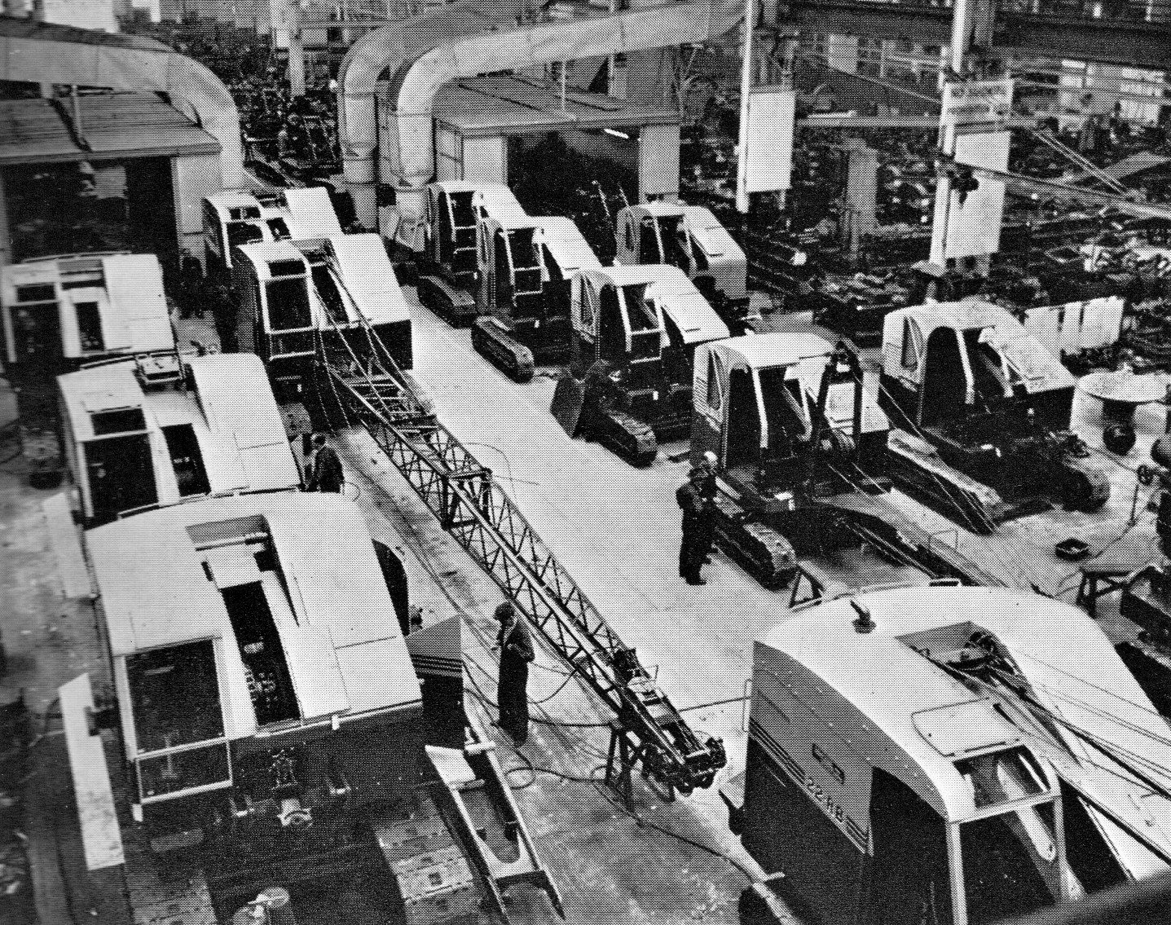
Exiting 18 Bay spray booths ready for fitting cabs and equipment

The last 22RB I swore I would be involved with that day was ready waiting in the service shop with rope reels and back stops, no birthday cake. Where’s my piece of birthday cake Bernard? Somebody said it was his birthday. The bucket bits etc were yet to arrive. Fair play Bernard had got it all organised. He could be a little abrupt at times but there was no malice behind it. I didn’t suppose he had one of the easiest of jobs. The rope reel still stood by the spray booth. It wasn’t too heavy, just a bit awkward to manoeuvre, so one of the labourers gave me a hand tipping the spooling frame on its side and we sort of rolled it around into the bay and righted it ready for roping. Sharpy had thought to organise a trestle on which to rest the boom head instead of the floor so there was no need to mess around looking for one. In my apprentice mind I was beginning to understand why he was a foreman. With everything now organised the job was pretty straight forward with the six part reeving being simple enough. Instead of a floating bridle there was a horizontal yoke sheave mounted just a bit back from the head and for some reason a jockey pulley for the hoist rope also bolted half way down. The bay was also blessed with a hand controlled gantry making things a lot easier and with the bucket and bits arriving not long after starting and after a suitable period, defined by moi, machine number three would also be parked up. This job would last as long I could make it and then I was going to disappear for a well deserved skive. It was getting toward the end of the afternoon so I surreptitiously investigated, checking on Sharpy’s whereabouts establishing that there was a big foreman’s meeting going on………so I disappeared; last seen clockin’ off.

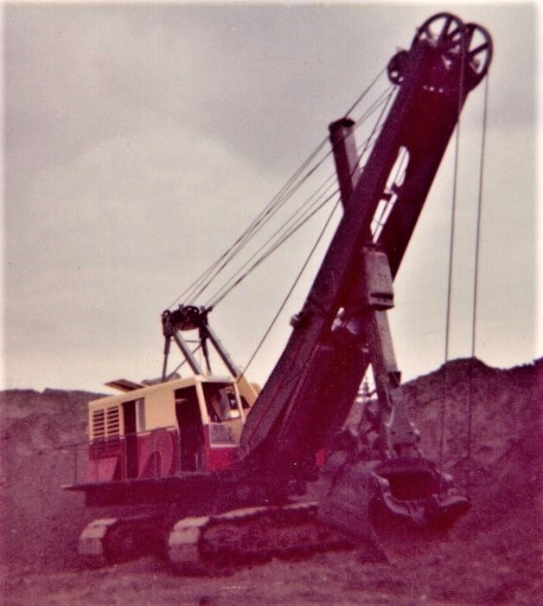
The first 71 shovel of the line

Over the next couple of days there were two or three more reeving and other jobs, one of them helping on the engine section getting them ready for installation on each machine before they trundled through the paint booth. While some details in my mind are a little vague trying to remember activities of so long ago I’m sure that Tony and I did several more roping jobs together before we once again parted company first thing on a sunny morning with him being whisked away leaving me contemplating the yard standing by a newly parked up 19-RB. It was while stood like a spare part that I was approached in a surprisingly diffident manner by my soon to be new best friend Jack Scott, the test department superintendent; a very pleasant individual who apart from having a naturally diffident manner always seemed a little nervous.

“There’s three machines stood by the dismantling and packing shop. Shall you bring them along and park them up next to the others?” Oh you betcha Jack I thought. Coming in that morning I had deliberately taken my time. Sneakily trying to avoid Bernard Sharp that’s what I was doing and in a further effort to skive - I had been over workin’- I’d gone outside to inspect the machines. I didn’t tell you that though did I? Mum’s the word OK or you ain’t my friend. It was almost teatime. It had been a very effective skive. “Shall I make a start before tea?” Tea time you have to understand was a sacrosanct ceremony. Men had been injured fighting over it. “Might as well leave it till after now Taff.” So I went in search of Tony. He was around somewhere and was eventually found sitting with another mate of his on Ray Hall’s 22 rev frame crew down Beevor Street end of 18 Bay. He’d been seconded to the calibrating team, temporarily short of a man, to assist with a seventy foot boom plus fly jib. He wasn’t sure when he would be back, if ever he’d said laughing but that was just the way it went.

Looking for Tony I’d missed my own cuppa and stole a few sips of his while crunching on a Kit Cat before making my way to the P & D Shop where the 22s stood awaiting my attention. Parked one behind the other once aboard the first one I set the fuel pump, pressed the start button, waited for the engine to wind the revs up and let the clutch lever out of its park position. With nothing in the way first command was to set up for a direct run to target without having to change course. I had a trick up my sleeve. Although I had never seen anybody actually use it there was a high speed selector pedal on the floor. What it did was slide an auxiliary pinion to engage directly with the primary drive pinion and bypass the normal transmission. When working on 22 rev frames I had physically installed the system and thought it was wasted. Now seemed a good opportunity to try it out. When selected no other function could be used but that was no problem when just travelling. So after spragging a few times to adjust my aim I disengaged the main clutch, reduced engine speed and pushed the speed pedal to the metal, feeling it looking for friendly teeth until it clunked into engagement. We were in business, slowly releasing the engine clutch as we moved off and increasing engine revolutions. It was certainly faster than standard and more than a bit rattley but having only to re sprag and steer just once using standard functions we soon arrived outside 18 Bay looking for parking space. It was an enjoyable experience and while bringing the next 22 across I noticed Scotty observing, perhaps taking note of my high speed approach. Managing to make the job last far too long at around half an hour a further instruction was received to report to the test department office. No charges made for dangerous driving just confirmation of my move at long last to ‘The Department’.

Incidents
RB had introduced their first dedicated truck or transit crane in 1956 with a basic two section 40 Foot but-jointed lattice boom and using pendant suspension. In 1957 the design was updated featuring a shortened 30 Foot pin-jointed arrangement for speed of erection. By the time 1962 arrived further updating allowed for the head boom section to be folded under the lower half to reduce forward overhang for transit. It must have been some time perhaps early to mid year when the particular incident occurred one nondescript overcast day lunchtime when a group of customers gathered to see a demonstration of the latest model. The location for the event was in front of the spare parts dispatch building and alongside the canteen; truck cab facing East down Beevor Street boom looking toward the test ground. With outriggers planted and set the boom equipped with additional centre section had been pinned together and was being raised from horizontal to a working position. Having arrived late and not witnessed this first stage of the demonstration a group of working types stood to one side watching events unfold just before the hooter was due to signal our return to labours. Picture the scene, operator sitting there deciding to disengage the main engine clutch, or was it to engage? Don’t remember which - it was sixty years ago now. Just pulling back the lever when it came away from its welded boss at the bottom...... with everyone looking on. I couldn’t believe what I was seeing and I don’t suppose the sales force or their prospective customers could either. A Ruston Bucyrus crane falling apart in front of their eyes. Just think about the implications. How many of our welded joints etc...? Don’t panic. Don’t panic. You could almost hear the metaphorical thud as somebody’s head metaphorically rolled. There must have been one almighty row over it afterwards but at the moment management were running around trying to find a welder, all eyes on the welder, poor dab, having to sacrifice his sandwich to duty dragging welding cables out from his work stations. Watch your eyes everybody. Blue and white flashes. Look away! Quality control must have been running around like proverbial headless chickens for days. Even as just an apprentice I was embarrassed and made my return to station as the hooter wailed and we never heard anymore about it. Just another day in infamy then but around twelve months previously they had launched the new 11-RB Transit Crane. Based on the American version a number of features had been up rated for the European market one of then being tubular construction for the boom with pinned connection for quick assembly. As an additional feature the boom head pulley shaft was extended either side for mounting temporary rubber wheels to enable smooth unfolding and erection with the whole unit being mounted on a six wheel Atkinson chassis. I confess I basically knew nothing about the 11-RB, like a lot of us, it being built quietly away from main build shops in one of the more remote buildings. Hah! Apprentices - walk around with their eyes closed half the time. Yes! I know Sid. I promise you I’ll ‘Think On and I’ll Buck Up’. But I am ‘improvin’.

While on the calibrating gang it was noticeable the number of foreign personnel that came to see how it was all done, occasionally perhaps to look good and feel a part of proceedings and to be photographed, donning overalls to observe for a few days. On machines driving in the actual test field they seemed to come from everywhere. On one occasion we had a 38 dragline on test when it was a really miserable day chucking it down with rain. The 38 could on occasions be quite a warm inside especially if it was packed with personnel which on this occasion it was. It was lunch break and since we couldn’t hear the hooter waling Phil turner had walked across from Test mess to let us know. He said afterwards that it was like watching the League of Nations climbing down one after another onto the tracks and a last step for mankind back onto mother earth. Apart from Albert Smith there were another six of us crammed in every nook and corner in front of and behind the engine trying to keep warm. A tale he loved to repeat whenever he had an opportunity.

As far as I can remember, known to me at the time, there were about a twelve fitters associated with the test department who congregated in the posh new mess room attached to 22 Bay. Test department bods had an unscripted sort of life wandering as they frequently did from one end of the works to the other between No 3 bay and the test ground. At the erecting shops for 38 and 54 machines they would take command as soon as build had been completed and set about adjusting clutches, brakes and anything else before raising the front end equipment ready to roll out of the doors. I can only presume that when the power units were supplied be it Paxman, or in the case of 30-RB machines Ruston engines, that the fuel system had been already primed all the way through to the injectors. The subject is worth a mention because RB personnel had no technical involvement with engines at all; something which personally I did found rather disappointing.

There may have been others on the crew that I didn’t see but duties amongst personnel varied and they may not always all have been in attendance together at any one time. Anyway - from delivering the machines from the packing shop I went to find Jack Scott but was intercepted by Phil Turner and spent the rest of the day on board a 38 dragline, mostly watching him drive but occasionally being given a spell at the controls myself. Of course my first act was to rip the throttle wide to which he reacted knocking it back down to idle. Though unpracticed at actually driving myself I had in earlier days been on a number of draglines and shovels and watched the technique. Trying to control a bucket on the end of two ropes at slow speed was frustrating. Anybody who does drive knows you just can’t get any rhythm going. To drive a dragline ‘Man you just gotta have de rhythm you know?’ I couldn’t really argue though so I just tried sneaking things up a notch after any spells out of the seat. There was one thing which they didn’t object to however and that was setting up the brakes to suit my own preference to the point where a little extra pressure and stroke would set the latch keep. Adjusting on a 38 was easy with a short floor level coupling rod having both left and right hand threads situated just behind the seat. With usually one or two machines working there was always a variety in the job you did with occasional visitation from customers both domestic and overseas.

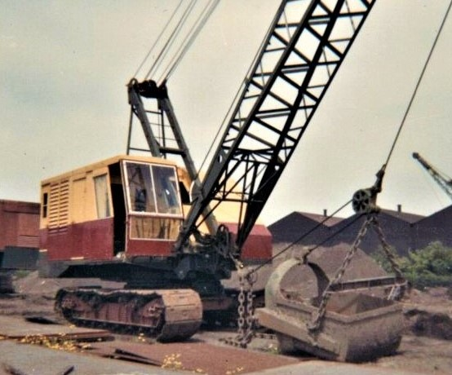
54-RB parked awaiting a customer and parked

One of the memorable visits was by a Swedish customer and his son named Lars. Lars senior was contemplating the purchase of a 38. It must have been for dragline work because there was already a machine with a sixty footy boom stood next to the standard sized digging hole in the middle of the field. Lars junior literally hi jacked it for the best part of the morning and rest of the afternoon digging the biggest and deepest hole that had ever been. Despite heavy hints they just couldn’t get him off it. We could only speculate, although it was never confirmed, that after an afternoon of such devoted digging daddy bought him his own dragline. It took several days to fill it back in again to what it was before. There was a more unpleasant tangle with a thick set, medium height, dark curly haired individual from the sales team undergoing familiarity with machine control. We were around the back tump of dirt on a 30-RB shovel and muggins was at the controls, doing a tidy job of it, or so I thought, when he butted in quite gruffly telling me to “Drive it properly”. When I looked at him enquiringly he told me to always use the backhaul clutch - that was what it was there for. Gave a real lecture on it. Can’t remember what my reply was because at the time the door latch had just discharged a load and it would have been pretty daft to engage the backhaul clutch when gravity would do the job a lot faster. He just didn’t seem to understand and would brook no discussion, obviously not familiar with how to drive them on site to meet production requirements. A real misery but fortunately the only time we met.
It was around this time that Dick Hall my exhibition attending chum was also having some tuition on a 110-RB electric shovel which never happened to me. Maybe it was a privilege only given unto student apprentices. He was also given a drive on a 22 the same week with the latest experimental hydraulic wrist backhoe attachment. My luck was definitely in when the following afternoon. We were paired up to share a driving experience and really get to grips with technique on a 22 shovel for a couple of hours, until I was overcome by what I assumed were lead paint fumes. It was a scorching hot day and it was one of the first to have an enclosed operator’s position sealed off from the 6YDA air cooled power unit. Pretty ill for a few hours and just made it to the ambulance room before passing out. Funny thing was that although I told the nursing staff what the problem was I never heard anything more about it. Still a good day though then in spite of the paint fumes........

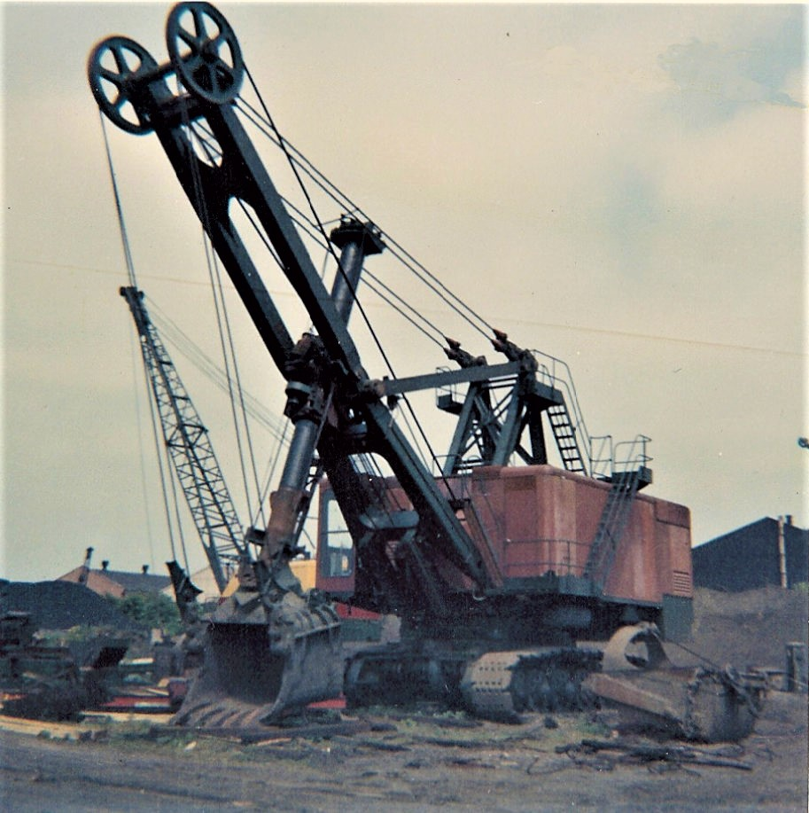
150-RB Electric Shovel Parked up on Test field

My first experience of actually driving a 38 happened a week or two after moving the three 22-RBs from outside the packing shop. I had on numerous occasions watched a member of Test department wind one up and slowly drive it down the No 3 Bay ramp out into Beevor Street, spragging to the left and trundling it up to the test ground. On the particular day something had sent me down to No 3 Bay and I was lurking wondering what I was doing there when Jack Scott, who must have had also been lurking in ambush, materialised from the shadows and in his usual diffident manner said. “Shall ye take yon shovel to the field and park it up? It’s all ready for you” Sometimes really unexpected things happen and that request was really unexpected. The thing was there were no other test department members about. Perhaps my hi-speed 22-RB driving technique a week or so earlier had impressed him after all? While pleasantly dazed he interrupted my thoughts with, “They’re opening the doors up for you now.” Two vaguely familiar overall clad gentlemen appeared to push the sliding doors aside. The world, or is it Beevor Street, was my oyster but I am in a state of shock. “Shall ye start’ er uwp then Taff? Climb on board, quick check around and press le button. Clonk, clonk, clonk, chuffa, clonka, splutter, splutter, smoke gets in your eyes, splutter - no one told me it would be this exciting - clonkitty, clonkitty, thumpitty, thumpa, chucka - chucka- chumpitty, chucka - chucka - chumpa..... Let the main clutch in - the gears turn - travel lever gingerly forward as we tip over the edge, not into oblivion but out into the street and we are rollin nice and easy down the slope. Scotty sees that I am in control and I sprag left and head for the field of dreams. Thanks mum, thanks dad - rolling free at last. Only three sprag corrections to reach my destination, passing workshops on the left and offices on the right. Please don’t look - you’ll make me nervous.

Then further along the canteen and spare parts dispatch and another building alongside which I never did find out what its purpose was. Next was the Ruston Research building where Phil Turner had once been borrowed along with a 22 dragline to dig a new basement and after that a patch of open ground which had become very interesting because of a Babcock Marion 43-M dragline busy recovering scrap metal, dropping it onto a conveyor belt for sorting. Interesting having a Marion working right next to RB. Another Kodak moment for the digger boy scrap book. Almost reaching the Ruston Beevor foundry on my right and sprag left just before some hedging, travel a few yards more before spragging right across the calibration area and onto the test ground and passing the dragline practice hole on my left. Filled back in now after Lars tried to dig his way to a coal mine with the 38. We should have given him a Boy Scout Badge or some sort of plaque for that. There’s no parking attendant and on the right next to the hedge three 38 machines are taking up space. First one’s a dragline next to it a shovel and then a gap to the last in line, another shovel. I draw next to the gap. Didn’t hold a driving licence and had never driven a car let alone parked one but this is a shovel. A’ course I can park a flippin’ shovel. Nowt to it is there? Roll past the parked shovel, stop, sprag left right around till square. Nip around the duck boards to the back and check my blind side. Yeah! ‘course there’s e‘nuff space. Return to control room and pull propel lever to back up for a couple of yards. Drop down onto terra firma and check side clearances between walkways. Jamy sod! Almost dead parallel - not more than six inches either side. I can’t believe it. Keep going backwards until machine fronts are aligned and check again. Disengage main clutch, shut down engine, slide door closed and saunter smugly back to Test Department mess room. Empty! Where is everybody?

I had never really been interested in hydraulic diggers. There really just weren’t any about during school years in the 50's so when I met Dick in the RB canteen for Shepherd’s pie one day in 1961 my interest was aroused but not seriously. A new design engineer had joined the company some while ago and had been working on an experimental one the initial fruit of which was being driven up to the test field the next day. Myself not then with the test department but still somewhere in the works putting things together, Dick in the drawing office, we met for an early lunch the next day having to run to be early in the queue, quick pudding, then take a walk up to the field to view the future of digging. Dick had already seen it and was non committal. What we were looking at was a four wheel mounted earth tump attack machine Designated the 2-RB. It featured a cambered bucket arm with wide bucket having only a lip and no teeth. Some impressive talk of swash pumps coupled to a high pressure hydraulic systems stirred interest, but for me, only just. Still very much in the experimental stage it was just a test bed and did not then look very exciting. Any operator involved must still have been at lunch so we had wandered back down to our various work places not very impressed. Next day John Chard one of the test crew was seen attacking a pile of dirt with it when it just seemed to stall with no oomph at all.

Time had moved on and now attached to The Test Department I had just walked in from the test ground where by a strange coincidence I had been with John Chard for the best part of the morning on a 30-RB drag shovel. A message had come down from on high to go and see Jack Scott. Was it going to be good news? “Oh hello Taff - shall ye’ go and find Ernie Hopcroft. He’s in’t field wi backhoe, yon side’t road in’t corner opposite main office block.” It took a few seconds to interpret what he was actually saying. I was getting more familiar with Lincoln speech now but sometimes still had to mull it over. Know what I mean? He didn’t actually say what he wanted me to do on arrival. Was it another 30 on backhoe? It was bound to be good in a field with a digger so I went along. It was not a 30-RB. Rope operated diggers were really my thing; far more moving bits and pieces to watch. This machine was a pre production 3-RB and the culmination of development work on the test bed 2-RB witnessed some while previously. Utilising a standard 10-RB caterpillar frame it was undergoing digging trials swinging around on a re designed turntable truck stuffed full of precision gears and hydraulic motors and driven by champion woods bowler Ernie at the controls creating a trench. It wasn’t hard digging. It was just digging.

He seemed relieved to see me; flattering and better than the usual grimace. He turned as I approached giving a friendly nod. “Have you been sent?” So just to stir things up a bit I laughingly told him I had been told he was in deep trouble and desperately in need of my advice. Just grinning in reply he asked to confirm who I was. “Is it Taff? I don’t think we‘ve spoken to each other before.” I could tell we were going to get along. “Well timed Taff. You can come up here and take over for half an hour. You don’t mind do you?” Yes we were definitely going to get along so I nodded eagerly. “You know how to drive it don’t you, just the three levers. I need to go and see somebody for half an hour. Just you keep digging steady in a straight line. You can cover for me, I shan’t be long. “Ernie was a thin faced and slightly tanned wiry individual about the same height as myself with his dark hair covered by a cloth cap and perhaps a slimmer version of Phil Turner. A moment later he was gone and I was sitting at the controls with a three foot deep trench stretching out in front of me. It was easy enough to operate and a totally different experience. With everything being rigid and no flexing ropes it felt very strange. He was a bowls champion of some note and I had the sneaky feeing he was off to talk about arrangements for a meet of the RB Bowls Club. It had been late morning when I arrived on site and he had not returned by lunchtime so with nobody to answer to I just sloped of to the canteen for egg and chips meeting Ray Hunt and Charlie Creasey on the same table so we did a bit of catching up. It was in some way surprising that although we all worked in the same factory, albeit a very large one, we didn’t meet up with each other that often. So after catching up on what had been happening and clocking back in early I made my way back out to the wilderness beyond the main office block, shortly followed by Ernie apologising for his extended absence and obviously relieved that the 3-RB was still in one piece. Digging trials quickly resumed and the rest of the afternoon spent whiling away time taking turns playing around chasing worms with the bucket and that was all I ever had to do with the 3-RB.

You never knew the quality of the visitors who would sometimes show up to spend time on test. We had worked with Lars from Sweden and now suddenly a young dark haired lad joined our happy band to get acquainted with RB Stuff. He was from an even more distant place this time being Saudi Arabia. He didn’t give anything away about himself really but did nevertheless join in with the spirit of the crew. I’m not sure if it was his given name but we christened him Lawrence because it seemed appropriate. We pulled his leg a bit but he didn’t seem to mind, giving as good as he got in terms of verbal exchange and soon became fully acquainted with our industrial language and bantered insults. He only gave us one stipulation: We were not ever call him a bastard. Although he knew it was not a serious jibe his religion and origins made it a deep insult so we accepted his condition and, within reason, called him everything else. I think in fact that although he never mentioned it somebody gleaned the news that he was actually a prince. If so he was one of the most laid back princes I have ever met. In fact he was the only one. He also had a skill which was discovered quite by chance. He was pretty good with a catapult. I think they must have used them in the desert for scaring off visiting pigeons, maybe even the odd eagle? Phil Turner sort of took him under his wing…..if you understand what I mean and often had him aboard a 38 dragline usually just to lean out of the cab and hold up a piece of cardboard so that he, P Turner, could try out his skill with a catapult. Test department was all things to all men. Phil was not a good shot and neither really was Lawrence who almost took of Phil’s right hand one morning. Depends really on what you class as skill. ’Test’ could be a lot of fun at times.

One thing we found in common with the boys from test was that they were just like apprentice and pretty skilled at skiving off when the need came; sometimes to our advantage. One morning there was a 38 dragline working in the centre ground, a shovel popping away around the back tump and a 30 backhoe with Charlie the Pole extending and deepening the hole opposite to the dragline. Lucky me I was with Charlie. The thing about the 30 was that it had a completely different feel to it than the other machines because it was by this time completely air controlled. You may remember my reference to them when arriving four years or so before. Three of them standing outside the apprentice school door which I had clambered over to inspect and which at that time still had manual cam and roller engaged clutches on the boom hoist. Those three machines incidentally had ended up being fitted with high vision logging cabs just a couple of weeks after my inspection; destination Canada. They had been moved to No 3 Bay over a couple of days one weekend. The 30-RB machines coming out of those doors now were the real McCoy with everything controlled by squashed air and I was watching closely as Charlie put it through its paces digging a big ‘ole int’ ground. He slowly turned to me after a ten minute spell, at which he was obviously getting bored, and asked,” If I let you drive will you promise not to break anything?” My reply was honest and straight from the heart. “I’ll try not to Charlie - why? Where are you going?” I was on to him. He was off for a skive somewhere. “Before you go just remind me about steering controls on this one can you? They moved the positions on these recently didn’t’ they?” Funny how you notice some things.” Er-yeah! OK” And he spent a few minutes with me at the controls while I got familiar before his very quick departure down the back yard and while he was gone I tried not to break the machine. A half hour later he returned looking anxious wondering if he should have left me after all when he saw the backhoe in a different place to where it was earlier. No it wasn’t upside down in the hole but it had been moved several times to do some steering practice and I confess I was feeling rather pleased with myself.

End Of Days & A fond Farwell
Time was moving on and a few weeks ago my days as an apprentice were over and I had become what some industries referred to as a journeyman fitter. What was I going to do? I knew I wasn’t going to get the push. I would have had wind of it but although they officially didn’t guarantee a job when your time was up nobody we knew of had been given the boot. Nothing from management and nobody had mentioned anything about this aspect of my life and neither had Charlie Everitt. I was restless however and although I could have stayed I did not want to get comfortable and remain in Lincoln for the rest of my life. There were these things to think about and also one unfinished ambition. I had once again been down to 3 Bay to collect a 38-RB shovel and brought it safely home to the parking ground but what I really wanted to do was bring a 54. Just before my time matured it had been arranged for me to have an afternoon on a 54 shovel and I was really looking forward to it. There had been the odd occasion when I had seen one being driven and just loved the slow whining plod of the Paxman engine and rattle of the crowd chains. The time was eleven thirty approximately on that day when I got sent for by the apprentice supervisor to escort some visitors around the works in the afternoon. I told him I couldn’t because I was already booked. Could he not get somebody else? No he couldn’t he was adamant. There would be other days. I was absolutely livid and should have gone to see Scotty and laid my cards on the table. I’m sure he would have helped. That’s what I should’ve done but didn’t and spent a miserable afternoon showing another group of students around. Subsequently on my last days on test I was hoping there might be another 54 to bring up but there wasn’t.
I should have been more pushy but I wasn’t. It was now October and winter would soon be here and Lincoln had some very cold winters. In the severe winter of 63 I was living in a small flat, if you could call it that, with a kitchen and loft sleeping quarters next to the river. I had nearly died overcome by fumes from a portable gas heater with no ventilation and being at a very low ebb almost catching pneumonia. It was time to move on. I had to leave; now or never. So I wrote to a few companies, checking out possibilities and on the Friday before my eventual departure went to see Scotty to give my notice. He just said “Oh! OK.” And that was it. I new I would miss the place and all the people I had come to know over the five years and as I cycled down the end of Beevor Street and out into The Rope Walk for the last time I swear I heard an echo from the past following on the breeze whispering P-r-o-m-i-s-e meeeeeeeee.

